March 5, 2025
Version 1.1
Fach
Katharina Tschirky
katharina@tschirky.ch

Titel

Inhaltsverzeichnis
Inhaltsverzeichnis 1
1 Lab – OSPF 2
2 IS-IS 4
3 BGP 5
4 Multicast 6

Lab – OSPF
- Can you answer why it so important for a link-state protocol like OSPF to ensure that the Link State Database (LSDB) is always synchronized between all routers in an area? What could happen if it was not the case?
Reasons why it’s important:
- Consistent Network Topology (same shortest path tree)
- Loop-Free Routing
- Faster convergence
What happens if it’s not the case:
- Routing Loops (Router A thinks best path is B and vice versa)
- Routing Inconsistencies (incorrect forwarding based on outdated information)
- Network Instability
- Traffic Black Holes (sending to a dead path because the router does not know about the new link)
- Per-packet load-balancing is not desirable for several reasons. Can you think of any reasons?
It might be challenging to reorder packets, especially TCP relies on packet order (congestion control e.g slow start). A packet out of order can be mistaken as packet loss.

Fragen bezogen auf das Lab Setup
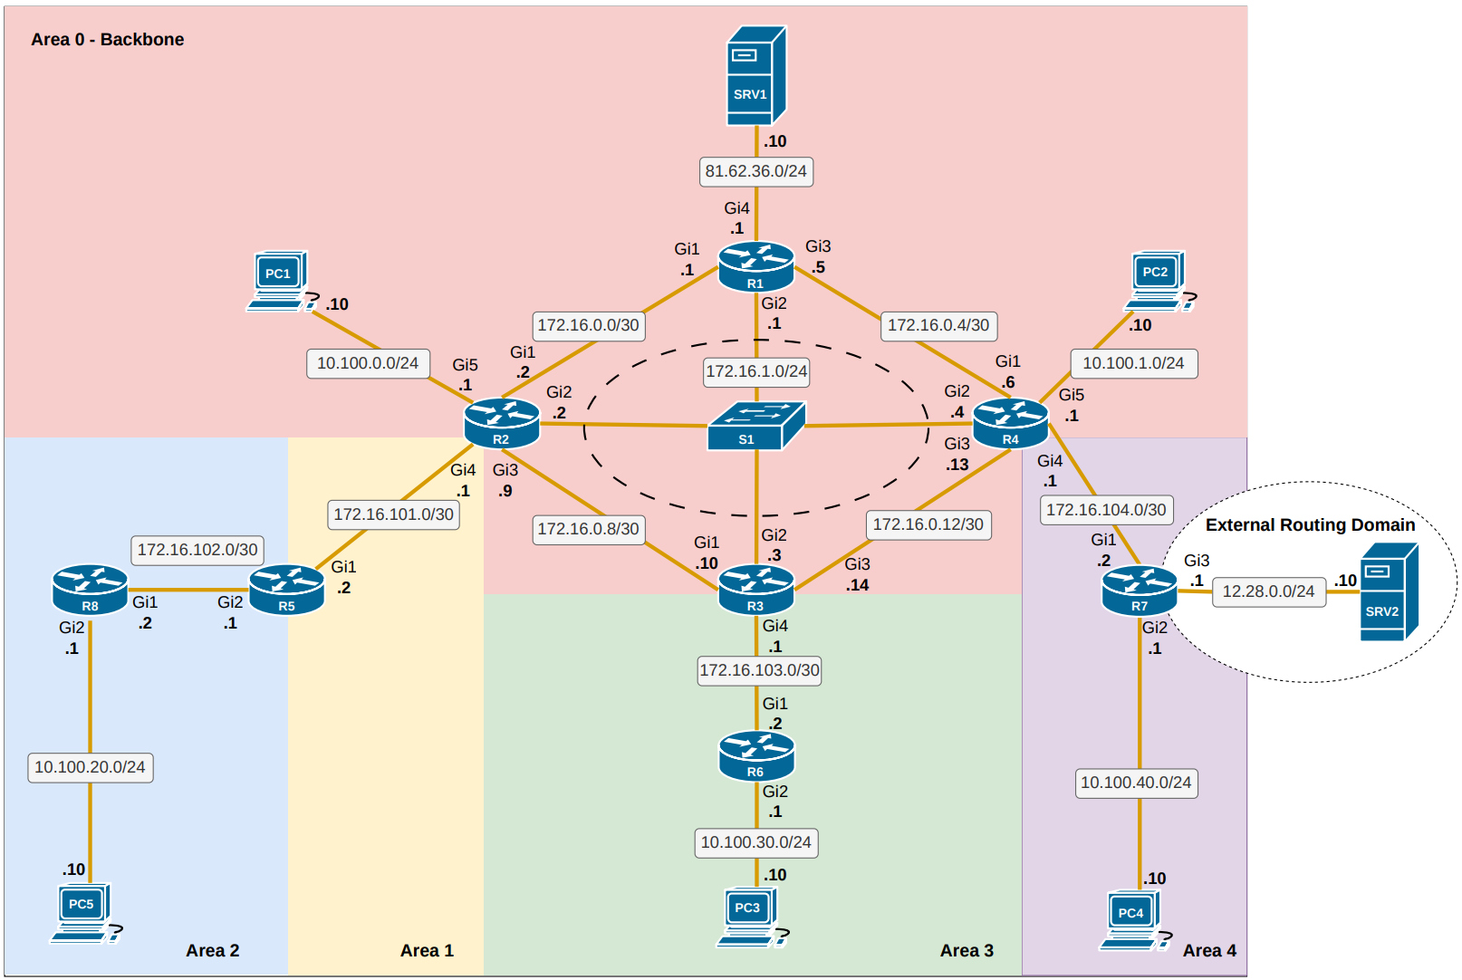
- Was muss man konfigurieren, damit in der backbone area pc1 und 2 kommunizieren
z.b für ein router und ein interface (muss für alle gemacht werden):
interface gigabitethernet1
ip ospf 1 area 0
exit

router ospf 1
router-id 2.2.2.2
passive-interface gigabitEthernet5

Ofc this has to be done for every router
- Was für ein Network Type ist in der Mitte beim Switch und welcher Type ist ohne switch?
In der Mitte gibt es wegen des Switches (L2) eine Broadcast Domain. Falls es keinen Switch hat, dann ist es nur noch ein point-to-point Netzwerk (Point-to-multipoint networks), folglich braucht es auch keinen designated router.
- Erkläre point-to-multipoint und broadcast networks
- Was passiert mit dem designated router, wenn broadcast domain aus ist?
Changes only happen if you shutdown the port. If you do shutdown then there won’t be a root anymore.
- Was muss man an der cost anpassen, damit es einen neuen root gibt?
- Was ist die challange, damit ost-west traffic immer noch load balancing hat?
The traffic hast to be symmetrical.

- Was war die challenge von area 2?
-Virtual link erstellen,
-Gestrichelte Linie muss neben die normale Linie von r5 und r2
-r5 wird zum border router wegen dem link (ist kein backbone)
- Erkläre area 3 (stub area)
-Hat default route
-Erhält keine type 5
- Erkläre die area 4 (totally not so stubby)
-Gibt type 7, die zu type 5 umgewandelt werden

IS-IS

BGP
- What are the difference between the logic of OSPF and BGP?
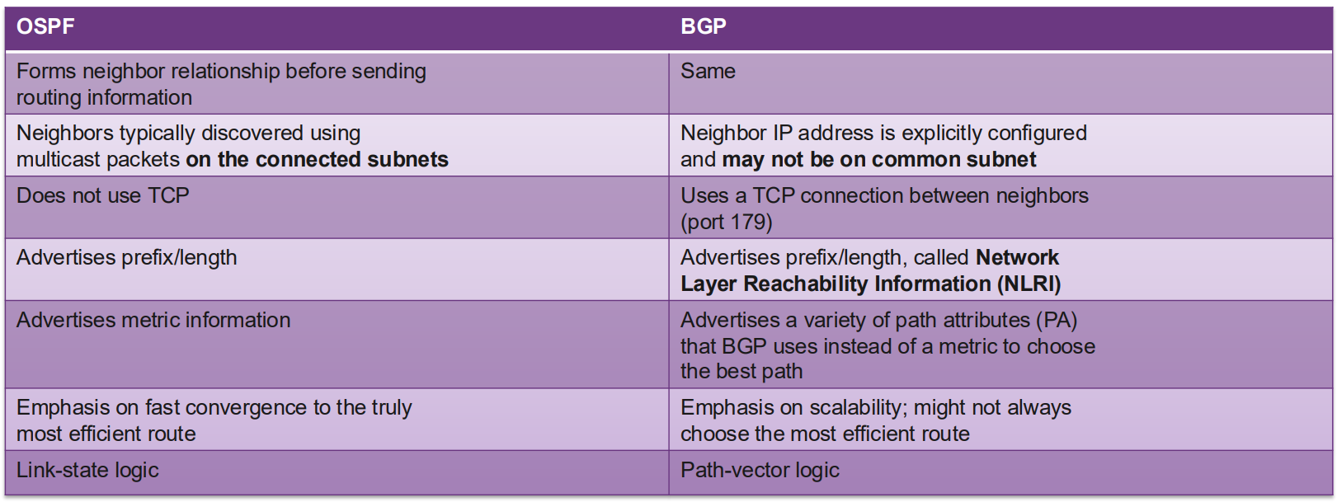
- ISP C will propose peering to ISP A ISP B will propose peering to ISP A What will ISP A propose?
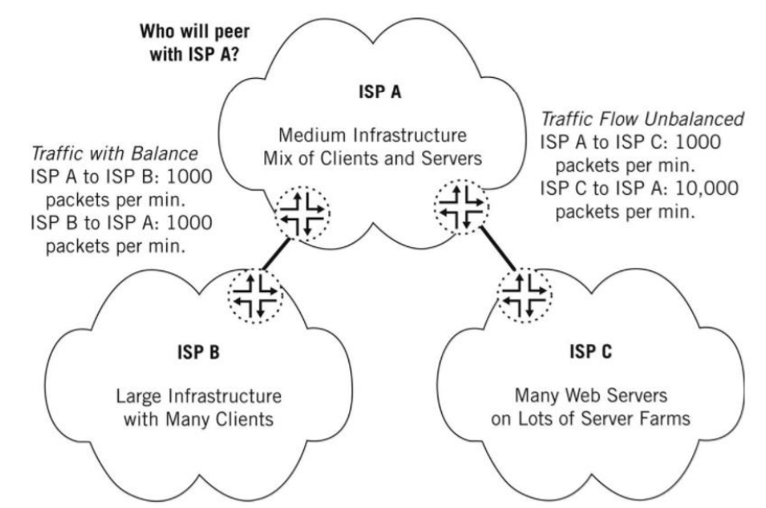
ISP A doesn’t want a peering with ISP C since there is no balance. ISP A (Transit) wants money

- What does RPKI solve?
- Prevents route hijacking
  - A prefix originated by an AS without authorization with malicious intent
- Prevents mis-origination
  - A prefix that is mistakenly originated by an AS which does not own it
  - Also known as route leakage

Multicast
- On the drawing below, R2 is configured as the Rendezvous Point. An IGMP join has been sent by a multicast receiver to router R7. Which entry will be created in the router R7 control–plane? How will R7 inform the RP of the existence of the receiver?
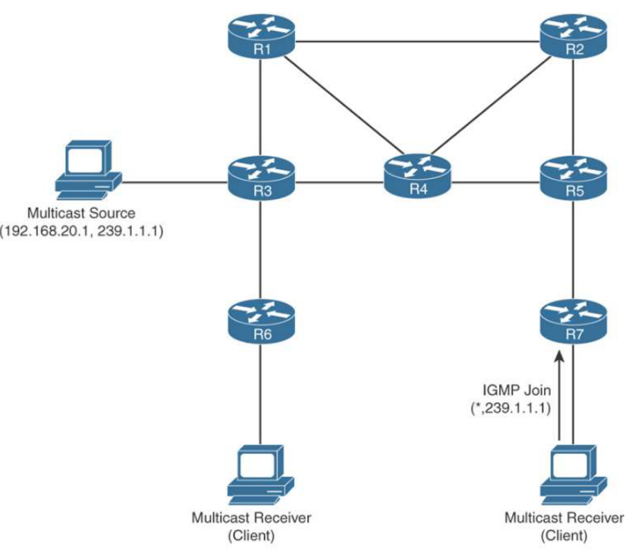
- IGMP snooping is enabled by default on a switch. Can you think of any situation where IGMP snooping should be turned off?

EVPN / VXLAN
- Can the Goal Be Reached with Only Switching?
- Can the Goal Be Reached with Only Routing?
- What are issues of traditional layer 2 networks?
- Spanning tree
  - It blocks loops, which means we get less bandwidth as redundant paths get blocked
- Limited amount of VLANs
  - We only get 4094 VLANs which can be an issue in large datacenters
- Large MAC address tables
  - Behind physical ports can be hundreds of VMs that all need to be added to the MAC table

