Student Name: Kushagra Vashistha UID: 24BAI70915
Branch: AIT-CSE (AIML) Section/Group: 24AIT_KRG2
Semester: 4
Subject Name: Database Management System Subject Code: 24CSH-298

Experiment
Experiment 1.1: Design and implementation of a Library Management System using PostgreSQL with DDL, DML and DCL commands.

Aim
The aim of this experiment is to design and implement a Library Management System database using PostgreSQL. The database is created using proper tables, primary keys, foreign keys and constraints. DML operations are performed and database security is implemented using roles and privileges.

Objective
The objective of this experiment is to gain practical knowledge of DDL, DML and DCL commands in PostgreSQL. It also helps in understanding how to create roles, grant permissions and revoke permissions to secure the database using role based access control.

Practical / Experiment Steps
1. Design the database structure for the Library Management System.
2. Create tables for books, members and issue records using DDL commands.
3. Apply primary keys, foreign keys and constraints to maintain data integrity.
4. Insert sample records into the tables using DML commands.
5. Update and delete records as required.
6. Create a database role named Librarian.
7. Grant required permissions like SELECT, INSERT and DELETE to the Librarian role.
8. Revoke permissions when needed to ensure database security.

Procedure of the Experiment
1. Start the system and log in to the computer.
2. Open pgAdmin and connect to PostgreSQL server.
3. Create a new database for the Library Management System.
4. Create tables such as Books, Members and Issue_Records using CREATE TABLE command.
5. Define primary keys and foreign keys while creating the tables.
6. Insert records into tables using INSERT command.
7. Update existing data using UPDATE command.
8. Delete unwanted records using DELETE command.
9. Create a role named Librarian with password using CREATE ROLE command.
10. Grant SELECT, INSERT and DELETE permissions to the Librarian role.
11. Revoke permissions using REVOKE command when required.
12. Execute all queries and verify the output.
CODE :
- ADMIN

CREATE TABLE BOOKS(
ID INT PRIMARY KEY,
NAME VARCHAR(20) NOT NULL,
AUTHOR_NAME VARCHAR(20) NOT NULL
)

INSERT INTO BOOKS VALUES(1,'HARRY POTTER','JK ROWLING')
INSERT INTO BOOKS VALUES(2,'LORD OF RINGS','KUSH')

ALTER TABLE BOOKS
ADD COUNT INT CHECK(COUNT>=1)

UPDATE BOOKS
SET COUNT=3
WHERE ID=1

SELECT * FROM BOOKS
SELECT COUNT(ID) FROM BOOKS
CREATE TABLE LIBRARY_VISITOR_USER(
USER_ID INT PRIMARY KEY,
USER_NAME VARCHAR(20) NOT NULL,
AGE INT CHECK(AGE>=17) NOT NULL,
EMAIL VARCHAR(20) UNIQUE NOT NULL
)
ALTER TABLE LIBRARY_VISITOR_USER
DROP COLUMN EMAIL

ALTER TABLE LIBRARY_VISITOR_USER
ADD EMAIL VARCHAR(50) UNIQUE NOT NULL

INSERT INTO LIBRARY_VISITOR_USER VALUES (1,'KUSHAGRA',20,'VASHISTHA.KUSHAGRA22@GMAIL.COM')

SELECT * FROM LIBRARY_VISITOR_USER

CREATE TABLE BOOK_ISSUE (
BOOK_ISSUE_ID INT PRIMARY KEY,
BOOK_ID INT REFERENCES BOOKS(ID) NOT NULL,
ISSUER_ID INT REFERENCES LIBRARY_VISITOR_USER(USER_ID) NOT NULL,
BOOK_ISSUE_DATE DATE NOT NULL
)

INSERT INTO BOOK_ISSUE VALUES (5552,1,1,'2026-01-09')

CREATE ROLE LIBRARIAN
WITH LOGIN PASSWORD '123456'

CREATE ROLE LIBRARIAN_1
WITH LOGIN PASSWORD '12233445'

GRANT SELECT ,INSERT ,DELETE,UPDATE ON BOOKS TO LIBRARIAN_1
GRANT SELECT ,INSERT ,DELETE,UPDATE ON LIBRARY_VISITOR_USER TO LIBRARIAN_1
GRANT SELECT ,INSERT ,DELETE,UPDATE ON BOOK_ISSUE TO LIBRARIAN_1

REVOKE SELECT ,INSERT ,DELETE,UPDATE ON LIBRARY_VISITOR_USER FROM LIBRARIAN_1
REVOKE SELECT ,INSERT ,DELETE,UPDATE ON BOOKS FROM LIBRARIAN_1
REVOKE SELECT ,INSERT ,DELETE,UPDATE ON BOOK_ISSUE FROM LIBRARIAN_1
- LIBRARIAN

SELECT * FROM books;
select * from book_issue;
select * from LIBRARY_VISITOR_USER;

INSERT INTO books VALUES(110,'ABCD','CLANS',2);
INSERT INTO books VALUES(150,'THE LORD','HRM',7);

DELETE FROM books
WHERE ID=150;

SELECT * FROM book_issue;
SELECT * FROM LIBRARY_VISITOR_USER;

Learning Outcomes:
- Understood the basics of relational database design using tables, keys, and relationships.
- Learned to apply primary key and foreign key constraints to maintain data integrity.
- Gained hands-on experience with INSERT, UPDATE, and DELETE operations safely.
- Understood how roles and privileges control access to database objects.
- Learned to use GRANT and REVOKE for implementing read-only users.
- Practiced ALTER TABLE and DROP TABLE for managing database changes.

SCREENSHOTS
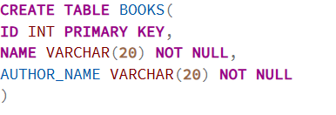
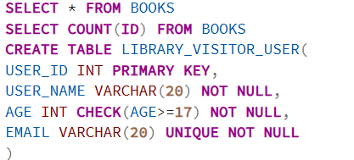
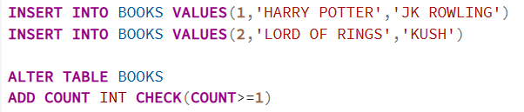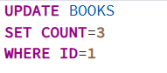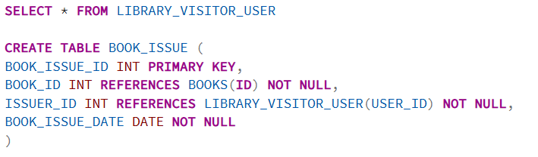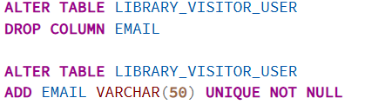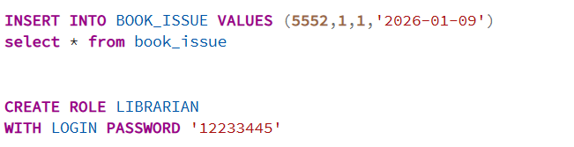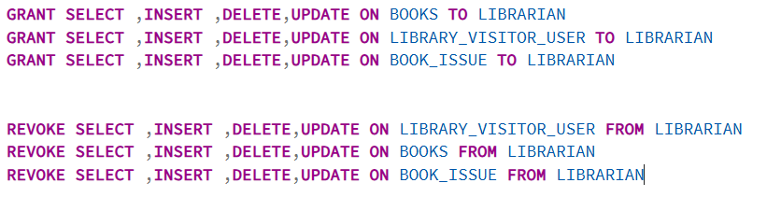
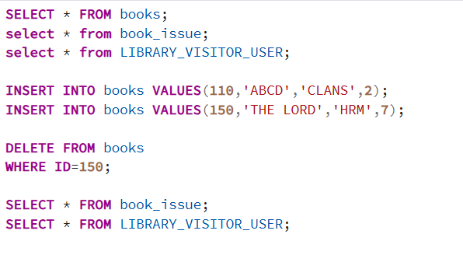
LIBRARIAN
