Student Name: KUSHAGRA VASHISTHA UID: 24BAI70915
Branch: AIT-CSE (AIML) Section/Group: 24AIT_KRG-G2
Semester: 4
Subject Name: Database Management System Subject Code: 24CSH-298

EXPERIMENT 7
Design and Performance Analysis of Materialized Views (SanDisk, JTG, PayPal)
AIM
To design and implement a materialized view and to compare and analyze execution time and performance differences between simple views, complex views, and materialized views, thereby understanding their impact on query optimization and system performance.

OBJECTIVE
- To create simple views, complex views, and materialized views.
- To evaluate their performance by comparing query execution time.
- To highlight the advantages of materialized views in enterprise-level applications.

SOFTWARE REQUIREMENTS
Database Management System:
Oracle Database Express Edition (Oracle XE)
PostgreSQL Database
Database Administration Tool / Client Tool:
Oracle SQL Developer (for Oracle XE)
pgAdmin (for PostgreSQL)

PROBLEM STATEMENT
In large-scale enterprise systems, frequent execution of complex queries can significantly affect performance. Organizations require optimized mechanisms to improve query response time without compromising data consistency.
Materialized views help improve performance by storing precomputed query results, reducing the need for repeated complex calculations.

PRACTICAL / EXPERIMENT STEPS
Step 1: Create base tables (Employee, Department, Payroll).
Step 2: Insert sample data into tables.
Step 3: Create a simple view based on a single table.
Step 4: Create a complex view involving joins and aggregation.
Step 5: Create a materialized view storing precomputed results.
Step 6: Execute queries on all views.
Step 7: Compare execution time and analyze performance.

STEP-WISE OUTPUT
Step 1 – Create Base Tables
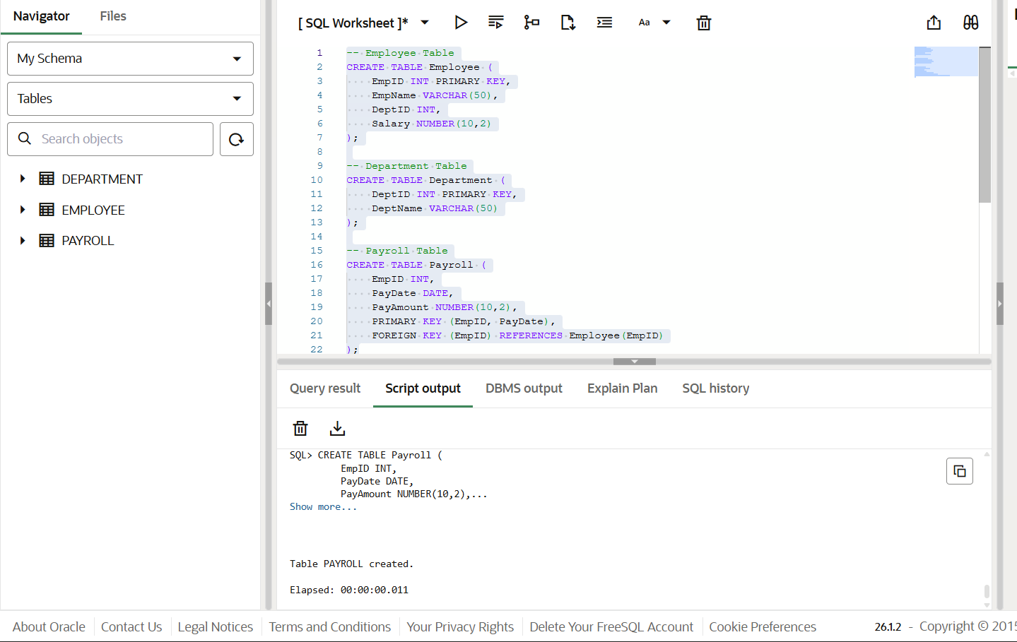
Step 2 – Insert Sample Data
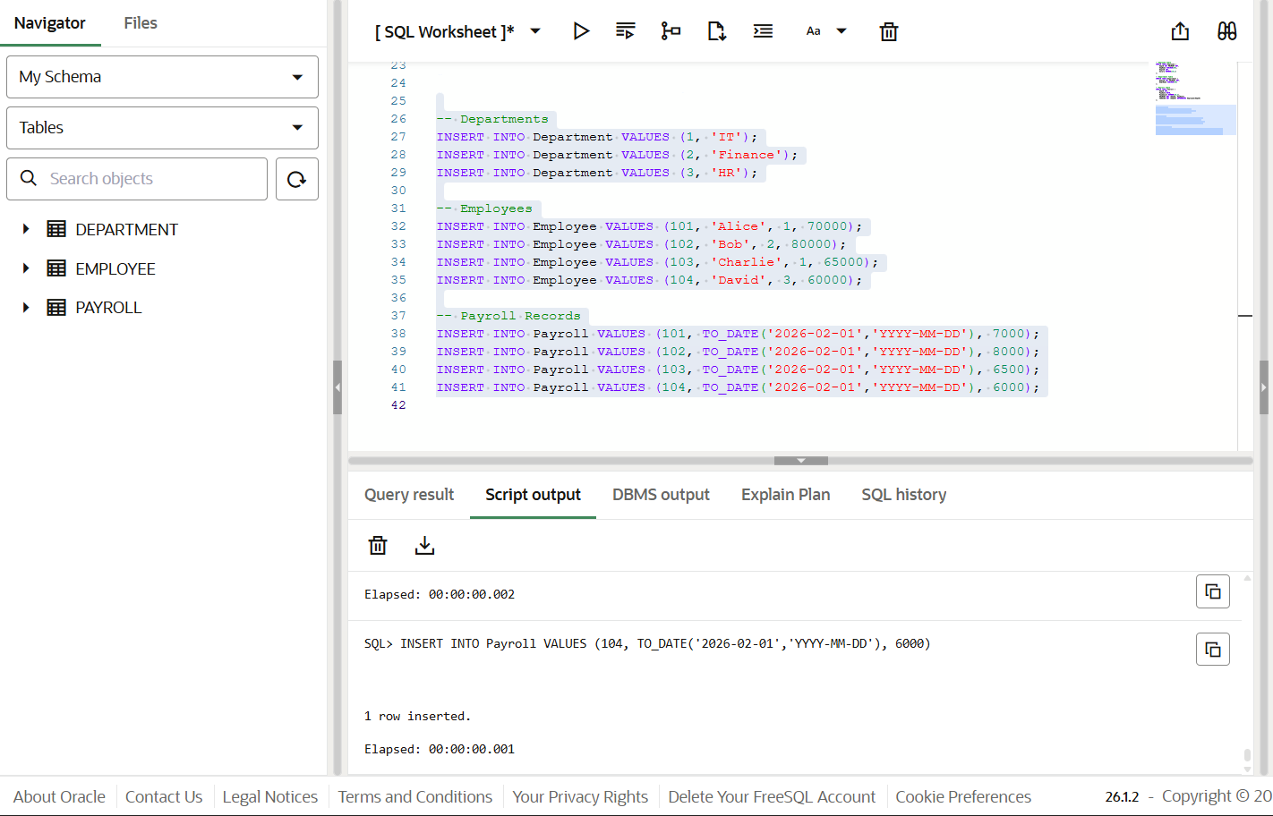
Step 3 – Create Simple View
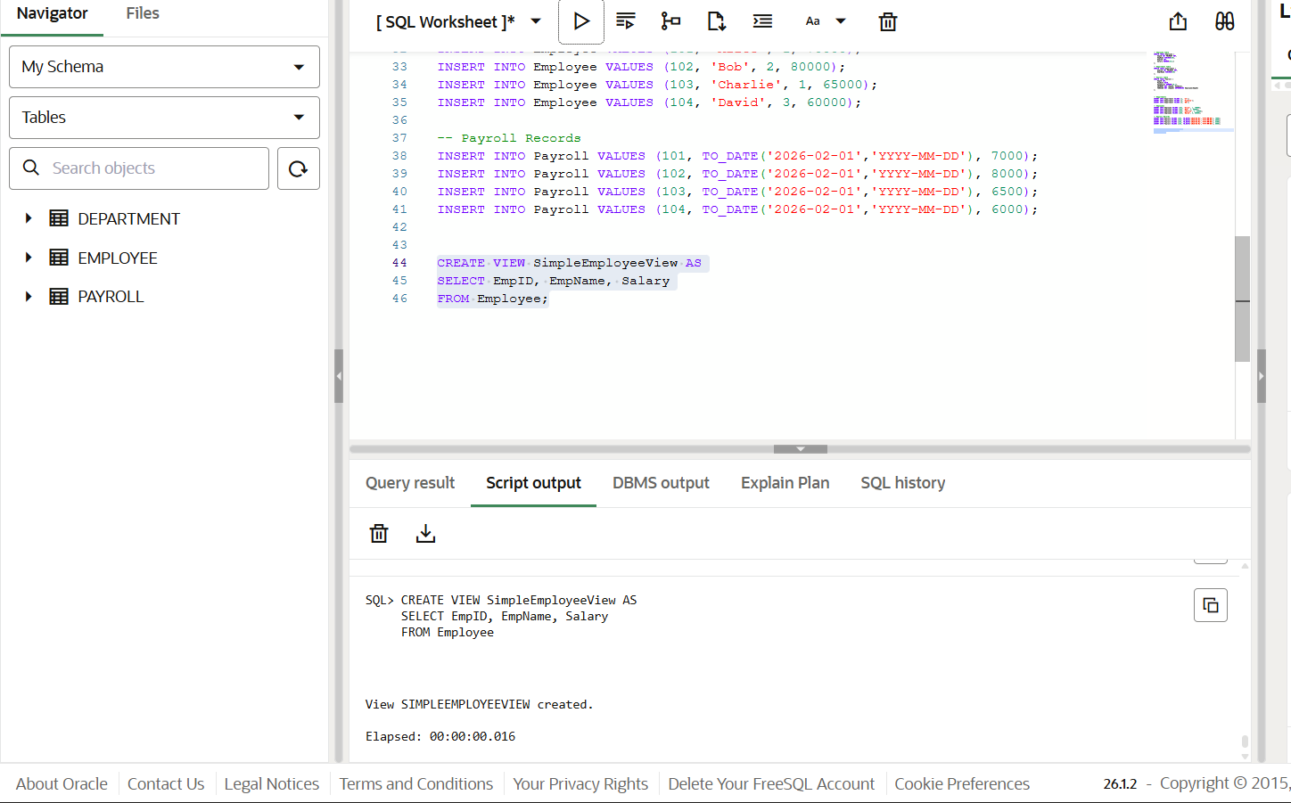
Step 4 – Create Complex View
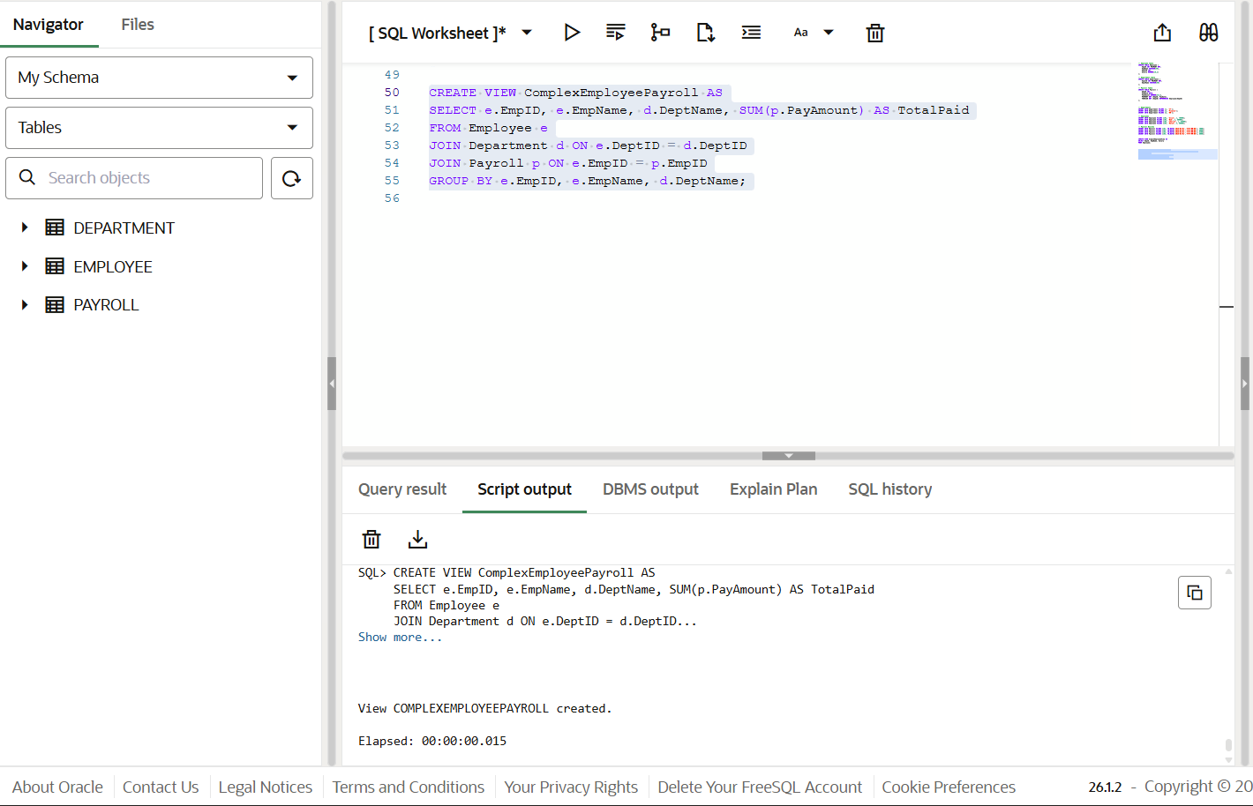
Step 5 – Create Materialized View
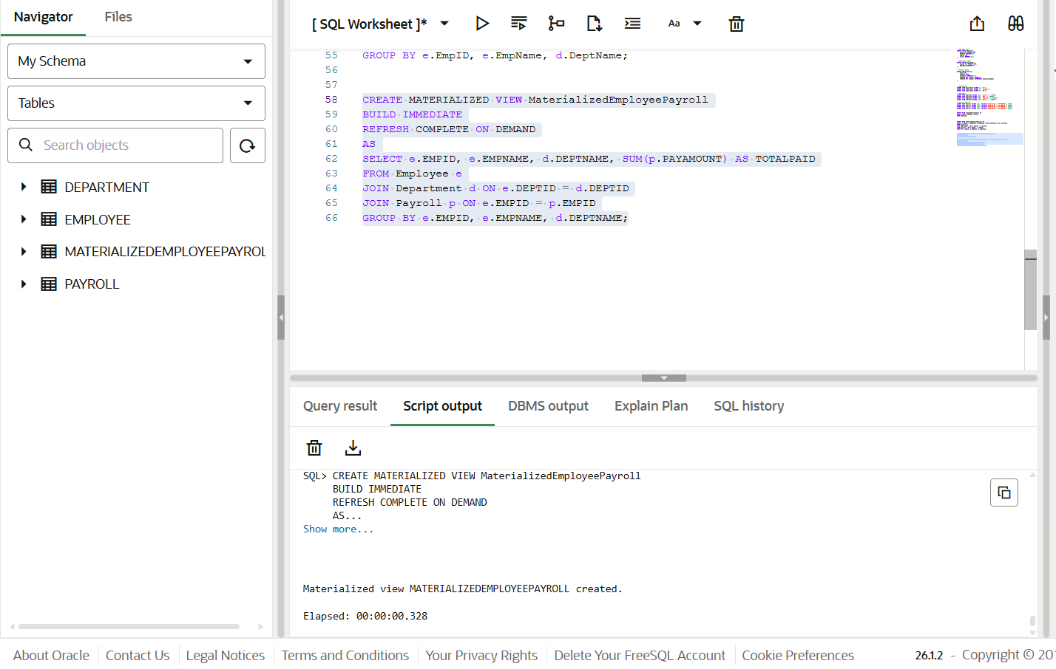
Step 6 – Execute Queries on Views
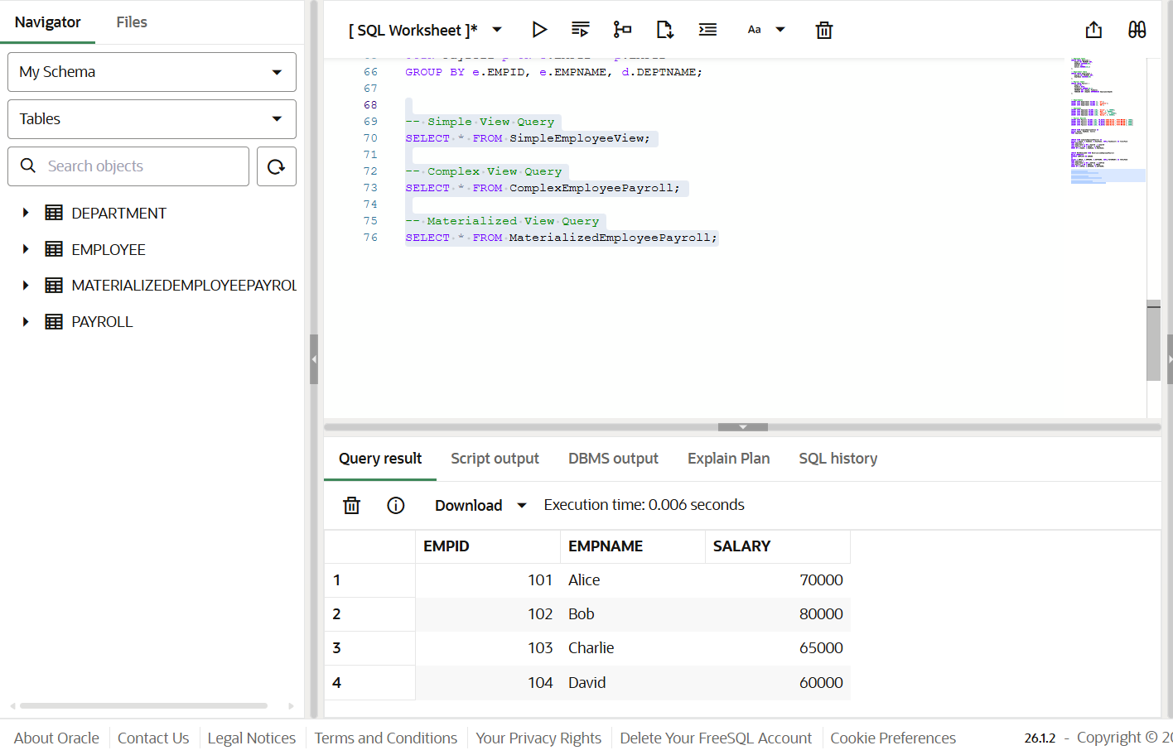
Step 7 – Compare Performance
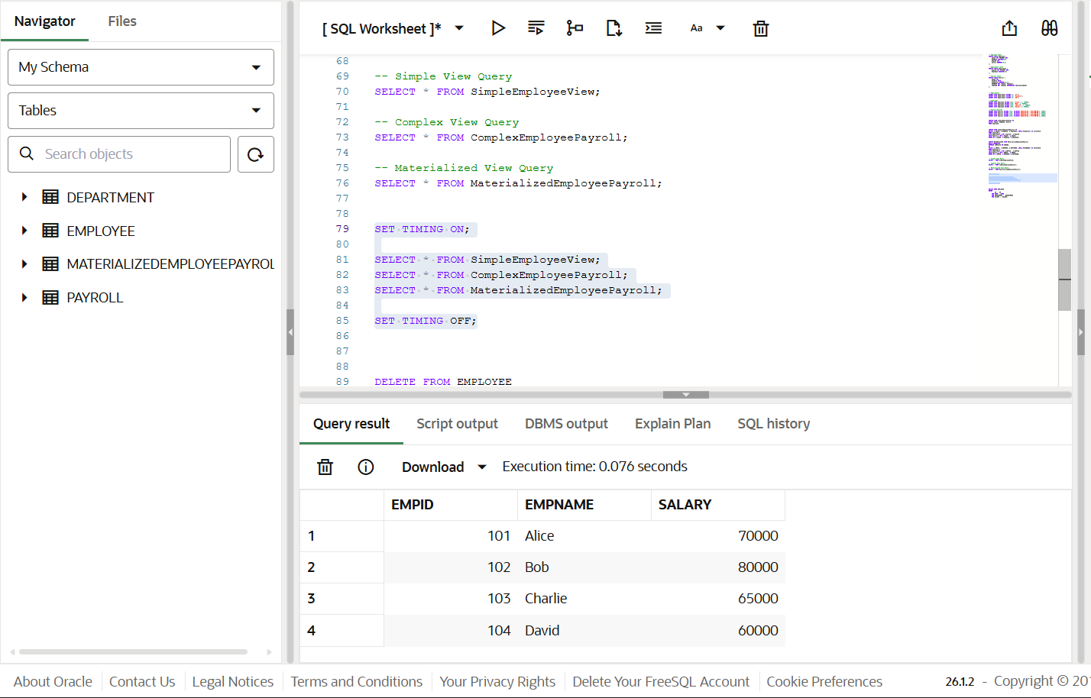

RESULT ANALYSIS
- Simple View
  - Created from a single table.
  - Executes quickly for small datasets.
  - No performance optimization for complex operations.
- Complex View
  - Includes joins and aggregation.
  - Slower than simple view because data is computed every time the query runs.
- Materialized View
  - Stores precomputed results physically.
  - Significantly faster for repeated queries.
  - Requires refresh mechanism to maintain updated data.

REAL-WORLD APPLICATION
Companies such as SanDisk, JTG, and PayPal handle large-scale transactional data.
In such organizations:
- Complex reports run frequently.
- Data warehouses require fast query responses.
- Business intelligence dashboards need optimized performance.
Materialized views are used to:
- Improve reporting speed.
- Reduce server workload.
- Enhance query optimization.
- Improve overall system performance.

LEARNING OUTCOME
After completing this experiment, the learner is able to:
- Understand the concept and working of materialized views in database systems.
- Differentiate between simple views, complex views, and materialized views.
- Create and refresh materialized views in Oracle and PostgreSQL.
- Measure and compare query execution time.
- Analyze performance benefits in data-intensive enterprise applications.

CONCLUSION
The experiment demonstrates that materialized views significantly improve query performance for repeated complex operations. While simple and complex views calculate results dynamically, materialized views store results physically, reducing computation time.
Therefore, materialized views are highly suitable for enterprise-level systems where performance and efficiency are critical.

