**Market Basket Analysis Report**

Questions

* Are there any interesting patterns or item relationships within Electronidex's transactions?
* Would Blackwell benefit from selling any of Electronidex's items?
* In your opinion, should Blackwell acquire Electronidex?
* If Blackwell does acquire Electronidex, do you have any recommendations for Blackwell? (Ex: cross-selling items, sale promotions, should they remove items, etc.)

About Electronidex

* Online Retailer
* PF: 125 products of 17 product type
* only able to pull data on the items that customers purchased per their transactions
* lack of funding

About the data

* transactions and the products they contained
* 9835 observations (transactions)
* After bringing it into the binary form, 9833 remained

**Important questions**

We suggest that the final goal of the analysis is not to gain information about transactions or items, but about how we could describe the customer base of ElectroIndex. How can transactional data give us information about the customer? One challenge is, that we do not know, to which customer a transaction belongs, and therefore, we cannot determine, if customers buy regularly. However, certain combinations of products may give a lead about, if the customer is buying for private use or professional use, i.e. is a company. And in addition there might be information about which kind of company it might be.

Since you know about the lack of funding of ElectroIndex, you have more information / data than the transactional dataset you sent us. Please make sure to give us all the information. Recommending, whether to buy or not to buy a company requieres a lot more information.

Additional data / information might be: All possible measures or datasets concerning business success.

All possilbe measures or datasets concerning the customer base.

Easily attainaable additonal data: estimation of profit per product

Both information might be qualitative as well.

**Question during Data exploration**

1. What are the most frequent items?

The iMac, then the HP Laptop, then the CYBERPOWER Gamer Desktop.

1. How many items do customers purchase the most?

1

1. Least?

The maximum value of items in a transaction was 30, which occurred once. 648 transactions included more than 10 items.

1. What's the average?

4.42

**Distribution of the no. of items per transaction**

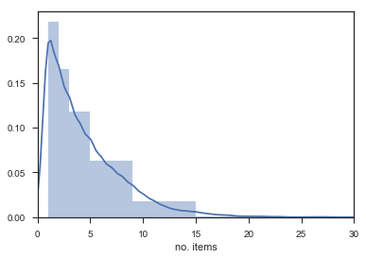

**Most frequent items by support**

The support of single item is the relative frequency it appears with in the transactions.

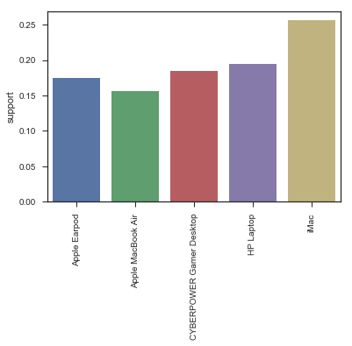

**Most frequent items by amount of transaction (more than 1000 transactions)**

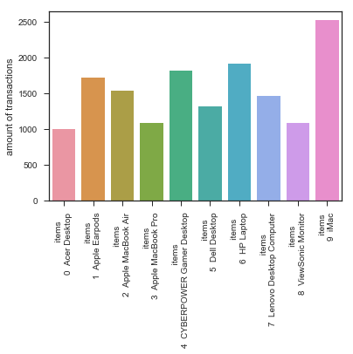

**What are the minimum values of the metrics which determine, if a rule is statistically significant?**

This depends on our goal and our population of interest. If we knew, what the optimal customer base is, our company could reach, and which products they buy, in which combinations, we could evaluate, how good a sample we have at hand.

However, since the sample has a lot of observations (transactions) we can assume, it is representative of the target customer base of our company.

One problem is, that there might be small subsets of the customer base, which differ in their characteristics from the rest. If this subset is small, the rules, which come from this subset are small as well, that is, they do not have a high support, even though, they have a high support within this special customer group. And maybe this group would be perfect to focus on, in further marketing strategies.

**Top rules by confidence with at least 5% support**

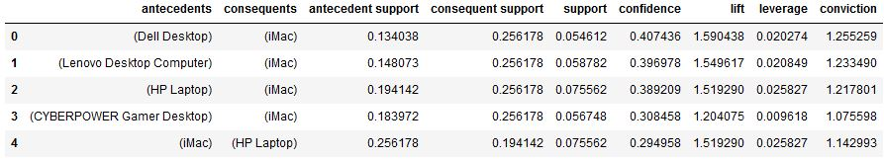

If marketing strategies want to recommend products based on already bought items, they should focus on the rules above.

What we can see from here is that Laptops are bought together with Laptops or with Desktops quite often. This can be specifically seen when looking at the lift metric, which is a lot higher than one.

This may suggest that ElectroIndex has business customers. To validate this, we computed the number of what we assumed to be business transactions. Precisely, we assumed that transactions, which contained two or more monitors and/or laptops, are business transactions. Thus, the computed number is a careful estimation, a lower limit of business transaction. We expect the real number to be higher. We could get closer to the real number by making further assumption, e.g. a business transaction could be in addition defined by having more than 5 items.

**Conclusion**

The determine, whether ElectroIndex complements Blackwell strategically, we need to understand ElectroIndex customer base, its market share, its profit rates for different product categories, its cost structure, its oppenents, the potential future development of its market, its organizational structure. To name only a few points. With the data at hand we do not even fully grasp the customer base of ElectroIndex. We can say that it has at least 57% business customers, probably a lot more. And I would guess, it has gamers as customers, as well.

To get to know more about their customers, we need customer-related data. And a lot more information. Additonally someone, that knows all these information for Blackwell, should evaluate the fit.