Question Answering System Project Report

Subject: COMP 90042 Web Search and Text Analysis
Date: 24th May 2017
Team Name in Kaggle Competition: Mainframe
Team Members: Kuan Qian (Jack) [686464]
Zequn Ma [696586]
Yueni Chang (Nia) [884622]

Introduction
In this project, we have made our attempts on building a question answering (QA) system. Starting with an implementation of the basic QA system described in specification, we have made error analysis and introduced some enhancements to the system. The basic and enhanced system are then evaluated using several different metrics.

The QA system takes 3 datasets in JSON format, for training, development and testing respectively. Each dataset is a JSON array, with each item being a "trial", that is, a set of documents (sentences) and questions. For training and development sets, answer to each question is also provided, including its content and label of the sentence containing the answer. The system takes questions along with a set of documents as input, and provides the answers as output.

Basic QA System
For the first part of the project, a basic QA system has been made. This does not only help us understanding the problem, but also provides a reasonable baseline evaluation for further development.

The basic system, as described in the specification, is formed by three main components. Firstly, the sentence retrieval component attempts to find the most relevant sentence to a certain question. We have applied the standard vector space model with TF-IDF values. The retrieved sentences are then used as the input for entity extraction component. Extracted entities are finally ranked as potential answers to the question, with the top answer returned as the final output. The system is designed and implemented to be consistent with the specification.

Our basic QA system uses 3-class Stanford NER as entity extraction tool, which recognizes entity of ‘PERSON’, ‘LOCATION’ and ‘ORGANIZATION’ types since it is most closed to the four required entity types, ‘OTHER’, ‘NUMBER’, ‘PERSON’ and ‘LOCATION’. Type ‘ORGANIZATION’ is put into type ‘OTHER’ according to the specification. In addition to Stanford NER, all tokens not recognized by NER tagger are checked by str.isdigit() function to see if it belongs to entity type ‘NUMBER’ and all non-sentence-initial tokens are checked to see if it belongs to ‘OTHER’ type. Consecutive tokens of same entity type are chunked into one entity as different objects are always separated by a determiner or comma in English grammar.

Rules in specification are used for ranking component. In the cases where the answer sentence contains multiple open class words from the question, the average distance from the entity to each word is used.

Error Analysis
1. Sentence retrieval
64% sentences retrieved in the basic QA system, while testing against the development set, are correct answer-containing sentences for corresponding questions. We are not sure if this function can be easily improved by using a more sophisticated information retrieval approach. On the other hand, 64% is quite acceptable considering the performance baseline. If entity recognition and answer ranking can correctly utilise a third of these sentences, it is possible to achieve an accuracy of 20% roughly.

2. Entity extraction
While running against the development set, only 19.3% of answers are extracted as entities, it turned out there was significant space of improvement for entity extraction component. Further testing showed that, basic entity extractor has following major disadvantages:
- Stanford NER is sensitive with hyphens and dots, which could appear in names of persons and organizations, which lowers the entity identification rate and leads to partial matches.
- str.isdigit() cannot deal with decimal marks, thousand separators very well. Additionally, numbers in word format and those should be returned together with a proper metric unit are neglected.
- Skipping the sentence-initial tokens leads to partial matches since some proper nouns can be used without a determiner, being put at the start of a sentence.

3. Question type
By inspecting the results from running the QA system on the training set, many questions had been identified as wrong types with the simple rule based classification. Especially for questions starting with "what" or "which", it was difficult to classify the question as correct type. It was also an issue with number types, questions asking for answer types such as year, money, measurements are all classified as "NUMBER" types. If these types can be distinguished, it was expected to increase the accuracy of our QA system.

4. Answer ranking
In many occasions, the few answers ranked on the top are of same rank. The ranking rules in basic QA system doesn't handle answers of same rank very well. From manual inspection of a sample of failed cases, while the first rule (answer should not appear in the original question) produces desirable results most of the time, the second (answer should match question type) and third rule (distance to open class words) are not as successful. Our simple, rule based approach for question type classification does not always give the correct type, and entity types in NER can also be wrong, both lead to failures in rule 2. Rule 3 often prefers the wrong result, with the straightforward reason that correct answer is not always closer to keywords in word distance. Even after rule 1 and 2, there are often many entities ranked at the same position, where rule 3 is the only judging criteria with a rather weak assumption. Because of these flaws, this component often prefers a wrong answer, this calls for a more specific ranking method.

Enhancement
1. More types
First obvious enhancement is to use a 7-class NER model instead of the 3-class one, which can recognize entities as ‘MONEY’, ‘PERCENT’, ‘LOCATION’, ‘DATE’, ‘TIME’, ‘ORGANIZATION’ and ‘PERSON’. In our final model, we kept 8 entity-type classes. ‘ORGANIZATION’ class is combined into ‘OTHER’ together with all other unrecognizable capitalized words to achieve better performance. Entities of type ‘NUMBER’ are extracted with the help of POS tagging. See point 3 for details.

2. Type classification
As more answer types are brought into the system, the basic rule based classification is no longer sufficient. Therefore, we decided to apply a machine learning classifier to replace rule based classifier. We suspect the main concept for question type classification is to determine the question type based on relevant words in the question. Hence, a simple Multinomial Naïve Bayes classification should pose an improvement to the system’s performance.

The model was trained used questions in the training set. The type of a question is determined from the following processing steps:
- Extract entities from the question’s answer sentence using the NER module in our system.
- If answer of the question exactly matches an entity extracted from answer sentence, the type of this entity is taken as the type of question. Otherwise skip the question.

The second step may skip over many questions, however given the amount of questions in training set, the remaining question should still be sufficient for training.

3. POS tagging in answer extraction and tokenization method
During the error analysis, we have found that Stanford NER is sensitive with dot and hyphen. What’s more, when changed to 7-class model, Stanford NER would also be sensitive with decimal mark and thousand separator when recognizing numeric part in for ‘MONEY’ and ‘PERCENT’ entities because all punctuations were isolated as a single token in tokenization. To enhance performance, another tokenizer is chosen which does not take dot or period apart from their context if they were used in names or as a decimal / thousand separator.

To cope with numbers in word format and numbers which are not ‘PERCENT’ or ‘MONEY’, we introduced part-of-speech tagger along with Stanford NER tagger to our entity extraction module. With NLTK default tagset, POS tagger tags all numbers and words for numbers as ‘CD’, which also includes those contains decimal mark or thousand separator if they are tokenized correctly. Running against development set, the enhanced entity extractor can correctly identify 35 % of the answer entities. Together with other components, it can finally achieve about 25% entity recognition rate. For more details, please see performance metrics in evaluation section.

4. Unsuccessful attempts
- Answer classification
Inspired by the textbook, attempt has been made for applying machine learning to classify potential answers. A classifier has been built to replace the rule based answer ranking component in the basic system, taking answer type matches, keyword matches, distance to keywords, novelty factor, punctuation location and rank of sentence retrieval as features. The classifier is trained using the training set, where potential answers are obtained by applying NER to sentences, and ‘yes/no’ labels are added by comparing the answers to the correct answer for an exact match. However, it does not lead to successful results, and none of the potential answers are classified as correct. Converting this into a regression task, where a probability replaces the binary result, does not help either.

- Syntactic distance
As an attempt to improve rule 3 in the basic system, syntactic distance is used to replace the word distance. Syntactic distance is defined as the shortest path from a word to another in the CFG tree structure, obtained with the Stanford Parser. However, this approach is more time consuming than expected, that finishing the task within time limit is not possible. Also, it does not result in significant improvement testing with a small subset of data.

- Answer extraction by selected pattern
Applying Stanford Parser, we observed the parsing pattern of answers in training set. It turned out many answers are noun phrases made up with common words, which usually consist of one determiner, one or more adjectives and a noun. And there were also are big proportion of identified entities are partial matches due to the reason that Stanford NER could only recognized one or two words in the entire phrases and our chunking method will take the recognized part and the unrecognized part into two or more entities. For example, phrase ‘the South of Boston Common’ is identified as (‘South’, OTHER), (‘Boston’, LOCATION) and (‘Common’, OTHER) since NER tagger can only recognize ‘Boston’ as a location while ‘South’ and ‘Common’ are identified as capitalized words. In such cases, POS tagger would always recognized these phrases as a sequence of proper nouns. In <>, we used regular expression parser to extract noun phrases with selected POS-tag patterns as an addition to our previous entity extraction.

When testing against whole development set, such model can identify 45% of answer entities. Entity identification rate on random samples from training set is higher than 30%. However, the larger number of extracted entities made answer ranking into a more difficult task. With a three times higher ranking failure rate, the overall accuracy was offset and only 12% of questions are answered correctly.

Evaluation

Results | Overall Accuracy | Overall Accuracy (including partial match) | Overall MRR | Sentence Retrieval | Entity Extraction | Answer Ranking
Basic | 0.1169 | 0.3461 | 0.1445 | 0.6418 | 0.3008 | 0.4245
Qtype_Classify | 0.1215 | 0.3585 | 0.1489 | 0.6418 | 0.3195 | 0.4361
Improved NER | 0.1518 | 0.2414 | 0.1929 | 0.6418 | 0.3686 | 0.4443
Both | 0.1655 | 0.2756 | 0.2276 | 0.6418 | 0.3686 | 0.4260

Table of results for the basic and enhanced system
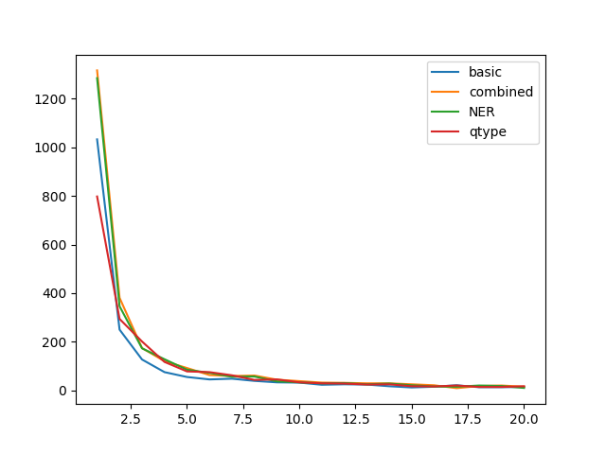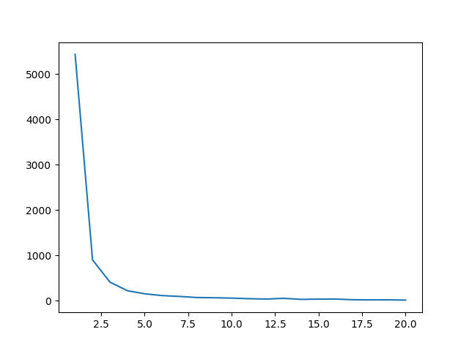
Distribution of ranks in answer ranking (left) and sentence retrieval (right)

DISCUSSIONS
Future Improvements
Predicates translation with dependency parsing
The next possible enhancement we will be attempting if given enough time would be extracting predicates (or relations) from documents and questions. Questions will be answered by matching predicate from question to predicate from relevant document (sentences), this process is similar to evaluating predicates in logical programming. This way, question types are less relevant and would yield a higher accuracy. This could be done by analysing the dependency trees of sentences. For example, each VERB can be considered a type of predicate with objects being other terms which are dependent to this VERB. Further tuning will be required to generate phrases as predicate names or objects for the answer extractor to perform well. An idea to do this is, for example, to concatenate words with dependencies such as nmod into one phrase as an entity (potential answer).

Answer ranking system
Performance of the system could also be improved by adapting different approaches. For example, it is believed that applying recurrent neural networks to answer ranking can significantly improve the result. By treating the answer ranking task as encoder-decoder problem (can be also understood as "translation" from answer to question), the system in TREC 2016 competition achieved very high performance [1].

Conclusion
A question answering system has been built for this project, including a basic implementation as well as several enhancements. Although some of the enhancement attempts, such as applying syntactic distance and performing classification on extracted entities directly, does not improve the results, other approaches do seem to contribute. Applying machine learning to classify question type results in slightly better accuracy. With both enhancements combined, the system achieved an accuracy of 0.1655 for the development set, and 0.18489(rank 8) as the evaluation result on Kaggle. We believe the system can be further improved by applying more advanced approaches.

