Thomas Creighton K00253257

**New Site – Design Stage**

**Research & Design**

1. Research & Concept Development: research various existing news websites
   1. sports / gaming / music / politics / local etc.
2. Audience Analysis: 2 personas of your target audience
3. Content: Wireframe of home page and full article page – desktop and mobile
4. Navigation Analysis: Navigation design.
5. Design: Photoshop / Illustrator of the home page – desktop and mobile

**Deliverables**

1. Word document/pdf documenting your research & content development
   1. what you liked/disliked on existing websites (desktop/tablet/mobile) – layout, fonts, colour schemes, usability etc
   2. why you chose your colour scheme, navigation style etc
2. Moodboard (.png)
3. Persona x2 (.pdf/.png)
4. Wireframe x4 (.png)
5. Navigation Design (.png)
6. Photoshop Design (.psd) (illustrator)

Contents

Concept 2

General Design 2

Responsive Navigation 4

Body Layout 5

Forms 6

Footer 6

Reference Websites: 7

# Concept

The news site I am designing will be centred around Comic Book Movie News, TV Show News and Videogame News.

# General Design

I will be using a simple CSS grid layout for the page layout and for the navigation bar. This will allow everything to remain responsive while giving me more control over exactly where all the elements are placed.

The pallet I am using is minimalist; black, white, off-white (grey) and red. This is to mimic the standard look of a newspaper while still adding an element of energy to the page. This is a design choice used by the likes of Empire Magazine to great effect.

I also have to consider the fact that the articles will all have large images, many quite colourful, and I do not want the websites designs to detract from the images or make the page appear confused and busy.



­­Headers and Heroes

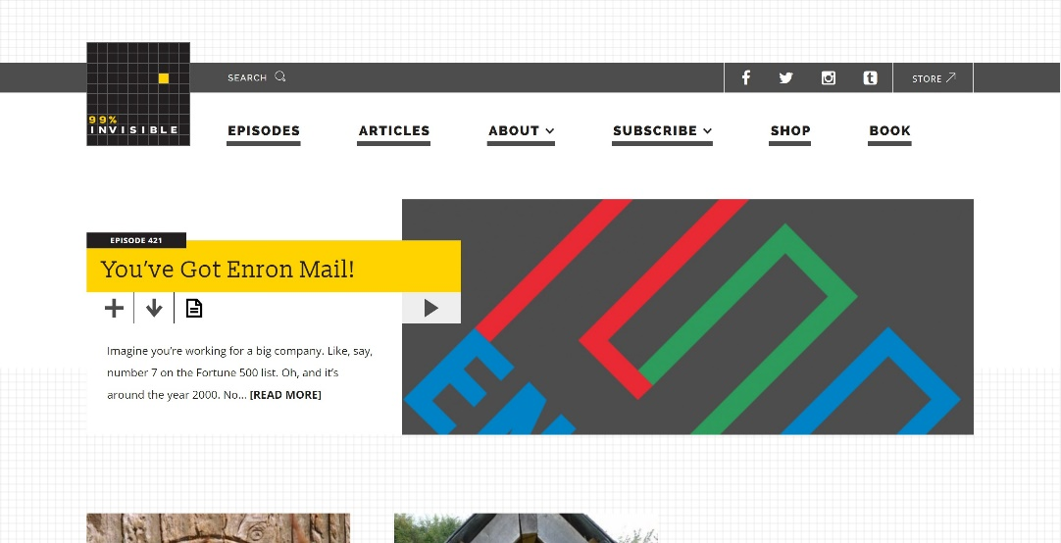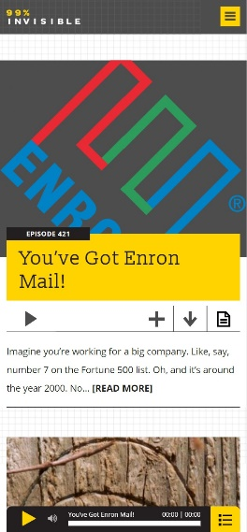

Above is the hero and (responsive) header/navigation bar for the 99% Invisible design news website. While I like the Two tier design of the navigation bar, I do not think it would be suitable for my site as I will not have as much information to convey.

I like the overlying card in the Hero that contains the Title, blurb, Autor and date that relate to the article linked. I will be using a similar concept in my design.

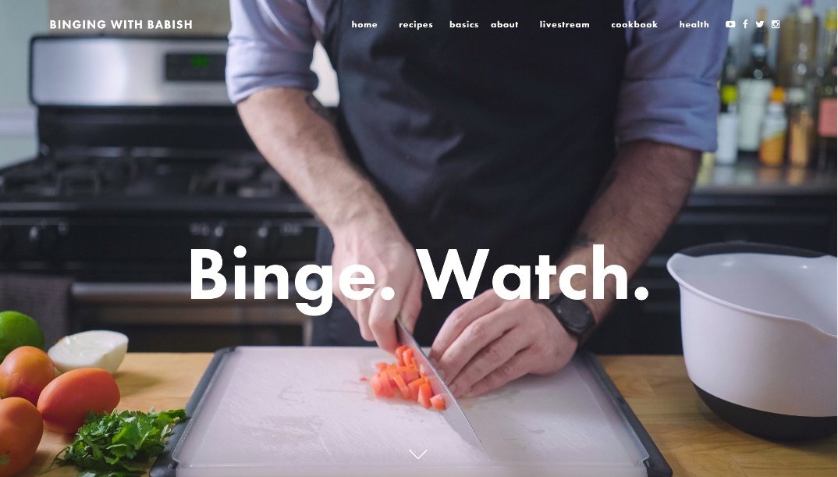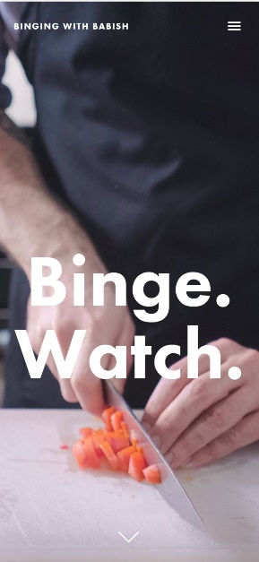

Above is the hero and (responsive) header/navigation bar for the Binging wit Babish cooking website.  
I quite like the use of lower case lettering in the navigation bar here. It makes for a more relaxing and welcoming design. I will be implementing this in my own design.  
This site also uses an interesting feature where the Hero always takes up 100% of the viewport height when the page is accessed, regardless the screen size.

I like the use of a hamburger menu in both sites above to handle the navigation bar. This is the solution I also plan to use.

# Responsive Navigation

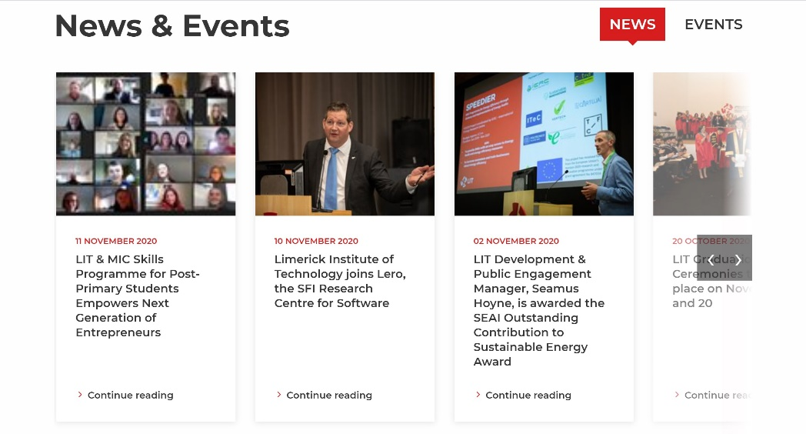 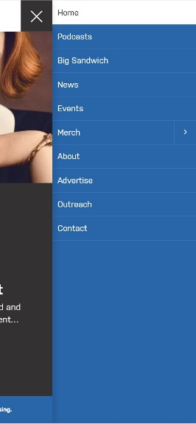

Above are exaples of a Corousel (LIT hompage) and a drop down menu activated by clicking on a hamburger menu (planet broadcasting).

I think the Carousel is a simple but effective way of handelling additional information on a page, espetiall in the case of a norrow view port.

The dropdown above has the interesting effect of moving the entire page to the left when it is in use. I like the look of this.

I will be implimenting both responsive examples above when designing the responsive elements of my website.

# Body Layout

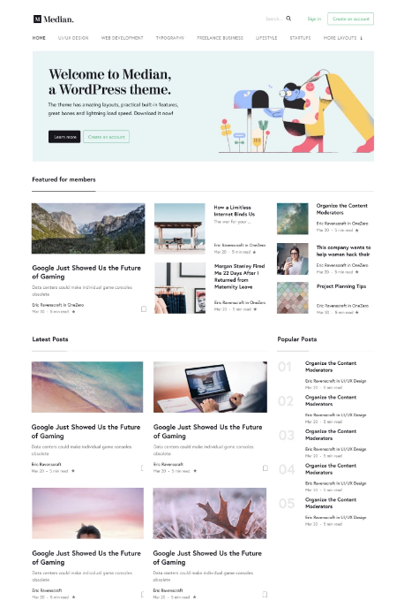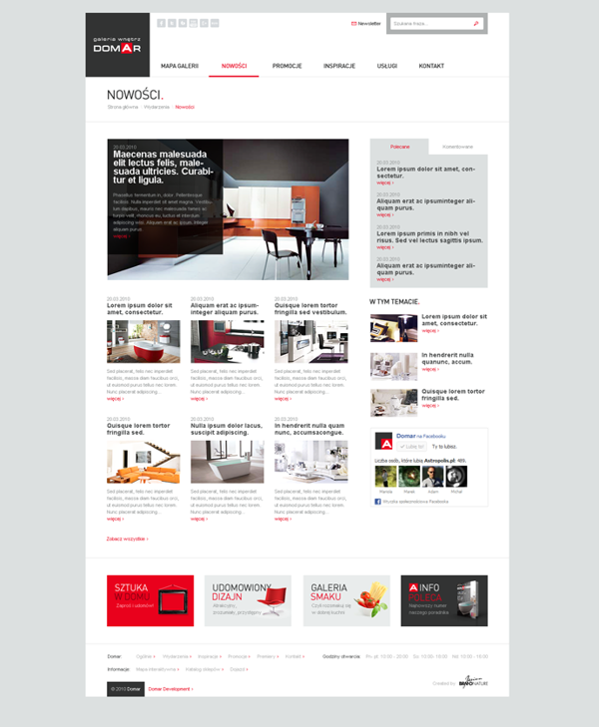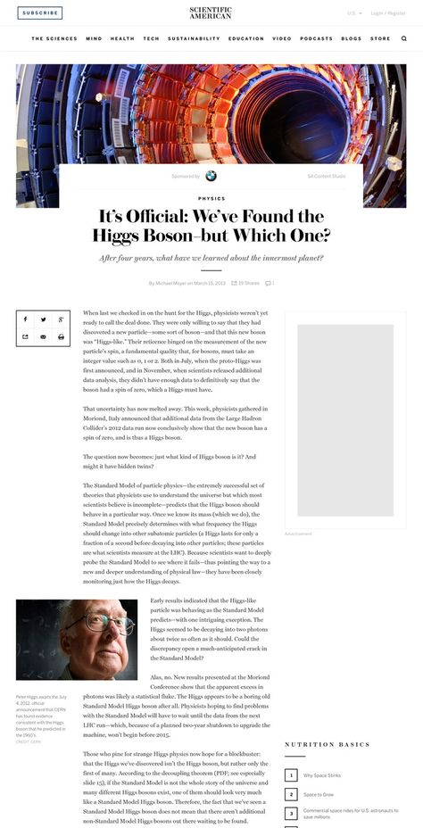

As mentioned in the General Design section, I intend to use the CSS Grid layout for my website.

As for the layout of the page itself, it will be similar to the three examples above (pintrest).

I like the idea of having a separate, direct navigation section on the righthand-side of the page. This can be used to link the user to popular websites and also to display advertisements on the different webpages.

The use of block elements resembling UI cards is quite pleasing, however I think having each row be occupied by one elongated card will make for an easier to read design. It will prevent the different articles from becoming jumbled and confusing.

# Forms

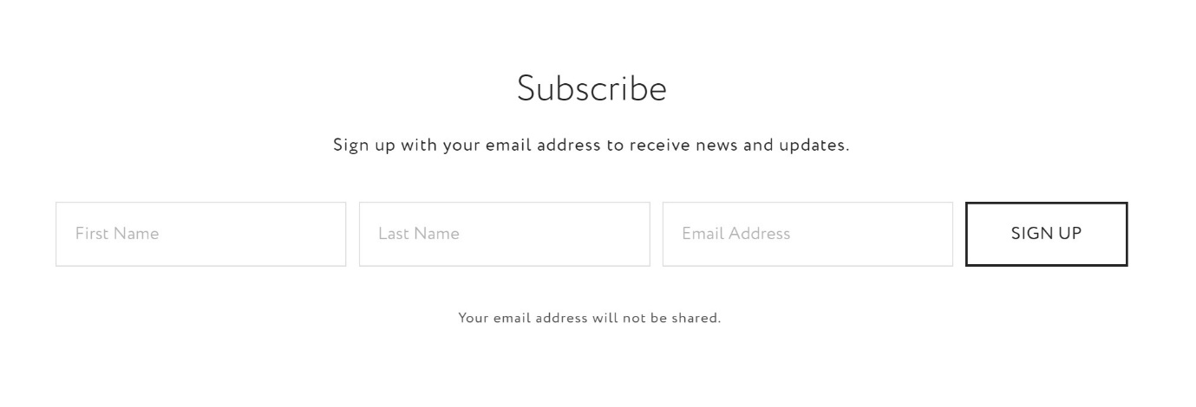

The addition of the subscribe form on the Binging with Babish home page makes for an aesthetically pleasing call to action. While I intend to have the option visible in the header of the page, an additional link could reinforce the idea in the readers mind.

# Footer

 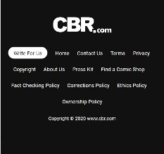

I quite like the simplified footer design above (cbr.com). It is to the point while still incluiding the relevant information. I will be using this type of layout in my own design.

# Reference Websites:

* **News sites**
  + <https://www.empireonline.com/>
  + <https://www.nationalgeographic.com/>
  + <https://www.cbr.com/>
  + <https://www.wired.com/>
  + <https://www.planetbroadcasting.com/>
* **Other sites**
  + <https://www.bingingwithbabish.com/#top>
  + <https://99percentinvisible.org/>
  + <https://www.hotpress.com/>
  + <http://kekselias.com/>