**Assignment 4 - Graphs**

Algorithms & Data Structures

H.Dip in Software Development

**Write an application that incorporates the source code that you studied in relation to Graph data structures. Some of this code will be used as your basis for this program.**

**The objective of the application is to set up a WEIGHTED DIRECTED graph object that represents the graph on the next page (Fig. 4.2). The user is then presented with the GUI (or something similar) in Fig. 4.1.**

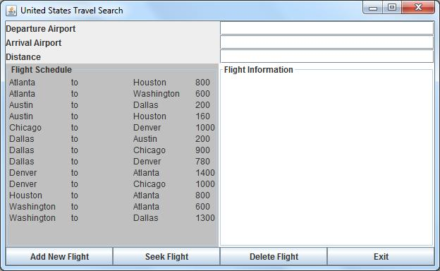

**Fig. 4.1**

**This GUI has textfields at the top that will allow the user to enter details for a new flight that is to be added to the graph. These textfields also permit the user to enter the departure and arrival airports and check for the existence of a flight. The command to add new flights OR checking for an existing flight are issued through the use of button components. Include a button to exit the application.**

**You decide which algorithm to use when searching for a flight path between two airports – depth-first search OR breadth-first search.**

**The GUI also has a textarea that will display relevant message to the user. e.g.**

***Airport X to Airport Y is our latest flight available***

***Airport X to Airport Y is already available***

***Airport X to Airport Y is not available***

#### Airport X to Airport Y is available

**When adding a new flight, check is either or both of the airports already exist in the graph object – duplicate airport vertices are not permitted in the graph object.**

**When seeking a flight, print out the airports passed through (as well as informing the user if the path exists or not).**

**Finally you must build in the ability to delete a flight route. This aspect wll be discussed in class. Take notes!**

**In all aspects of the application, remember a bi-directional flight is treated as two separate routes.**

**N.B.**

**Deadline: Your solution must be uploaded to Moodle on or before your practical in the week ending April 3rd 2020. Your final sign off is during your practical on that date. As this is the final practical of the semester – ABSOLUTELY NO submissions will be accepted after that practical session.**

**Take the appropriate steps to backup your work at all times. Remember, PCs and Servers do fail and lose data.**

**Des O' Carroll 2020**

**Fig 4.2**

1400

160

780

1300

900

200

1000

800

600

# Austin

# Chicago

# Dallas

# Houston

# Denver

# Washington

# Atlanta