K00288477: Gary O Connor

BSc in Mobile & Web Computing – Year 3

MyUni – Clubs & Societies

Mobile Application Development

Contents

Introduction 2

Research 2

Who? 2

What? 2

When? 2

Where? 2

Why? 3

Planning 4

Design 5

Bibliography 7

# Introduction

MyUni – Clubs & Societies is a one stop shop for information and updates to events organised and ran by clubs and societies from the Technological University of the Shannon: Midwest.

Students can view a list of clubs and societies within TUS that they are eligible to join. Access detailed information related to each club including a chairperson, the clubs email address, the meeting time for their next planned activity and a google maps location-based service so they can find their way.

Students can create a profile on the application to save their favourite clubs to be viewed from the profile screen. Students will receive a notification reminding them about events from clubs that they have favourited on the app.

Clubs can be registered with the admin of the application. These are clubs approved by the TUS University to prevent an oversaturation of clubs being created on the application.

Club admin accounts can create new events that will be displayed to users. The details of these events can also be updated and deleted.

# Research

## Who?

This application was created for the student body of TUS Midwest. This app is developed to meet the need of the students who are interested in joining a club or society while studying at TUS Midwest. It is predicted that this app will likely be used by students in their first year. Being in a new environment, they will find this app extremely useful for gathering information about what recreational options are available to them as TUS students.

## What?

The app main function is information exchange. Students can view information related to clubs or societies that they may be interested in joining.

## When?

The app can be used at any time they may look for information about a club or society. It is predicted that students will mainly use the app while on the TUS Midwest campus. Students currently in their first year or any users who are new to the college will find the location service , on the club details view, extremely helpful for navigating the campus in order to find their meeting point.

## Where?

It is predicted that students will mainly use the app while on the TUS Midwest campus. Students currently in their first year or any users who are new to the college will find the location service , on the club details view, extremely helpful for navigating the campus in order to find their meeting point.

## Why?

Currently, the main platform available to students to receive news is the student email account.

The student mail is used by every student in TUS. The student mail currently receives general academic emails, course specific emails, direct student/ lecturer correspondence, event announcements for sports, clubs, societies, Student Union events, mental health services and physical health services.

Because of this oversaturation of information, emails about clubs & societies can often be lost among emails that may be deemed more important to the student at the time of viewing.

A study in 2021 by Meyer et al. found that

*The amount of information available has thus become excessive, but it is difficult to assess its quality. As a result, information overload has become a widespread problem. Indeed, information overload was cited as one of the most frequent stressors by 22.5% of respondents in a representative German sample (*[*Meyer et al., 2021*](https://pmc.ncbi.nlm.nih.gov/articles/PMC10322198/#ref106)*).*

This app targets the demographic of Clubs & Societies. At the present time, sports club’s schedules are sent out on a weekly basis from the sports club. These can vary from GAA trainings and competitive matches to “Badminton for Beginners”. The former is a competitive team for serious athletes, whereas the latter is aimed at promoting inclusion in sport, creating an entry point for those who want to take part in a fun activity to make friends and have fun.

Indeed, it was difficult for this student to find quality information on the various clubs and societies available within TUS.

The most information I was able to find was a spreadsheet, available on the TUS website which contained information from the previous academic year. Many of these clubs and societies that this student did not know existed given that this student has been attending the campus for three years.

<https://tus.ie/sport/clubs-socs/>

# Planning

A five-screen mobile application built in Jetpack compose using Android Studio and firebase NoSQL DBMS.

Home Screen

* Entry point to the app.
* User log in.
* User registration

If the user has already logged in:

* View All Clubs
* View Favourites

Profile Screen

* Personal Details, (Name, Student number, student email, course title)
* Update details
* View Favourite Clubs
* View Club Details

Clubs & Societies Screen

* View all Clubs and Societies
* View Club Details (Email address, Chairperson)
* View Next Meeting (Time and Location)

Club Details Screen

* View Club Details (Email address, Chairperson)

Settings Screen

* Toggle Theme mode (Dark mode, Light mode)
* Change account password
* Log out of account on this device.
* Delete Account

Navigation is achieved using a Drawer menu which is available on all screens. This menu will provide links to navigate between the main screens. The user also has the option to log out from this menu.

# Design

The app was designed using a Material Theme Builder web app, which allows users to create a theme using based on Google’s Material Design system. This is a free open-source resource from google. The web app allowed this student to build the theme based on the TUS logo and export that theme to Jetpack Compose format.

Prototypes were then created using Figma, a collaborative web application for interface design.

Atomic design principals were followed during the development of the Figma prototype, allowing for a consistent design across all screens.

Atoms such as text and rectangles were used to create Molecules like the buttons and text fields below. These molecules were then used to create Organisms like the “Form-Dark” component below.

These components were then used to create each of the screens pictured below.

# Core Features

The app was designed around the core features identified with the app. What the app will do and for who?

User Features:

* Secure Log-in and Registration
* View all Clubs & Societies from TUS
* View Club details
* Add to Favourites

Admin Features:

* Create a new event club event

## Secure Log-in and Registration

This allows a potential user to register a new account using an email address and password. Because this app is specific to TUS, a regular expression has been implemented to verify the email address used. The email address must follow the pattern of defined TUS student email addresses.

TUS email addresses start with a “k” followed by eight digits. The domain name is also specified to prevent non-Students from accessing the application.

## View All Clubs and Societies

Once a user has created an account and logged in, they will be able to access a list of all clubs and societies in TUS that are open to join and take part in activities with. This is accessible right from the home page if a user is logged in. The navigation menu also contains a navigation link for easy access from anywhere in the app.

## View Club Details

From the list of Clubs and Societies, the user will be able to select “Details” which will cause a drill down view of the club to appear, listing the details of the club.

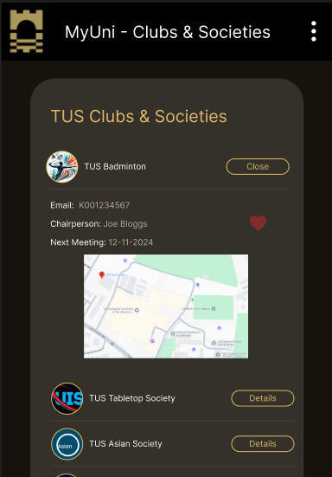The drill down contains contact information for the club’s chairperson, as well as a Date for the next meeting and the location of the meeting or event.

## Add to Favourites

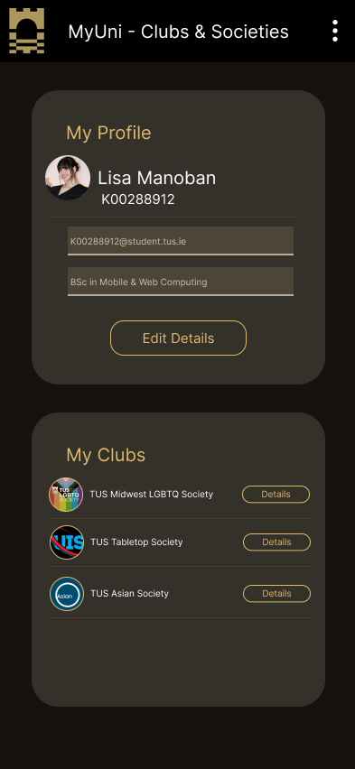From the drill down view, the user is also able to add the club to their favourite clubs by tapping the heart icon on the right. The user’s favourite clubs can be viewed from the Profile Screen.

A similar drilldown view is also available from this view.

## Create a new event club event

Admin accounts have access to create a new event for their club. Admin accounts, unlike user accounts, must be created by the admin of the platform. This is to restrict what clubs can be created on the app. This aims to prevent clubs being created that do not exist.

Details of the next upcoming event will appear in the drill down menu.

# Project Implementation

The app was developed in Android Studio using Jetpack Compose and Kotlin. Jetpack compose is Androids recommended modern toolkit for developing android apps.

The app uses Firebase Authentication and Real Time Database to support secure login and registration, and CRUD functionality.

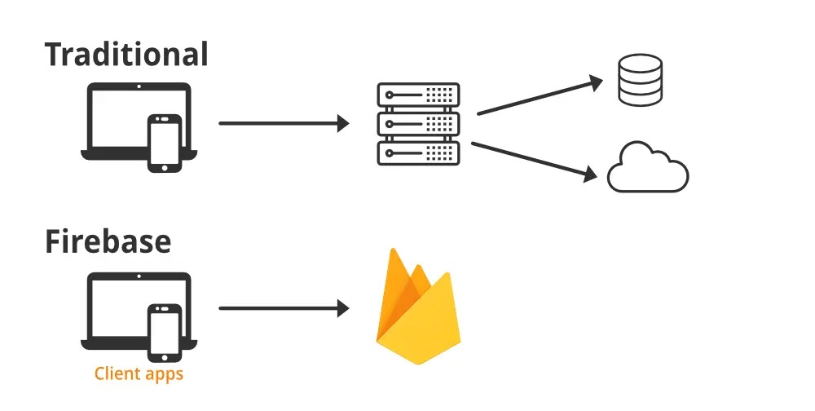

Firebase provides backend services with minimal set up and provides powerful tools to use in the application to manage data.

# Atomic Design Implementation

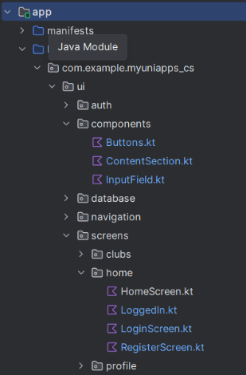Using the popular AI code generator, Builder.io, I was quickly able to export figma frames to Jetpack Compose code to cut down on development time when creating the code for my figma designs.

While this approach was a quick way to develop custom composable functions, it still required some editing to make sure the functions worked for my purposes and allowed passing of attributes as variables to be used in the parent functions.

This meant that I could create the skeleton for all my buttons while still being able to define attributes like “text” and “onClick” lambda functionality.

While I only created two buttons, I was able to reuse these two functions multiple times across multiple screens, each having different functions and names.

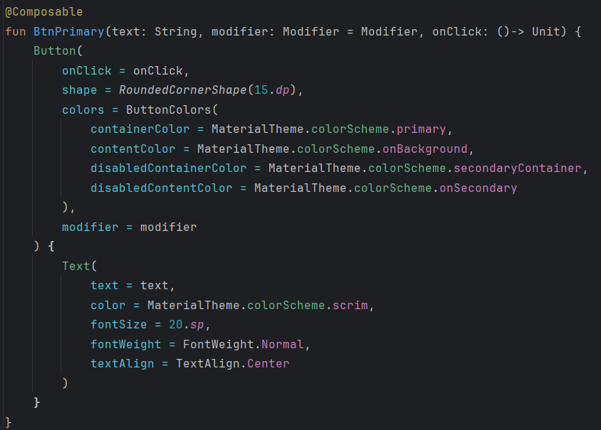

Parent Composable

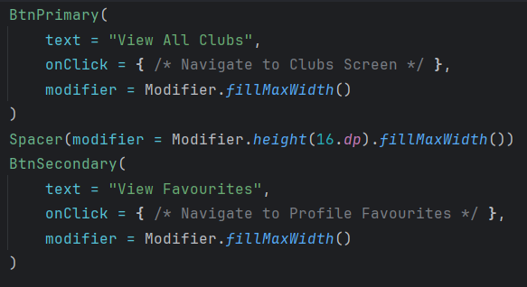

Usage

## Component Mapping Document

|  |  |  |  |  |
| --- | --- | --- | --- | --- |
| Component Name | Type | Description | Reusability Notes | File path |
| BtnPrimary | Molecule | Primary Button, Bright contrasting colours | LogIn Form, Create Account form, HomeScreen | ui\components |
| BtnSecondary | Molecule | Secondary Button, Bright outline, transparent background | LogIn Form, Create Account form, HomeScreen | ui\components |
| InputField | Molecule | Input Text Field | Used in all forms,  Profile Screen | ui\components |

# Bibliography

1. *Meyer B., Zill A., Dilba D. (2021). Entspann dich, Deutschland! TK-Stressstudie 2021. Hamburg: Techniker Krankenkasse.* [[Google Scholar](https://scholar.google.com/scholar_lookup?title=Entspann%20dich,%20Deutschland!%20TK-Stressstudie%202021&author=B.%20Meyer&author=A.%20Zill&author=D.%20Dilba&publication_year=2021&)]