104062261 HW3 Report

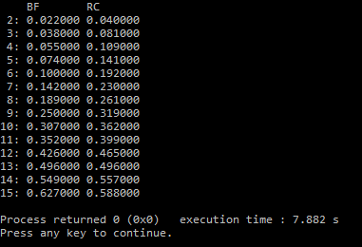

Here is the data I have collected from my computer. When the problem size n is 15, the recursive algorithm will beats the brute-force algorithm. However, sometime the problem size n is between 14 and 16. If we use the brute-force algorithm when the problem size n is less than 15, the crossover point still won’t change.