104062261 Algorithm HW8 Report

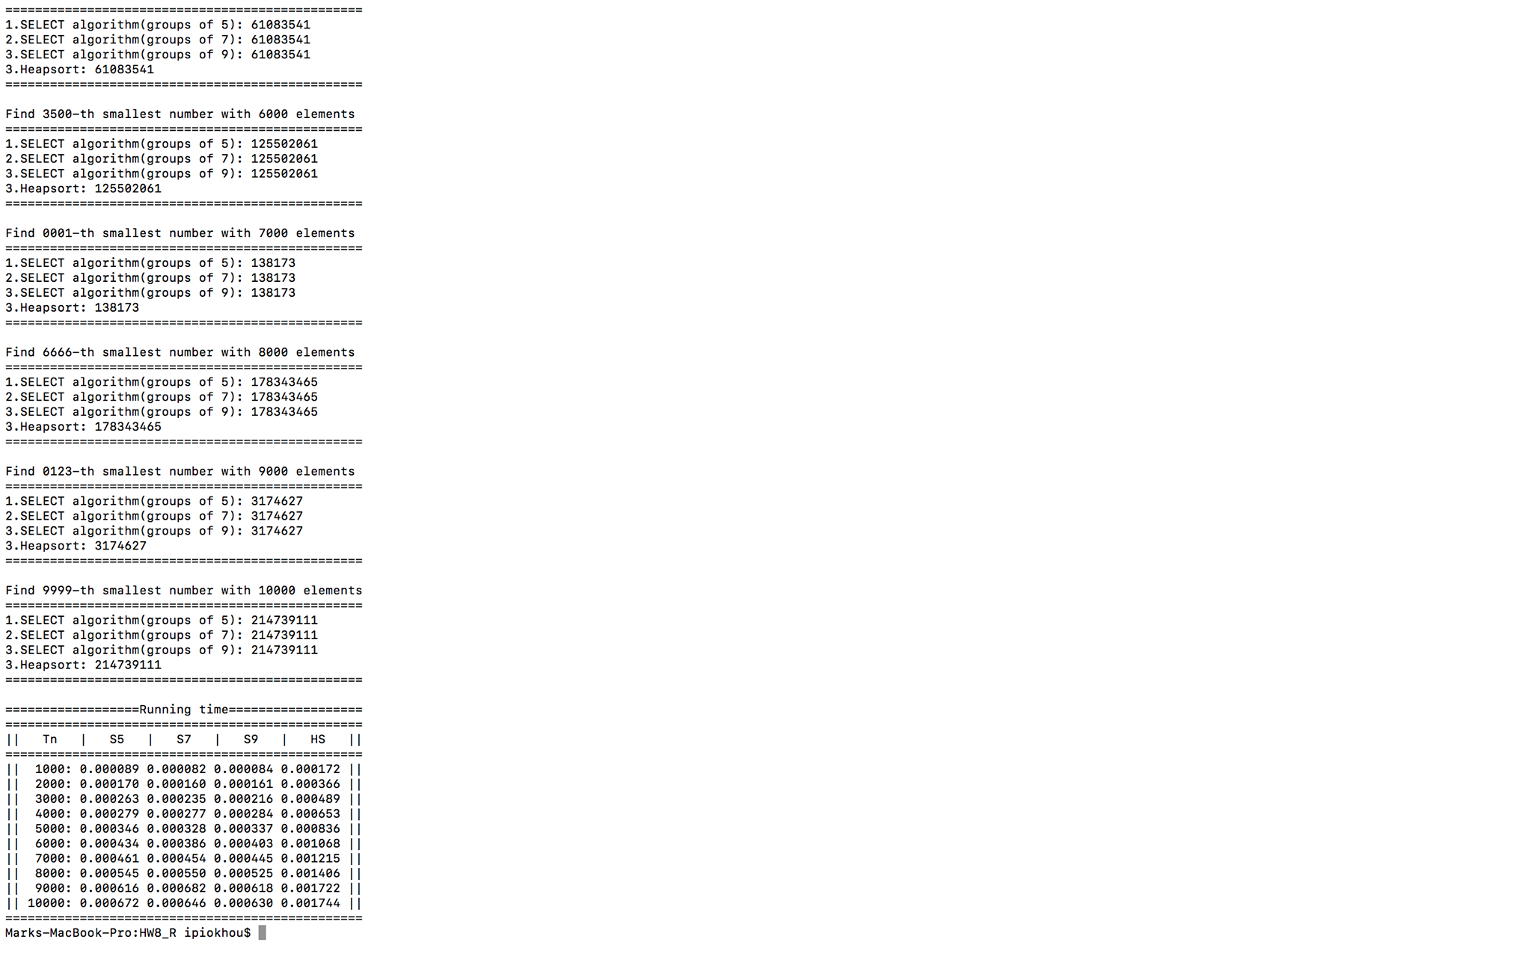

For the SELECT algorithm part, we can see that if we divided the elements into groups 7 and 9, the running time is very close to we divided the elements into groups 5, and all of those are also run in linear time.

For the Heapsort compare to the Select algorithm, because time complexity of each are $O(nlgn)$ and $O(n)$, so we can see that the Heapsort running time is larger than the select algorithm. However, Heapsort is to sorting all of those elements, SELECT algorithm is using for find out the k-th smallest or largest element, the idea of those two are not the same.