Shaping large 2D raw data file formats into a suitable format for blender software that is resized in disk space and brought to the web

Martin Hering-Bertram
Program Coordinator Media Computer Science (B.Sc.)
Martin.Hering-Bertram@hs-bremen.de
Hochschule Bremen City University of Applied Sciences
Flughafenallee 10
28199 Bremen
Karolin Leitermann
Wissenschaftliche Koordinatorin des SAW-Projektes „Digital Materialities“
K.Leitermann@dsm.museum
Deutsches Schifffahrtsmuseum
Leibniz-Institut für Maritime Geschichte
Hans-Scharoun-Platz
27568 Bremerhaven
Hackaton 2022 Team
{Hendrik Bohling, Fergan, Christine, Istabraq, David, Luka}

Documentation and Research Paper
Hackaton 2022

ABSTRACT
Visualization nowadays is used everywhere to visualize large amounts of data. Common in statistics and research, huge amounts of data from table sets are processed and displayed in an easy to read and understandable form. The goal is to improve the audiences knowledge, finding gaps in given data or to gain a different perspective on provided databases to discover new relations. Displaying information in different ways is useful and progress in this sector is interestingly followed by teachers, schools, trainees or museums. Last one mentioned has problems in transferring their vastly collected artifacts into the web for a wider audience. File sizes of stored scanned items are too large and solutions are needed. We won’t address this problem specifically. In terms this is a low cost project with the aim to help the Deutsche Schiffahrtsmuseum to bring their attractions online so that they can be explored by a variety of people. Our goal is to achieve this with open-source software and tools that are easily available in the internet. In this paper you will find a well documented software and all the necessities to accomplish such a project with its flaws and difficulties as well as a conclusion about its advantage and disadvantages.

BACKGROUND
The German Maritime Museum / Leibniz Institute for Maritime History (DSM) organized a two-day hackathon and visualization workshop in cooperation with Faculty 4 (Electrical Engineering and Computer Science) of the Bremen University of Applied Sciences (HSB) and the MAPEX Center for Materials and Processes at the University of Bremen. The hackathon was open to students from Bremen and the surrounding area and took place under the motto "Seaman’s Gear" on 8. and 9. October at the HSB. The online presentation of visualized technical devices should be made possible using open source applications.
Keywords
Visualization, Modelling, Animation, Web Development, Large Data, File Formats

Distribution
Permission to make digital or hard copies of all or part of this work for personal or classroom use is granted without fee provided that copies are not made or distributed for profit or commercial advantage and that copies bear this notice and the full citation on the first page. To copy otherwise, or republish, to post on servers or to redistribute to lists, requires prior specific permission and/or a fee.

1 INTRODUCTION

2 TOOLS

2.1 Blender
2.2 Node.js
2.2.1 Setup
# Install dependencies (only the first time)
npm install

# Run the local server at localhost:8080
npm run dev

# Build for production in the dist/ directory
npm run build

2.3 three.js

3 MILESTONES

3.1 Mile 1
The aim for this mile was to create a functional product. We were able to polish a barometer and animate different parts of it from given raw data. This was also shaped into different component parts beforehand as it was a rough scan provided from the DSM with a lot of glued polygons and undifferentiated parts of the barometer. We also analyzed its mechanism and figured out that we have to rework some parts to be able to animate them properly. An additional feature idea came into one of our authors mind that we could link the barometers animation to real world data similar to a weather application.

4 DESIGN
The preparatory work for the digitization of the barometer was created on the 3D modeling program Dragonfly. Complications arose, which is why digitization continued on Blender 3D. Here we were able to present the fine components in more detail.
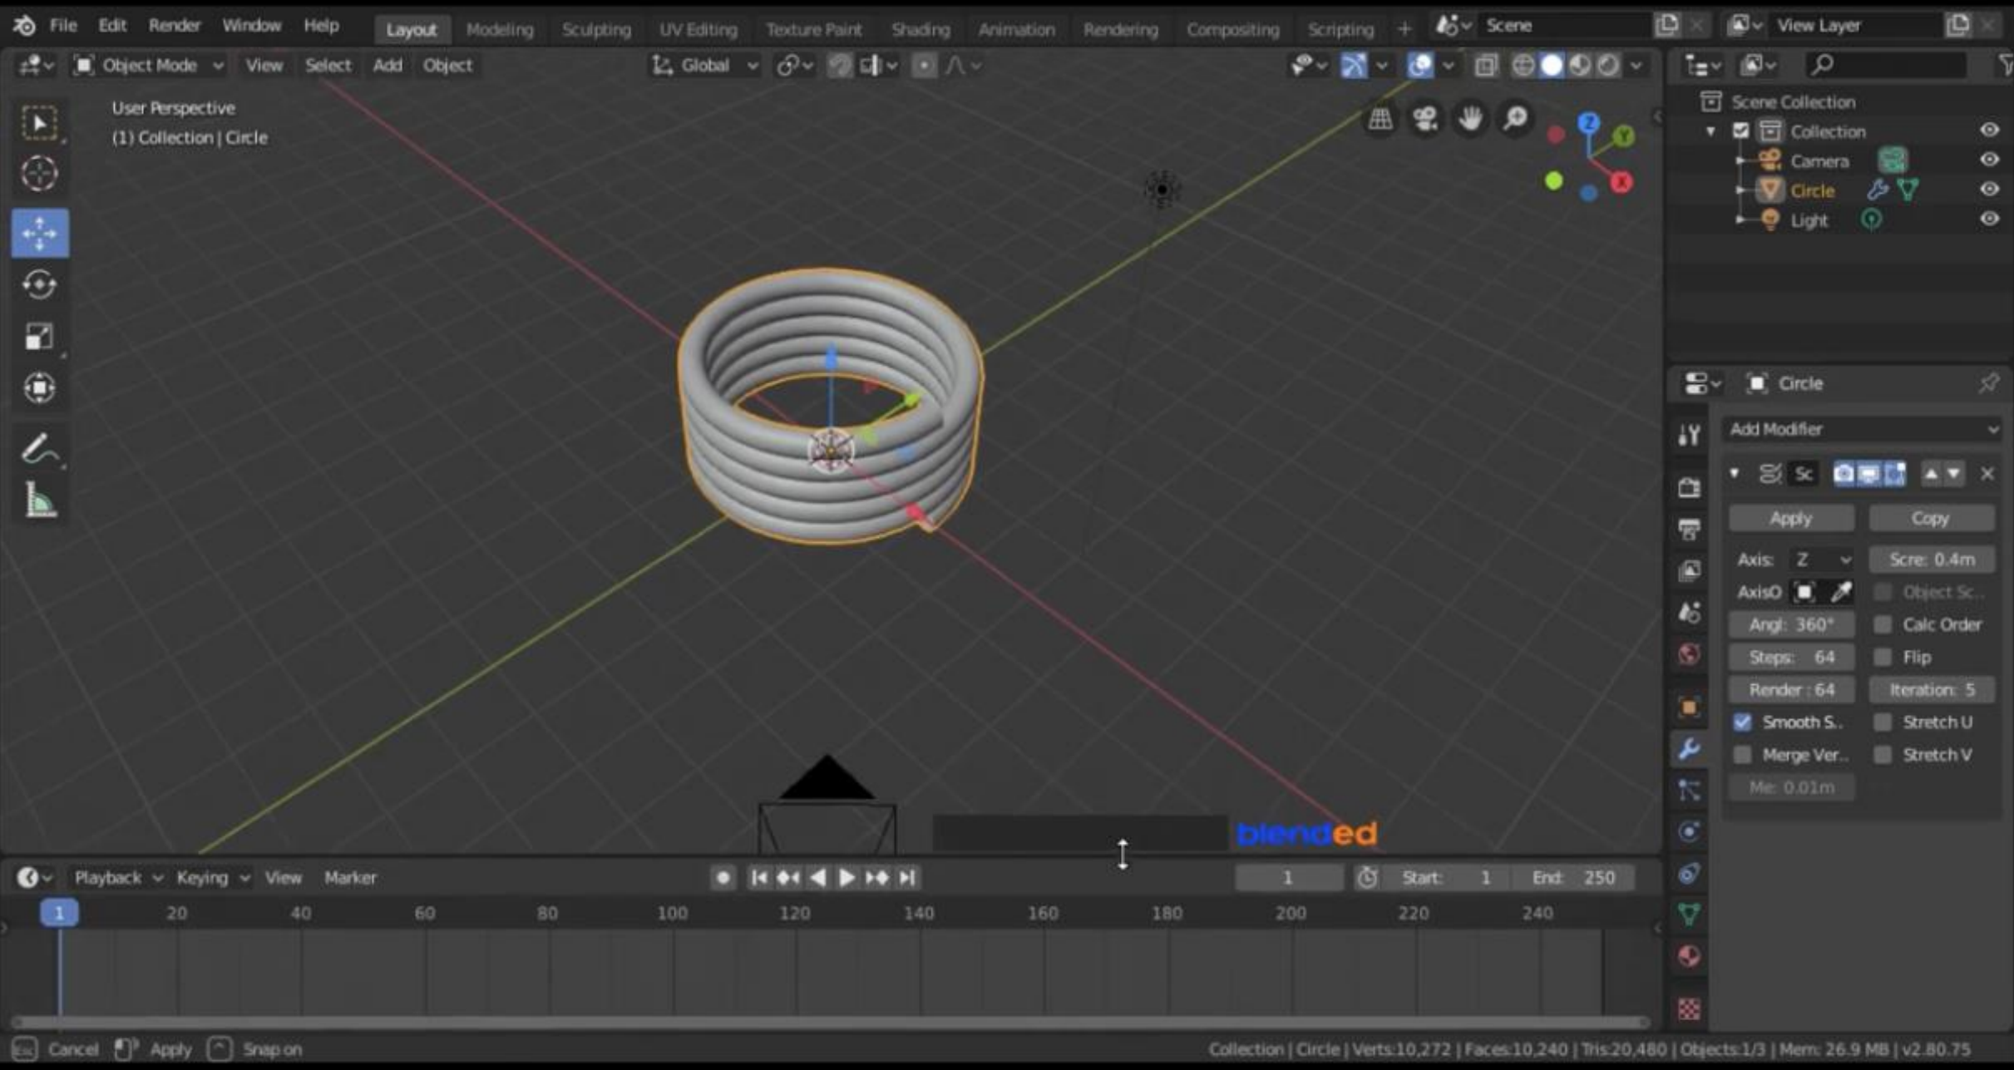
Figure 1: Animation

4.1 Animation
In Blender 3D you can not only record objects in the room but also add a movement and thus create an animation. In this case, the spring created must be able to expand and pull together again. It is possible by setting the "screw" values higher or lower in the "Modifier Window". So you set a maximum and a minimum, these points are recorded in the lower "Frame menu", e.g. the minimum value 1 is for seconds and the maximum value is 10 seconds. Blender 3D then adjusts the movement and projects the desired animation.
4.2 Components

4.2.1 The chain
During the Hackathon we thought we wanted to showcase the Barometer,in a contemporary way, so we agreed on the idea of adding a chain to the device. The Chain was created using a Torus and an Array Modifiers.
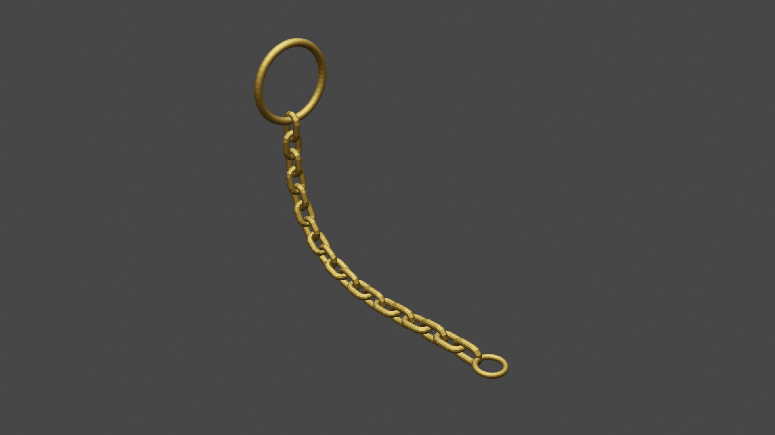
Figure 2: The chain
4.2.2 The Body
Using the original scan from the DSM as reference, I was able to build a body that had all the original features of the initial case.
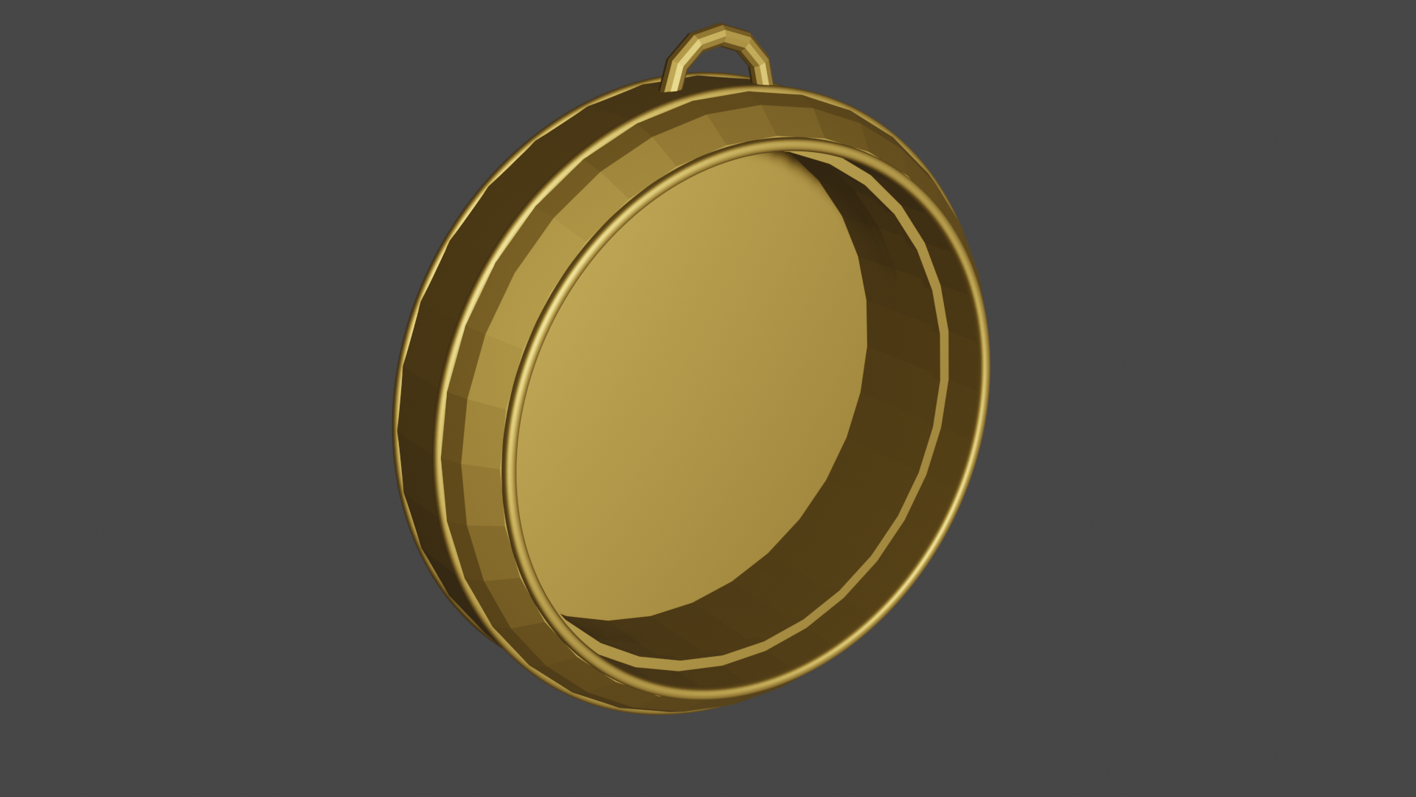
Figure 3: Front body
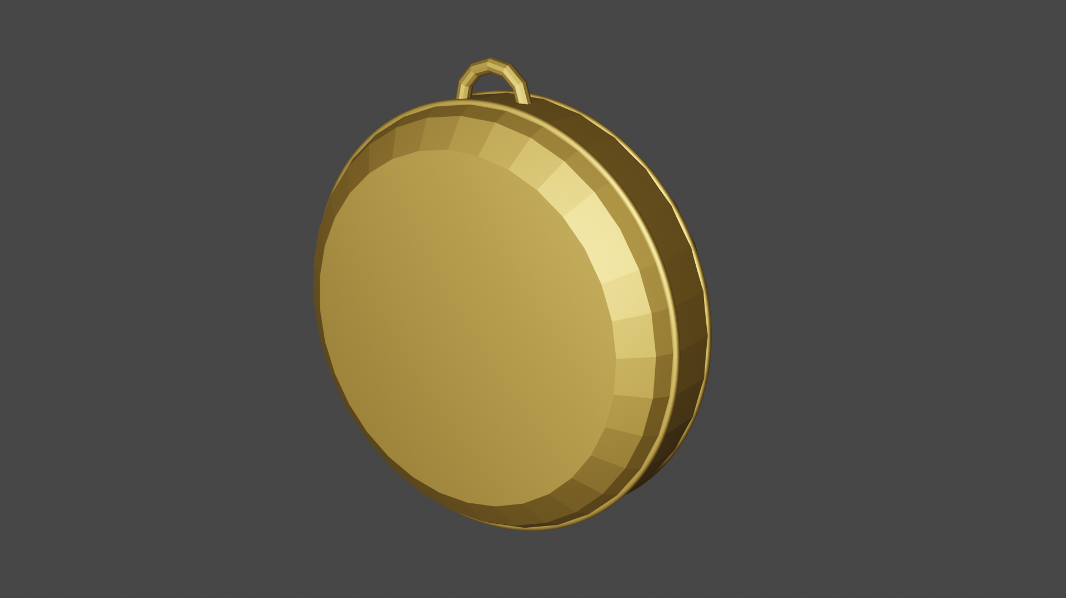
Figure 4: Back body

4.2.3 The spring

The spring, which has the function of opening from the privacy flap, the barometer itself, at the push of a button. It spring could be easily created in Blender. You start creating a circle, then add the "screw" modifier to the object. This creates a circular tube that can be shaped as desired. With the modifier menu you can increase the "Itaration". As soon as you have done this, you can already recognize a spring and, if necessary, process it further.

4.3 Mechanism

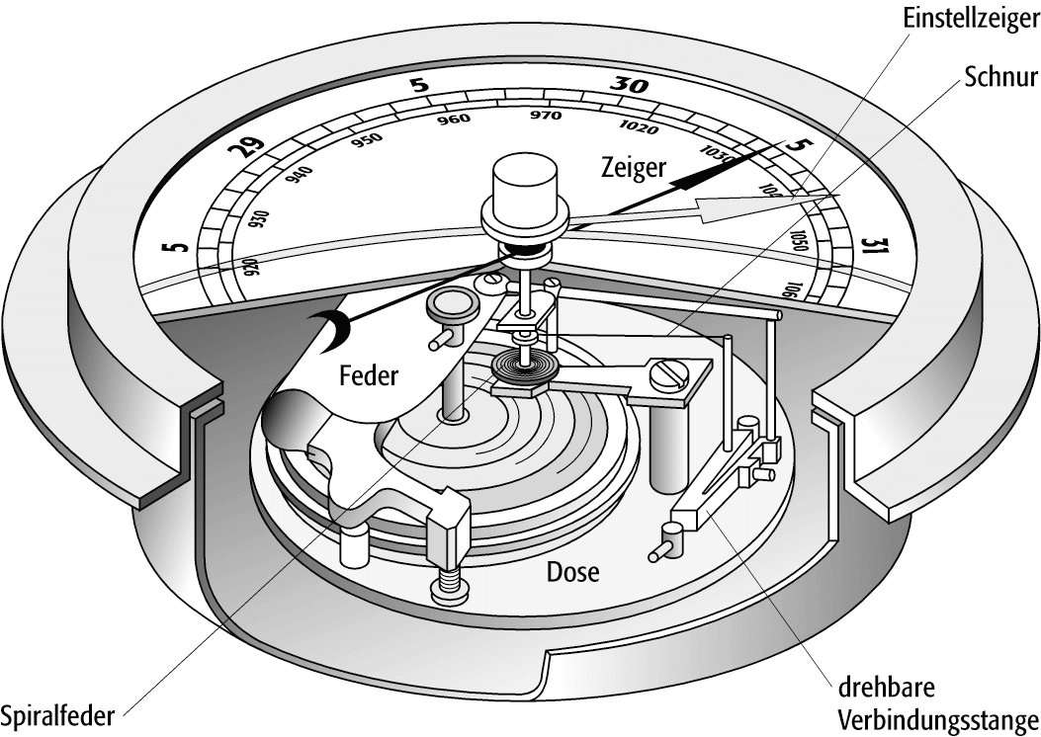
Figure 4: Mechanism inside

4.4 Wep-App User Interface
Three different views should be implemented for the expanded interaction of the web application. A number was assigned to each of these views and thus made available directly under the
representation of the respective component [ie the barometer case].


The clickable buttons are the outer rectangles with the arrow icons. The views switch automatically if one of the numbers is not pressed.
Within a view there is a selection of animations that can be played. Further interaction options will follow in the future.

4.5 METHODS

4.5.1 μ-computer tomography
X-ray tube consists of an object placed on a rotatable sample holder and a detector panel.
Creates projections (2D), which then stitched together to 3D object. Dragonfly software is then used to create the mesh from image stack.
4.5.2 Vidi Barometer
Vidi Barometer - used to measure air pressure in a certain environment
4.5.3 Chronometer
Measures Longitude (360 deg/24 hours = 15 deg for 1 hour). Needs 2 parameters: Location of observation and destination.
4.5.4 Boxsextant
Measures distance between 2 Objects to determine position (Latitude)

4.6 COMPARISON

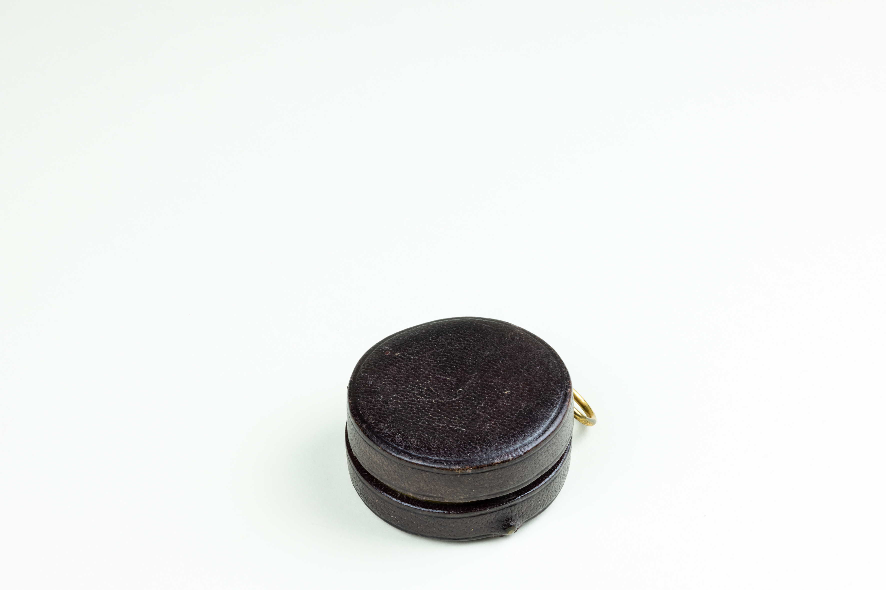
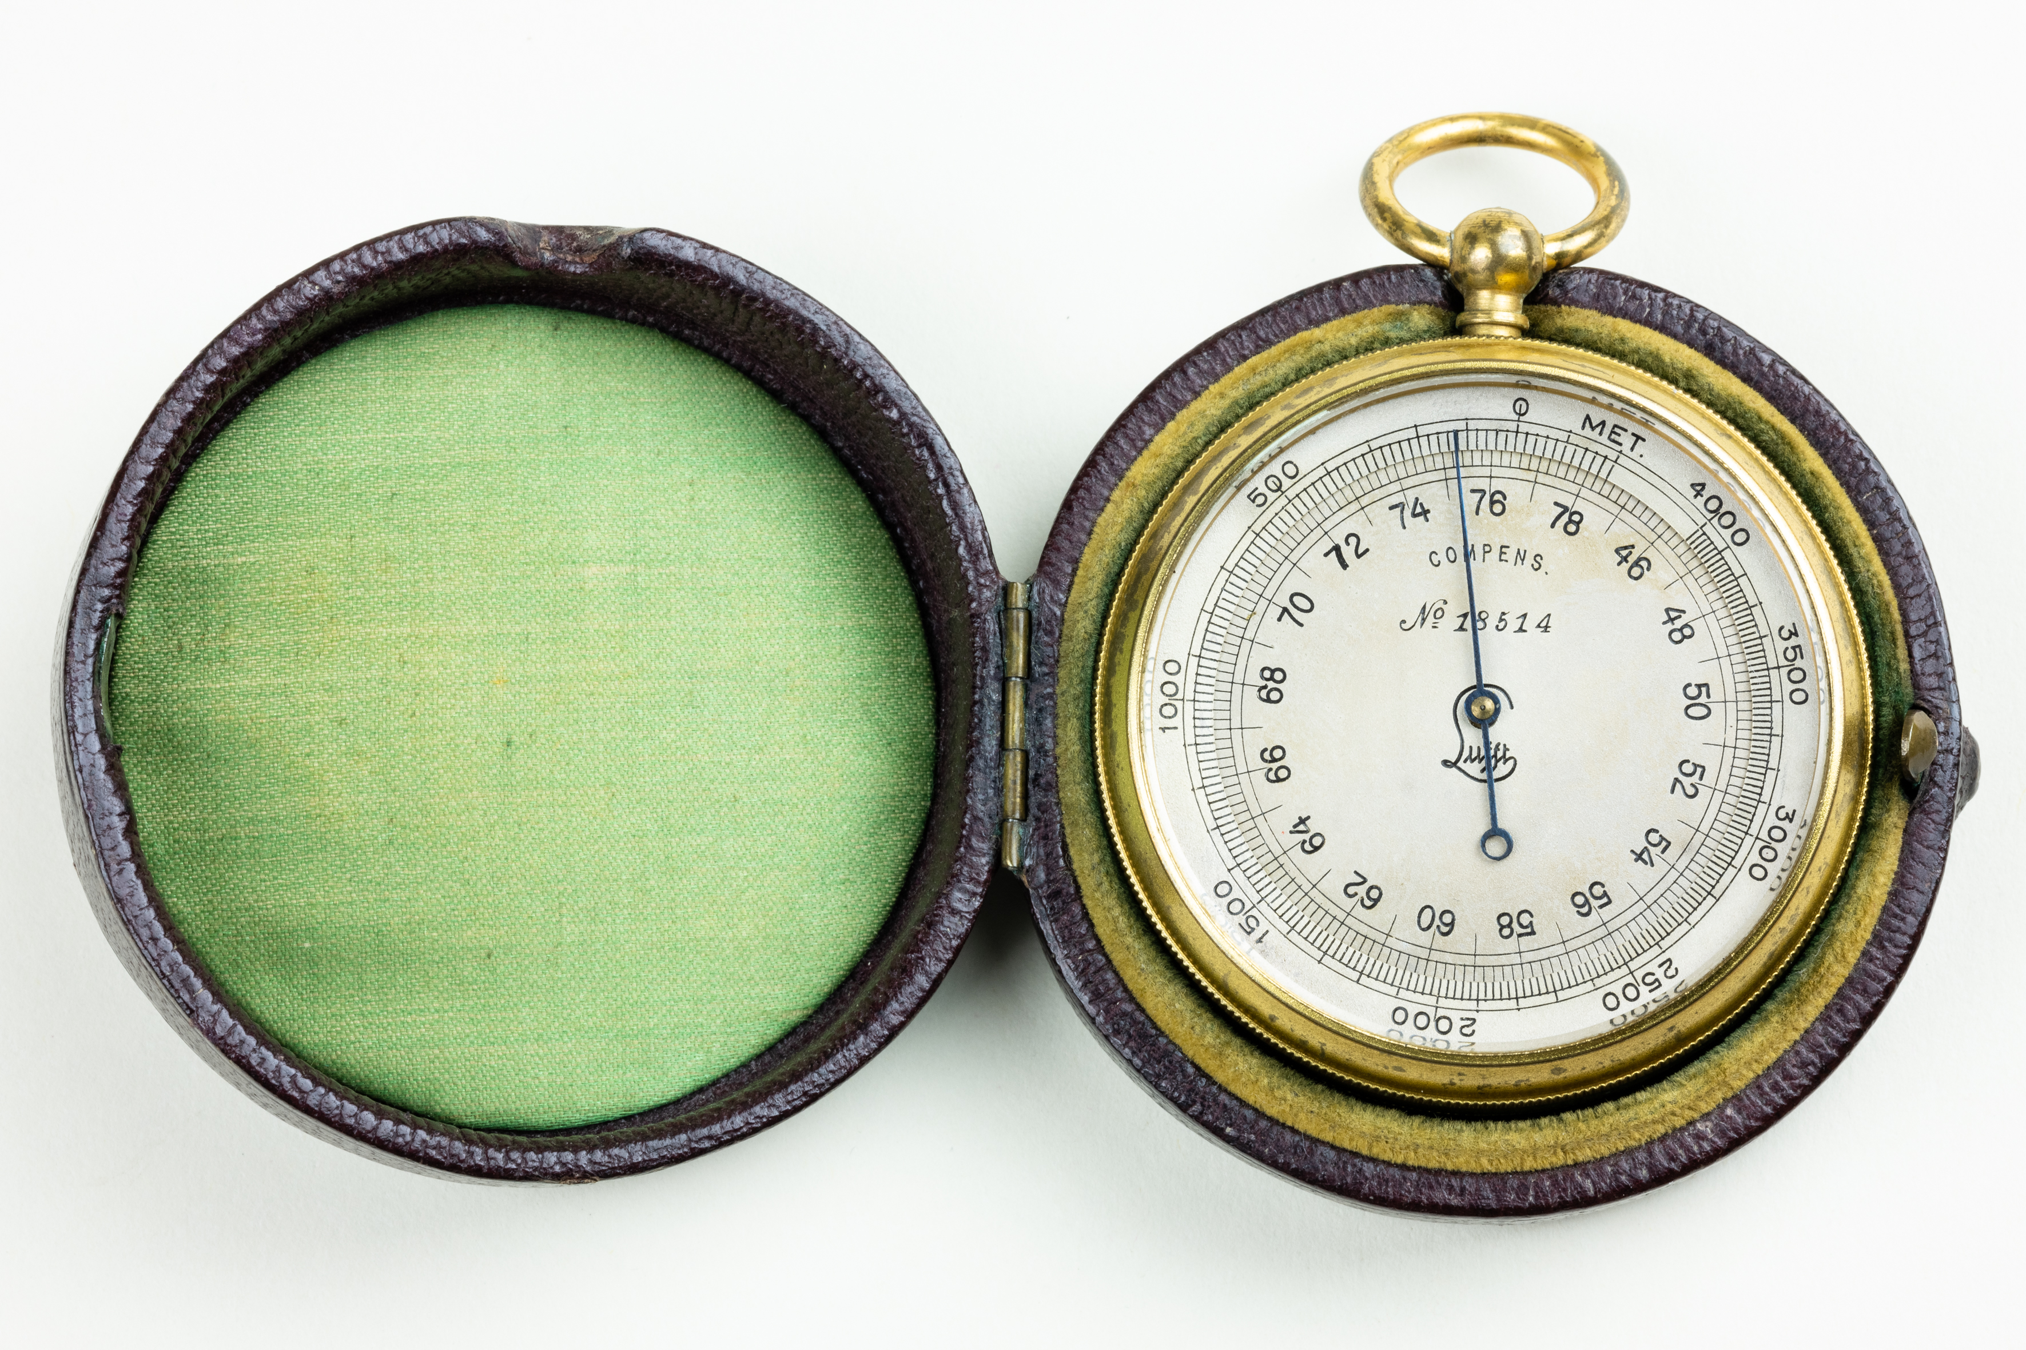
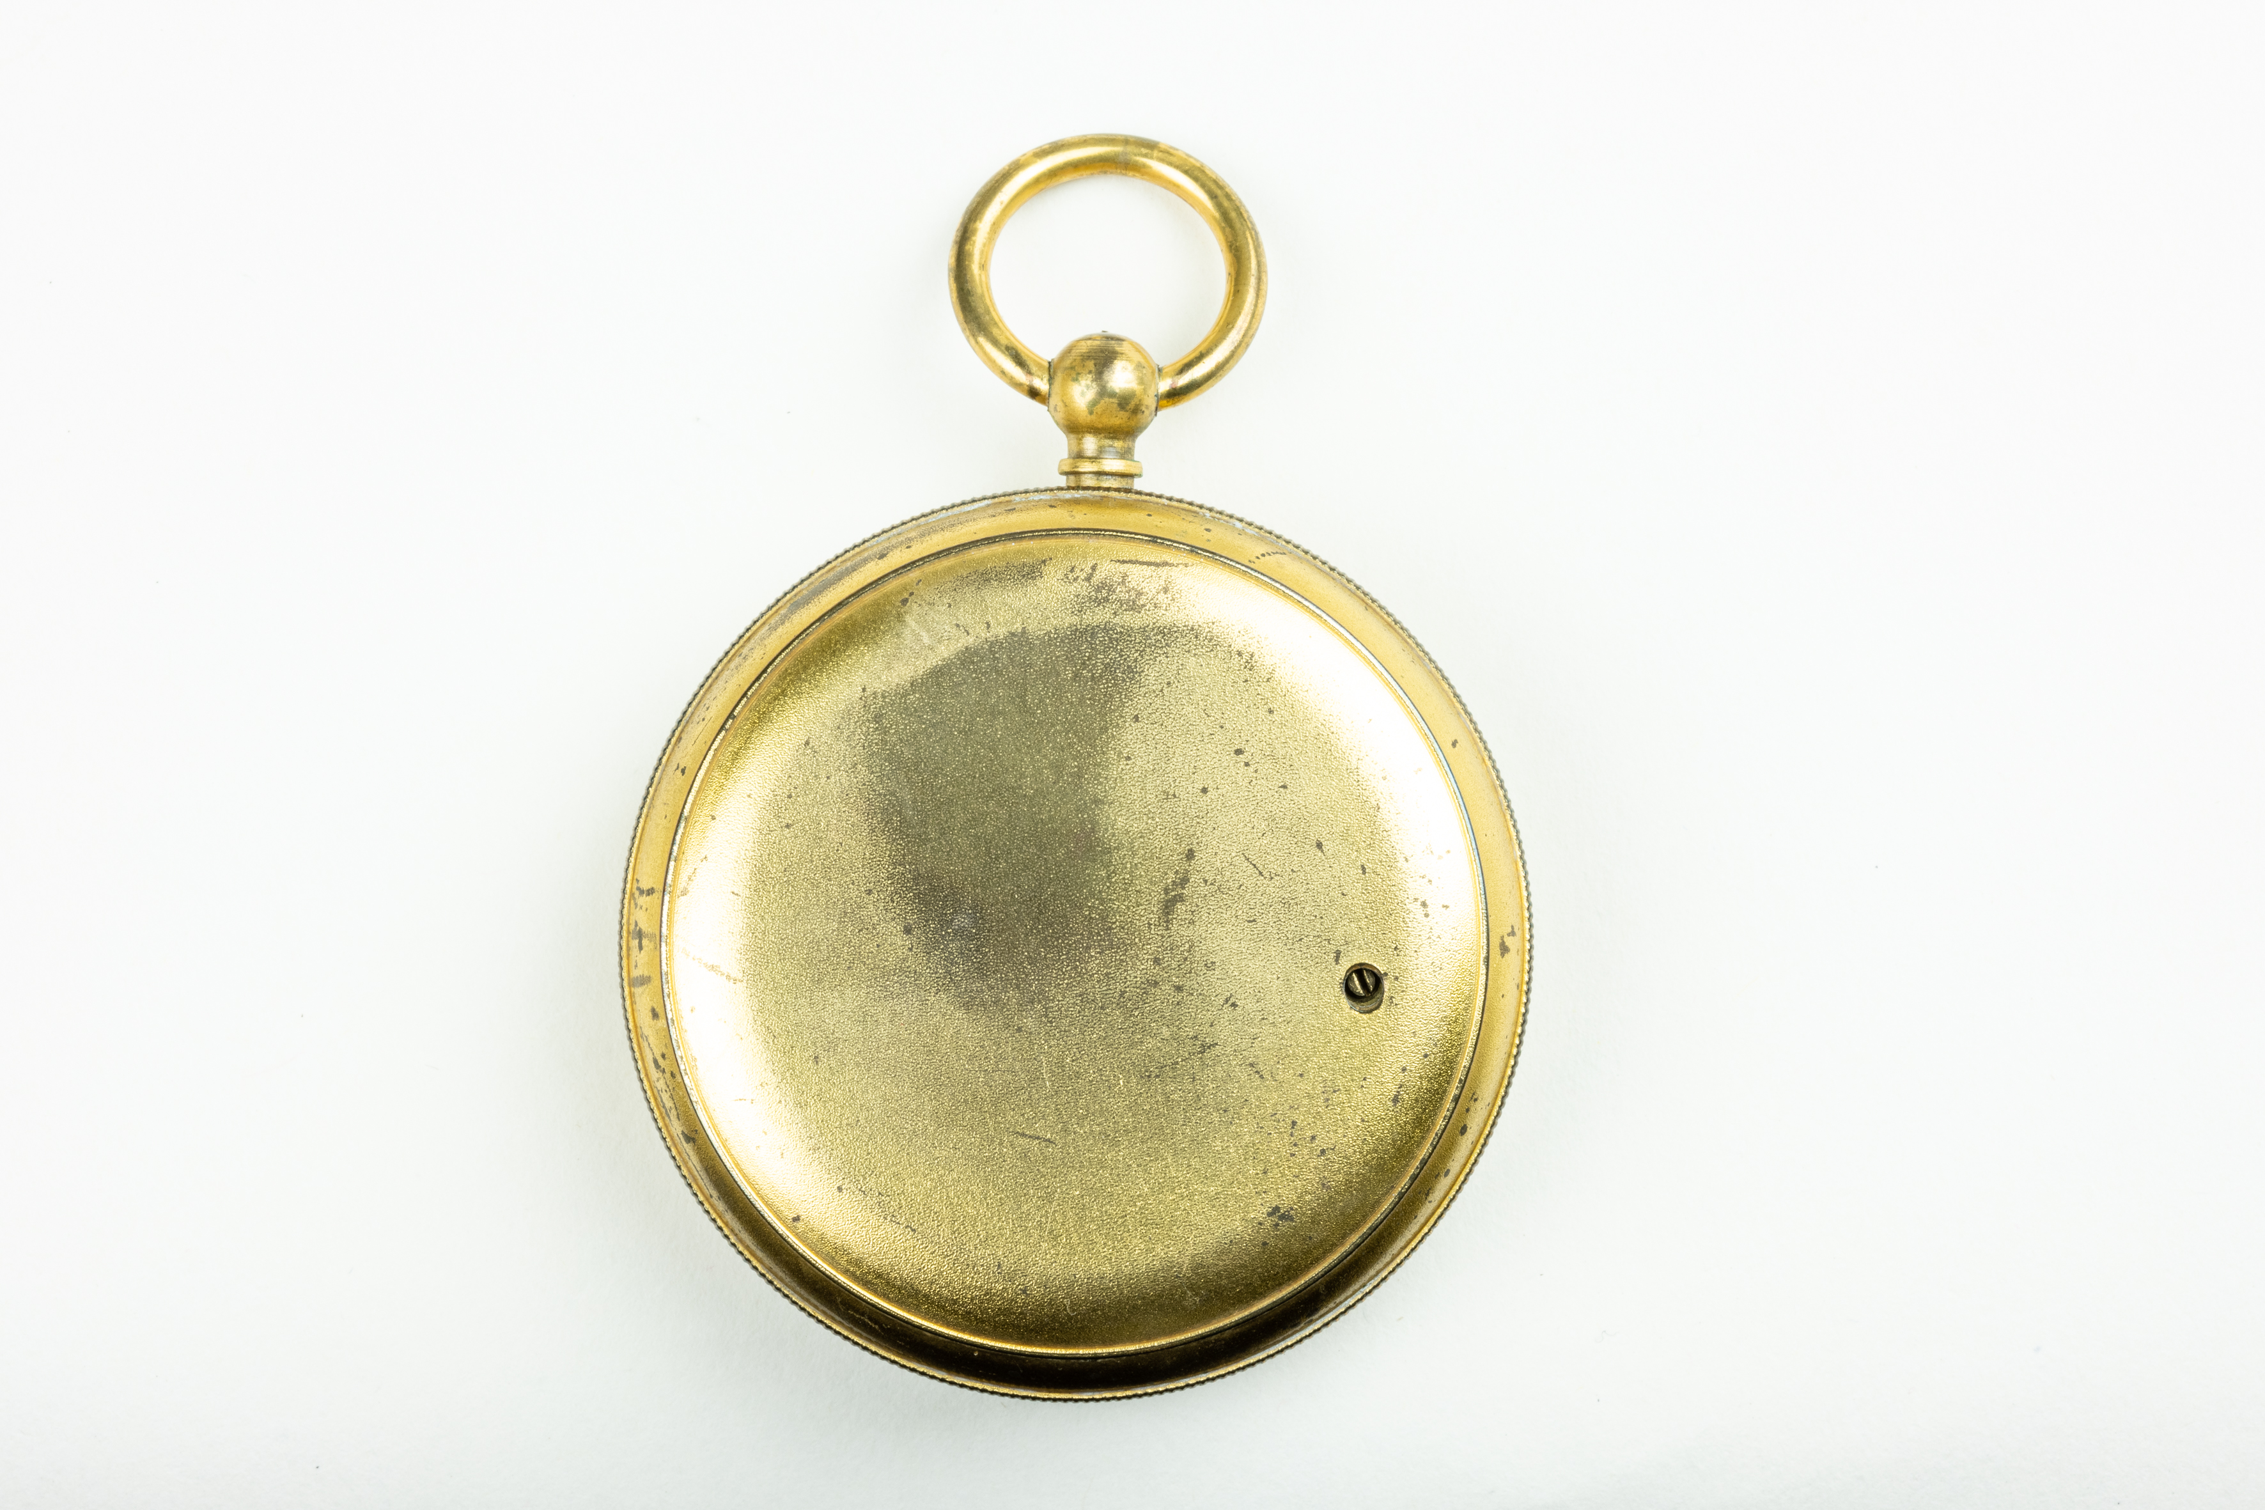
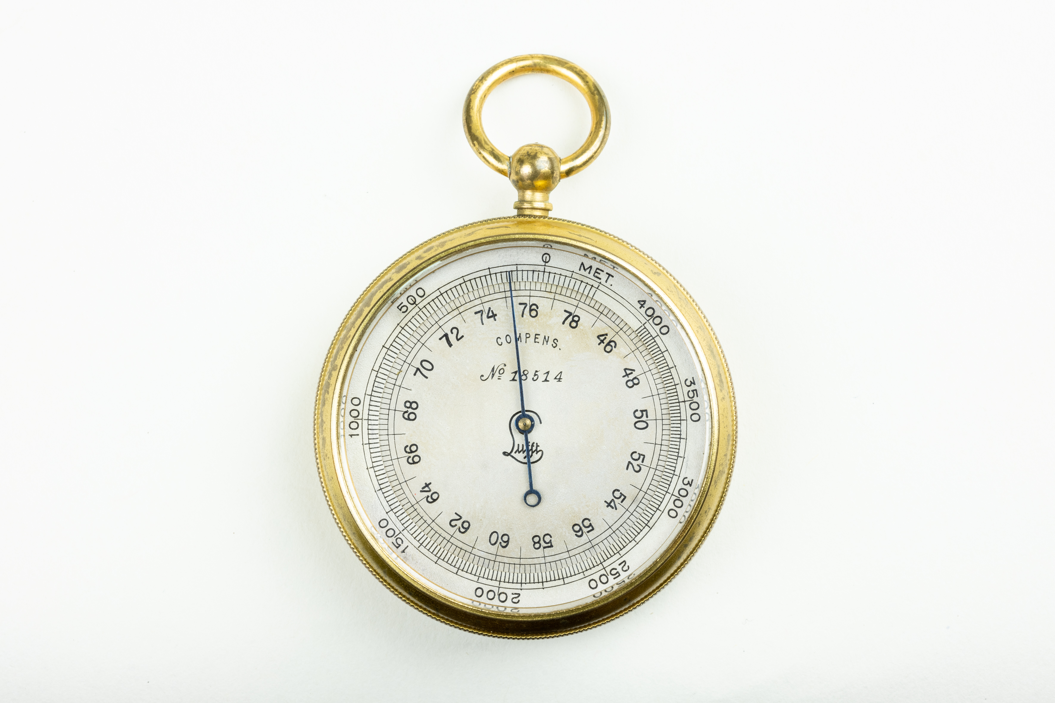

4.6 RELATED WORK

4.7 TESTINGS

4.8 REFERENCES

https://3d.dsm.museum/seamansgear/



