Sentiment Analysis on IMDb Movie Reviews
Project Report by Keviyaneinuo Medom

1. Introduction
This report documents the design, implementation, and evaluation of a sentiment analysis system for IMDb movie reviews. The objective was to build a Natural Language Processing (NLP) pipeline capable of classifying customer reviews as Positive, Negative, or Neutral, providing a way to understand audience sentiment without manually reading each review.

2. Objectives
- Preprocess raw review text (cleaning, tokenization).
- Convert text into numerical features using TF-IDF.
- Train a Logistic Regression classifier to distinguish Positive and Negative reviews.
- Extend the binary output with a rule-based Neutral category.
- Evaluate the model using standard classification metrics.
- Visualize frequently occurring words using Word Clouds.
- Summarize findings as business-relevant insights.

3. Dataset
The dataset used is a CSV file of IMDb movie reviews (movie.csv.gz, gzip-compressed) containing two columns: text (the review content) and label (0 = Negative, 1 = Positive). The dataset originally contains 40,000 reviews. After removing rows with missing text and 277 duplicate reviews, 39,723 reviews remained for analysis. The class distribution is close to balanced, with approximately equal numbers of Positive and Negative reviews, which supports the use of accuracy as a meaningful evaluation metric.

4. Methodology

4.1 Text Preprocessing
Each review was converted to lowercase, and HTML line-break tags (<br />), which were present in a large portion of the raw text, were removed prior to punctuation stripping. URLs and punctuation were then removed, and common English stopwords were filtered out to reduce noise before feature extraction.

4.2 Feature Extraction
Cleaned reviews were transformed into numerical feature vectors using TF-IDF (Term Frequency - Inverse Document Frequency), limited to the 5,000 most informative terms. TF-IDF was selected because it down-weights common but uninformative words while emphasizing terms that are distinctive to a given review.

4.3 Model Training
The dataset was split into training (80%) and test (20%) sets using stratified sampling to preserve the original class balance. A Logistic Regression classifier was trained on the TF-IDF features using the binary Positive/Negative labels as ground truth.

4.4 Neutral Category
Because the source dataset provides only binary labels, a third, Neutral category was derived separately using TextBlob polarity scoring. Reviews with a polarity score above 0.1 were labeled Positive, below -0.1 were labeled Negative, and scores in between were labeled Neutral. This label is used for descriptive analysis and is independent of the Logistic Regression model, which was trained and evaluated on the original binary ground-truth labels.

5. Results
The Logistic Regression model achieved an overall accuracy of 88.46% on the held-out test set (7,945 reviews). Detailed precision, recall, and F1-scores per class are shown below.
Class | Precision | Recall | F1-Score
Negative (0) | 0.8962 | 0.8693 | 0.8825
Positive (1) | 0.8737 | 0.8998 | 0.8866

The confusion matrix below summarizes the model's predictions against the actual labels.
 | Predicted Negative | Predicted Positive
Actual Negative | 3445 | 518
Actual Positive | 399 | 3583

The relatively balanced precision and recall across both classes indicate the model does not systematically favor one sentiment over the other. The majority of errors involve reviews with mixed or ambiguous language, which is consistent with the existence of a Neutral category in real-world feedback.

6. Word Cloud Analysis
Word clouds were generated separately for positive and negative reviews to visualize the most frequent terms in each group. An initial version of the word cloud was dominated by the token "br", traced back to unremoved HTML line-break tags in the raw review text; this was corrected by stripping HTML tags during preprocessing. After the fix, occurrences of "br" dropped from over 23,000 reviews containing the tag to just 2 residual occurrences across the full dataset.
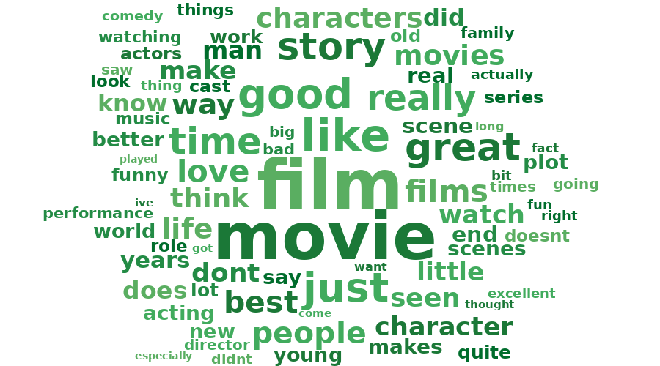
Figure 1: Most frequent words in positive reviews.
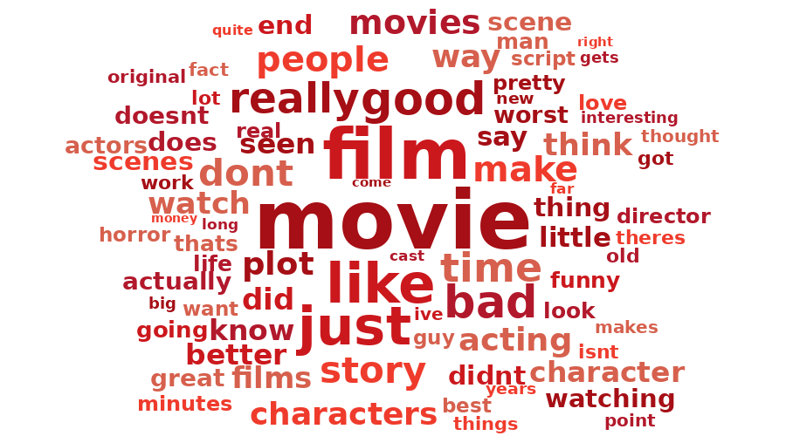
Figure 2: Most frequent words in negative reviews.
The corrected visualizations highlight genre- and production-related terms (e.g., "story", "character", "acting") as common across reviews, with sentiment-specific vocabulary distinguishing the positive and negative groups. These figures were generated from the same cleaned word-frequency data used by the notebook, rendered here as a frequency-based text layout rather than the WordCloud library's exact rendering.

7. Business Insights
- Automated sentiment classification allows large volumes of reviews to be categorized without manual reading, reducing the time required to assess audience or customer opinion.
- Word clouds identify the specific terms associated with positive and negative sentiment, which can inform decisions about what aspects of a product or film are being praised or criticized.
- The confusion matrix indicates that misclassifications are concentrated in reviews with mixed or ambiguous sentiment, corresponding to the Neutral category identified separately.
- Including a Neutral category prevents ambiguous feedback from being forced into a strictly Positive or Negative bucket, which would otherwise distort aggregate sentiment reporting.
- The same pipeline (text cleaning, TF-IDF, Logistic Regression) is not specific to movie reviews and can be adapted to other review or feedback datasets with minimal modification.

8. Conclusion and Future Work
The implemented pipeline successfully classifies IMDb movie reviews with high accuracy using a straightforward TF-IDF and Logistic Regression approach. The addition of a rule-based Neutral category addresses a key limitation of the original binary-labeled dataset. Future improvements could include replacing the TextBlob-based Neutral heuristic with a properly labeled three-class dataset, experimenting with more advanced models such as BERT, and deploying the classifier as part of a real-time review monitoring application.

