**Kaushik Puntambekar – 1912037**

**Practical - 1**

1. Write a program to sum all the items in a list.

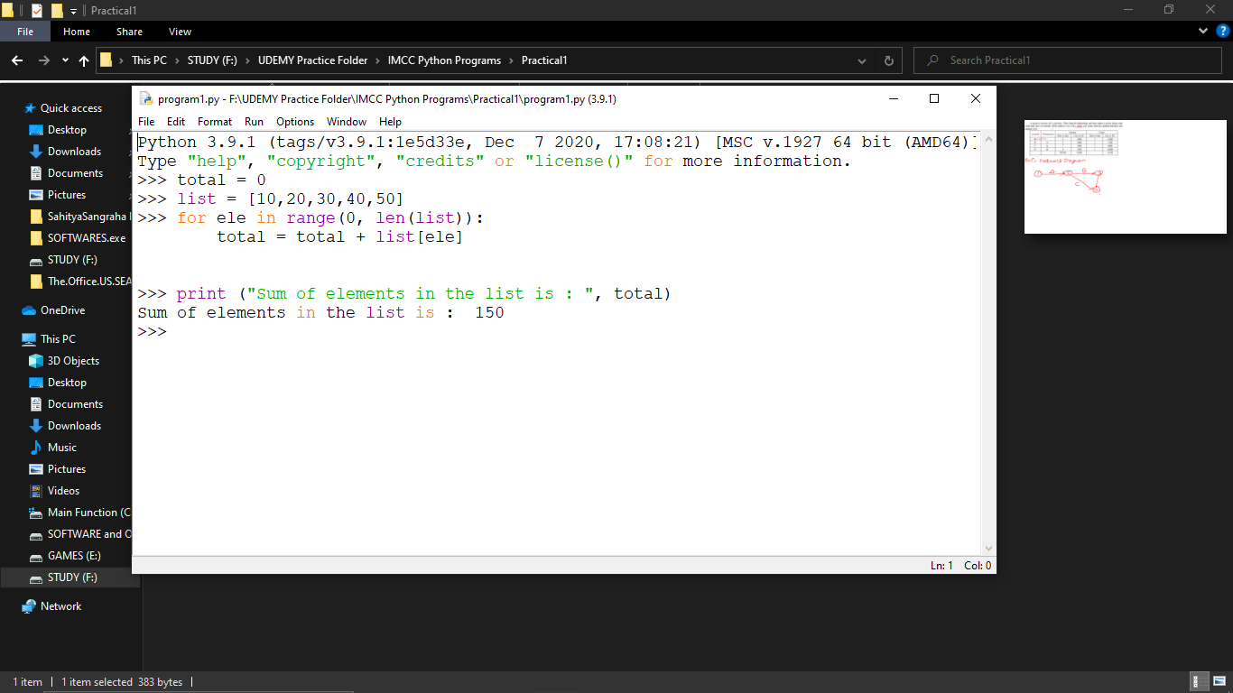

1. Write a program to get the largest number from the list.

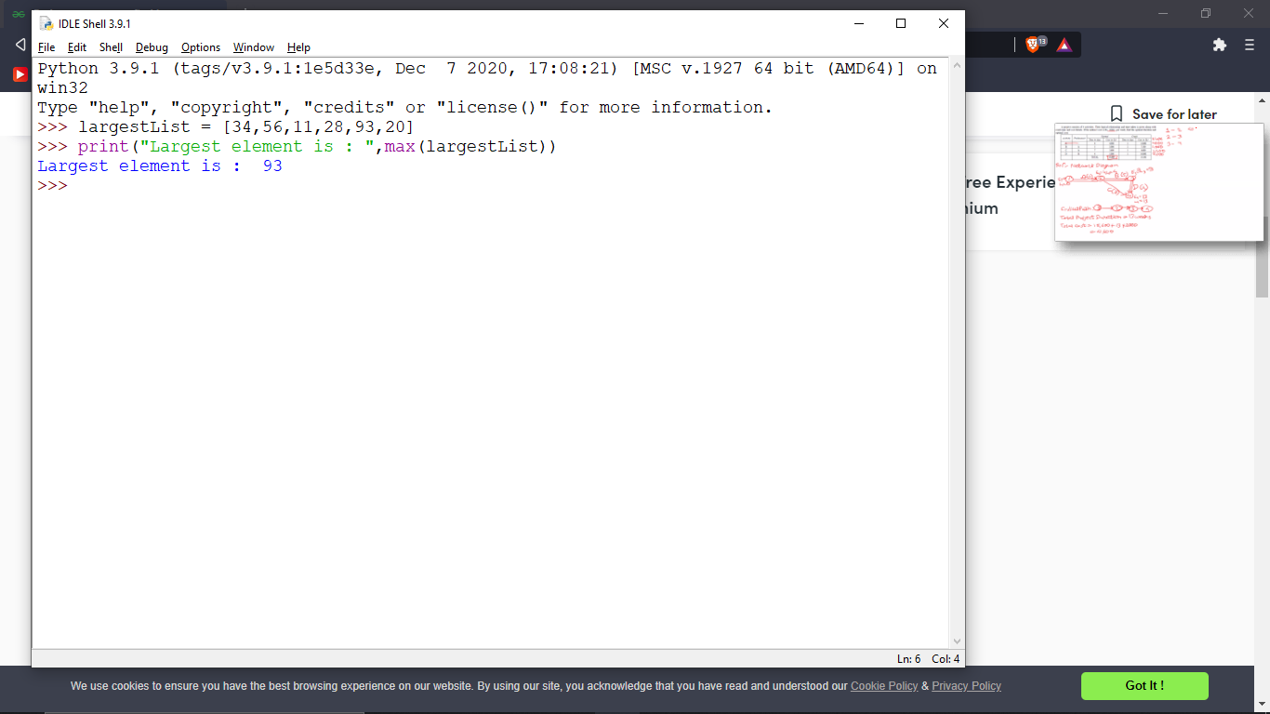

1. Write a program to remove duplicates from the list.

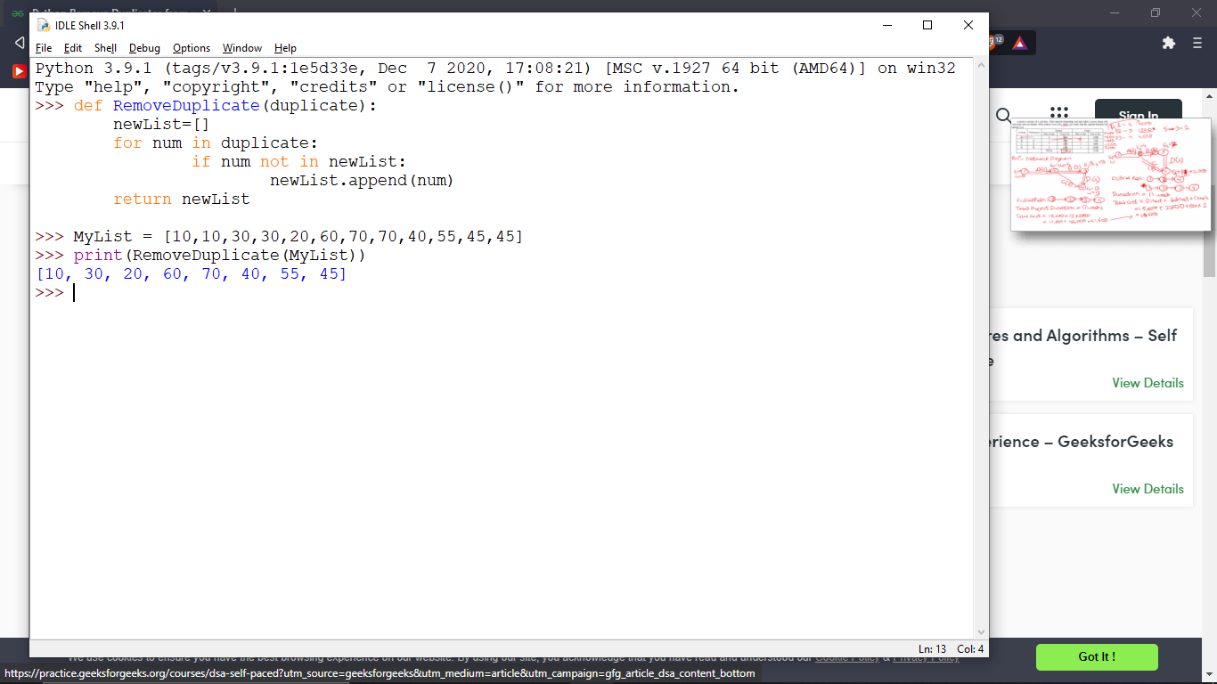

1. Write a program for displaying reversal of a number.

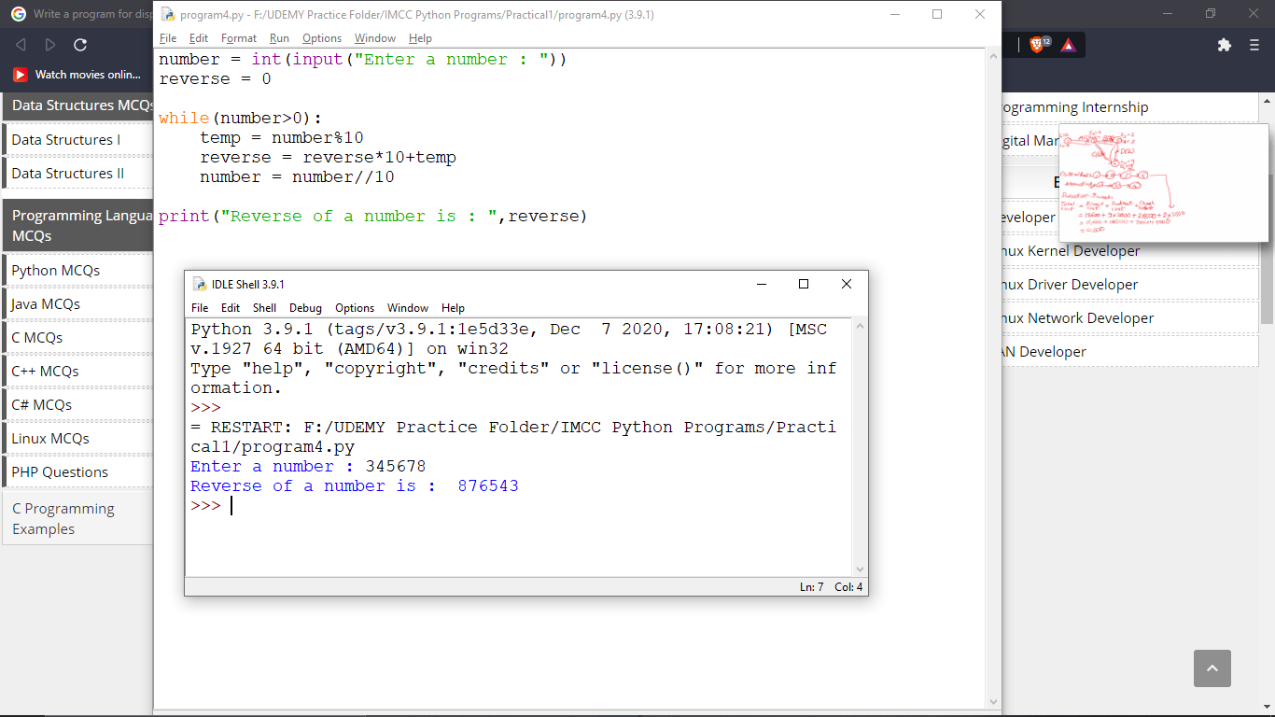

1. Write a program for finding biggest number among 3 numbers.

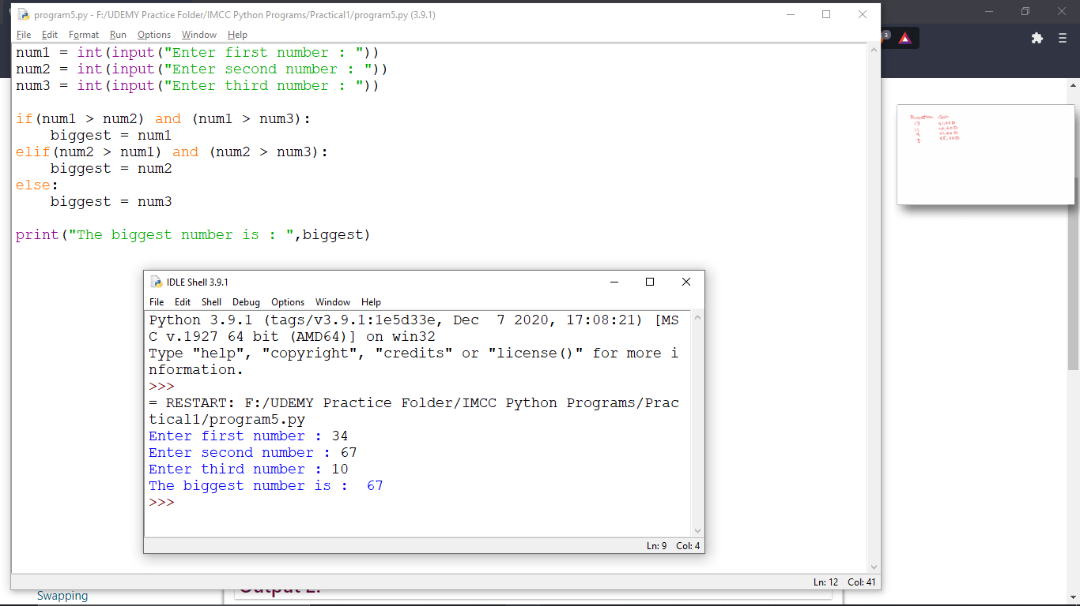

1. Write a program to read person’s age from keyboard and display whether he is eligible for voting or not.

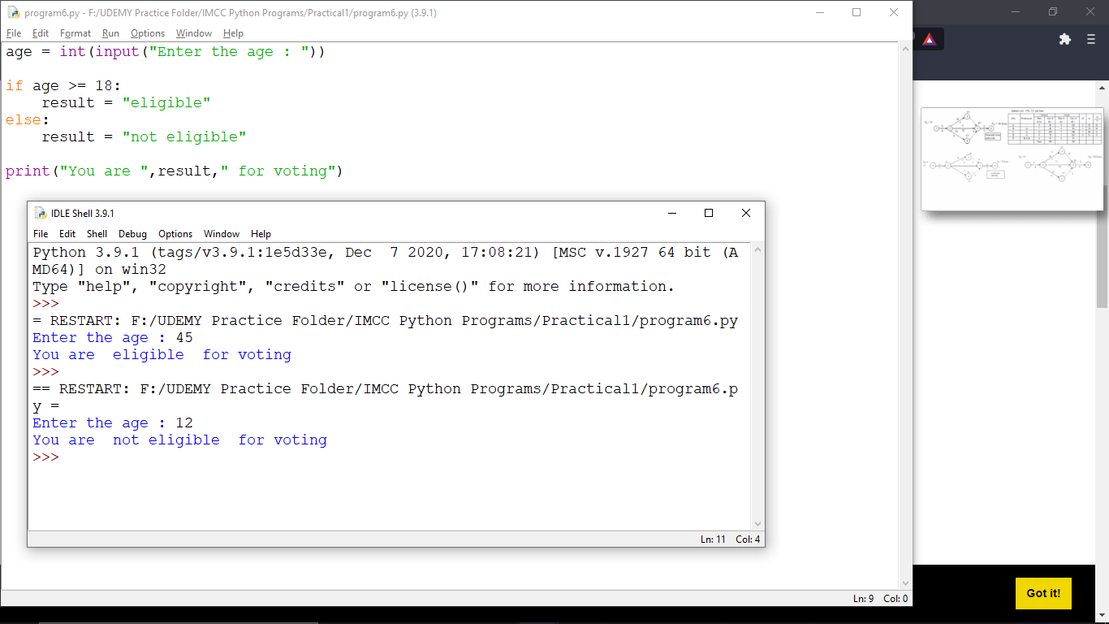

1. Write a program to perform various operations on string using string libraries.

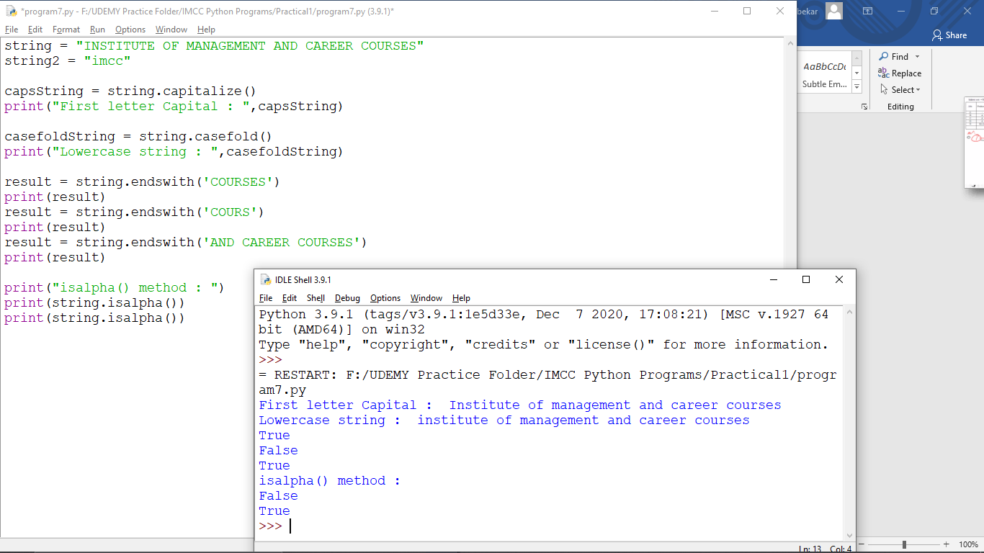

1. Write a program to accept line of text and find the number of characters, number of vowels and number of blank spaces in it.

