**HW21 - Find pitfalls in the Project**

1. **Method overloading**

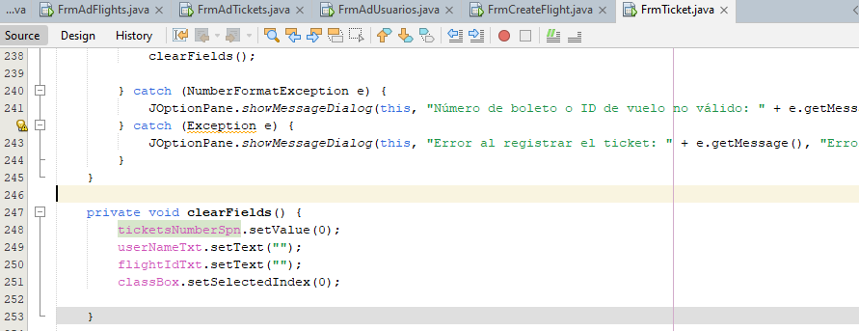  
**Explanation**:

In this code the button is used to perform actions that should not be its own.

**Possible solution:**

Create a class with generic functions and only call them in the button action code

1. **Duplicate Code**

**Explanation:**

In this code a function to clean cells of another class is duplicated

**Possible solution:**

Create a generic class so you can reuse code instead of duplicating it

1. **Long Methods**

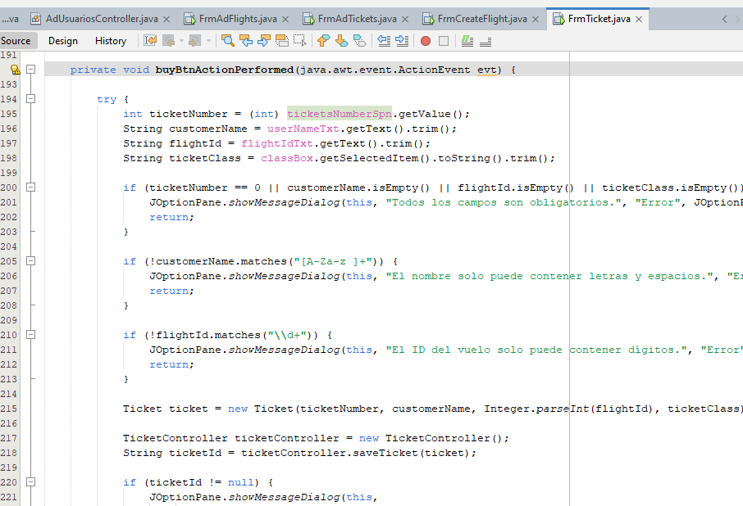

**Explanation:**

In this code the button is overloaded to validate if all the fields are completed and that they have the correct data type.

**Possible solution:**

Create a generic class in utils that performs that action and only call it on the button

1. **Duplicate Code**

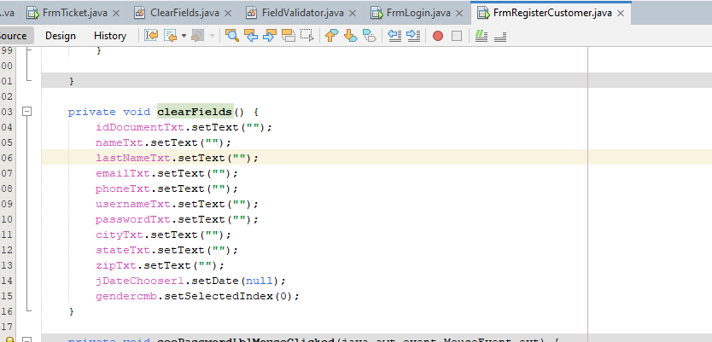

**Explanation:**

In this code a function to clean cells of another class is duplicated

**Possible solution:**

Create a generic class in utils that performs that action and only call it on the button

1. **Long Methods**

**Explanation:**

This class has a method that is too long and is not efficient when reusing it.

**Possible solution:**

Break this method into smaller methods that perform the same actions as the original.

1. **Duplicate Code and Overloading Class**

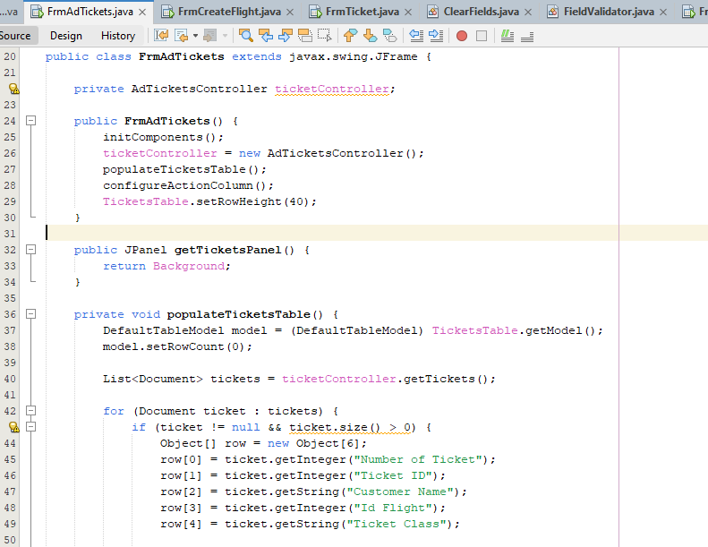

**Explanation:**

In the code of these three classes, the code for handling tables in the interface is repeated and a screen that is only for viewing is overloaded.

**Possible solution:**

Take the code out of there and create new classes in utils to only handle a call from the screen.