**HOMEWORK 3**

**Problem 1:** (Map representation) Generate the map representations for the following Boolean functions.

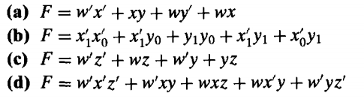

**Problem 2:** (Map method) Using the map method, determine the prime implicants of the following Boolean functions.

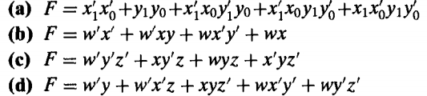

* **Review** Chapter 4: Simplications of Boolean Functions.