
LOGO USAGE GUIDELINES
A practical standard for event covers, community assets, websites, social media, and partner communications

WORKING BRAND SPECIFICATION • VERSION 1.0 • AUGUST 2026
SOURCE NOTE This guide is derived from the supplied Webcmd event artwork. Color values, spacing, and minimum sizes are practical working specifications—not a substitute for an official vector trademark kit.

01 PURPOSE AND AUTHORITY
Use this guide whenever the Webcmd logo appears in an asset produced by organizers, campus communities, partners, sponsors, or vendors.

What this guide protects
The Webcmd identity combines a terminal-window symbol with a two-tone wordmark. Consistent scale, spacing, color, and placement make the brand recognizable across fast-moving event campaigns and collaborative partner assets.
- Recognition: the same lockup should look familiar across posters, Luma covers, decks, websites, badges, and social posts.
- Legibility: the terminal symbol, command prompt, and “webcmd” wordmark must remain readable at the final display size.
- Ownership: the logo must remain distinct from event titles, host marks, campus identities, sponsor rows, and decorative graphics.
- Quality: teams should use approved production files instead of screenshots, retyped wordmarks, or traced approximations.

The master signature
Master horizontal lockup shown in the supplied reference artwork.
Terminal symbol | Rounded browser/terminal window containing a command chevron and underscore.
Wordmark | Lowercase “webcmd”; “web” appears in dark navy and “cmd” in electric blue.
Lockup relationship | Symbol and wordmark are treated as one signature. Do not independently resize or reposition either part.
Reference status | The raster sample is suitable for guidance and mockups. Obtain an approved SVG/PDF master for high-resolution production.
02 CLEAR SPACE AND SCALE
Give the logo enough room to remain a signature—not another piece of event copy.

Clear-space rule
Maintain a protected area around the full horizontal lockup. For this working specification, define x as the dominant blue outline stroke/spacing unit in the terminal icon. Keep at least 1x clear on all sides; use 1.5x when the surrounding layout is visually dense.
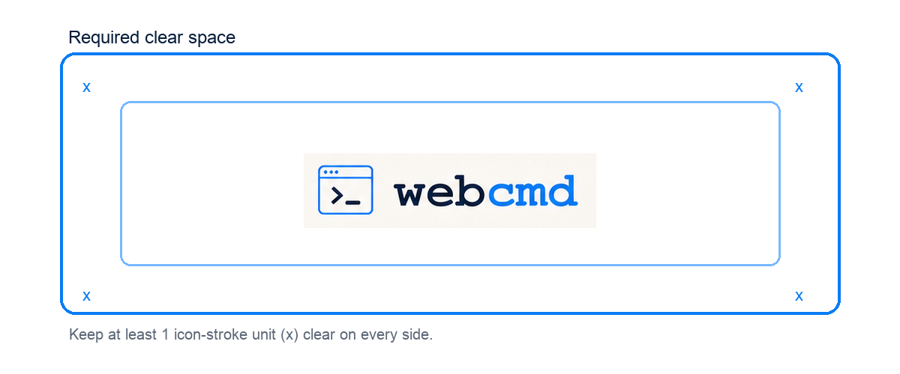
CLEAR SPACE INCLUDES Text, borders, page edges, sponsor marks, QR codes, badges, stamps, illustrations, and interactive controls. Background texture may continue behind the logo only if contrast stays strong.

Minimum size
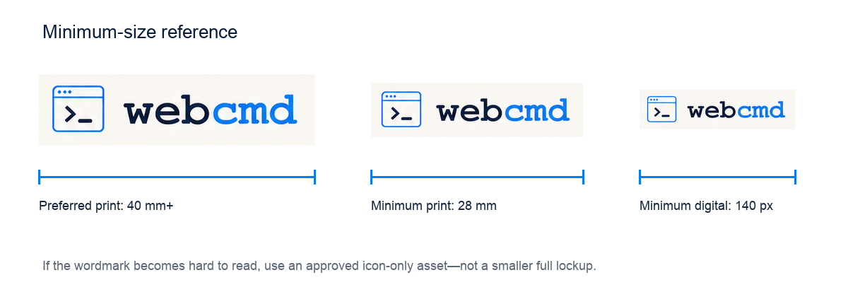
Minimum sizes are guardrails, not targets. Increase the logo size for low-resolution projection, video compression, fabric printing, embossing, or any process that softens fine terminal-icon details.

Recommended size by use
Application | Working minimum | Recommendation
Luma / event cover | 180 px wide | Use 220–320 px when the logo is a host endorsement.
Website header | 140 px wide | Keep full lockup at 160–220 px; test at 100% browser zoom.
Social graphic | 160 px wide | Use 8–12% of the canvas width, respecting clear space.
A4/Letter print | 28 mm wide | Prefer 40–55 mm depending on hierarchy.
Large-format print | Process-dependent | Proof from viewing distance; use a vector master.

03 COLOR AND BACKGROUND
Preserve the two-tone signature and choose backgrounds that make every element immediately legible.

Working color palette
The values below are approximate samples from the supplied raster artwork. Replace them with official production values when Webcmd publishes a canonical brand kit.
Role | HEX | RGB | Use
Webcmd navy | #071D3B | 7, 29, 59 | “web”, prompt glyph, primary text
Command blue | #087CF3 | 8, 124, 243 | “cmd”, icon outline, accents
White | #FFFFFF | 255, 255, 255 | Preferred field or reversed mark
Light blue | #EAF4FF | 234, 244, 255 | Quiet approved background

Background selection
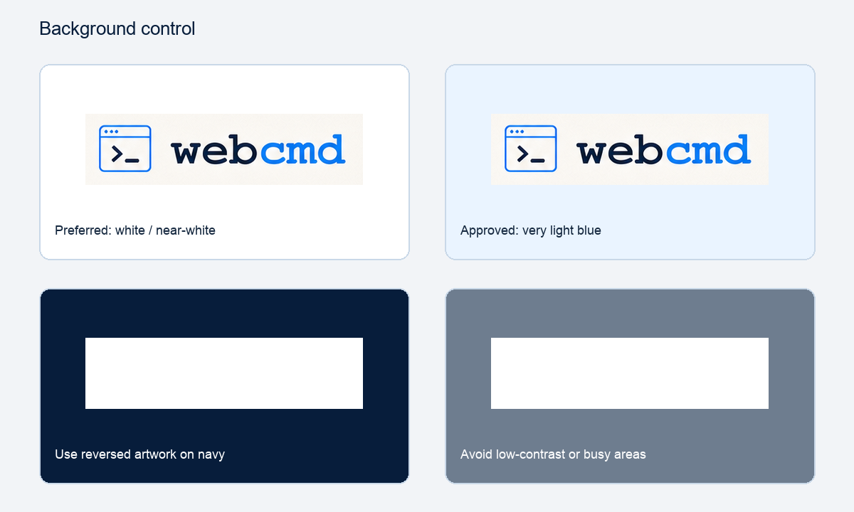
- Preferred: full-color logo on white, warm white, or a very light neutral/blue field.
- Conditional: full-color logo on photography only when placed over a calm, high-contrast area or a subtle light holding field.
- Dark surfaces: use an approved reversed lockup with white wordmark/icon treatment; do not manufacture it by simply applying an effect.
- Avoid: gradients, patterns, and imagery that run through the letterforms or terminal symbol and reduce edge definition.
CONTRAST TARGET For digital interfaces, aim for at least 3:1 contrast between the logo’s least-contrasting essential element and the immediate background. When in doubt, use the preferred light field.

04 EVENT AND PARTNER ASSETS
Webcmd should read as the host or presenting brand while leaving room for the event’s own title, venue, date, and collaborators.

Recommended hierarchy
- Place the Webcmd lockup in a stable endorsement zone: upper-left, upper-center, or a dedicated footer/header band.
- Keep the event title visually dominant when the event—not the company—is the primary message.
- Separate campus edition, city, date, venue, and time into editable fields rather than baking them into the Webcmd logo.
- Group partner/sponsor marks in their own row, aligned by optical height and separated from the Webcmd clear-space area.
- Export a clean master template before adding event-specific details so future organizers do not repeatedly edit flattened artwork.

Luma cover guidance
Recommended | Avoid
Keep the logo inside platform-safe margins. | Do not put the logo beneath Luma UI overlays or crop zones.
Use an editable area for date, city, edition, and venue. | Do not merge a campus name into the Webcmd wordmark.
Review mobile thumbnail legibility. | Do not approve based only on the full-size desktop preview.
Use SVG or high-resolution PNG exports. | Do not upload screenshots or repeatedly recompressed JPEGs.

Co-branding
When another organization is a co-host, do not force both marks into a single new lockup. Place them as separate signatures with equal clear space. Use an understated divider or “in partnership with” line only when the relationship needs explanation.
APPROVAL TRIGGER Request a brand review when a partner wants to recolor the logo, place it inside another badge, combine it with a campus seal, animate its individual letters, or present it as an endorsement of an unrelated product.

05 DIGITAL, SOCIAL, AND MOTION
Design for the actual viewing environment: small screens, platform crops, variable backgrounds, and compressed exports.

Web and product UI
- Use the horizontal lockup in navigation when space permits; use only an approved icon-only file for compact or square contexts.
- Give the logo a meaningful accessible name such as “Webcmd” when it links to the home page. Avoid filenames as alt text.
- Do not place the logo inside buttons unless the action is specifically Webcmd authentication, launch, or navigation.
- Use a crisp SVG for responsive interfaces. Provide PNG fallbacks only where SVG is unsupported.

Social media and video
Context | Placement | Checks
Square feed post | Top-left or bottom-left safe zone | Thumbnail size, platform crop, contrast
Vertical story/reel | Upper safe band, away from handles and captions | Top/bottom UI overlays, motion readability
Video opening card | Centered or endorsement corner | Hold 1.5–2 seconds; avoid busy footage
Video watermark | Use only approved compact asset | Opacity, minimum size, non-interference
Profile/avatar | Use approved icon-only mark | Circle crop, 32 px legibility

Motion principles
If animation is approved, preserve the final master lockup and use restrained motion. A simple fade, terminal cursor blink, or short symbol-to-wordmark reveal is preferable to bouncing, elastic distortion, particle disintegration, or letter-by-letter recoloring.
MOTION ACCESSIBILITY Respect reduced-motion preferences, avoid rapid flashes, and ensure the final static logo remains on screen long enough to recognize.

06 MISUSE AND QUALITY CONTROL
Most logo problems come from rebuilding, squeezing, decorating, or placing the mark too close to competing content.
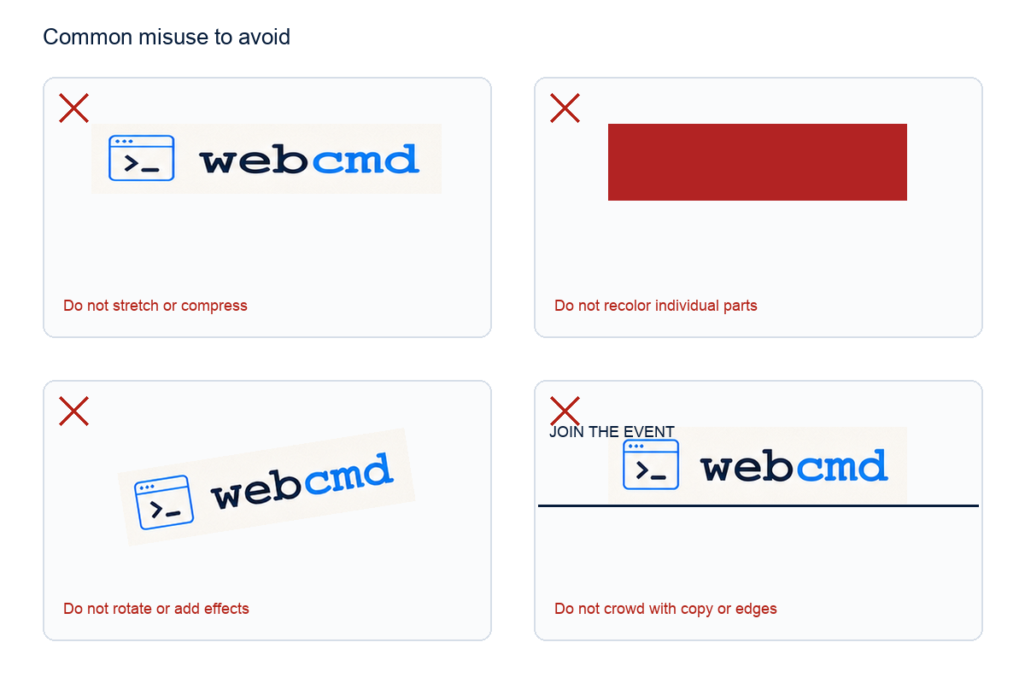

Never alter the master artwork
- Do not retype “webcmd” in a similar font or redraw the terminal symbol.
- Do not stretch, compress, skew, rotate, outline, shadow, glow, bevel, blur, mask, or texture the logo.
- Do not change the navy/blue relationship, recolor individual letters, or use unapproved gradients.
- Do not move the icon, change the gap, stack the icon above the wordmark, or create a vertical lockup without an approved source asset.
- Do not put the logo in a shape, stamp, badge, speech bubble, browser chrome, or partner lockup unless the composition is explicitly approved.
- Do not crop any part of the terminal icon, letterforms, or required clear-space zone.

Fast diagnostic
If the logo feels weak, first increase clear space or improve background contrast. If it feels too dominant, reduce it proportionally or move it to a quieter endorsement zone. Do not solve hierarchy problems by lowering opacity, distorting the lockup, or removing parts of it.
07 FILES, HANDOFF, AND GOVERNANCE
A reliable asset package and approval routine prevent accidental logo drift across decentralized event teams.

Recommended asset package
File | Variant | Primary use | Notes
SVG | Full color | Web, design tools, digital | Preferred master for responsive use.
PDF/EPS | Full color / reversed | Professional print | Preserve vectors and embedded color profile.
PNG | Full color / reversed | Slides, office apps, social | Transparent background; export at 1x and 2x.
Icon SVG/PNG | Approved icon-only | Avatar, favicon, compact UI | Do not crop icon from the full lockup.
README/PDF | Usage guide | Vendors and partners | Include version, owner, and approval route.

File naming
Use descriptive, versioned names such as webcmd-logo-horizontal-fullcolor.svg, webcmd-logo-horizontal-reversed.svg, and webcmd-icon-fullcolor-2x.png. Avoid “final-final”, ambiguous dates, or filenames that omit the variant.

Accessibility and metadata
- Use “Webcmd” as concise alt text when the logo conveys brand identity. Use empty alt text when an adjacent heading already names Webcmd and the logo is purely decorative.
- Keep meaningful text event date, venue, and registration instructions as live text where possible rather than embedding everything in an image.
- For image-only event covers, repeat essential event information in the page title, description, and registration fields.
- Preserve color contrast and do not use color alone to explain status, partnership level, or required actions.

Ownership and exceptions
Assign one brand owner or channel to approve exceptions, distribute master files, and retire outdated exports. Record approved deviations with the asset, date, use case, and approver so one-off treatments do not become accidental standards.
TRADEMARK NOTE This working guide does not define trademark registration, licensing rights, or legal attribution language. Confirm those requirements with the authorized Webcmd brand or legal owner before external commercial use.

08 PRE-PUBLISH CHECKLIST
Use this one-minute review before exporting or sending any asset that includes the Webcmd logo.
- I used an approved logo file not a screenshot, trace, or retyped substitute.
- The lockup proportions, icon/wordmark relationship, and two-tone color treatment are unchanged.
- The logo has at least 1x clear space and is not touching copy, edges, stamps, badges, or partner marks.
- The full lockup is at or above the working minimum size and remains readable in the smallest expected view.
- The background provides strong contrast; the logo does not sit over a busy or low-contrast image area.
- Event title, edition, date, venue, and time remain separate from the Webcmd logo artwork.
- Partner marks are grouped separately and aligned by optical height.
- Mobile crops, social thumbnails, presentation mode, and print proofs have been checked where relevant.
- The correct file format was used: SVG/PDF for vector workflows; PNG for transparent raster use.
- Alt text or surrounding accessible text identifies Webcmd and repeats essential event details.
- Any exception reversed artwork, motion, icon-only use, co-branding, or merchandise—has explicit approval.

Quick decision rule
USE THE SAFEST DEFAULT Full-color horizontal lockup, on white or near-white, at a comfortable size, with generous clear space. If the asset requires anything else, use an approved alternate file or request review.

09 AT-A-GLANCE REFERENCE
A compact final-page card for organizers, partners, and production vendors.
Preferred horizontal lockup from the supplied reference artwork.

Reference summary
Preferred lockup | Horizontal terminal icon + lowercase wordmark
Working colors | Navy #071D3B and blue #087CF3
Clear space | Minimum 1x on every side; 1.5x in dense layouts
Minimum full lockup | 140 px digital / 28 mm print; larger preferred
Preferred background | White, warm white, or very light neutral/blue

PRODUCTION REMINDER Use approved SVG/PDF masters for production, keep event-specific details separate from the logo, and request review for reversed, icon-only, animated, co-branded, or merchandise applications.

