Locana
“Local roots, National network” — Company Profile

About
We convert last-mile human presence into dependable, ethical, verified data — for institutions who need to know what's actually happening on the ground, not just what a dashboard implies.

Vision
Trusted ground truth, everywhere.
To build India's most trusted ethical, hyperlocal field intelligence network — so that ground truth from every corner of the country is heard, verified, and valued by the institutions that rely on it.

Mission
How we get there.
- Build and certify a network of local field professionals across India's states, languages, and terrains.
- Apply rigorous, consent-first, ethically reviewed protocols to every engagement.
- Make field professionals partners in value creation — fair pay, skills, and career progression, not just labor.

Services
Six ways we put ground truth to work — each service line pairs local field capacity with domain-specific rigor, built for clients who need the data to be right, not just fast.
Service | What it covers
Decision Intelligence & Impact Analytics | Baseline, midline, and endline studies and impact evaluations that hold up to donor and government scrutiny.
Vernacular AI Data | Structured, consent-first collection and annotation of voice, image, and text data for India's AI ecosystem.
Geospatial Verification | Independent on-ground ground-truthing of satellite and drone data for climate, agriculture, and environment.
Credit & Risk Data | Field-verified yield assessments and SHG/FPO grading that feed underwriting-grade credit and insurance models.
Digital Inclusion | Community-paced digital adoption support — prototyping, piloting, and handholding through new tools and services.
Capability & Skilling | Recurring, vernacular capacity-building for frontline workers, FPO boards, SHG leaders, and entrepreneurs.

How We Work
Verification-first, not collection-first. Quality isn't a QC step added at the end — it's built into how every engagement is designed.
- Trained, certified teams — every field professional completes ethics, consent, and safeguarding certification before deployment.
- Multi-layer checks — back-checks, spot checks, and supervisor reviews built into the field plan, not added after the fact.
- Geo & timestamp verified — GPS, timestamp, and multimedia validation on every record, for defensible, auditable data.
- Gender-matched fieldwork — interviewer-respondent gender matching wherever it improves data quality and respondent comfort.

Our Network Model
How Locana connects institutional stakeholders to communities through a certified last-mile network — and where we're headed.
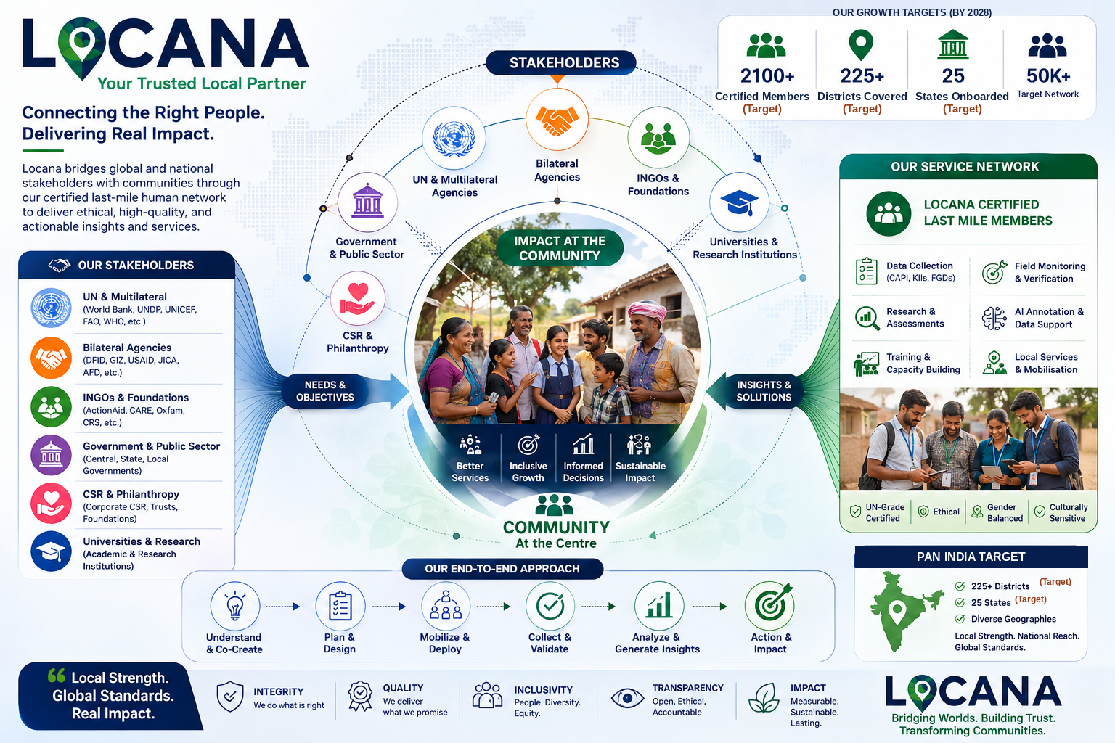
Figures shown are Locana's growth targets, not current achieved numbers.

Membership Plan
Locana's certified field professional network is organized into six tiers, each gating course access, project eligibility, and market day-rate band.
Tier | Enrollment Fee | Courses / Certification | Benefit level | Market rate (₹/day)
Basic | Free | Free orientation: “Introduction to Ethical Field Research” | Entry level, non-verified | 500–700
Economy (Certified) | ₹99 | Self-paced Ethical Research Certification — consent/FPIC, safeguarding, field conduct | Ethics Basics Certified | 700–1,000
Silver | ₹499 | 5-course bundle: Ethics & Consent; Vernacular AI Data Basics; Domain Specialization; CAPI & Digital Field Tools; Community Engagement | Multi-skill field professional | 1,000–1,200
Gold | ₹999 | Everything in Silver, plus Advanced Domain Specialization, Team Leadership & Field Supervision, QC & Back-Check Certification. Carries the flagship CASP credential. | Supervisor level | 1,200–1,500
Diamond | ₹1,499 | Everything in Gold, plus Project Management, Multi-Team Coordination, and Client Account Management modules | Manager level | 1,500–2,000
Platinum (Locana Fellow) | Earned, not purchased | Train-the-Trainer certification; co-design credit on new course content | Promoted from Gold/Diamond via performance and star rating | Top tier + rev-share
Market day-rate bands are indicative field-assignment pay ranges tied to tier — to be validated against actual project economics as the network scales.
Membership fee-credit mechanic: the ₹99/₹499/₹999/₹1,499 fee is credited back against the member's first paid, QC-passed assignment.

