Name: Konark patel

Mobile number: 8849492455

project: mainor

projectname: coldbox

In this project, we are going to solve the [cold box](https://tryhackme.com/room/colddboxeasy) lab. To solve this we are going to follow usual methodologies..

1. Information gathering
2. Scanning and enumeration
3. Exploitation
4. Privilege Escalation
5. User and root flags

## Information gathering

Let's start our Nmap scan using the following command

Nmap -A -T4 <IP Address>

And using this command we got an output that there is only one port is opened in the TCP layer that is HTTP — 80

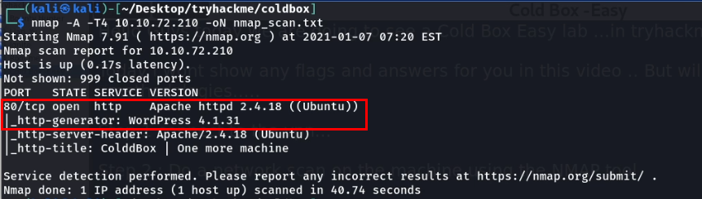

After finding out the http port is opened , I further enumerated and found there is a word press blog is running in this machine

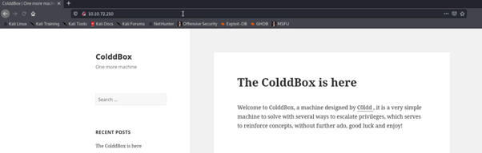

So I checked for the login page for the wp-admin panel and I got a login portal for the WordPress blog

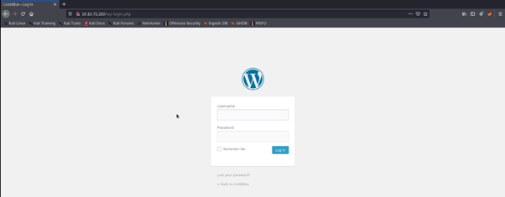

So I checked for the login page for the wp-admin panel and I got a login portal for the WordPress blog



## Scanning and Enumeration

Next I have an idea to enumerate the users credentials, for that we have an wonderful tool called wp-scan, the below command is used for to enumerate the users

wp-scan –url http://IP Address –enumerate u

This command will enumerate all the users in the login portal.

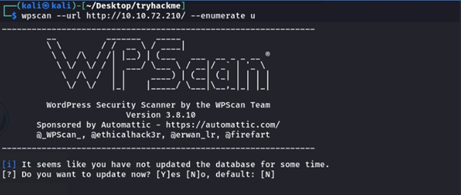

After some time the the scan completed and given a results of 4 valid users

After viewing the results I confirmed that the user is c0ldd because the machine name also cold so having that as a hint I used this username in the login portal and again confirmed the user is valid with the error thrown by the portal

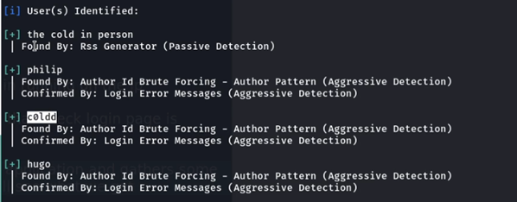

After viewing the results I confirmed that the user is c0ldd because the machine name also cold so having that as a hint I used this username in the login portal and again confirmed the user is valid with the error thrown by the portal

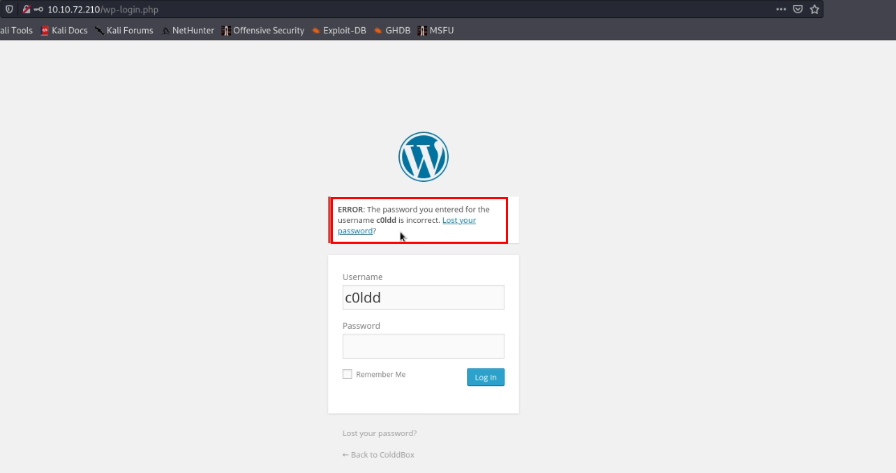

It's great we found the user and now I am going to brute force this login portal with a favorite pass list called rockyou.txt, the tool which I am going to use here is same wp-scan and the below command is used to enumerate the passwords of the mentioned users

wp-scan –url <http://ipaddress/wp-login.php> — passwords <password file > — usernames <username>

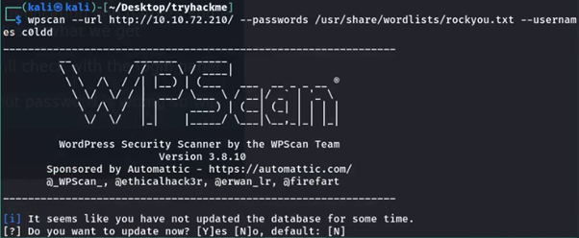

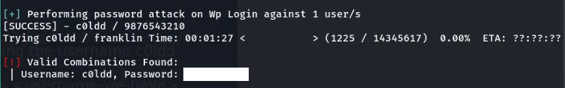

Then using this I logged into the WordPress dashboard

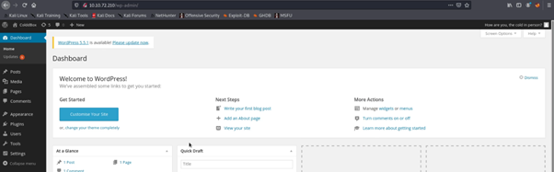

## Exploitation

And in WordPress pentesting we knew that if we can able to change the theme editor code then we can able to get the reverse shell easily so I also did the same just edited the 404.php page with my php reverse shellcode and updated the 404.php page. To know more about the WordPress pentesting visit [hacking articles](https://www.hackingarticles.in/wpscanwordpress-pentesting-framework/) blog

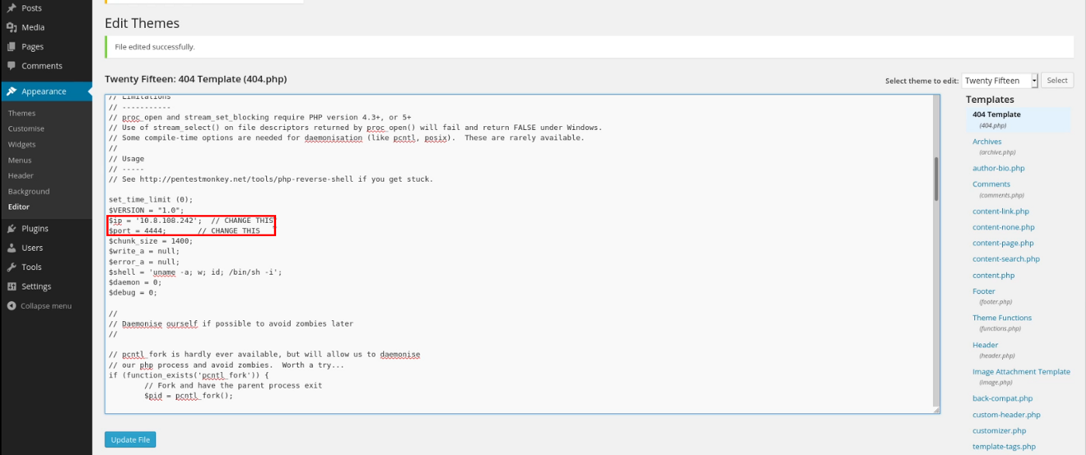

Then after the success update, I started my net cat listener

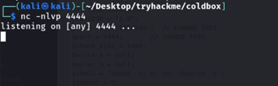

Then I accessed the page in the browser and I got a reverse connection from the webserver

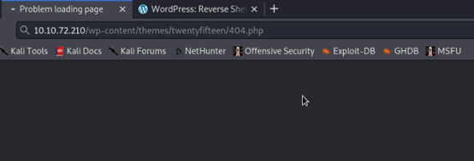

We successfully got a shell of the www-data user

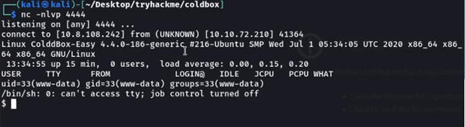

After this step I thought I easily get the user flag but unfortunately I can able to get that because the machine saying that permission is denied for the www-data user

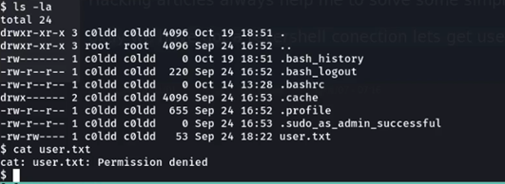

So our next step is to enumerate the internal configuration files and need to get the credentials for any user, so I finalized that this is the WordPress application so it has a wp-config .php file that contains some basic information and sometimes it has hardcoded the password with the file. So I enumerated the file and found a password for the user c0ldd

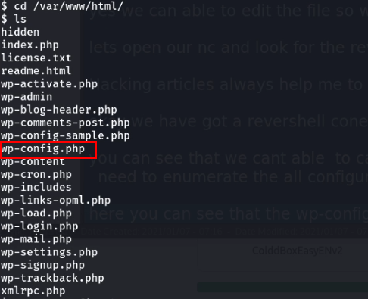

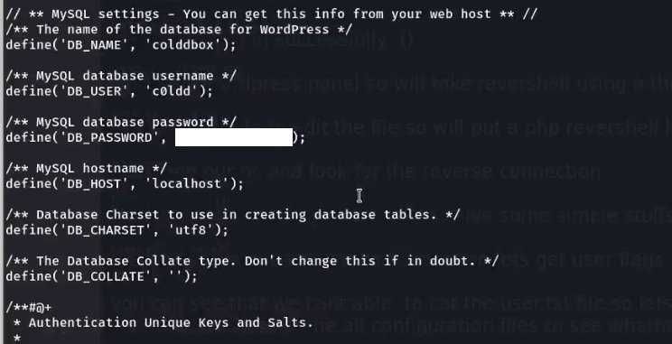

I found the DB credentials so I tried these credentials to switch to the user c0ldd using su command and I successfully logged in as a c0ldd user

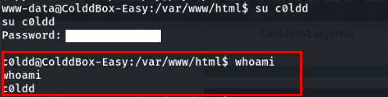

Now we need to get the user flag, but I will not show the user flag here. But you can view the user flag now without any issues

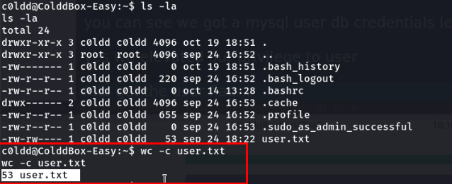

## Privilege Escalation

Now we need to escalate our privilege to root to get the root user flag

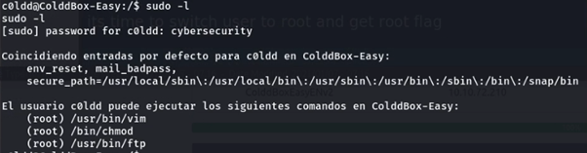

Great we have found that vim is able to run with root permissions, so will go for our favorite website called [GTFOBIN](https://gtfobins.github.io/) and form there I found a command to run vim as sudo root

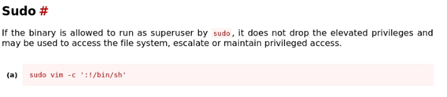

By this command, I escalated as root and got a root flag

