

Kinematic Analysis of ARISTO Robot using RoboAnalyzer

Project-1 Report

Kaamya K

Mentor: Dr. A Gopichand

Robotics | Batch 12

Table of Contents

|  |  |
| --- | --- |
| Page no. | Title |
| 3 | Abstract |
| 3 | Introduction |
| 4 | D-H Parameters |
| 5 | Forward Kinematics |
| 5 | Inverse Kinematics |
| 6 | RoboAnalyzer |
| 6 | Execution |
| 11 | Results |
| 14 | Conclusion |

1. **Abstract**

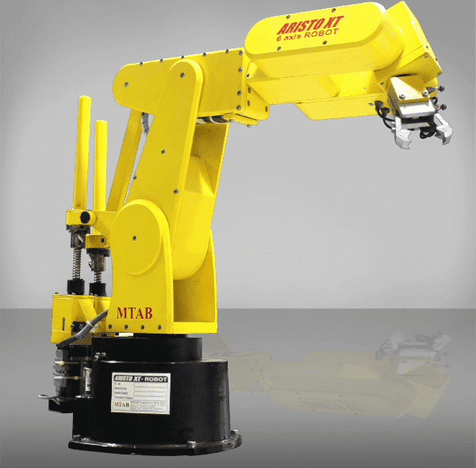A robot is an advanced device which is multifunctional and reprogrammable, designed to move parts, materials, tools, or any specialised devices through variable programmed motions to execute a range of tasks across various sectors.

An ARISTO Robot is a 6-axis articulated robot. Articulated robots are powered by a variety of means and can be used to lift small parts with great accuracy. They are used in various tasks to reduce human efforts – such as painting, welding, and assembly.

Grippers of a manipulators are desired to move in a required fashion to do a specific task. The execution of a particular task requires the manipulator to follow a preplanned path, which is the larger problem of the motion or trajectory planning and motion control for the manipulator.

In present work, forward and inverse kinematics analysis of ARISTO Robot end effector is done for the given inputs using RoboAnalyzer. Further, this project will describe the real-time working space simulation of robotic manipulators. The main advantage of using this software is that simulation tasks can be performed under exact conditions as they are in real time. In this type of robot simulation, point to point control of robot takes place.

1. **Introduction**

The MTAB 6-axis ARISTO Robot is a 6-axis [generally depicted as: X, Y, Z, W, P & R] robotic articulated arm for industrial training and research, and hence is manufactured to industrial standards. The robot can lift around 2-5kg of payload and can be used with pneumatic or electric grippers.

MTAB Aristo Robots are widely use in different applications, like pick-and-place, machine loading and unloading, palletizing and for welding curved paths. Possible different paths include:

1. Point-to-point
2. Linear
3. Circular
4. Interpolation

The robot operates with a power supply of 230V AC, 50/60 Hz and 5A.

1. **DH Parameters**

The Denavit and Hartenberg parameters are used to study and analyse kinematics of robot movements, particularly at their end effectors. This is done by setting up coordinate frames for every joint and establishing a set of transformations that take place from one joint frame to the next (adjacent). The parameters are as follows:

1. *Joint Offset – ‘b’ / ‘d’ (m)*: Length of intersections of common normal on join axis (translation along the Zi-1 axis by di).
2. *Joint Angle – ‘θ’ (∘)*:Angle between orthogonal projections of the common normal to the plane normal to the joint axes (rotation about the Zi-1 axis by *θ* i).
3. *Link Length – ‘a’ (m)*: Measures as distance between common normal to the axis (translation along Xi axis – newly rotated axis).
4. *Twist Angle / Link Twist – ‘α’ (∘)*: Angle between orthogonal projections of the joint axes onto a plane normal to common normal (rotation about the Xi axis by αi).

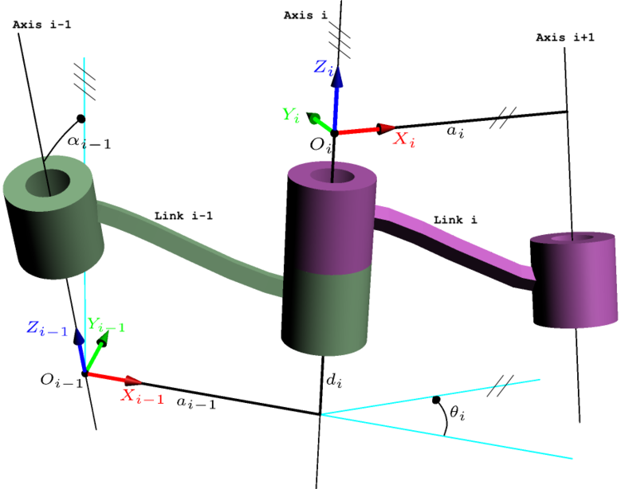

1. **Forward Kinematics**

A manipulator is composed of serial links which are affixed to each other’s revolute or prismatic joints from the base frame through the end effector. Calculating the position and orientation of the end effector in terms of joint variable is called forward kinematics. In order to have forward kinematics for a robot mechanism in a systematic manner, one should use a suitable kinematics model.

Denavit-Hartenberg method that uses the four parameters is the most common method for describing robot kinematics. Using DH parameters, transformation matrix is obtained in order to find the position of the end effector.

1. **Inverse Kinematics**

Inverse kinematics problem of serial manipulators is needed for control of manipulators. Solving inverse kinematics is computationally expensive and generally takes a very long time in the real time control of manipulators. Tasks to be performed by a manipulator are in Cartesian space, whereas actuators work in joint space. Cartesian space orientation matrix and position vectors. However, joint space is represented by joint angles. The conversion of the position and orientation of a manipulator end effector from Cartesian space to joint space is the inverse kinematics problem.

Known parameters include link length and position of end effector, and its orientation. Using these values, it is possible to determine the joint parameters depending upon the joint type (**R**evolute-joint: joint angle and **P**rismatic-joint: joint offset).

1. **RoboAnalyzer**

RoboAnalyzer is a 3D model-based software that can be used to teach and learn the Robotics concepts. It is an evolving product developed in Mechatronics Lab, Department of Mechanical Engineering at IIT Delhi, New Delhi, India.

Mathematics involved in the study of robotics, such as forward and inverse kinematics. is initially difficult to understand, as is conveying the essence of mathematics of robotics. This is due to fact that the forward and inverse kinematics involve 3D transformations among other changing conditions. It is also to be noted that the industrial robots are represented using [Denavit and Hartenberg (DH) parameters](http://www.roboanalyzer.com/uploads/2/5/8/8/2588919/dhparams.pdf)  which are difficult to perceive and visualize in 3D. RoboAnalyzer helps eliminate the above mentioned difficulties.

1. **Execution**

The ARISTO Robot is listed for selection in RoboAnalyzer software under 6-DoF, i.e., 6 degrees of freedom, indicating the number of independent movements that can be performed by the object. Each joint is typically associated with one DoF each. All the joints in the robot are of revolute type (R-joint).

Following are the default / standard DH parameters applied to the robot:

JVi, JVf indicate initial and final values of the variable DH parameter (depending on joint type).

|  |  |  |  |  |  |  |
| --- | --- | --- | --- | --- | --- | --- |
| Joint | (b)/(d)m | (θ)∘ | (a)m | (Α)∘ | JVi | JVf |
| J1 | 0.322 | Variable | 0 | 90 | 0 | 60 |
| J2 | 0 | Variable | 0.3 | 0 | 90 | 60 |
| J3 | 0 | Variable | 0 | 90 | 180 | 150 |
| J4 | -0.375 | Variable | 0 | 90 | -180 | -200 |
| J5 | 0 | Variable | 0 | 90 | -90 | 60 |
| J6 | 0.063 | Variable | 0 | 0 | 0 | 60 |

[DH Parameters may be visualised by selecting the joint and corresponding parameter. The same may also be done from base frame to end effector.]

End Effector configuration is obtained as follows with default values:

Applying forward kinematics (performing FKin operation under Analyses), the curved path generated by the end effector through the motion from initial to final values of DH parameters may be observed. With this motion, the change in DH parameters can be viewed by updating the end effector configuration, as follows:

The change in position of end effector post finalisation of all the variable parameters’ values, can be viewed as follows:

|  |  |
| --- | --- |
|  |  |
|  |  |

Supposing we are aware of the current end effector configuration, joint variables may be derived through inverse kinematics. Applying the Ikin operation, we have the default values coinciding with the initial DH parameter values, and the end effector position as obtained from initial end effector configuration matrix:

|  |  |  |  |  |  |
| --- | --- | --- | --- | --- | --- |
| *Joint* | *(b)/(d)m* | *(a)m* | *(α)∘* | *End Effector’s Position* | |
| *J1* | 0.322 | 0 | 90 | *X(m)* | 0.35 |
| *J2* | 0 | 0.3 | 0 | *Y(m)* | 60 |
| *J3* | 0 | 0 | 90 | *Z(m)* | 150 |
| *J4* | -0.375 | 0 | 90 | *Orientation Matrix* | |
| *J5* | 0 | 0 | 90 |  | |
| *J6* | 0.063 | 0 | 0 |

The input data in this table is replaced with that obtained from the end effector position (through forward kinematics analysis performed previously). Hence, we have the following inputs for end effector position and orientation matrix:

|  |  |
| --- | --- |
| *End Effector’s Position* | *Orientation Matrix* |
| *X(m):* 0.2149  *Y(m):* 0.3350  *Z(m):* 0.2254 |  |

Through the Ikin (Inverse Kinematics) analysis, a total of eight possible solutions may be derived from the RoboAnalyzer software, all of which are listed:

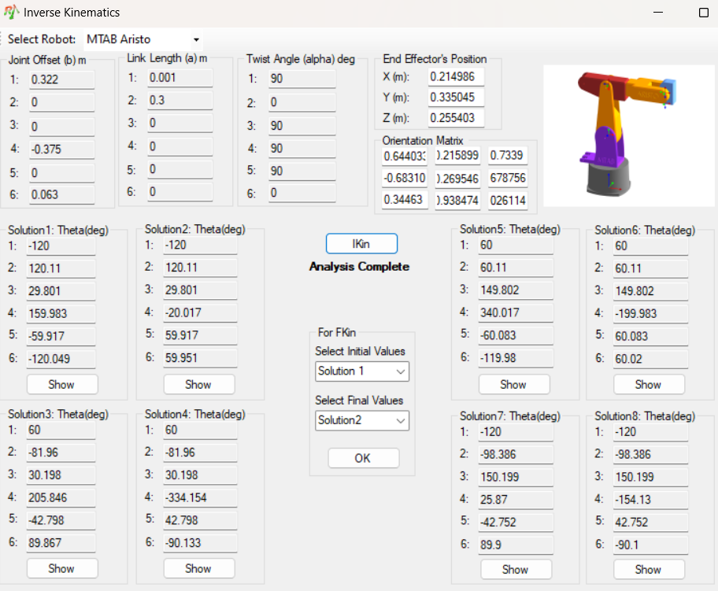

From the given set of solutions, Solution-6 can be observed to be coinciding with, or similar to the final values (JVf) of the variable DH parameter (Joint Angle, θ) of the ARISTO Robot. The same may also be applied to check for the initial values (JVi) through the input of initial end effector configuration and orientation matrix:

|  |  |
| --- | --- |
| *End Effector’s Position* | *Orientation Matrix* |
| *X(m):* 0.375  *Y(m):* 0  *Z(m):* 0.559 |  |

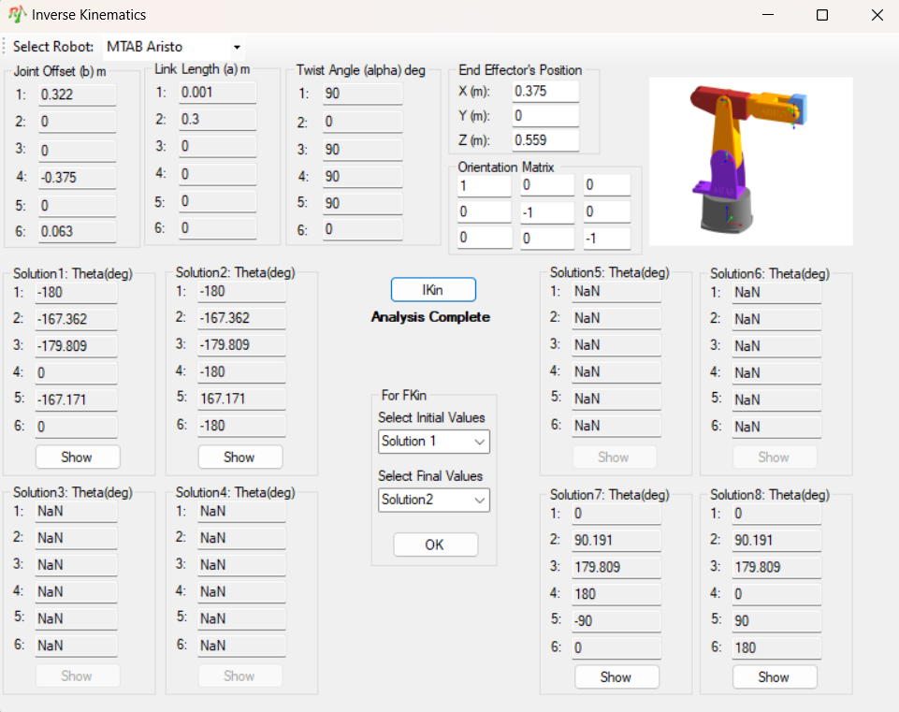

Once again, four possible solutions have been derived through Ikin analysis in RoboAnalyzer, wherein the *absolute* values of Solution-7 can be observed to coincide with, or range to the closer approximations, to the initial values (JVi) of the variable DH parameter (Joint Angle, θ) of the ARISTO Robot.

1. **Results**

Following are the changes obtained in various joints and links of the ARISTO Robot, visualised in form of a graph (upon varying the parameters from initial to final values – Forward Kinematics). Identical values have been obtained for joint parameters during forward and inverse kinematic analyses.

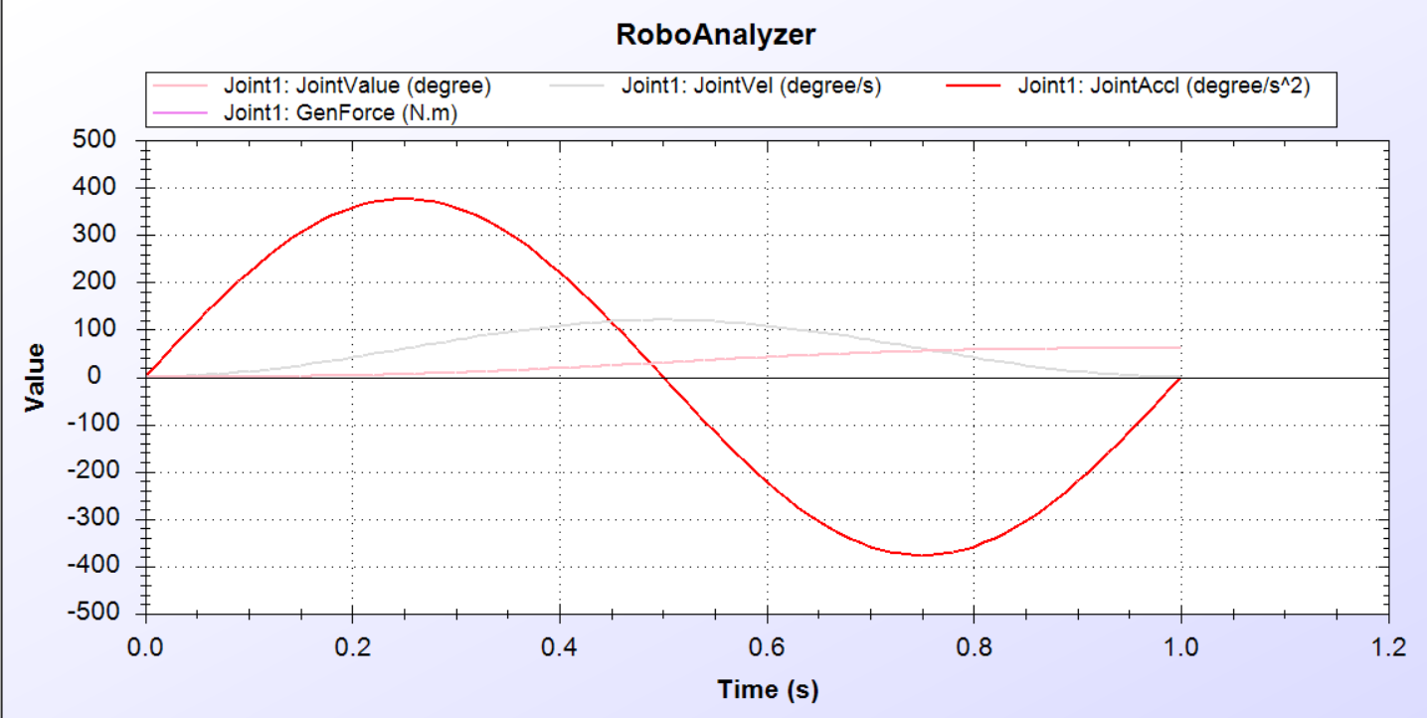

1. **Conclusion**

Forward and inverse kinematics for MTAB ARISTO Robot is determined by using RoboAnalyzer software. The values have been cross-examined and determined to match the corresponding position and orientation of each joint. It is very complicated to find velocity, force, and torque values in theoretical approach. By using RoboAnalyzer, it is easy to find velocity, acceleration graphs and their values’ corresponding links and joints, and simulation of robot end effector arm can be performed. It has proven, through the project, to help in forward and inverse kinematic analyses and their usage in prediction of end effector positioning and joint variables respectively. This MTAB ARISTO robot is suitable for writing, pick and place, palletizing, assembly and welding curved paths.

[End of Document]