

Kinematic Analysis of Stanford Robot using RoboAnalyzer

Project-2 Report

Kaamya K

Mentor: Dr. A Gopichand

Robotics | Batch 12

Table of Contents

|  |  |
| --- | --- |
| Page no. | Title |
| 3 | Abstract |
| 3 | Introduction |
| 4 | D-H Parameters |
| 5 | Forward Kinematics |
| 5 | Inverse Kinematics |
| 5 | RoboAnalyzer |
| 6 | Execution |
| 9 | Results |
| 11 | Conclusion |

1. **Abstract**

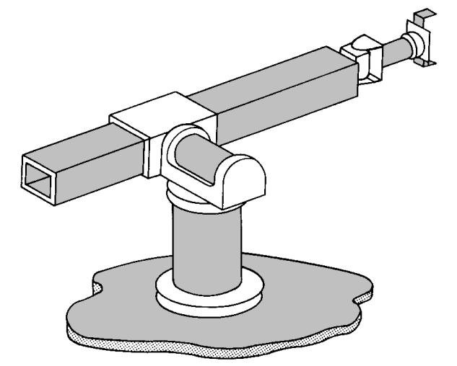A robot is an advanced device which is multifunctional and reprogrammable, designed to move parts, materials, tools, or any specialised devices through variable programmed motions to execute a range of tasks across various sectors.

In this project, the analysis and modelling of 6 joint axes of a Stanford robotic arm – having 3 DoF Spherical arm and wrist respectively has been done to solve its kinematics. Kinematics provides the rational explication of a robotics manipulator. Denavit Hartenberg criterion has been used to solve the kinematics equations. Kinematic analysis is carried out to find out the position and orientation using RoboAnalyzer.

Figure shows that Stanford manipulator consists of a rotation body, an extension arm, wrist and end effector – made of 6 joints (5 R-joints and 1 P-joint). From bottom to top, all 6 kinematics parameters of manipulator’s joints are θ1, θ2, d3, θ4, θ5 and θ6. End effector’s position and altitude is related to the structure of manipulator’s connecting rod and kinematics parameters of manipulator’s joints.

1. **Introduction**

The The Stanford arm is an [industrial robot](https://en.wikipedia.org/wiki/Industrial_robot) with six [degrees of freedom](https://en.wikipedia.org/wiki/Degrees_of_freedom), designed at [Stanford University](https://en.wikipedia.org/wiki/Stanford_University) by [Victor Scheinman](https://en.wikipedia.org/wiki/Victor_Scheinman) in 1969. The Stanford arm is a [serial manipulator](https://en.wikipedia.org/wiki/Serial_manipulator) whose [kinematic chain](https://en.wikipedia.org/wiki/Kinematic_chain) consists of two [revolute joints](https://en.wikipedia.org/wiki/Revolute_joint) at the base, a [prismatic joint](https://en.wikipedia.org/wiki/Prismatic_joint), and a [spherical joint](https://en.wikipedia.org/wiki/Spherical_joint). Because it includes several [kinematic pairs](https://en.wikipedia.org/wiki/Kinematic_pair), it is often used as an educational example in [robot kinematics](https://en.wikipedia.org/wiki/Robot_kinematics).

1. **DH Parameters**

The Denavit and Hartenberg parameters are used to study and analyse kinematics of robot movements, particularly at their end effectors. This is done by setting up coordinate frames for every joint and establishing a set of transformations that take place from one joint frame to the next (adjacent). The parameters are as follows:

1. *Joint Offset – ‘b’ / ‘d’ (m)*: Length of intersections of common normal on join axis (translation along the Zi-1 axis by di).
2. *Joint Angle – ‘θ’ (∘)*:Angle between orthogonal projections of the common normal to the plane normal to the joint axes (rotation about the Zi-1 axis by *θ* i).
3. *Link Length – ‘a’ (m)*: Measures as distance between common normal to the axis (translation along Xi axis – newly rotated axis).
4. *Twist Angle / Link Twist – ‘α’ (∘)*: Angle between orthogonal projections of the joint axes onto a plane normal to common normal (rotation about the Xi axis by αi).

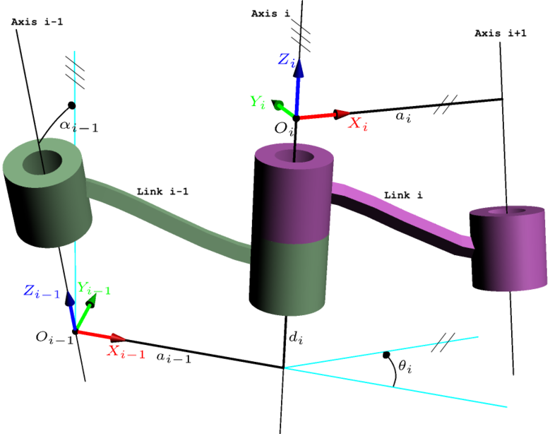

1. **Forward Kinematics**

A manipulator is composed of serial links which are affixed to each other’s revolute or prismatic joints from the base frame through the end effector. Calculating the position and orientation of the end effector in terms of joint variable is called forward kinematics. To have forward kinematics for a robot mechanism in a systematic manner, one should use a suitable kinematics model.

Denavit-Hartenberg method that uses the four parameters is the most common method for describing robot kinematics. Using DH parameters, transformation matrix is obtained in order to find the position of the end effector.

1. **Inverse Kinematics**

Inverse kinematics problem of serial manipulators is needed for control of manipulators. Solving inverse kinematics is computationally expensive and generally takes a very long time in the real time control of manipulators. Tasks to be performed by a manipulator are in Cartesian space, whereas actuators work in joint space. Cartesian space orientation matrix and position vectors. However, joint space is represented by joint angles. The conversion of the position and orientation of a manipulator end effector from Cartesian space to joint space is the inverse kinematics problem.

Known parameters include link length and position of end effector, and its orientation. Using these values, it is possible to determine the joint parameters depending upon the joint type (**R**evolute-joint: joint angle and **P**rismatic-joint: joint offset).

1. **RoboAnalyzer**

RoboAnalyzer is a 3D model-based software that can be used to teach and learn the Robotics concepts. It is an evolving product developed in Mechatronics Lab, Department of Mechanical Engineering at IIT Delhi, New Delhi, India.

Mathematics involved in the study of robotics, such as forward and inverse kinematics. is initially difficult to understand, as is conveying the essence of mathematics of robotics. This is due to fact that the forward and inverse kinematics involve 3D transformations among other changing conditions.

It is also to be noted that the industrial robots are represented using [Denavit and Hartenberg (DH) parameters](http://www.roboanalyzer.com/uploads/2/5/8/8/2588919/dhparams.pdf)  which are difficult to perceive and visualize in 3D. RoboAnalyzer helps eliminate the above mentioned difficulties.

1. **Execution**

The Stanford Robot is listed for selection in RoboAnalyzer software under 6-DoF, i.e., 6 degrees of freedom, indicating the number of independent movements that can be performed by the object. Each joint is typically associated with one DoF each. 5 joints in the robot are of revolute type (R-joint), and 1 of Linear / Prismatic (P-joint).

Following are the default / standard DH parameters applied to the robot:

JVi, JVf indicate initial and final values of the variable DH parameter (depending on joint type).

|  |  |  |  |  |  |  |
| --- | --- | --- | --- | --- | --- | --- |
| Joint | (b)/(d)m | (θ)∘ | (a)m | (Α)∘ | JVi | JVf |
| J1-R | 0.762 | Variable | 0 | -90 | 0 | 60 |
| J2-R | 0.393412 | Variable | 0 | -90 | -90 | -150 |
| J3-P | Variable | -90 | 0 | 0 | 0.635 | 0.735 |
| J4-R | 0.2268 | Variable | 0 | -90 | 0 | 60 |
| J5-R | 0 | Variable | 0 | -90 | 180 | 150 |
| J6-R | 0.4318 | Variable | 0 | 0 | 180 | 150 |

[DH Parameters may be visualised by selecting the joint and corresponding parameter. The same may also be done from base frame to end effector.]

End Effector configuration is obtained as follows with default values:

Applying forward kinematics (performing FKin operation under Analyses), the curved path generated by the end effector through the motion from initial to final values of DH parameters may be observed. With this motion, the change in DH parameters can be viewed by updating the end effector configuration, as follows:

The change in position of end effector post finalisation of all the variable parameters’ values, can be viewed as follows:

|  |  |
| --- | --- |
|  |  |
|  |  |

1. **Results**

Following are the changes obtained in various joints and links of the Stanford Robot, visualised in form of a graph (upon varying the parameters from initial to final values – Forward Kinematics).

1. **Conclusion**

Forward kinematics for Stanford Robot is determined by using RoboAnalyzer software. It is very complicated to find velocity, force, and torque values in theoretical approach. By using RoboAnalyzer, it is easy to find velocity, acceleration graphs and their values’ corresponding links and joints, and simulation of robot end effector arm can be performed. We can find the orientation of Stanford arm using given values and plotting the same in RoboAnalyzer.

[End of Document]