Exercise Artificial Intelligence
Assignment 4

1 Bayesian Nets – Constructing a Net
(A) Draw the best Bayesian network you can think of for this domain. Explain every step in detail (i.e., the variable ordering you chose, why you chose this ordering, why you model each dependency, ...).

According to the assignment text, the system consist of the variables Stressed, Seeds, Experienced, GoodMove, Sailing and Happy. Happy has 3 possible States, all other variables have Boolean values.

The existence of Seeds as well as the Experienced level of the Unicorn depend on no other variable.
The Stressed variable of a unicorn is influenced by the presence of Seeds and the Experienced level of the unicorn.
If the unicorn is Stressed or not influences if the unicorn does a GoodMove.
The probability of going Sailing is influenced by GoodMove.
The Happy(-ness) of the unicorn depends on the Stressed state and if the unicorn goes Sailing.

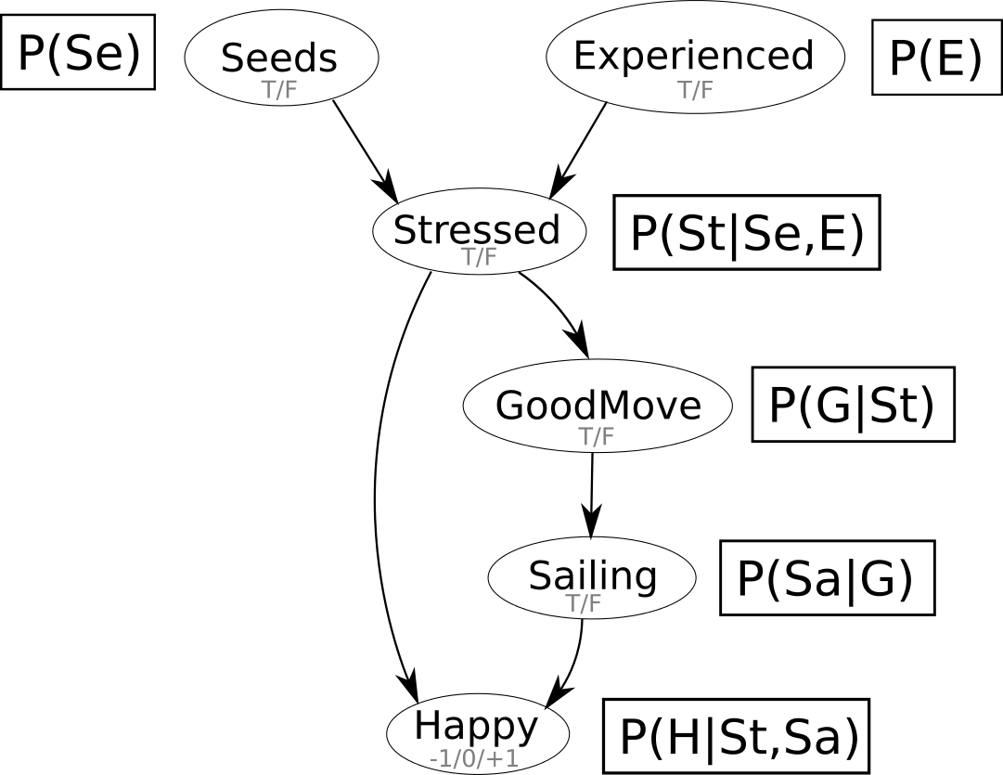
(B) How many independent values are contained in the joint probability distribution, given the nodes from above and assuming that no conditional independence relations are known to hold among them? How many independent values would your network tables contain?

Seeds and Experienced are independent, all other variables depend on those two. The table would contain those two independent variables.

2 Q-Learning
(B) Explain why!
There is only one objective in our scenario (to evaporate the cloud and stay alive), so this is the only action that gets a reward, it doesn't matter how much it is discounted.

(C) Describe the role of γ in the Q-learning algorithm. Can you give an example problem (within the rainbows and unicorns world) for which different values for γ would possibly lead to different solutions?
The discount factor defines the importance of future rewards. Therefore, for the agent, immediate rewards are weighted higher then rewards in the far future. This is important if more than one actions give rewards, and the rewards are not the same for each action.
e.g. an action that makes your fellow unicorn go sailing gives you 100 reward, an action like visiting a fountain gives only 50 reward. The second action can be made before the first, so depending on the discount for future rewards, the agent may decide to visit the fountain, because the discount factor is so low, that the bigger reward for the later action is not worth it, or the agent goes for the “go sailing” action, because the discount factor is so high, that future actions are only slightly penalized. This example assumes, that you have to decide between one action or the other i.e. not both are possible.

