Exercice Artificial Intelligence
Assignment 2

2 Logic
First translate given textual knowledge base to proposition logic:
If the unicorn is magical or goes sailing on rainbows, then it can plant rainbow seeds.
(1) (is_magical ˅ goes_sailing) → plant_rainbow_seeds
If the unicorn is mythical, then it is immortal and goes sailing on rainbows,
(2) is_mythical → (is_immortal ˄ goes_sailing)
but if it is not mythical, then it is just a mortal mammal.
(3) not(is_mythical) → is_mammal
If the unicorn is either immortal or a mammal, then it is horned.
(4) (is_immortal ˅ is_mammal) → is_horned
The unicorn is magical if it is horned.
(5) is_horned → is_magical

Choose backward chaining as inference method, to use backward chaining rule (1) and (4) are split up into:
(1.1) is_magical → plant_rainbow_seeds
(1.2) goes_sailing → plant_rainbow_seeds
(4.1) is_immortal → is_horned
(4.2) is_mammal → is_horned
It seems intuitive that you are allowed to do this, but here is the prove for Rule (1)
(is_magical ˅ goes_sailing) → plant_rainbow_seeds ≡
not(is_magical ˅ goes_sailing) ˅ plant_rainbow_seeds ≡ implication elimination
(not(is_magical) ˄ not(goes_sailing)) ˅ plant_rainbow_seeds ≡ De Morgan
(not(is_magical) ˅ plant_rainbow_seeds) ˄ (not(goes_sailing) ˅ plant_rainbow_seeds) ≡
distributivity of ˅ over ˄
(is_magical → plant_rainbow_seeds) ˄ (goes_sailing → plant_rainbow_seeds)
implication elimination
(A) Can you prove that the unicorn goes sailing on rainbows?
This can not be proven, the only Rule which implies “goes_sailing” is Rule (2), and the Precondition of Rule (2), “is_mythical”, is not implied by any other Rule, therefore it can not be proven, hence “goes_sailing” can also not be proven.
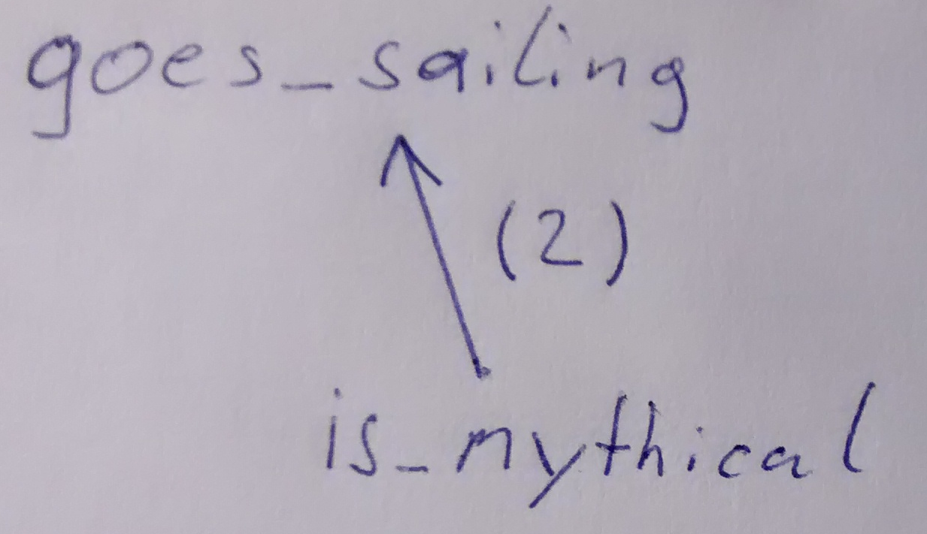

(B) Can you prove that the unicorn can plant rainbow seeds?
Use backward chaining, start with goal “plant_rainbow_seeds”.
“plant_rainbow_seeds” is implied by “is_magical” (Rule 1.1), which is implied by “is_horned” (Rule 5), which is implied by both “is_mammal” (Rule 4.2) and “is_immortal” (Rule 4.1).
“is_mammal” is implied by “not(is_mythical)”, and is_immortal by “is_mystical”, it is easy to see that either “is_mammal” is true, or “is_immortal” is true, hence “is_horned” is true, hence “is_magical” is true, hence “plant_rainbow_seeds” is true.
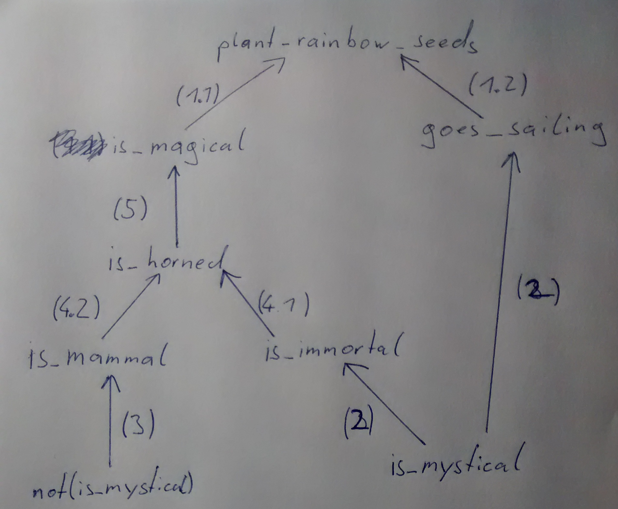

3 Logic and Games
(A) Can you provide a proof that unicorn U can reach the fountain F without going sailing?
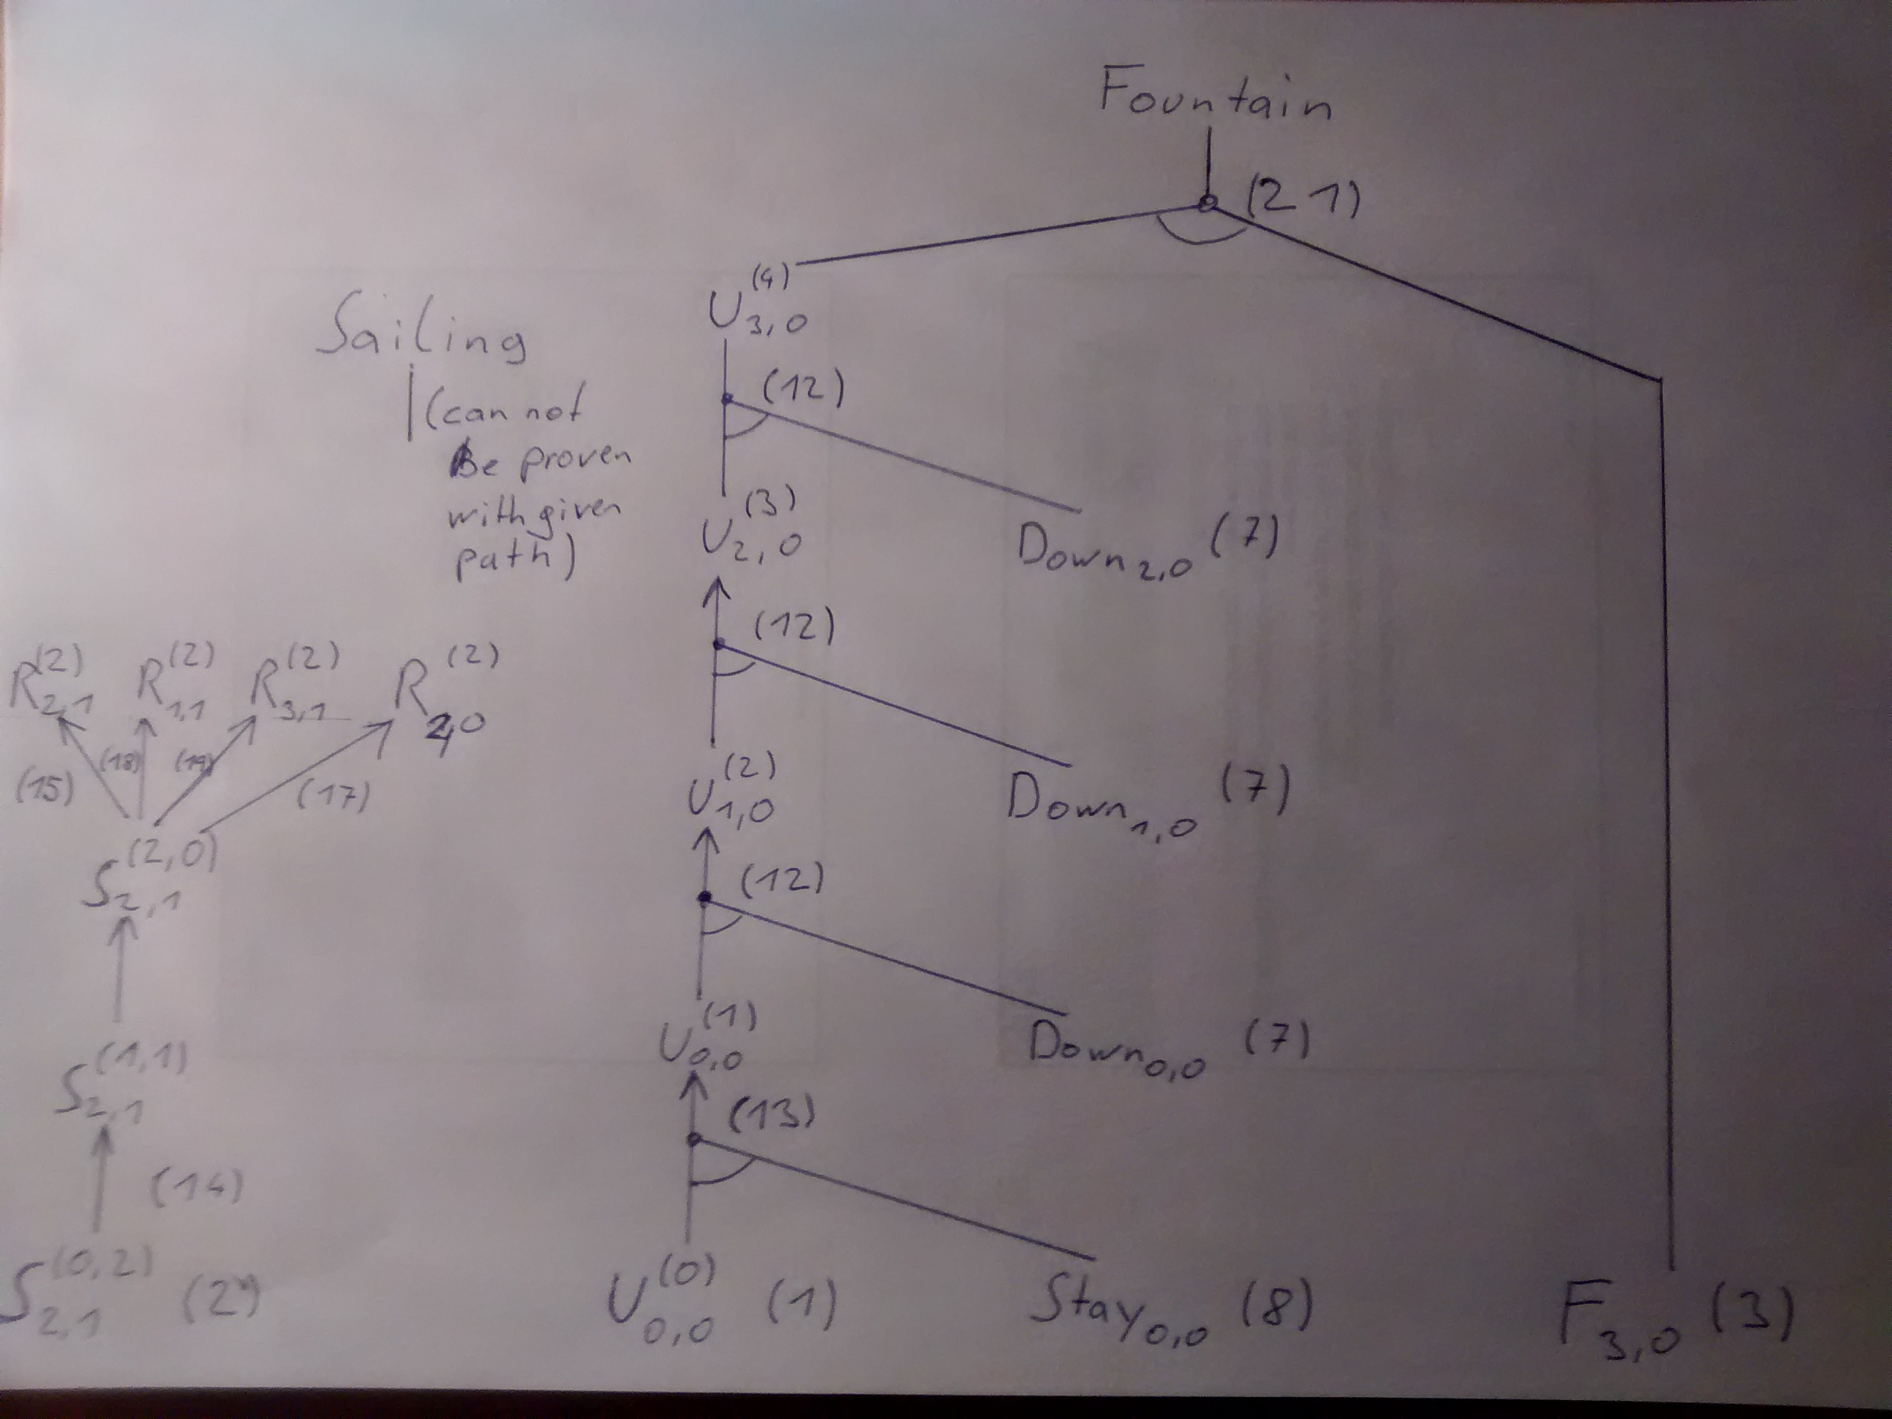
Textual description of the image above:
I used forward chaining as inference Method, as the Rules given are Horn Clauses.
In the bottom row are the relevant (=used for prove) Facts from the knowledge base, starting from these the other Facts are derived.
Description of left column:
S^{(0, 2)}_{2, 1} Rule 2
S^{(1, 1)}_{2, 1} Rule 14
S^{(2, 0)}_{2, 1} Rule 14
R⁽²⁾_{2, 1} Rule 15
R⁽²⁾_{1, 1} Rule 18
R⁽²⁾_{3, 1} Rule 19
R⁽²⁾_{2, 0} Rule 17
Starting with Rule 2 S^{(0,2)}_{2,1}, you can two times apply Rule 14, which decreases the fuse of the seed. When the fuse is zero, you have to apply Rule 15, 17, 18 and 19, which create a rainbow.
Description of middle column:
U⁽⁰⁾_{0, 0} Rule 1
Down_{i, j} Rule 7
Stay_{i, j} Rule 8
U⁽¹⁾_{0, 0} Rule 13
U⁽²⁾_{1, 0} Rule 12
U⁽³⁾_{2, 0} Rule 12
U⁽⁴⁾_{3, 0} Rule 12
Starting with Facts from Rule 1, 7 and 8: U⁽⁰⁾_{0, 0}, Down_{i, j}, Stay_{i, j}. First stay at the same place by applying Rule 13. Then go down to the Fountain by using Rule 12 three times.
Prove Fountain: Fountain can be proven with Rule 21, U^{(t)}_{i, j} ˄ F_{i, j} → Fountain. This can be proven with Fact in Rule 3 F_{3, 0}, and U⁽⁴⁾_{3, 0} (which we derived in the middle column).
Prove that Sailing is false: Because of Rule 22 Sailing ˄ Fountain → false, we must also prove that Sailing is false. With given Path of the Unicorn, Sailing can not be proven, because the only Rule, which proves Sailing is Rule 20 U^{(t)}_{i, j} ˄ R^{(t)}_{i, j}→ Sailing, but the preconditions are not met (look at left column and middle column).

