Rich Text Format Test Document

Normal
Video provides a powerful way to help you prove your point. When you click Online Video, you can paste in the embed code for the video you want to add. You can also type a keyword to search online for the video that best fits your document.

Bold
To make your document look professionally produced, Word provides header, footer, cover page, and text box designs that complement each other. For example, you can add a matching cover page, header, and sidebar. Click Insert and then choose the elements you want from the different galleries.

Italiac
Themes and styles also help keep your document coordinated. When you click Design and choose a new Theme, the pictures, charts, and SmartArt graphics change to match your new theme. When you apply styles, your headings change to match the new theme.

Underline
Save time in Word with new buttons that show up where you need them. To change the way a picture fits in your document, click it and a button for layout options appears next to it. When you work on a table, click where you want to add a row or a column, and then click the plus sign.

Colour
Reading is easier, too, in the new Reading view. You can collapse parts of the document and focus on the text you want. If you need to stop reading before you reach the end, Word remembers where you left off - even on another device.

Highlighting
Video provides a powerful way to help you prove your point. When you click Online Video, you can paste in the embed code for the video you want to add. You can also type a keyword to search online for the video that best fits your document.

Strikeout
To make your document look professionally produced, Word provides header, footer, cover page, and text box designs that complement each other. For example, you can add a matching cover page, header, and sidebar. Click Insert and then choose the elements you want from the different galleries.

Superscript
Themes and styles also help keep your document coordinated. When you click Design and choose a new Theme, the pictures, charts, and SmartArt graphics change to match your new theme. When you apply styles, your headings change to match the new theme.

Subscript
Save time in Word with new buttons that show up where you need them. To change the way a picture fits in your document, click it and a button for layout options appears next to it. When you work on a table, click where you want to add a row or a column, and then click the plus sign.

Centre
Reading is easier, too, in the new Reading view. You can collapse parts of the document and focus on the text you want. If you need to stop reading before you reach the end, Word remembers where you left off - even on another device.

Right
Video provides a powerful way to help you prove your point. When you click Online Video, you can paste in the embed code for the video you want to add. You can also type a keyword to search online for the video that best fits your document.

Justified
To make your document look professionally produced, Word provides header, footer, cover page, and text box designs that complement each other. For example, you can add a matching cover page, header, and sidebar. Click Insert and then choose the elements you want from the different galleries.

Fill
Themes and styles also help keep your document coordinated. When you click Design and choose a new Theme, the pictures, charts, and SmartArt graphics change to match your new theme. When you apply styles, your headings change to match the new theme.

Large
Save time in Word with new buttons that show up where you need them. To change the way a picture fits in your document, click it and a button for layout options appears next to it. When you work on a table, click where you want to add a row or a column, and then click the plus sign.

Small
Reading is easier, too, in the new Reading view. You can collapse parts of the document and focus on the text you want. If you need to stop reading before you reach the end, Word remembers where you left off - even on another device.

Bullets
- Videos provides a powerful way to help you prove your point.
- When you click Online Video, you can paste in the embed code for the video you want to add.
- You can also type a keyword to search online for the video that best fits your document.

Numbered
- To make your document look professionally produced, Word provides header, footer, cover page, and text box designs that complement each other.
- For example, you can add a matching cover page, header, and sidebar.
- Click Insert and then choose the elements you want from the different galleries.

Multilevel
- Themes and styles also help keep your document coordinated.
  - When you click Design and choose a new Theme, the pictures, charts, and SmartArt graphics change to match your new theme.
    - When you apply styles, your headings change to match the new theme.

Indented
Save time in Word with new buttons that show up where you need them. To change the way a picture fits in your document, click it and a button for layout options appears next to it. When you work on a table, click where you want to add a row or a column, and then click the plus sign.

Border
Reading is easier, too, in the new Reading view. You can collapse parts of the document and focus on the text you want. If you need to stop reading before you reach the end, Word remembers where you left off - even on another device.

Heading 1

Video provides a powerful way to help you prove your point. When you click Online Video, you can paste in the embed code for the video you want to add. You can also type a keyword to search online for the video that best fits your document.

Heading 2

To make your document look professionally produced, Word provides header, footer, cover page, and text box designs that complement each other. For example, you can add a matching cover page, header, and sidebar. Click Insert and then choose the elements you want from the different galleries.

Title

Themes and styles also help keep your document coordinated. When you click Design and choose a new Theme, the pictures, charts, and SmartArt graphics change to match your new theme. When you apply styles, your headings change to match the new theme.

Table
Save time in Word with new buttons that show up where you need them. To change the way a picture fits in your document | click it and a button for layout options appears next to it. When you work on a table | click where you want to add a row or a column | and then click the plus sign.

Chart

Picture
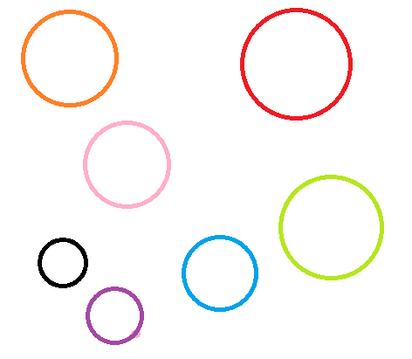

Image With Text Wrapping
Video provides a powerful way to help you prove your point. When you click Online Video, you can paste in the embed code for the video you want to add. You can also type a keyword to search online for the video that best fits your document.

Image Behind Text
To make your document look professionally produced, Word provides header, footer, cover page, and text box designs that complement each other. For example, you can add a matching cover page, header, and sidebar. Click Insert and then choose the elements you want from the different galleries.

Image In Front Of Text
Themes and styles also help keep your document coordinated. When you click Design and choose a new Theme, the pictures, charts, and SmartArt graphics change to match your new theme. When you apply styles, your headings change to match the new theme.

Rotated Image

Bookmark
Save time in Word with new buttons that show up where you need them. To change the way a picture fits in your document, click it and a button for layout options appears next to it. When you work on a table, click where you want to add a row or a column, and then click the plus sign.

Link
Reading is easier, too, in the new Reading view. You can collapse parts of the document and focus on the text you want. If you need to stop reading before you reach the end, Word remembers where you left off - even on another device.

