**Department of Computer Science**

**National University of Computer & Emerging Sciences**

Supervisor

Sir Muhammad Shahzad

Volunteer Organizer with Management Entity (VowMe)

Jibran Tariq

ROLL #: 14K-3408

Table Contents

1 Motivation 3

2 Overview 3

2.1 Significance of the project 3

2.2 Description of the project 3

2.3 Background of the project 3

3 Related Work 4

4 Proposed System Architecture 4

5 Methodology 5

5.1 Features 5

6 Design Artifacts 6

7 Project Timeline Milestone 7

8 System Architecture 9

9 Code Repository 10

10 Screen Shot of Website 10

10.1 Dashboard 10

10.2 User Profile 11

10.3 Volunteer List 11

10.4 Cause List 12

10.5 Volunteer Profile 12

10.6 Notification 13

10.7 Report 13

Distribution List

|  |  |  |
| --- | --- | --- |
| ***Name*** | ***Role*** | |
| Mr. Muhammad Shahzad | | Supervisor |
|  | | Co- Supervisor |

Sign-Off

|  |  |
| --- | --- |
| ***Sign-off Authority*** | ***Sign-off Date*** |
| Mr. Muhammad Shahzad | Signature |
|  |  |

# Motivation

People like to bring a positive change to the society, and they do that by volunteering for various projects and causes. For some, the act offers a chance to give something back to the community or make a difference to the lives of people around them – for others, it provides an opportunity to develop new skills or gain experience or knowledge that they didn’t have before.

It is important for us to encourage, support and engage people into voluntary activities. The support shouldn’t just be there because it’s for good causes but it is another step towards a better society as a whole. People who have a purpose outside of their everyday working role are more motivated, healthier and happier. So, volunteering for good causes is a great act whichever way you look at it.

# Overview

The idea of this project revolves around finding registered volunteer campaigns and minimizing the hurdles in the ways of volunteers by providing them a channel to communicate and easily join hands for the purpose.

## Significance of the project

This project will allow volunteers to join campaigns easily within their area without facing any hurdles and join other volunteers by providing well organized channel to communicate. On another side, organizer can manage campaigns easier by monitoring volunteer’s activities.

## Description of the project

This project will provide a way for volunteers to find registered volunteer campaign within their area, communicate more easily with other volunteers who are registered within same volunteer campaign. It will record/track volunteer hours of volunteers and will allow volunteers to provide feedback about campaigns and peers. Also, the application will provide a way for organizers to create the volunteer campaign, maintains volunteer’s basic information and send notifications related to campaign.

## Background of the project

There is almost no local application to encourage people to get enroll into volunteer campaign near to their area. There are few groups like **TCF** [1]**, Cup of Kindness** [2]**, Robinhood Army** [3] which are doing campaigns without having well organized platform. However, they are facing hurdles to broadcast their cause and engage people to get enroll into campaign. Some people face obstacles when trying to join various campaigns and have a hard time finding registered campaigns for volunteering.

# Related Work

There are some international volunteer applications which are providing some features of project but there is no local applications. **GoVolunteer** [4] and **VolunteerMe** [5] are examples of International volunteer applications which are restricted in local.

# Proposed System Architecture

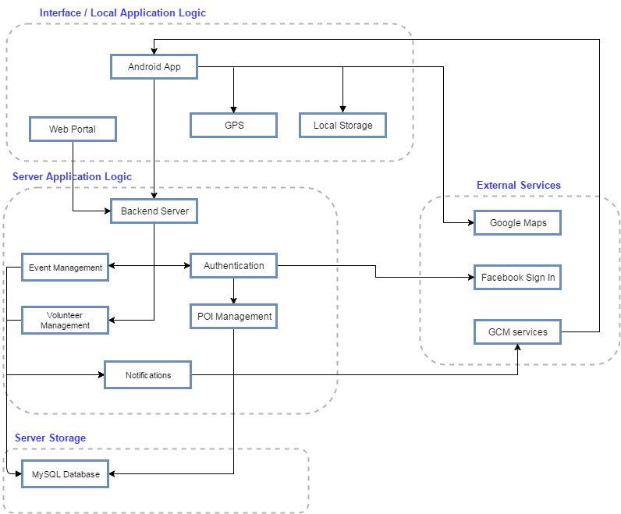

# Methodology

The project is based on mobile as well as web application, which will develop to work on the Android platform and Server-side language.

The mobile interface will starts from the register page where volunteer must provide basic details or can allow fetch information from 3rd party application like Facebook. After registration, system track volunteer’s location and on the basis of location, system redirects to screen where list of registered campaign will be shown with characteristics like durations, location and short description and title of campaign. Complete details with register button should display when volunteer touches on the specific campaign. Volunteer can register into campaign by providing express interest on the specific campaign. System must generate notification to organizer. System will notify registered volunteer when new volunteer will get enroll in same campaign. Volunteer can send joining invitation request to peer volunteer with 120 characters note. Volunteer can accept or reject invitation request. System should provide details of peer volunteer to another volunteer when invitation request is accepted. Volunteer can provide feedback about campaign and volunteer for future actions.

The web application must utilize for creating campaigns, approval volunteer into campaign and monitor volunteer’s activities like invitation request to other volunteer.

Organizer can change details of campaigns and invites peoples for campaigns.

## Features

Following are important features of the VowMe.

* **Provide location based Campaigns.**

System will provide campaigns on the basis of volunteer’s location within range of 100 miles.

* **Notification of new registered volunteers.**

System will notify registered volunteers about new comers in campaigns.

* **Link peer volunteer within campaigns.**

Volunteer will able to send notification to another volunteer after registration in campaigns.

* **Follow up on campaigns.**

Organizer will monitor and send notification to volunteers about the activities and ask feedback on activities

* **Feedback about volunteers and campaigns.**

Volunteers will allow to provide feedback on activity ofcampaigns as well as about co-volunteers.

* **Send invitations to peoples.**

Organizer will able to send invitations to people via emails.

* **Track Volunteer Hour**

Volunteers will able to track/manage volunteer hours to show their company.

# Design Artifacts

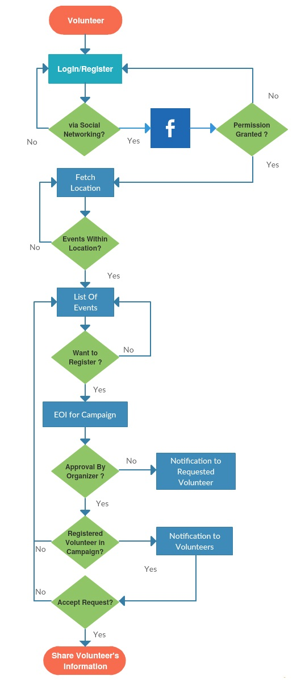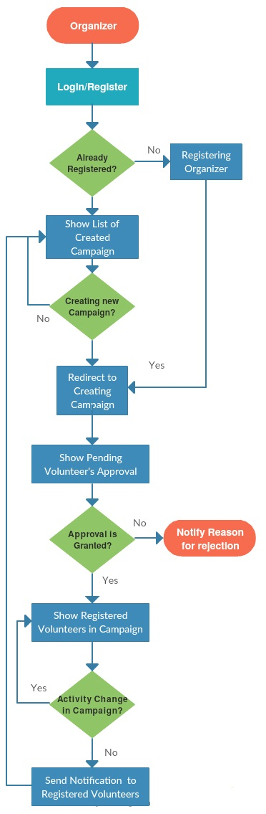

# Project Timeline Milestone

|  |  |  |  |  |
| --- | --- | --- | --- | --- |
| Task Name | Duration | Start | Finish | Predecessors |
| **Volunteer Organizer with Management Entity (VowMe)** | **164 days** | **Thu 2/16/17** | **Tue 10/3/17** |  |
| **Project 1 Deliverables** | **78 days** | **Thu 2/16/17** | **Mon 6/5/17** |  |
| **Documentation For VowMe** | **43 days** | **Thu 2/16/17** | **Mon 4/17/17** |  |
| Research And Development | 3 days | Thu 2/16/17 | Mon 2/20/17 |  |
| Proposal Submission | 2 days | Fri 2/24/17 | Mon 2/27/17 | 4 |
| Proposal Defense | 1 day | Tue 2/28/17 | Tue 2/28/17 | 5 |
| Requirement Gathering | 10 days | Wed 3/1/17 | Tue 3/14/17 | 6 |
| Analysis | 5 days | Wed 3/15/17 | Tue 3/21/17 | 7 |
| FS Document | 10 days | Wed 3/22/17 | Tue 4/4/17 | 8 |
| Design Document | 3 days | Wed 4/5/17 | Fri 4/7/17 | 9 |
| FS Document Review Internal | 2 days | Mon 4/10/17 | Tue 4/11/17 | 10 |
| Design Document Review | 2 days | Wed 4/12/17 | Thu 4/13/17 | 11 |
| Design & FS Co-ordination to Stakeholders | 2 days | Fri 4/14/17 | Mon 4/17/17 | 12 |
| **Development Business Objectives** | **23 days** | **Tue 4/18/17** | **Thu 5/18/17** |  |
| Task (Design review, Code impact analysis) | 2 days | Tue 4/18/17 | Wed 4/19/17 | 13 |
| Development Task For Architecture Design | 10 days | Thu 4/20/17 | Wed 5/3/17 | 15 |
| Development Task For Backend Design | 3 days | Thu 5/4/17 | Mon 5/8/17 | 16 |
| Development Task For Layout Design | 3 days | Tue 5/9/17 | Thu 5/11/17 | 17 |
| Development Task For Integration design | 3 days | Fri 5/12/17 | Tue 5/16/17 | 18 |
| Integration and Unit Test | 2 days | Wed 5/17/17 | Thu 5/18/17 | 19 |
| Code Review & Code Regression | 2 days | Fri 5/12/17 | Mon 5/15/17 | 18 |
| Testing | 1 day | Tue 5/16/17 | Tue 5/16/17 | 21 |
| **Development Interfacing For web application** | **14 days** | **Wed 5/17/17** | **Mon 6/5/17** |  |
| Task (Design review) | 2 days | Wed 5/17/17 | Thu 5/18/17 | 22 |
| Development Task Interfacing | 5 days | Fri 5/19/17 | Thu 5/25/17 | 24 |
| Integration and Unit Test | 2 days | Fri 5/26/17 | Mon 5/29/17 | 25 |
| Code Review & Code Regression | 2 days | Tue 5/30/17 | Wed 5/31/17 | 26 |
| Testing | 3 days | Thu 6/1/17 | Mon 6/5/17 | 27 |
| Semster Gap | 7 days | Tue 6/6/17 | Wed 6/14/17 | 28 |
| **Project 2 Deliverables** | **80 days** | **Wed 6/14/17** | **Tue 10/3/17** |  |
| **Designing and Requirement For Mobile Interfacing** | **49 days** | **Wed 6/14/17** | **Mon 8/21/17** |  |
| Brain Storming | 10 days | Wed 6/14/17 | Tue 6/27/17 |  |
| Progress Report Creation | 4 days | Wed 6/28/17 | Mon 7/3/17 | 32 |
| Progress Report Review and Meetings | 2 days | Tue 7/4/17 | Wed 7/5/17 | 33 |
| User Manual Documentation Requirements | 5 days | Thu 7/6/17 | Wed 7/12/17 | 34 |
| Analysis | 5 days | Thu 7/13/17 | Wed 7/19/17 | 35 |
| FS Document | 5 days | Thu 7/20/17 | Wed 7/26/17 | 36 |
| Design Document | 5 days | Thu 7/27/17 | Wed 8/2/17 | 37 |
| FS Document Review Internal | 3 days | Thu 8/3/17 | Mon 8/7/17 | 38 |
| Design Document Review | 3 days | Tue 8/8/17 | Thu 8/10/17 | 39 |
| Design & FS Co-ordination to Stakeholders | 4 days | Fri 8/11/17 | Wed 8/16/17 | 40 |
| Brain Storming | 3 days | Thu 8/17/17 | Mon 8/21/17 | 41 |
| **Development BO** | **21 days** | **Tue 8/22/17** | **Tue 9/19/17** |  |
| Lead Task (Design review, Code impact analysis) | 1 day | Tue 8/22/17 | Tue 8/22/17 | 42 |
| Development Task For Architecture Design | 5 days | Wed 8/23/17 | Tue 8/29/17 | 44 |
| Development Task For Layout Design | 4 days | Wed 8/30/17 | Mon 9/4/17 | 45 |
| Development Task For Backend Design | 5 days | Tue 9/5/17 | Mon 9/11/17 | 46 |
| Development Task For Integration design | 3 days | Tue 9/12/17 | Thu 9/14/17 | 47 |
| Code Review & Code Regression | 3 days | Fri 9/15/17 | Tue 9/19/17 | 48 |
| Integration and Unit Test | 3 days | Tue 9/12/17 | Thu 9/14/17 | 47 |
| **Development Interfacing For Mobile Application** | **13 days** | **Fri 9/15/17** | **Tue 10/3/17** |  |
| Task (Design review) | 4 days | Fri 9/15/17 | Wed 9/20/17 | 50 |
| Development Task Interfacing | 5 days | Thu 9/21/17 | Wed 9/27/17 | 52 |
| Integration and Unit Test | 4 days | Thu 9/28/17 | Tue 10/3/17 | 53 |
| Code Review & Code Regression | 3 days | Thu 9/21/17 | Mon 9/25/17 | 52 |
| Testing | 3 days | Tue 9/26/17 | Thu 9/28/17 | 55 |
| Project completion | 1 day | Fri 9/29/17 | Fri 9/29/17 | 56 |

Green means completed. Rest is in progress.

# System Architecture

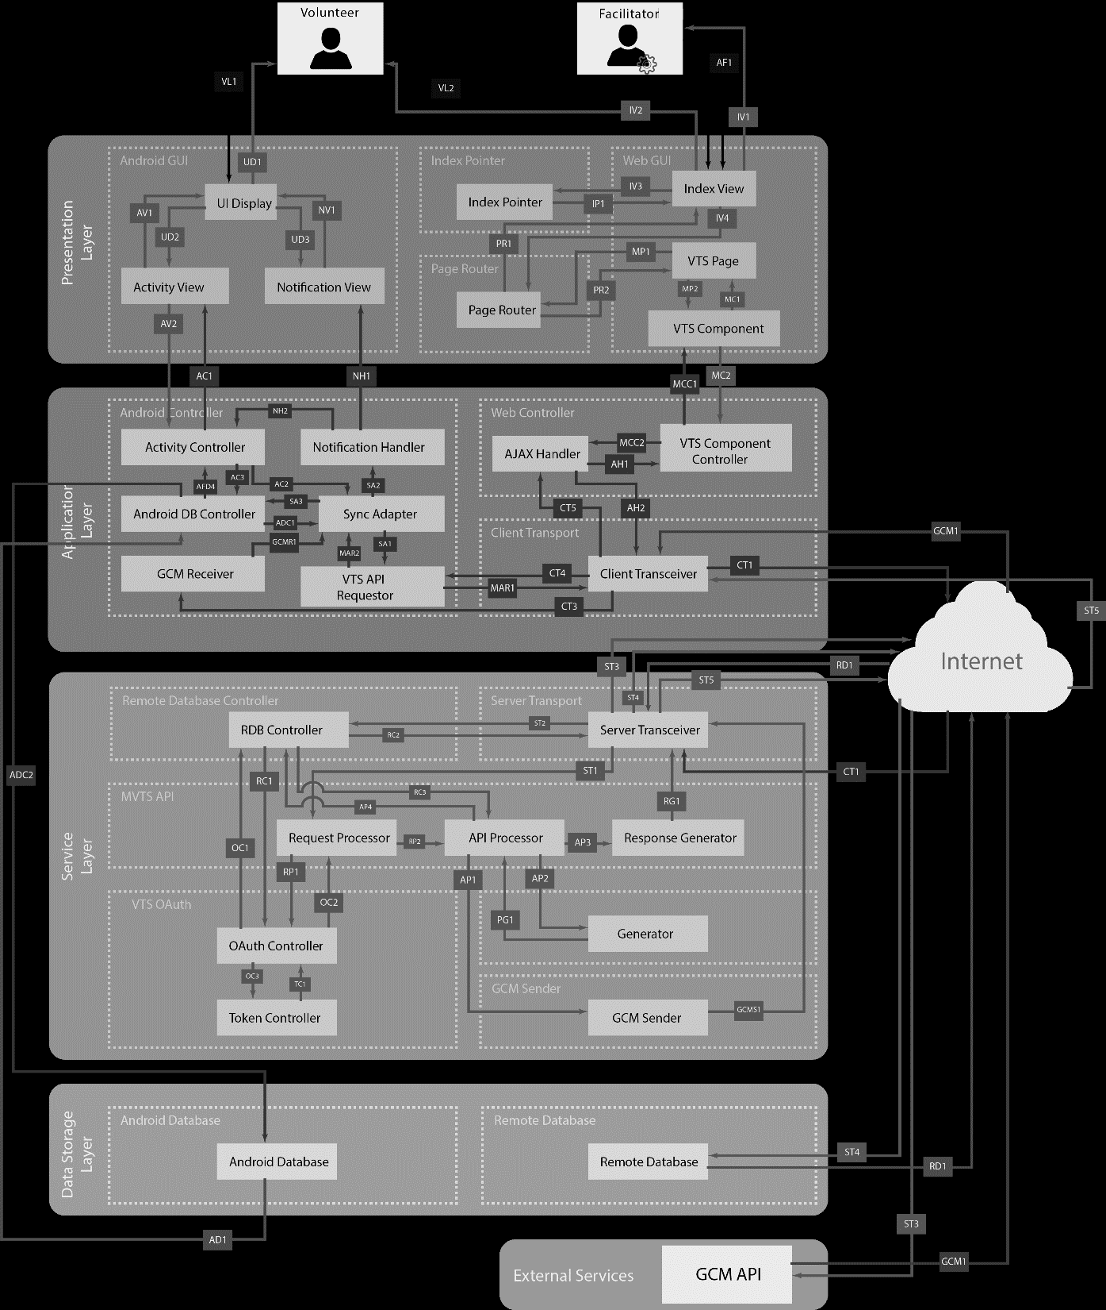

# Code Repository

The code is replaced at <https://github.com/k143408/vowme>

# Screen Shot of Website

## Dashboard

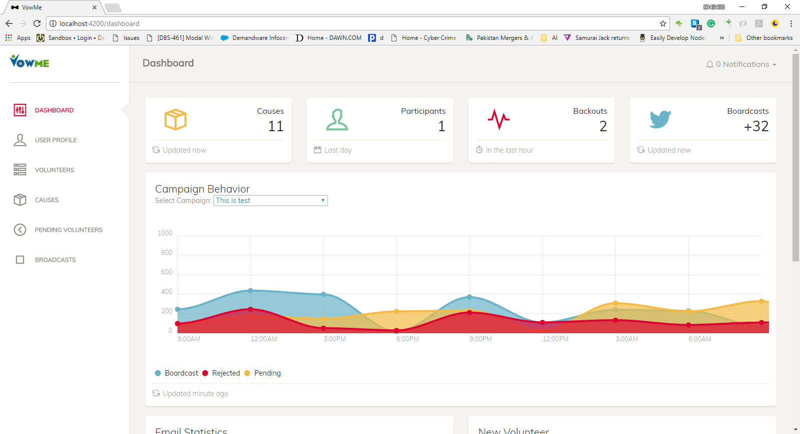

## User Profile

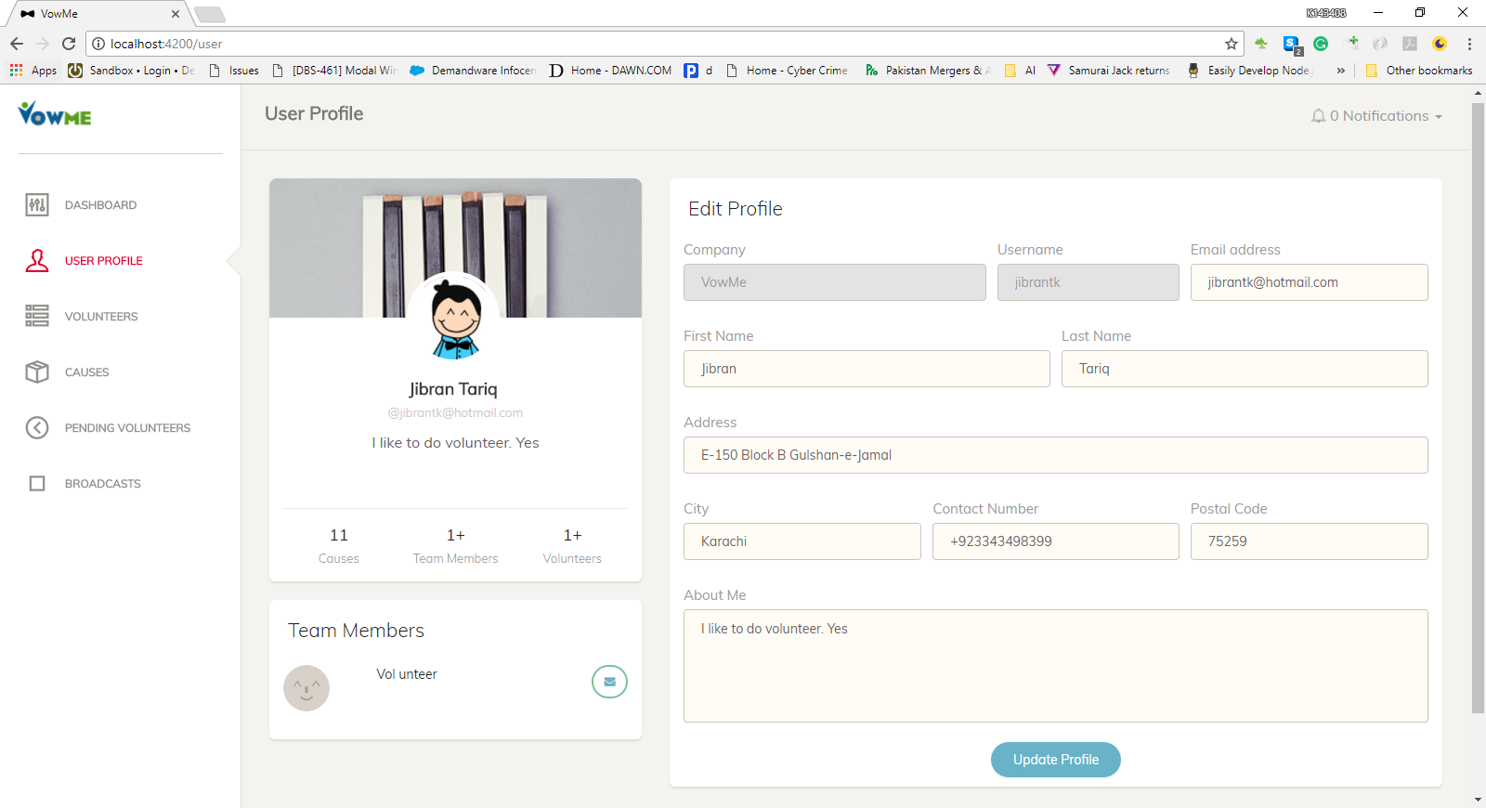

## Volunteer List

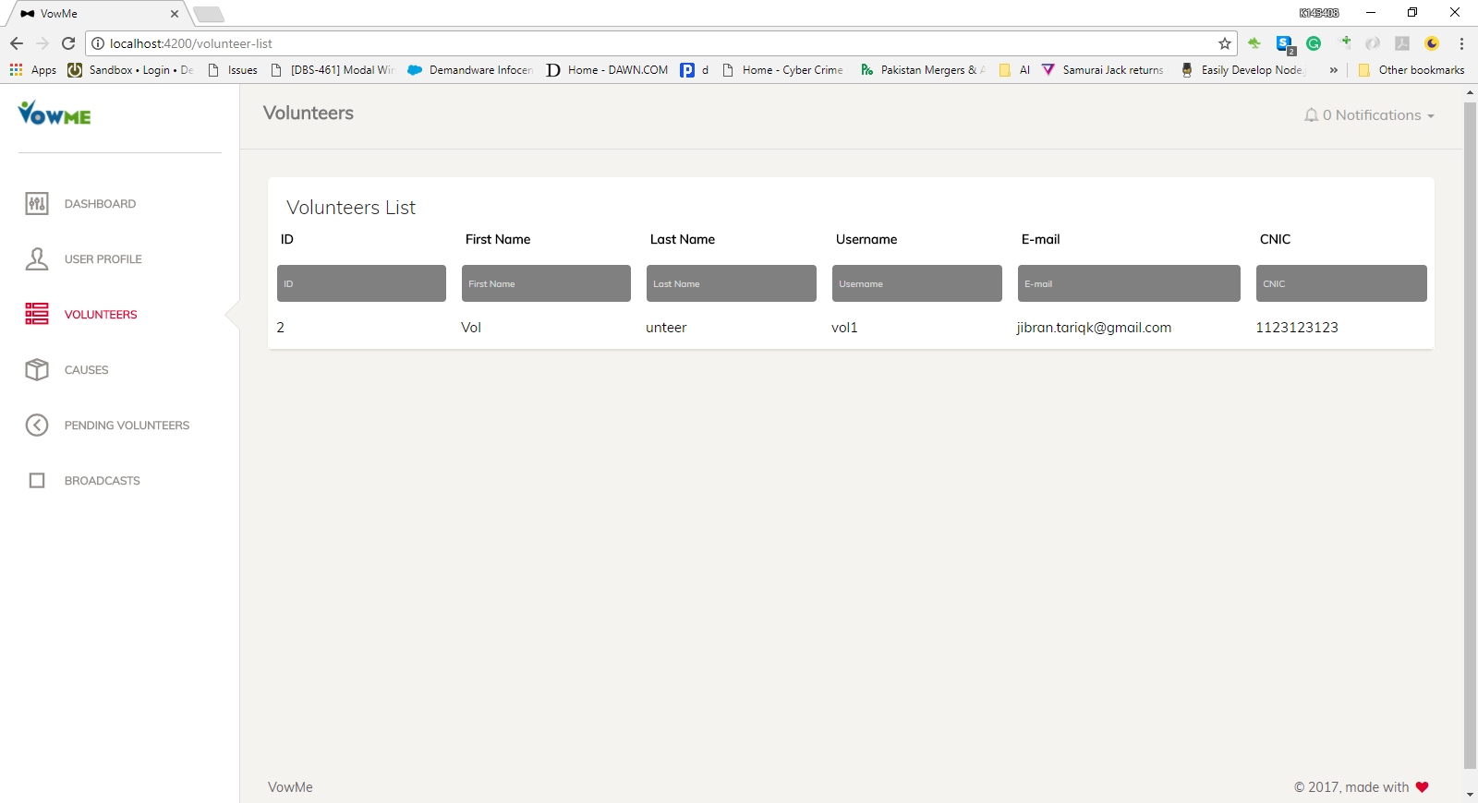

## Cause List

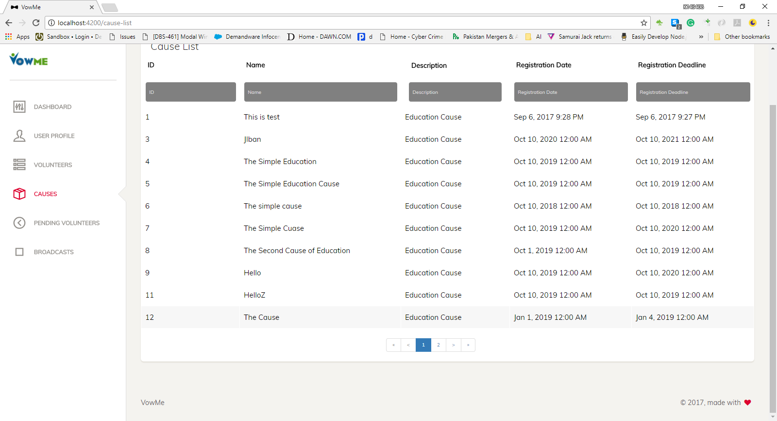

## Volunteer Profile

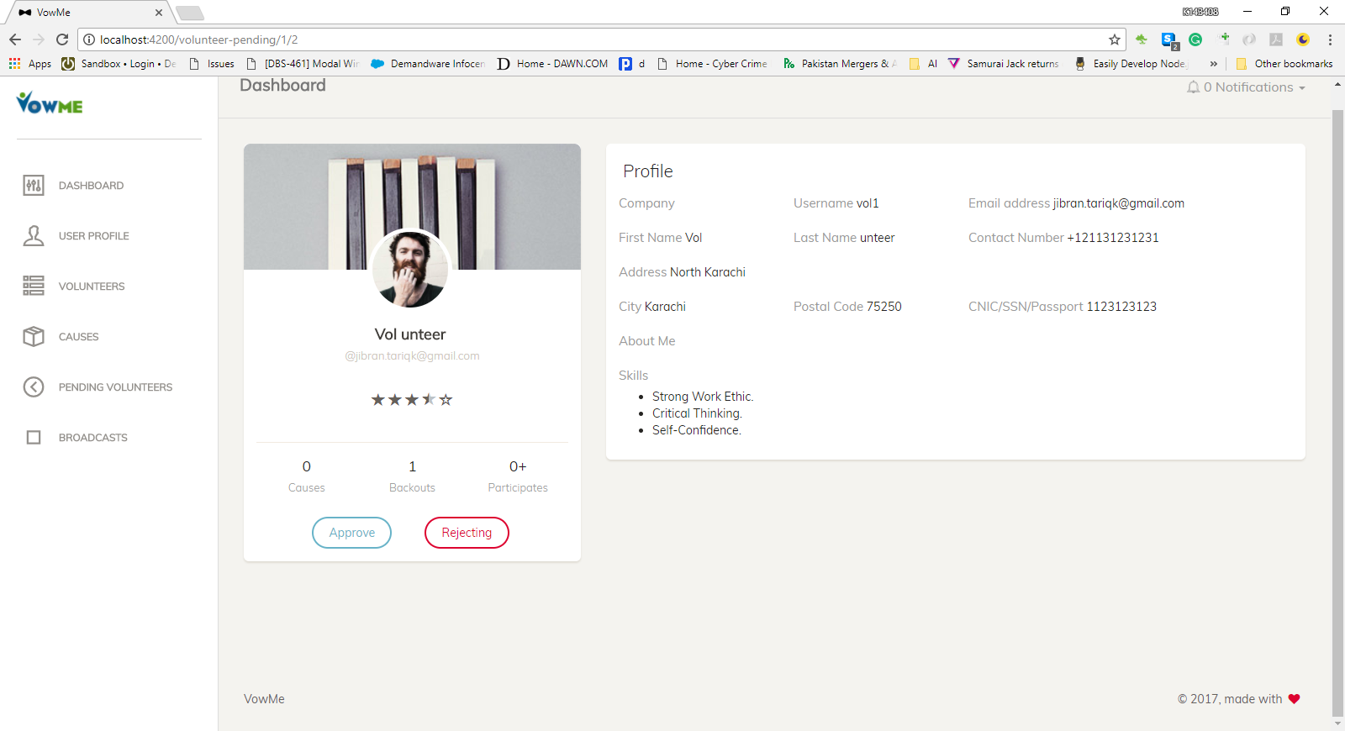

## Notification

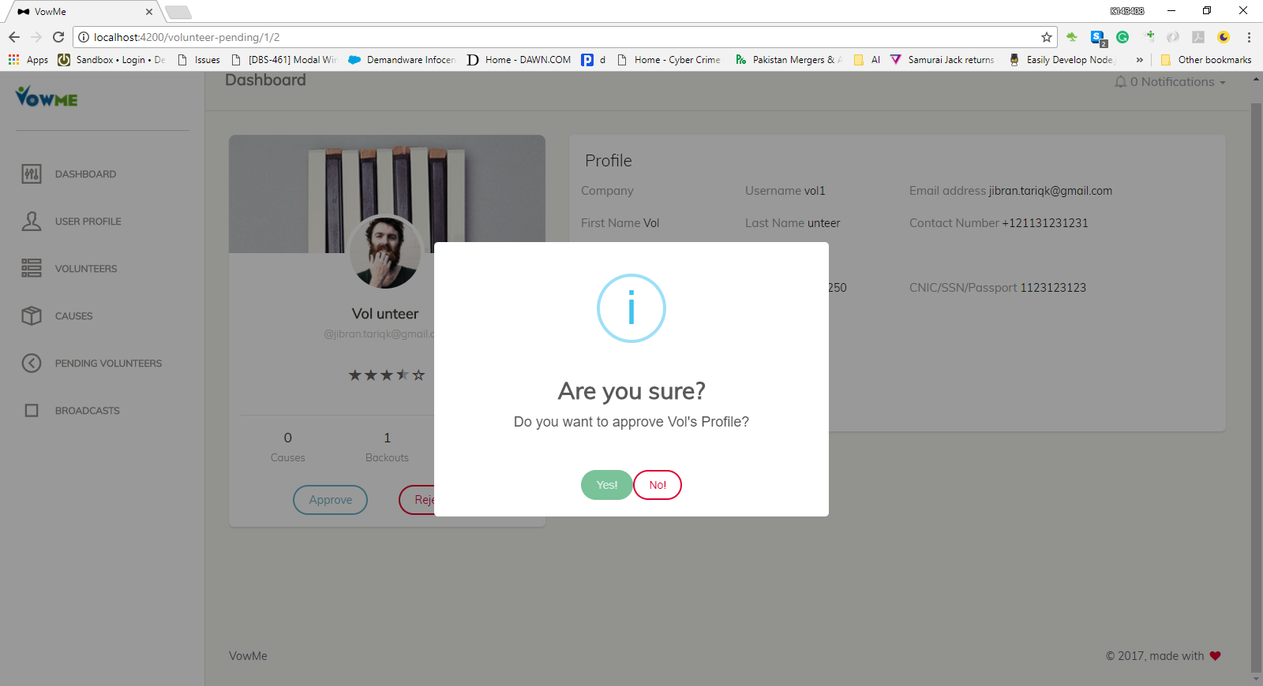

## Report

## 

