Test.c
#include <stdio.h>
#include <math.h>
#include <unistd.h>
int main (void)
{
int a,b;
printf("Enter the numbers");
scanf("%d%d",&a,&b);
printf("addition: %d",add(a,b));
return 0;
}
add.c
#include <stdio.h>
#include <math.h>
void add(int a,int b)
{
int res;
res=a+b;
printf("in function %d ",res);
}
output:
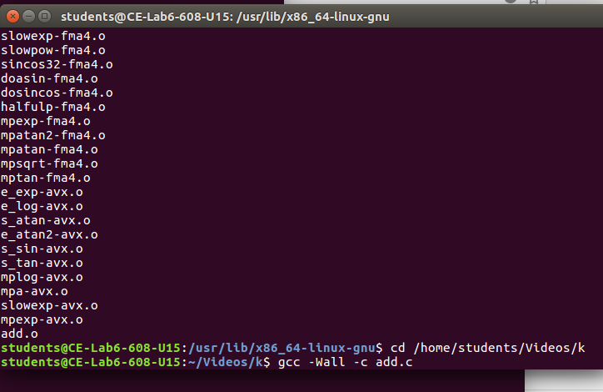

students@CE-Lab6-608-U15:~/Videos/k$ gcc test.c -lm
students@CE-Lab6-608-U15:~/Videos/k$ ./a.out
Enter the numbers2 3
addition: 5

