GRADE 1 · MATHEMATICS
Practice Worksheet
Ordering · Shapes · Sets of 0–5 · Addition & Subtraction to 50 · Time · Ordinal Numbers · Length · Money
Name: _______________________________ | Date: _______________________________
TOPICS COVERED
Ordering Numbers | Shapes | Sets of 0, 1, 2, 3, 4, 5 | Addition up to 50
Subtraction up to 50 | Time | Ordinal Numbers | Length

ORDERING NUMBERS
1. Circle the smallest number: 8 3 6 1
2. Write these numbers in order, smallest to largest: 9, 4, 7

3. Which number is greater — 12 or 15? Circle it.
4. Order these numbers from largest to smallest: 6, 14, 2

5. Fill in the missing number: 10, 11, ____, 13

SHAPES
6. Circle the shape that has 3 sides.

7. How many sides does a square have? ____
8. Circle the shape that has no corners.

9. Count the triangles in the picture below. Write the number: ____
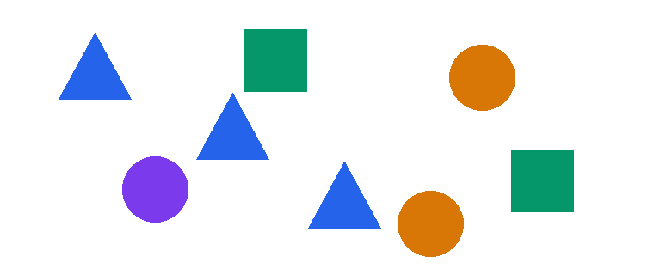
10. Draw your own square, circle, and triangle in the box below.

SETS OF 0, 1, 2, 3, 4, 5
11. Count the stars and write the number: ____

12. Count the apples and write the number: ____
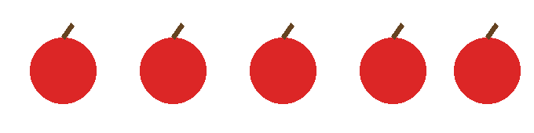
13. Circle the set that has 2 objects.

14. Circle the box that has 0 objects.

15. Draw 4 circles in the box below.

ADDITION UP TO 50
16. 12 + 7 = ______
17. 25 + 14 = ______
18. Sam has 18 marbles and gets 9 more. How many marbles does he have now?

19. 30 + 15 = ______
20. 22 + 6 = ______

SUBTRACTION UP TO 50
21. 45 − 12 = ______
22. 38 − 9 = ______
23. There were 40 birds on a tree. 15 flew away. How many birds are left?

24. 29 − 14 = ______
25. 50 − 27 = ______

TIME
26. What time does this clock show? ______
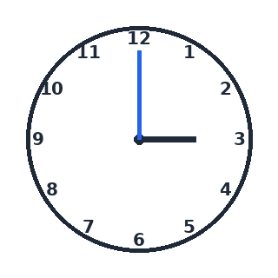
27. Draw hands on the clock to show 7 o'clock.
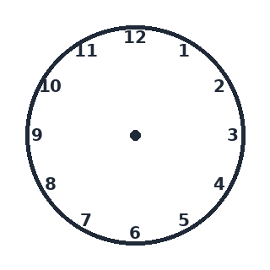
28. Draw hands on the clock to show half past 5.

29. Circle the clock that shows 9 o'clock.
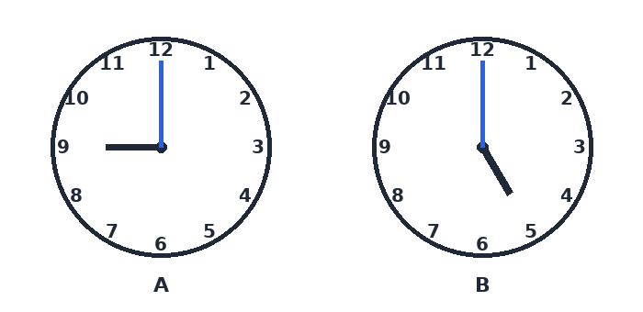
30. If it is 2 o'clock now, what time will it be in one hour? ______

ORDINAL NUMBERS
31. Look at the row of shapes below. Circle the 3rd shape.

32. In the same row, what shape is in the 1st position? ______
33. Write the ordinal number for position 5: ______
34. In the word CAT, which position is the letter T in? ______
35. Circle the shape in the 2nd position in the row above.

LENGTH
36. Circle the longer pencil.

37. How many paperclips long is the line below? ______

38. Which is shorter — a shoe or a bus? ______
39. Circle the longest object below.
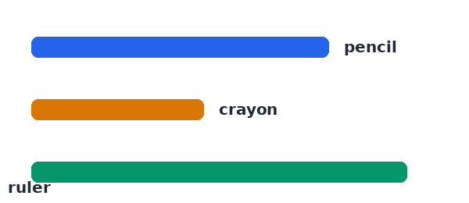
40. Order the lines A, B, and C from shortest to longest: ______


MONEY
41. How much money is shown in total? ______
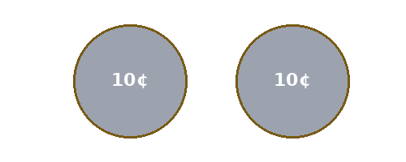
42. Circle the coin that is worth 5 cents.
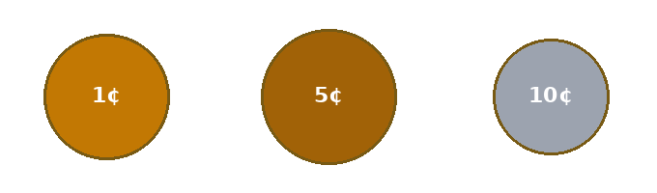
43. If you have 3 pennies, how many cents do you have? ______
44. Which is worth more — a dime or a nickel? ______
45. Count the coins below. How many cents in total? ______
