**useReducer Hook**

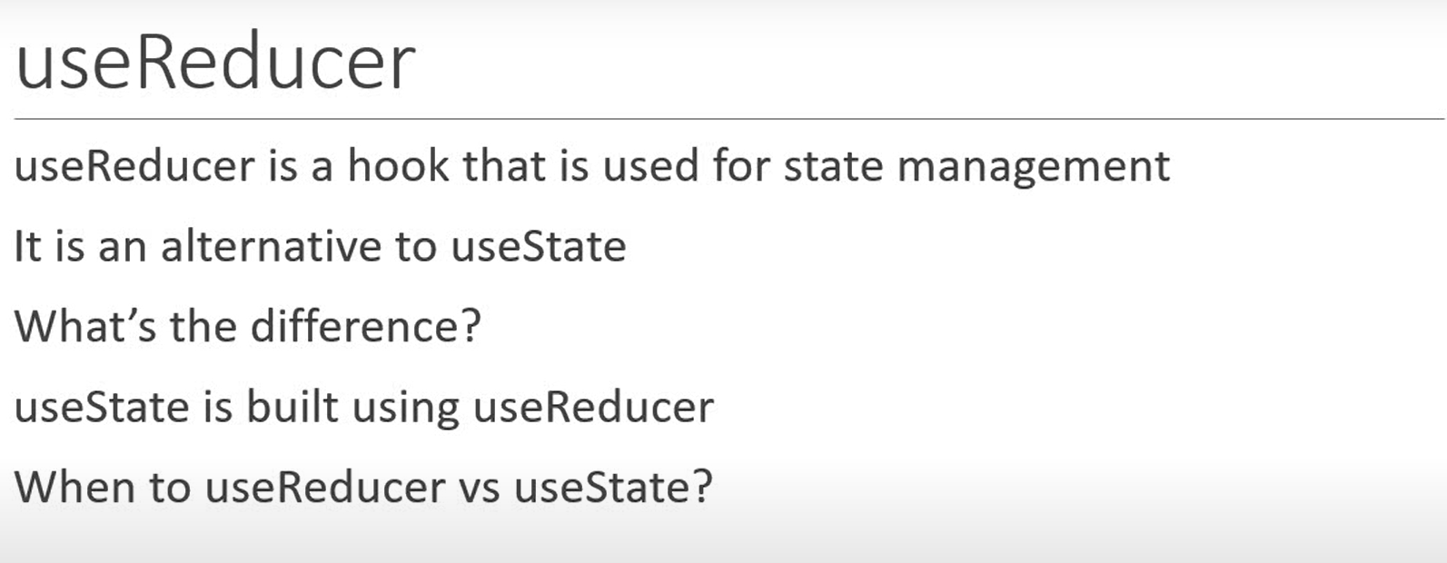

*useReducer* hook is similar to the *reduce()* method in JavaScript.

The *reduce()* method has two forms.

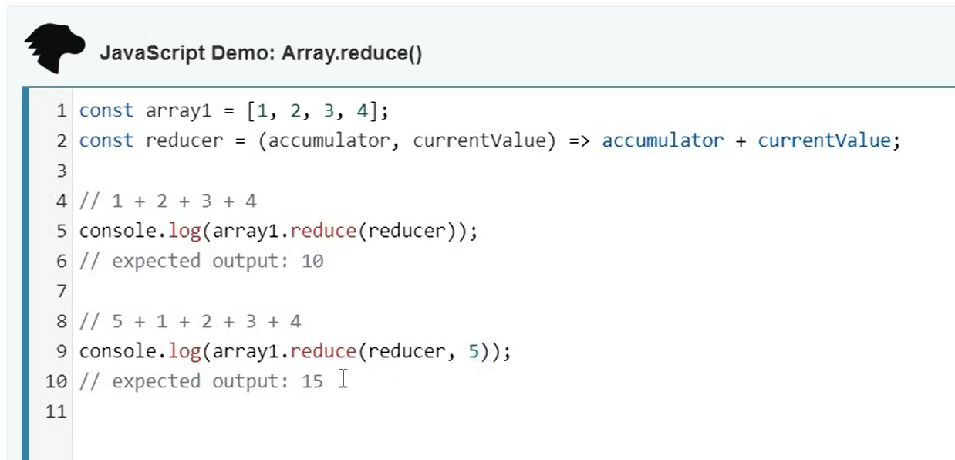

*reduce()* vs *useReducer* hook:

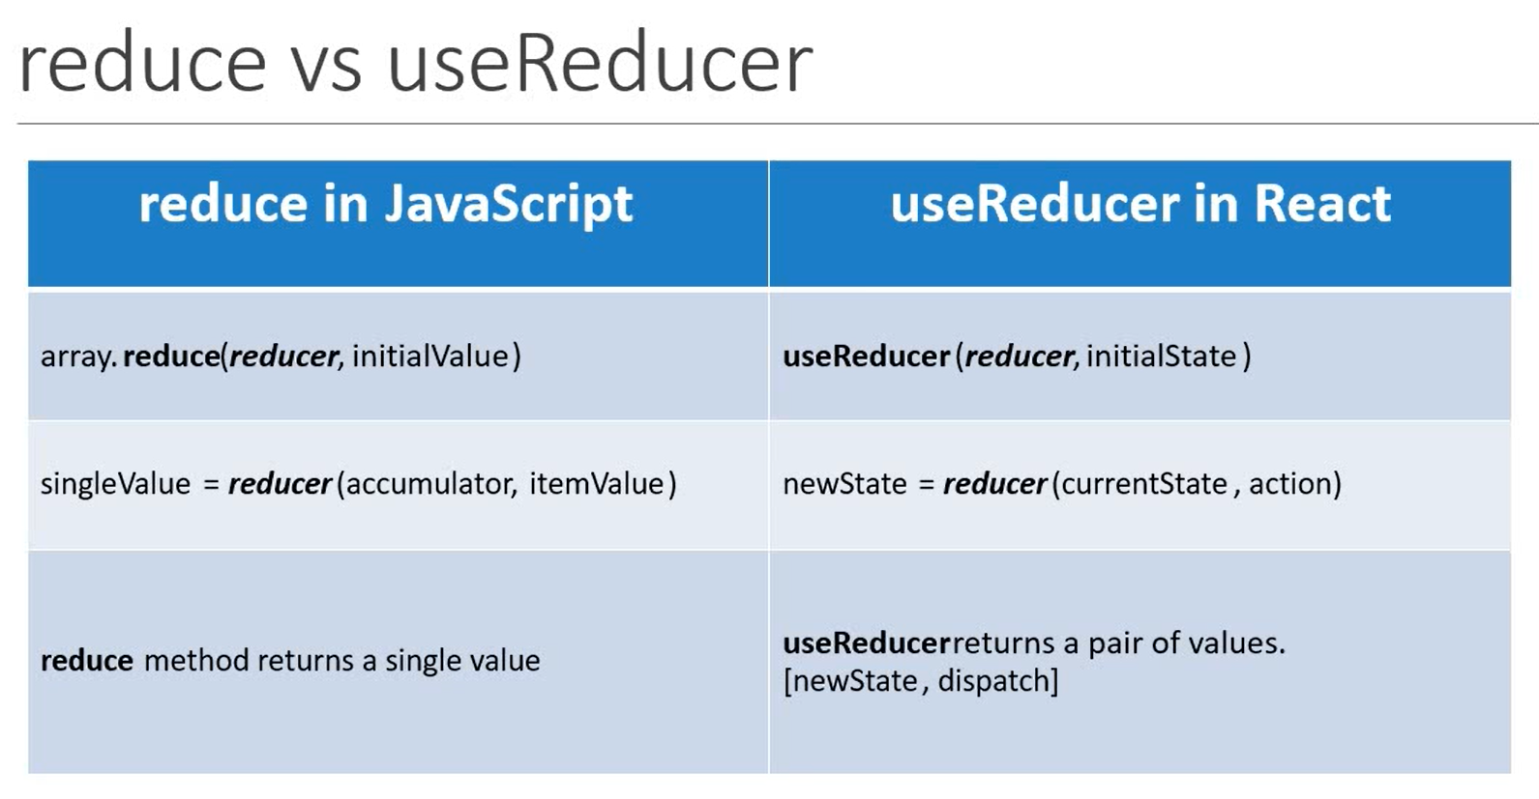

The syntax for *useReducer* is:

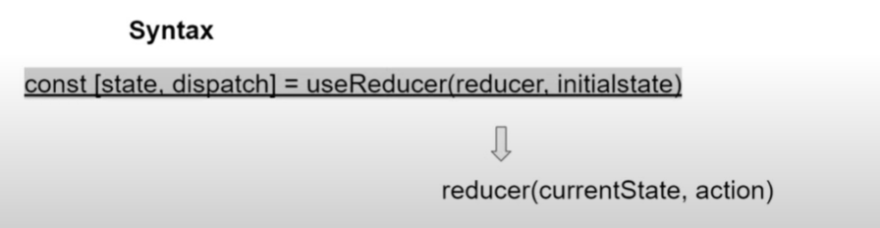

In *Counter.js* define two buttons:

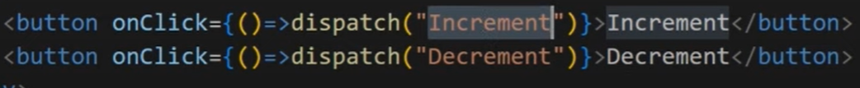

The *Counter* function will look something like:

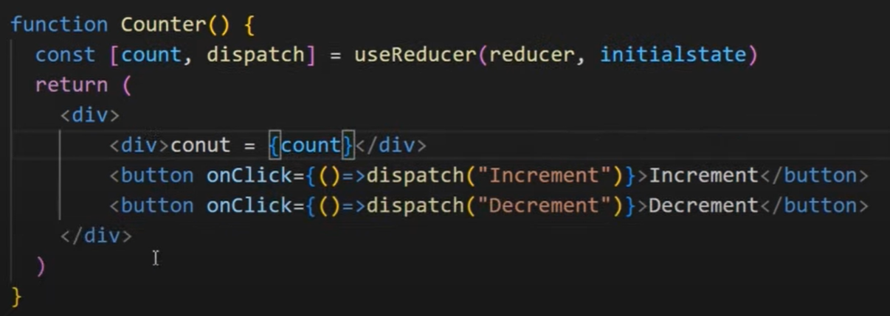

We need to declare the initial state variable (*initialstate*) & the *reducer* function.

