Comprehensive Documentation
Pangasinan Language LLM — Thesis Technical Reference
PEFT-LoRA Fine-Tuning of LLaMA 3.1-8B

This document serves as the complete technical README for the thesis project.

1. What the Project Is About
The primary objective of this project is to develop a specialized application designed to host a Large Language Model (LLM) specifically fine-tuned for the Pangasinan language. By leveraging advanced natural language processing techniques, the system will be trained to accurately comprehend, process, and generate text in Pangasinan.

2. Why Do This Project
By creating this specialized application, the initiative aims to bridge the gap in low-resource language support within modern AI frameworks. This ensures that regional languages are preserved and represented in the evolving landscape of artificial intelligence.

3. How We'll Execute

3.1 Gathering Entries for Our Dataset

3.1.1 Manual Entry Using the Data Annotation Tool
A dataset annotation tool has been deployed at kiruu.space/dataset. The annotator enters the required "input" and "output" values based on the instructions provided. The tool follows the ALPACA dataset format, which is designed for use in PEFT-LoRA training. Entries saved by the annotator are automatically stored in a Firestore database in JSON format.

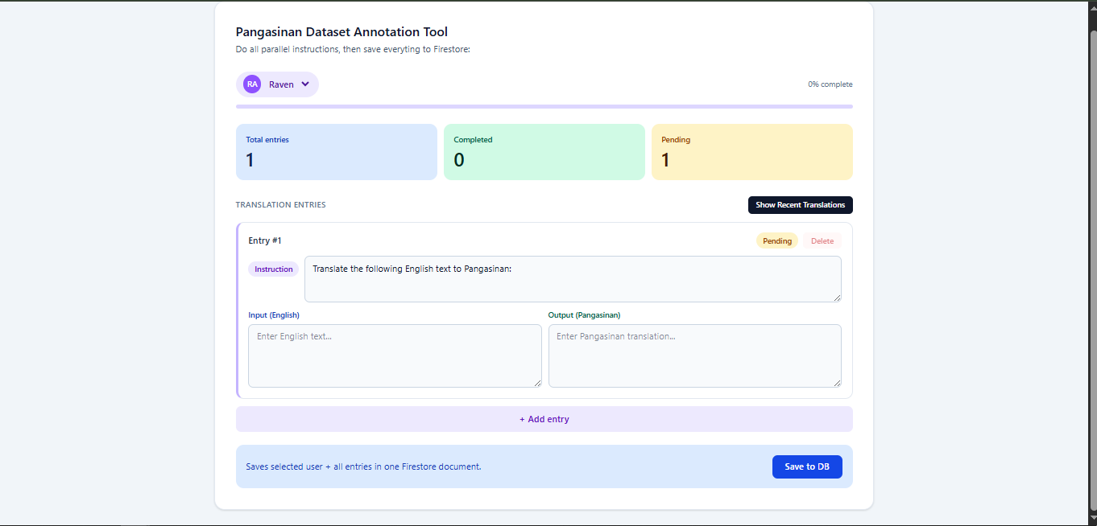

Annotated data is then validated by designated validators, either using their preferred method or by using the validation tool deployed at kiruu.space/validation.

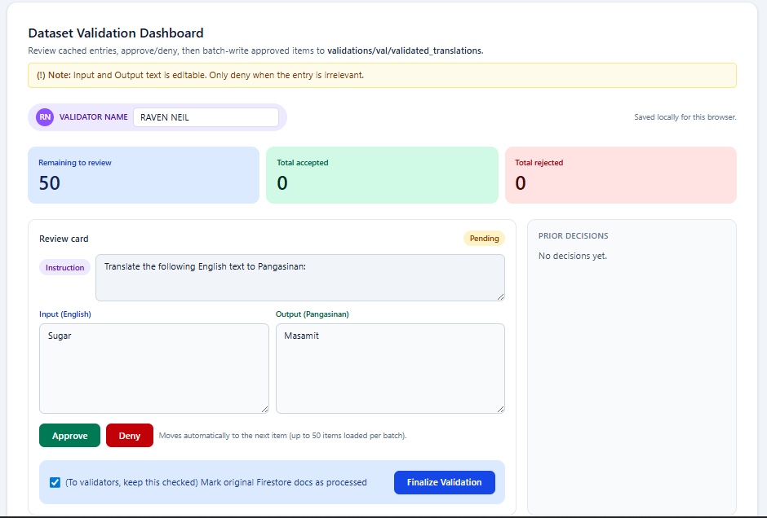

This tool fetches the latest 50 entries from the Firestore document and caches them in the browser. Validators can approve, deny, or edit the "input" and "output" values, then finalize the validation — which is reflected immediately in the database.

3.1.2 External Datasets from Online Sources
A limited number of Pangasinan datasets are available online. One example is the PLTAT/alpaca_pangasinan dataset on HuggingFace. Any dataset that follows the ALPACA format can be incorporated into training.

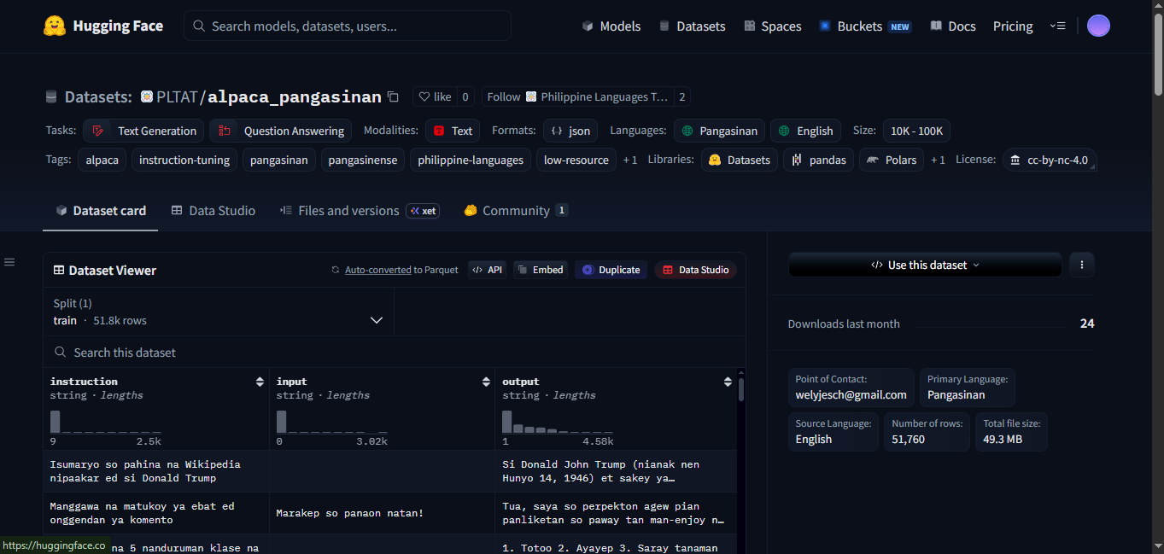

3.1.3 Auto-Generated Dataset
Dataset generation can be automated through two approaches:

Unsloth's Data Recipes
Unsloth Studio can automatically generate dataset pairs from unstructured files using a built-in visual workflow builder called Data Recipes, which transforms raw documents into structured JSONL training data. When provided with a Pangasinan-English dictionary PDF or text file, a synthetic pipeline can extract terms and definitions, then instruct an LLM to generate diverse, conversational Pangasinan prompt-response pairs optimized for fine-tuning an 8B model.

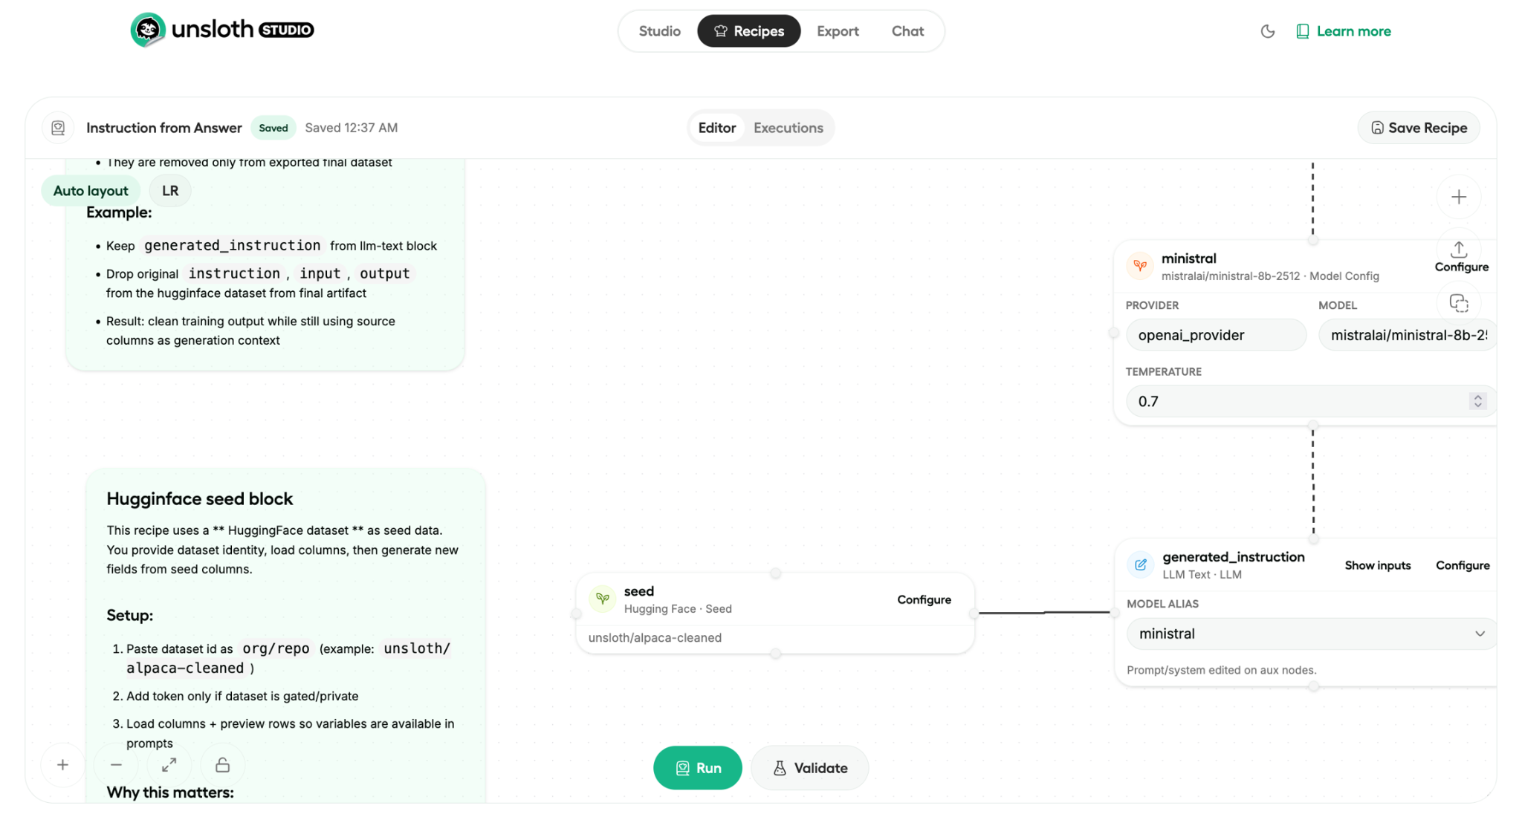

Google Cloud Platform — Translate API
Using the GCP V3 Translate API, files stored in a Google Cloud Storage bucket can be processed in bulk to produce Pangasinan translations. English text files are uploaded to the bucket, the API processes them, and the translated outputs are saved to a separate folder.

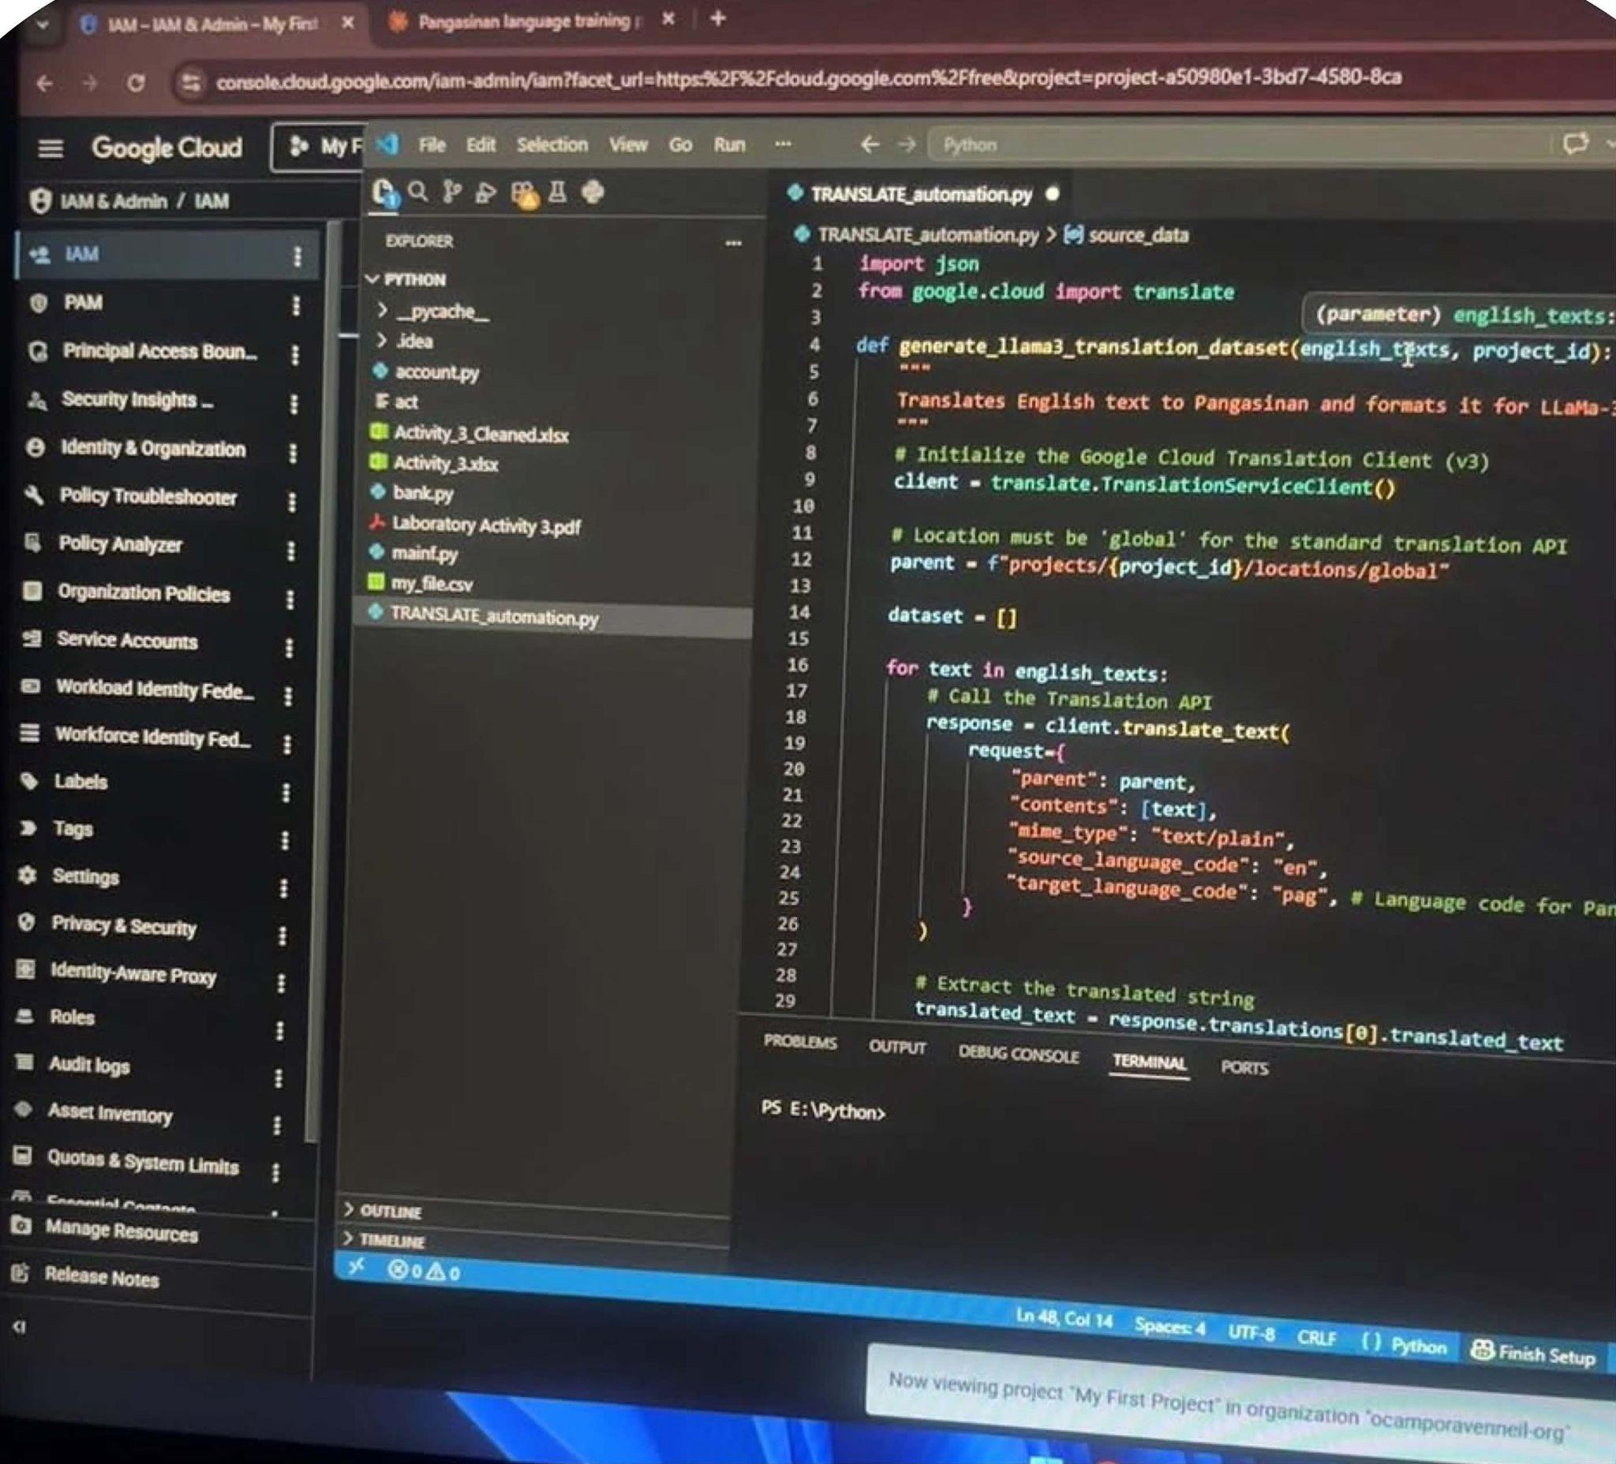

⚠ Important Note
Auto-generated datasets must be reviewed and cleaned individually before use in training.

3.2 Training the LLM
Rather than creating a model from scratch, this project fine-tunes a pre-existing base model — LLaMA 3.1-8B — using PEFT-LoRA. This approach significantly reduces computational cost while preserving strong language capabilities.

What Is LLaMA 3.1-8B?
LLaMA 3.1-8B is the base Large Language Model selected for this project, forming the foundation of the Pangasinan Conversational Agent.

Role & Architecture | Serves as the pre-trained foundation, built on the broader LLaMA 3 architecture. Not created from scratch.
Fine-Tuning Method | Fine-tuned via Parameter-Efficient Fine-Tuning (PEFT) with LoRA (Low-Rank Adaptation) to adapt to Pangasinan syntax and semantics.
Technical Specification | Configured for Causal Language Modeling (CAUSAL_LM). Base model path: unsloth/llama-3.1-8b-unsloth-bnb-4bit.
General Use Case | A cost-effective choice suited to chat/conversational applications.

What Is Parameter-Efficient Fine-Tuning (PEFT)?
Traditional full fine-tuning of LLMs requires updating every parameter in the model — a process that is computationally expensive and highly memory-intensive for large models. PEFT is a family of techniques that address this limitation by updating only a small, targeted subset of the model's parameters during fine-tuning, while achieving performance comparable to full fine-tuning.

What Is LoRA (Low-Rank Adaptation)?
LoRA is a specific and widely-used PEFT technique. Instead of modifying the original weights of a pre-trained LLM, LoRA injects small, trainable matrices — called LoRA adapters — into the existing layers of the model. These adapter matrices have a significantly lower rank than the original weight matrices, meaning they contain far fewer parameters. During fine-tuning, only the parameters of these LoRA adapters are updated, while the vast majority of the original model's weights remain frozen.

This approach yields three key benefits:

- Faster Training: Fewer parameters to update results in significantly quicker training times.
- Lower Memory Usage: Reduced memory footprint makes it possible to fine-tune large models on consumer-grade GPUs.
- Smaller Checkpoints: The resulting LoRA adapter file is much smaller than a fully fine-tuned model, making storage and deployment more manageable.

Training Process
Using the PEFT-LoRA setup described above, a LoRA adapter is generated from the training dataset. The Colab notebook below walks through this process end-to-end. To create your own adapter, upload your dataset, update the filename variable, and execute each cell in order.

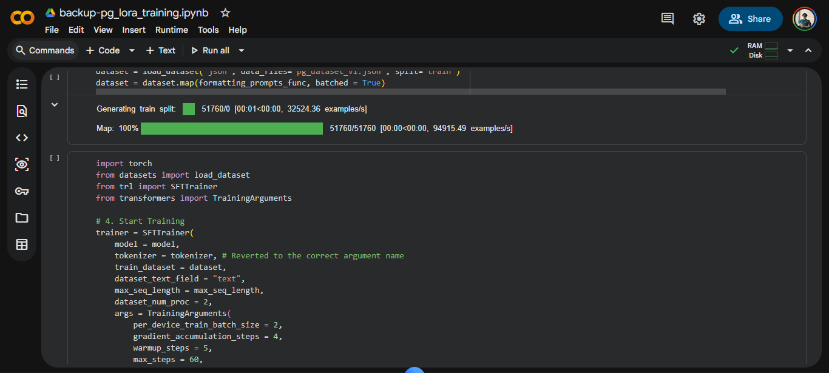

Training has been completed using the pg_dataset_v1.json dataset. The resulting LoRA adapter is available at: Google Drive — LoRA Adapter.

