crc.v
// ============================================================
// crc.v (module crc16_checker)
// CRC-16/CCITT checker
// Polynomial : x^16 + x^12 + x^5 + 1 (0x1021)
// Convention : init=0xFFFF, MSB-first, no reflection,
// no final-XOR, no augmentation bits
// 'busy' is the only state bit (no redundant state register),
// so RTL and synthesized netlist have identical flop sets.
// ============================================================
`timescale 1ns/1ps

module crc16_checker (
input wire clk,
input wire rst_n, // active-low synchronous reset
input wire start, // pulse: begin new packet (idle only)
input wire bit_valid, // data_bit is valid this cycle
input wire data_bit, // serial data, MSB-first
input wire last_bit, // this accepted bit is the last
input wire [15:0] expected_crc, // captured on start
output reg busy, // 1 while processing a packet
output reg [15:0] crc_result, // final CRC after last_bit
output reg match, // crc_result == expected_crc
output reg done // 1-cycle pulse after last_bit
);

reg [15:0] crc_reg; // working CRC
reg [15:0] exp_reg; // captured expected value

wire feedback;
wire [15:0] crc_next;
wire accept;

assign feedback = crc_reg[15] ^ data_bit;
assign crc_next = {crc_reg[14:0], 1'b0} ^ (feedback ? 16'h1021 : 16'h0000);
assign accept = busy & bit_valid;

always @(posedge clk) begin
if (!rst_n) begin
busy <= 1'b0;
crc_reg <= 16'hFFFF;
exp_reg <= 16'h0000;
crc_result <= 16'h0000;
match <= 1'b0;
done <= 1'b0;
end
else begin
done <= accept & last_bit; // 1-cycle pulse on the accepted last bit

if (!busy) begin
if (start) begin
busy <= 1'b1;
crc_reg <= 16'hFFFF;
exp_reg <= expected_crc;
end
end
else if (accept) begin
if (last_bit) begin
crc_result <= crc_next;
match <= (crc_next == exp_reg);
busy <= 1'b0;
crc_reg <= 16'hFFFF;
end
else begin
crc_reg <= crc_next;
end
end
// stall (busy && !bit_valid): hold everything
end
end

endmodule

crc_tb.v
// ============================================================
// crc_tb.v - self-checking testbench for crc16_checker
// Plain Verilog-2001 (no SystemVerilog, no 'automatic').
//
// Checks per packet: busy after start, done pulse, busy low,
// crc_result vs reference, match, done is 1 cycle only, and
// crc_result/match HOLD until the next packet completes.
//
// Tests
// T0 reset sanity
// T1 hard-coded known answers (reference model self-check)
// T2 1-bit packets (bit=0, bit=1)
// T3 lengths 1..40, random data, no stalls
// T4 lengths 1..40, random stalls + junk on stall/start cycles
// (includes last_bit=1 while bit_valid=0 -> must be ignored)
// T5 long packets (64, 72, 128, 256 bits) with stalls
// T6 wrong expected_crc: every single-bit flip + all-bits flip
// T7 idle noise: bit_valid/last_bit/data toggling while idle
// T8 start pulse while busy must be ignored
// T9 back-to-back packets (start the cycle after done)
// T10 all-zeros / all-ones payloads
// T11 reset during packet (incl. reset on the last-bit cycle),
// then a fresh packet must still be correct
// ============================================================
`timescale 1ns/1ps

module crc16_tb;

// ---------------- clock / DUT signals --------------------
reg clk;
reg rst_n;
reg start;
reg bit_valid;
reg data_bit;
reg last_bit;
reg [15:0] expected_crc;
wire busy;
wire [15:0] crc_result;
wire match;
wire done;

crc16_checker dut (
.clk (clk),
.rst_n (rst_n),
.start (start),
.bit_valid (bit_valid),
.data_bit (data_bit),
.last_bit (last_bit),
.expected_crc(expected_crc),
.busy (busy),
.crc_result (crc_result),
.match (match),
.done (done)
);

initial clk = 1'b0;
always #5 clk = ~clk; // 100 MHz

// ---------------- 32-bit Galois LFSR ----------------------
function [31:0] lfsr_next;
input [31:0] x;
begin
lfsr_next = {x[30:0], 1'b0} ^ ({32{x[31]}} & 32'hB400_0000);
end
endfunction

// ---------------- shared state ----------------------------
integer err_cnt;
integer pkt_cnt;
integer idx;
integer idx2;
reg [31:0] lfsr;
reg [255:0] pkt;
reg [15:0] rcrc; // reference CRC of last packet
reg [15:0] prev_res; // what crc_result must hold
reg prev_match; // what match must hold
reg [15:0] ref_crc;
reg ref_fb;
reg sp_stall;

// ---------------- reference model -------------------------
// bit_stream[255] is the first transmitted bit.
// init FFFF, poly 1021, MSB first, no reflect, no final XOR.
task ref_compute;
input [255:0] bit_stream;
input [31:0] num_bits;
output [15:0] crc_out;
integer k;
begin
ref_crc = 16'hFFFF;
for (k = 0; k < num_bits; k = k + 1) begin
ref_fb = ref_crc[15] ^ bit_stream[255 - k];
ref_crc = {ref_crc[14:0], 1'b0};
if (ref_fb) ref_crc = ref_crc ^ 16'h1021;
end
crc_out = ref_crc;
end
endtask

// ---------------- random packet ---------------------------
task gen_pkt;
integer w;
begin
for (w = 0; w < 8; w = w + 1) begin
lfsr = lfsr_next(lfsr);
pkt = {pkt[223:0], lfsr};
end
end
endtask

// ---------------- reset helper ----------------------------
task apply_reset;
input [31:0] n;
integer k;
begin
rst_n = 1'b0;
start = 1'b0;
bit_valid = 1'b0;
data_bit = 1'b0;
last_bit = 1'b0;
expected_crc = 16'h0000;
for (k = 0; k < n; k = k + 1) @(posedge clk);
#1;
rst_n = 1'b1;
prev_res = 16'h0000;
prev_match = 1'b0;
end
endtask

// ---------------- error helper ----------------------------
task fail;
input [31:0] id;
input [8*48-1:0] msg;
begin
$display("ERROR [T%0d] t=%0t : %0s", id, $time, msg);
err_cnt = err_cnt + 1;
end
endtask

// ---------------- drive one packet ------------------------
// Call aligned at (posedge clk + 1ns). Returns aligned at the
// same point right after the edge that accepted the last bit.
// mode[0] random stalls
// mode[1] junk: bit_valid/data/last toggle on start and stall cycles
// mode[2] extra start pulse in the middle of the packet
task send_packet;
input [255:0] bits;
input [31:0] n_bits;
input [15:0] exp_crc;
input [2:0] mode;
input [31:0] id;
integer j;
begin
// ---- start cycle ----
start = 1'b1;
expected_crc = exp_crc;
if (mode[1]) begin
bit_valid = 1'b1; data_bit = 1'b1; last_bit = 1'b1; // must NOT be taken
end else begin
bit_valid = 1'b0; data_bit = 1'b0; last_bit = 1'b0;
end
@(posedge clk); #1;
start = 1'b0;
expected_crc = ~exp_crc; // expected must have been captured at start
bit_valid = 1'b0; data_bit = 1'b0; last_bit = 1'b0;

if (busy !== 1'b1) fail(id, "busy not high after start");
if (done !== 1'b0) fail(id, "done high after start");
if (crc_result !== prev_res) fail(id, "crc_result changed at start");
if (match !== prev_match) fail(id, "match changed at start");

// ---- data bits ----
for (j = 0; j < n_bits; j = j + 1) begin
// optional stall cycles (bit_valid = 0)
if (mode[0]) begin
lfsr = lfsr_next(lfsr);
sp_stall = (lfsr[1:0] != 2'b00);
end else begin
sp_stall = 1'b0;
end
while (sp_stall) begin
bit_valid = 1'b0;
if (mode[1]) begin
data_bit = lfsr[4];
last_bit = lfsr[5] | lfsr[6]; // last_bit=1 with bit_valid=0 happens
end else begin
data_bit = 1'b0;
last_bit = 1'b0;
end
@(posedge clk); #1;
if (busy !== 1'b1) fail(id, "busy dropped during stall");
if (done !== 1'b0) fail(id, "done during stall");
if (crc_result !== prev_res) fail(id, "crc_result changed in stall");
if (match !== prev_match) fail(id, "match changed in stall");
lfsr = lfsr_next(lfsr);
sp_stall = (lfsr[1:0] == 2'b11);
end

// the accepted bit
bit_valid = 1'b1;
data_bit = bits[255 - j];
last_bit = (j == n_bits - 1) ? 1'b1 : 1'b0;
if (mode[2] && (n_bits >= 4) && (j == (n_bits >> 1)))
start = 1'b1; // bogus start while busy
@(posedge clk); #1;
start = 1'b0;

if (j < n_bits - 1) begin
if (busy !== 1'b1) fail(id, "busy dropped mid-packet");
if (done !== 1'b0) fail(id, "done mid-packet");
if (crc_result !== prev_res) fail(id, "crc_result changed mid-packet");
if (match !== prev_match) fail(id, "match changed mid-packet");
end
end
bit_valid = 1'b0; data_bit = 1'b0; last_bit = 1'b0;
end
endtask

// ---------------- check just after the last-bit edge -------
task check_packet;
input [15:0] ref_val;
input exp_match;
input [31:0] id;
begin
pkt_cnt = pkt_cnt + 1;
if (done !== 1'b1) fail(id, "done not asserted");
if (busy !== 1'b0) fail(id, "busy still high after last bit");
if (crc_result !== ref_val) begin
$display(" crc_result=%04h reference=%04h", crc_result, ref_val);
fail(id, "crc_result != reference");
end
if (match !== exp_match) fail(id, "match wrong");
prev_res = ref_val;
prev_match = exp_match;
end
endtask

// ---------------- done must drop, results must hold --------
task check_done_drop;
input [31:0] id;
begin
@(posedge clk); #1;
if (done !== 1'b0) fail(id, "done longer than 1 cycle");
if (busy !== 1'b0) fail(id, "busy high while idle");
if (crc_result !== prev_res) fail(id, "crc_result did not hold");
if (match !== prev_match) fail(id, "match did not hold");
end
endtask

// ---------------- one complete packet, fully checked -------
task run_packet;
input [255:0] bits;
input [31:0] n_bits;
input [15:0] exp_crc; // value handed to DUT as expected_crc
input [2:0] mode;
input [31:0] id;
reg [15:0] r;
begin
ref_compute(bits, n_bits, r);
send_packet(bits, n_bits, exp_crc, mode, id);
check_packet(r, (exp_crc == r), id);
check_done_drop(id);
end
endtask

// convenience: expected = true CRC
task run_good;
input [255:0] bits;
input [31:0] n_bits;
input [2:0] mode;
input [31:0] id;
reg [15:0] r;
begin
ref_compute(bits, n_bits, r);
run_packet(bits, n_bits, r, mode, id);
end
endtask

// ---------------- idle noise ------------------------------
task idle_noise;
input [31:0] cycles;
input [31:0] id;
integer k;
begin
for (k = 0; k < cycles; k = k + 1) begin
lfsr = lfsr_next(lfsr);
start = 1'b0;
bit_valid = 1'b1;
data_bit = lfsr[3];
last_bit = 1'b1;
@(posedge clk); #1;
if (busy !== 1'b0) fail(id, "busy rose without start");
if (done !== 1'b0) fail(id, "done rose while idle");
if (crc_result !== prev_res) fail(id, "crc_result changed while idle");
if (match !== prev_match) fail(id, "match changed while idle");
end
bit_valid = 1'b0; data_bit = 1'b0; last_bit = 1'b0;
end
endtask

// ---------------- known-answer helper ----------------------
task known;
input [255:0] bits;
input [31:0] n_bits;
input [15:0] known_crc;
input [31:0] id;
reg [15:0] r;
begin
ref_compute(bits, n_bits, r);
if (r !== known_crc) begin
$display(" ref model=%04h known=%04h", r, known_crc);
fail(id, "reference model != known answer");
end
run_packet(bits, n_bits, known_crc, 3'b000, id);
end
endtask

// =========================================================
// MAIN
// =========================================================
initial begin
err_cnt = 0;
pkt_cnt = 0;
lfsr = 32'hDEAD_BEEF;
pkt = 256'h0;
prev_res = 16'h0000;
prev_match = 1'b0;
start = 1'b0; bit_valid = 1'b0; data_bit = 1'b0; last_bit = 1'b0;
expected_crc = 16'h0000;
rst_n = 1'b0;

$dumpfile("/home/vlsi19/23bec1412_l29l30_asic/proj/crc16_tb.vcd");
$dumpvars(0, crc16_tb);

// ---- T0: reset sanity ----
$display("=== T0: reset sanity ===");
apply_reset(4);
if (busy !== 1'b0 || done !== 1'b0 || match !== 1'b0 || crc_result !== 16'h0000)
fail(0, "outputs not cleared by reset");
@(posedge clk); #1;

// ---- T1: known answers (hard-coded, independent of RTL and model) ----
$display("=== T1: known answers ===");
pkt = 256'h0; pkt[255:184] = 72'h31_32_33_34_35_36_37_38_39; // "123456789"
known(pkt, 32'd72, 16'h29B1, 1);
pkt = 256'h0; pkt[255:248] = 8'h41; // "A"
known(pkt, 32'd8, 16'hB915, 1);
pkt = 256'h0; pkt[255:240] = 16'h4142; // "AB"
known(pkt, 32'd16, 16'h4B74, 1);
pkt = 256'h0; pkt[255:248] = 8'h00; // 0x00
known(pkt, 32'd8, 16'hE1F0, 1);
pkt = 256'h0; pkt[255:248] = 8'hFF; // 0xFF
known(pkt, 32'd8, 16'hFF00, 1);

// ---- T2: single-bit packets ----
$display("=== T2: 1-bit packets ===");
pkt = 256'h0; pkt[255] = 1'b1; run_good(pkt, 32'd1, 3'b000, 2);
pkt = 256'h0; pkt[255] = 1'b0; run_good(pkt, 32'd1, 3'b000, 2);
pkt = 256'h0; pkt[255] = 1'b1; run_good(pkt, 32'd1, 3'b010, 2); // junk on start cycle

// ---- T3: lengths 1..40, no stalls ----
$display("=== T3: lengths 1..40 ===");
for (idx = 1; idx <= 40; idx = idx + 1) begin
gen_pkt;
run_good(pkt, idx, 3'b000, 3);
end

// ---- T4: lengths 1..40, stalls + junk ----
$display("=== T4: stalls + junk, lengths 1..40 ===");
for (idx = 1; idx <= 40; idx = idx + 1) begin
gen_pkt;
run_good(pkt, idx, 3'b011, 4);
end

// ---- T5: long packets ----
$display("=== T5: long packets ===");
gen_pkt; run_good(pkt, 32'd64, 3'b011, 5);
gen_pkt; run_good(pkt, 32'd72, 3'b001, 5);
gen_pkt; run_good(pkt, 32'd128, 3'b011, 5);
gen_pkt; run_good(pkt, 32'd256, 3'b011, 5);

// ---- T6: wrong expected values ----
$display("=== T6: wrong expected_crc ===");
gen_pkt;
ref_compute(pkt, 32'd24, rcrc);
for (idx = 0; idx < 16; idx = idx + 1)
run_packet(pkt, 32'd24, rcrc ^ (16'h0001 << idx), 3'b000, 6); // one bit off
run_packet(pkt, 32'd24, ~rcrc, 3'b000, 6); // all bits off
run_packet(pkt, 32'd24, rcrc, 3'b000, 6); // and correct again

// ---- T7: idle noise ----
$display("=== T7: idle noise ===");
idle_noise(10, 7);
gen_pkt; run_good(pkt, 32'd12, 3'b000, 7);
idle_noise(10, 7); // results must still hold

// ---- T8: start while busy ----
$display("=== T8: start while busy ===");
for (idx = 4; idx <= 24; idx = idx + 4) begin
gen_pkt;
run_good(pkt, idx, 3'b100, 8);
gen_pkt;
run_good(pkt, idx, 3'b111, 8);
end

// ---- T9: back-to-back (start in the cycle right after done) ----
$display("=== T9: back-to-back ===");
gen_pkt;
ref_compute(pkt, 32'd16, rcrc);
send_packet(pkt, 32'd16, rcrc, 3'b000, 9);
check_packet(rcrc, 1'b1, 9);
pkt = 256'h0; pkt[255:248] = 8'h55;
ref_compute(pkt, 32'd8, rcrc);
send_packet(pkt, 32'd8, rcrc, 3'b000, 9); // no idle cycle in between
check_packet(rcrc, 1'b1, 9);
pkt = 256'h0; pkt[255:248] = 8'hAA;
ref_compute(pkt, 32'd8, rcrc);
send_packet(pkt, 32'd8, ~rcrc, 3'b000, 9); // third one with wrong expected
check_packet(rcrc, 1'b0, 9);
check_done_drop(9);

// ---- T10: all-zeros / all-ones ----
$display("=== T10: all-zeros / all-ones ===");
pkt = 256'h0; run_good(pkt, 32'd16, 3'b000, 10);
pkt = 256'h0; run_good(pkt, 32'd33, 3'b011, 10);
pkt = {256{1'b1}}; run_good(pkt, 32'd16, 3'b000, 10);
pkt = {256{1'b1}}; run_good(pkt, 32'd33, 3'b011, 10);

// ---- T11: reset during a packet ----
$display("=== T11: reset during packet ===");
gen_pkt; run_good(pkt, 32'd20, 3'b000, 11); // leaves non-zero result / match=1

// (a) reset in the middle of a packet
start = 1'b1; expected_crc = 16'h1234;
@(posedge clk); #1;
start = 1'b0;
for (idx = 0; idx < 5; idx = idx + 1) begin
bit_valid = 1'b1; data_bit = idx[0]; last_bit = 1'b0;
@(posedge clk); #1;
end
rst_n = 1'b0; bit_valid = 1'b0;
@(posedge clk); #1;
rst_n = 1'b1;
prev_res = 16'h0000; prev_match = 1'b0;
if (busy !== 1'b0 || done !== 1'b0 || crc_result !== 16'h0000 || match !== 1'b0)
fail(11, "reset did not clear outputs");
@(posedge clk); #1;
gen_pkt; run_good(pkt, 32'd17, 3'b011, 11); // fresh packet must be correct

// (b) reset on the very cycle that would accept the last bit
start = 1'b1; expected_crc = 16'hABCD;
@(posedge clk); #1;
start = 1'b0;
bit_valid = 1'b1; data_bit = 1'b1; last_bit = 1'b0; @(posedge clk); #1;
bit_valid = 1'b1; data_bit = 1'b0; last_bit = 1'b0; @(posedge clk); #1;
rst_n = 1'b0; bit_valid = 1'b1; data_bit = 1'b1; last_bit = 1'b1; // would be last bit
@(posedge clk); #1;
rst_n = 1'b1; bit_valid = 1'b0; last_bit = 1'b0; data_bit = 1'b0;
prev_res = 16'h0000; prev_match = 1'b0;
if (busy !== 1'b0 || done !== 1'b0 || crc_result !== 16'h0000 || match !== 1'b0)
fail(11, "reset on last-bit cycle published a result");
@(posedge clk); #1;
if (done !== 1'b0) fail(11, "done after reset-on-last-bit");
gen_pkt; run_good(pkt, 32'd9, 3'b000, 11);

// ---- summary ----
#20;
$display("-----------------------------------------");
$display("packets checked : %0d", pkt_cnt);
if (err_cnt == 0)
$display("*** ALL TESTS PASSED ***");
else
$display("*** %0d ERRORS DETECTED ***", err_cnt);
$display("-----------------------------------------");
$dumpflush;
$finish;
end

// ---------------- watchdog -------------------------------
initial begin
#20000000;
$display("TIMEOUT: simulation exceeded 20 ms");
$dumpflush;
$finish;
end

endmodule

innovus netlist
/*
###############################################################
# Generated by: Cadence Innovus 21.15-s110_1
# OS: Linux x86_64(Host ID cad312vitcc.vit.ac.in)
# Generated on: Thu Oct 29 14:46:44 2026
# Design: crc16_checker
# Command: saveNetlist crc16_checker.v
###############################################################
*/
// Generated by Cadence Genus(TM) Synthesis Solution 21.14-s082_1
// Generated on: Oct 29 2026 14:18:42 IST (Oct 29 2026 08:48:42 UTC)
// Verification Directory fv/crc16_checker
module crc16_checker (
clk,
rst_n,
start,
bit_valid,
data_bit,
last_bit,
expected_crc,
busy,
crc_result,
match,
done);
input clk;
input rst_n;
input start;
input bit_valid;
input data_bit;
input last_bit;
input [15:0] expected_crc;
output busy;
output [15:0] crc_result;
output match;
output done;

// Internal wires
wire [15:0] exp_reg;
wire [15:0] crc_reg;
wire [15:0] crc_next;
wire n_0;
wire n_1;
wire n_2;
wire n_3;
wire n_4;
wire n_5;
wire n_6;
wire n_7;
wire n_8;
wire n_9;
wire n_10;
wire n_11;
wire n_12;
wire n_13;
wire n_14;
wire n_15;
wire n_16;
wire n_18;
wire n_19;
wire n_20;
wire n_21;
wire n_22;
wire n_23;
wire n_24;
wire n_25;
wire n_26;
wire n_27;
wire n_28;
wire n_29;
wire n_30;
wire n_31;
wire n_32;
wire n_33;
wire n_34;
wire n_35;
wire n_36;
wire n_37;
wire n_38;
wire n_39;
wire n_40;
wire n_41;
wire n_42;
wire n_43;
wire n_44;
wire n_45;
wire n_46;
wire n_47;
wire n_48;
wire n_49;
wire n_50;
wire n_51;
wire n_52;
wire n_53;
wire n_54;
wire n_55;
wire n_56;
wire n_57;
wire n_58;
wire n_59;
wire n_60;
wire n_61;
wire n_62;
wire n_63;
wire n_64;
wire n_65;
wire n_66;
wire n_67;
wire n_68;
wire n_69;
wire n_70;
wire n_71;
wire n_72;
wire n_73;
wire n_74;
wire n_75;
wire n_76;
wire n_77;
wire n_78;
wire n_79;
wire n_80;
wire n_81;
wire n_82;
wire n_83;
wire n_84;
wire n_85;
wire n_86;
wire n_87;
wire n_88;
wire n_89;
wire n_90;
wire n_91;
wire n_92;
wire n_93;
wire n_94;
wire n_95;
wire n_96;
wire n_97;
wire n_98;
wire n_99;
wire n_100;
wire n_101;
wire n_102;
wire n_103;
wire n_104;
wire n_105;
wire n_106;
wire n_107;
wire n_108;
wire n_109;
wire n_110;
wire n_111;
wire n_112;
wire n_113;
wire n_114;
wire n_115;
wire n_116;
wire n_117;
wire n_118;
wire n_119;
wire n_120;
wire n_121;
wire n_122;
wire n_123;
wire n_124;
wire n_125;
wire n_127;
wire n_128;
wire n_129;
wire n_130;
wire n_131;
wire n_132;
wire n_133;
wire n_134;
wire n_135;
wire n_136;
wire n_137;
wire n_138;
wire n_139;
wire n_140;
wire n_141;
wire n_142;
wire n_143;
wire n_144;
wire n_145;
wire n_146;
wire n_169;

DFFQX2 match_reg (.CK(clk),
.D(n_146),
.Q(match));
NOR2XL g2528__2398 (.A(n_139),
.B(n_145),
.Y(n_146));
MXI2XL g2529__5107 (.A(n_144),
.B(match),
.S0(n_134),
.Y(n_145));
NOR3XL g2530__6260 (.A(n_41),
.B(n_142),
.C(n_143),
.Y(n_144));
NAND4XL g2531__4319 (.A(n_9),
.B(n_11),
.C(n_90),
.D(n_141),
.Y(n_143));
OAI211XL g2532__8428 (.A0(exp_reg[14]),
.A1(n_130),
.B0(n_19),
.C0(n_137),
.Y(n_142));
DFFQX2 \crc_result_reg[5] (.CK(clk),
.D(n_138),
.Q(crc_result[5]));
AOI211X1 g2533__5526 (.A0(exp_reg[7]),
.A1(n_127),
.B0(n_18),
.C0(n_136),
.Y(n_141));
DFFQX2 \crc_result_reg[12] (.CK(clk),
.D(n_140),
.Q(crc_result[12]));
NOR2XL g2553__6783 (.A(n_139),
.B(n_133),
.Y(n_140));
NOR2XL g2548__3680 (.A(n_139),
.B(n_135),
.Y(n_138));
DFFQX2 busy_reg (.CK(clk),
.D(n_132),
.Q(busy));
AOI211X1 g2550__1617 (.A0(exp_reg[12]),
.A1(n_119),
.B0(n_10),
.C0(n_107),
.Y(n_137));
OAI211X1 g2549__2802 (.A0(exp_reg[5]),
.A1(n_112),
.B0(n_12),
.C0(n_106),
.Y(n_136));
DFFQX1 \crc_reg_reg[11] (.CK(clk),
.D(n_125),
.Q(crc_reg[11]));
DFFQX1 \crc_reg_reg[4] (.CK(clk),
.D(n_114),
.Q(crc_reg[4]));
DFFQX1 \crc_reg_reg[13] (.CK(clk),
.D(n_131),
.Q(crc_next[14]));
DFFQX1 \crc_reg_reg[15] (.CK(clk),
.D(n_116),
.Q(crc_reg[15]));
DFFQX1 \crc_reg_reg[12] (.CK(clk),
.D(n_120),
.Q(crc_next[13]));
DFFQX1 \crc_reg_reg[5] (.CK(clk),
.D(n_113),
.Q(crc_next[6]));
DFFQX1 \crc_reg_reg[6] (.CK(clk),
.D(n_129),
.Q(crc_next[7]));
DFFQX1 \crc_reg_reg[3] (.CK(clk),
.D(n_115),
.Q(crc_next[4]));
DFFQX1 \crc_reg_reg[2] (.CK(clk),
.D(n_111),
.Q(crc_next[3]));
DFFQX1 \crc_reg_reg[10] (.CK(clk),
.D(n_122),
.Q(crc_next[11]));
DFFQX1 \crc_reg_reg[1] (.CK(clk),
.D(n_123),
.Q(crc_next[2]));
DFFQX1 \crc_reg_reg[7] (.CK(clk),
.D(n_110),
.Q(crc_next[8]));
DFFQX1 \crc_reg_reg[9] (.CK(clk),
.D(n_121),
.Q(crc_next[10]));
DFFQX1 \crc_reg_reg[8] (.CK(clk),
.D(n_117),
.Q(crc_next[9]));
DFFQX1 \crc_reg_reg[14] (.CK(clk),
.D(n_124),
.Q(crc_next[15]));
AOI21XL g2587__1705 (.A0(crc_result[5]),
.A1(n_134),
.B0(n_108),
.Y(n_135));
AOI21XL g2588__5122 (.A0(crc_result[12]),
.A1(n_134),
.B0(n_109),
.Y(n_133));
OAI22XL g2586__8246 (.A0(n_79),
.A1(n_16),
.B0(n_15),
.B1(n_139),
.Y(n_132));
DFFQX2 \crc_result_reg[0] (.CK(clk),
.D(n_105),
.Q(crc_result[0]));
OAI211XL g2575__7098 (.A0(n_128),
.A1(n_130),
.B0(n_21),
.C0(n_169),
.Y(n_131));
OAI211XL g2574__6131 (.A0(n_128),
.A1(n_127),
.B0(n_20),
.C0(n_169),
.Y(n_129));
NAND2XL g2559__1881 (.A(n_169),
.B(n_89),
.Y(n_125));
OAI211XL g2576__5115 (.A0(n_118),
.A1(n_130),
.B0(n_71),
.C0(n_169),
.Y(n_124));
NAND2XL g2577__7482 (.A(n_169),
.B(n_87),
.Y(n_123));
DFFQX2 \crc_result_reg[7] (.CK(clk),
.D(n_99),
.Q(crc_result[7]));
DFFQX2 \crc_result_reg[2] (.CK(clk),
.D(n_102),
.Q(crc_result[2]));
DFFQX2 \crc_result_reg[1] (.CK(clk),
.D(n_98),
.Q(crc_result[1]));
DFFQX2 \crc_result_reg[3] (.CK(clk),
.D(n_84),
.Q(crc_result[3]));
DFFQX2 \crc_result_reg[10] (.CK(clk),
.D(n_97),
.Q(crc_result[10]));
DFFQX2 \crc_result_reg[6] (.CK(clk),
.D(n_100),
.Q(crc_result[6]));
DFFQX2 \crc_result_reg[4] (.CK(clk),
.D(n_101),
.Q(crc_result[4]));
DFFQX2 \crc_result_reg[9] (.CK(clk),
.D(n_104),
.Q(crc_result[9]));
DFFQX2 \crc_result_reg[13] (.CK(clk),
.D(n_95),
.Q(crc_result[13]));
NAND2XL g2585__4733 (.A(n_169),
.B(n_80),
.Y(n_122));
NAND2XL g2584__6161 (.A(n_169),
.B(n_81),
.Y(n_121));
OAI211XL g2552__9315 (.A0(n_119),
.A1(n_118),
.B0(n_78),
.C0(n_169),
.Y(n_120));
NAND2XL g2583__9945 (.A(n_169),
.B(n_82),
.Y(n_117));
NAND2XL g2578__2883 (.A(n_169),
.B(n_85),
.Y(n_116));
NAND2XL g2579__2346 (.A(n_169),
.B(n_92),
.Y(n_115));
NAND2XL g2580__1666 (.A(n_169),
.B(n_83),
.Y(n_114));
OAI211XL g2551__7410 (.A0(n_112),
.A1(n_118),
.B0(n_70),
.C0(n_169),
.Y(n_113));
NAND2XL g2581__6417 (.A(n_169),
.B(n_86),
.Y(n_111));
OAI211XL g2582__5477 (.A0(n_118),
.A1(n_127),
.B0(n_73),
.C0(n_169),
.Y(n_110));
DFFQX2 \crc_result_reg[11] (.CK(clk),
.D(n_96),
.Q(crc_result[11]));
DFFQX2 \crc_result_reg[15] (.CK(clk),
.D(n_93),
.Q(crc_result[15]));
DFFQX2 \crc_result_reg[8] (.CK(clk),
.D(n_103),
.Q(crc_result[8]));
DFFQX2 \crc_result_reg[14] (.CK(clk),
.D(n_94),
.Q(crc_result[14]));
NOR2XL g2611__2398 (.A(n_134),
.B(n_119),
.Y(n_109));
NOR2XL g2621__5107 (.A(n_134),
.B(n_112),
.Y(n_108));
NOR2XL g2589__6260 (.A(exp_reg[12]),
.B(n_119),
.Y(n_107));
NAND2XL g2590__4319 (.A(exp_reg[5]),
.B(n_112),
.Y(n_106));
NOR2XL g2591__8428 (.A(n_139),
.B(n_76),
.Y(n_105));
DFFQX1 \exp_reg_reg[8] (.CK(clk),
.D(n_63),
.Q(exp_reg[8]));
DFFQX1 \exp_reg_reg[4] (.CK(clk),
.D(n_67),
.Q(exp_reg[4]));
DFFQX1 \exp_reg_reg[9] (.CK(clk),
.D(n_62),
.Q(exp_reg[9]));
DFFQX1 \exp_reg_reg[12] (.CK(clk),
.D(n_59),
.Q(exp_reg[12]));
DFFQX1 \exp_reg_reg[0] (.CK(clk),
.D(n_77),
.Q(exp_reg[0]));
SDFFQX1 \crc_reg_reg[0] (.CK(clk),
.D(n_36),
.Q(crc_next[1]),
.SE(n_91),
.SI(crc_next[1]));
DFFQX1 \exp_reg_reg[1] (.CK(clk),
.D(n_56),
.Q(exp_reg[1]));
DFFQX1 \exp_reg_reg[11] (.CK(clk),
.D(n_60),
.Q(exp_reg[11]));
DFFQX1 \exp_reg_reg[2] (.CK(clk),
.D(n_74),
.Q(exp_reg[2]));
DFFQX1 \exp_reg_reg[3] (.CK(clk),
.D(n_75),
.Q(exp_reg[3]));
DFFQX1 \exp_reg_reg[15] (.CK(clk),
.D(n_72),
.Q(exp_reg[15]));
DFFQX1 \exp_reg_reg[10] (.CK(clk),
.D(n_61),
.Q(exp_reg[10]));
DFFQX1 \exp_reg_reg[7] (.CK(clk),
.D(n_64),
.Q(exp_reg[7]));
DFFQX1 \exp_reg_reg[6] (.CK(clk),
.D(n_65),
.Q(exp_reg[6]));
DFFQX1 \exp_reg_reg[5] (.CK(clk),
.D(n_66),
.Q(exp_reg[5]));
DFFQX1 \exp_reg_reg[13] (.CK(clk),
.D(n_58),
.Q(exp_reg[13]));
DFFQX1 \exp_reg_reg[14] (.CK(clk),
.D(n_57),
.Q(exp_reg[14]));
NOR2XL g2615__5526 (.A(n_139),
.B(n_46),
.Y(n_104));
NOR2XL g2593__6783 (.A(n_139),
.B(n_47),
.Y(n_103));
NOR2XL g2594__3680 (.A(n_139),
.B(n_52),
.Y(n_102));
NOR2XL g2612__1617 (.A(n_139),
.B(n_50),
.Y(n_101));
NOR2XL g2613__2802 (.A(n_139),
.B(n_55),
.Y(n_100));
NOR2XL g2614__1705 (.A(n_139),
.B(n_43),
.Y(n_99));
NOR2XL g2592__5122 (.A(n_139),
.B(n_53),
.Y(n_98));
NOR2XL g2616__8246 (.A(n_139),
.B(n_45),
.Y(n_97));
NOR2XL g2617__7098 (.A(n_139),
.B(n_44),
.Y(n_96));
NOR2XL g2618__6131 (.A(n_139),
.B(n_54),
.Y(n_95));
NOR2XL g2619__1881 (.A(n_139),
.B(n_49),
.Y(n_94));
NOR2XL g2620__5115 (.A(n_139),
.B(n_48),
.Y(n_93));
AOI22XL g2627__7482 (.A0(n_91),
.A1(crc_next[4]),
.B0(n_88),
.B1(crc_next[3]),
.Y(n_92));
AOI211X1 g2632__4733 (.A0(exp_reg[0]),
.A1(n_68),
.B0(n_8),
.C0(n_42),
.Y(n_90));
AOI22XL g2623__6161 (.A0(n_91),
.A1(crc_reg[11]),
.B0(n_88),
.B1(crc_next[11]),
.Y(n_89));
AOI22XL g2624__9315 (.A0(n_91),
.A1(crc_next[2]),
.B0(n_88),
.B1(crc_next[1]),
.Y(n_87));
AOI22XL g2625__9945 (.A0(n_91),
.A1(crc_next[3]),
.B0(n_88),
.B1(crc_next[2]),
.Y(n_86));
AOI22XL g2626__2883 (.A0(n_91),
.A1(crc_reg[15]),
.B0(n_88),
.B1(crc_next[15]),
.Y(n_85));
NOR2XL g2622__2346 (.A(n_139),
.B(n_51),
.Y(n_84));
AOI22XL g2628__1666 (.A0(n_91),
.A1(crc_reg[4]),
.B0(n_88),
.B1(crc_next[4]),
.Y(n_83));
AOI22XL g2629__7410 (.A0(n_91),
.A1(crc_next[9]),
.B0(n_88),
.B1(crc_next[8]),
.Y(n_82));
AOI22XL g2630__6417 (.A0(n_91),
.A1(crc_next[10]),
.B0(n_88),
.B1(crc_next[9]),
.Y(n_81));
AOI22XL g2631__5477 (.A0(n_91),
.A1(crc_next[11]),
.B0(n_88),
.B1(crc_next[10]),
.Y(n_80));
INVXL g2654 (.A(n_169),
.Y(n_79));
NAND2XL g2634__2398 (.A(crc_next[13]),
.B(n_91),
.Y(n_78));
NOR2XL g2658__5107 (.A(n_139),
.B(n_24),
.Y(n_77));
MXI2XL g2662__6260 (.A(n_69),
.B(crc_result[0]),
.S0(n_134),
.Y(n_76));
NOR2XL g2641__4319 (.A(n_139),
.B(n_34),
.Y(n_75));
NOR2XL g2640__8428 (.A(n_139),
.B(n_35),
.Y(n_74));
NAND2XL g2637__5526 (.A(crc_next[8]),
.B(n_91),
.Y(n_73));
NOR2XL g2633__6783 (.A(n_139),
.B(n_25),
.Y(n_72));
NAND2XL g2635__3680 (.A(crc_next[15]),
.B(n_91),
.Y(n_71));
NAND2XL g2636__1617 (.A(crc_next[6]),
.B(n_91),
.Y(n_70));
MXI2XL g2674__2802 (.A(n_69),
.B(n_68),
.S0(crc_reg[11]),
.Y(n_119));
MXI2XL g2673__1705 (.A(n_69),
.B(n_68),
.S0(crc_reg[4]),
.Y(n_112));
NOR2XL g2642__8246 (.A(n_139),
.B(n_37),
.Y(n_67));
DFFQX2 done_reg (.CK(clk),
.D(n_40),
.Q(done));
NOR2XL g2643__7098 (.A(n_139),
.B(n_39),
.Y(n_66));
NOR2XL g2644__6131 (.A(n_139),
.B(n_27),
.Y(n_65));
NOR2XL g2645__1881 (.A(n_139),
.B(n_22),
.Y(n_64));
NOR2XL g2646__5115 (.A(n_139),
.B(n_30),
.Y(n_63));
NOR2XL g2647__7482 (.A(n_139),
.B(n_32),
.Y(n_62));
NOR2XL g2648__4733 (.A(n_139),
.B(n_26),
.Y(n_61));
NOR2XL g2649__6161 (.A(n_139),
.B(n_28),
.Y(n_60));
NOR2XL g2650__9315 (.A(n_139),
.B(n_29),
.Y(n_59));
NOR2XL g2651__9945 (.A(n_139),
.B(n_33),
.Y(n_58));
NOR2XL g2652__2883 (.A(n_139),
.B(n_31),
.Y(n_57));
NOR2XL g2656__2346 (.A(n_139),
.B(n_23),
.Y(n_56));
MXI2XL g2667__1666 (.A(crc_next[6]),
.B(crc_result[6]),
.S0(n_134),
.Y(n_55));
MXI2XL g2661__7410 (.A(crc_next[13]),
.B(crc_result[13]),
.S0(n_134),
.Y(n_54));
MXI2XL g2663__6417 (.A(crc_next[1]),
.B(crc_result[1]),
.S0(n_134),
.Y(n_53));
MXI2XL g2664__5477 (.A(crc_next[2]),
.B(crc_result[2]),
.S0(n_134),
.Y(n_52));
MXI2XL g2665__2398 (.A(crc_next[3]),
.B(crc_result[3]),
.S0(n_134),
.Y(n_51));
MXI2XL g2666__5107 (.A(crc_next[4]),
.B(crc_result[4]),
.S0(n_134),
.Y(n_50));
MXI2XL g2660__6260 (.A(crc_next[14]),
.B(crc_result[14]),
.S0(n_134),
.Y(n_49));
MXI2XL g2655__4319 (.A(crc_next[15]),
.B(crc_result[15]),
.S0(n_134),
.Y(n_48));
MXI2XL g2669__8428 (.A(crc_next[8]),
.B(crc_result[8]),
.S0(n_134),
.Y(n_47));
MXI2XL g2670__5526 (.A(crc_next[9]),
.B(crc_result[9]),
.S0(n_134),
.Y(n_46));
MXI2XL g2671__6783 (.A(crc_next[10]),
.B(crc_result[10]),
.S0(n_134),
.Y(n_45));
MXI2XL g2672__3680 (.A(crc_next[11]),
.B(crc_result[11]),
.S0(n_134),
.Y(n_44));
MXI2XL g2668__1617 (.A(crc_next[7]),
.B(crc_result[7]),
.S0(n_134),
.Y(n_43));
CLKINVX1 g2677 (.A(n_91),
.Y(n_128));
NOR2XL g2683__2802 (.A(exp_reg[0]),
.B(n_68),
.Y(n_42));
NAND4XL g2659__1705 (.A(n_13),
.B(n_7),
.C(n_14),
.D(n_6),
.Y(n_41));
NOR2XL g2679__5122 (.A(n_139),
.B(n_134),
.Y(n_40));
MXI2XL g2680__8246 (.A(exp_reg[5]),
.B(expected_crc[5]),
.S0(n_38),
.Y(n_39));
MXI2XL g2681__7098 (.A(exp_reg[4]),
.B(expected_crc[4]),
.S0(n_38),
.Y(n_37));
NAND2XL g2657__6131 (.A(n_88),
.B(n_68),
.Y(n_36));
MXI2XL g2684__1881 (.A(exp_reg[2]),
.B(expected_crc[2]),
.S0(n_38),
.Y(n_35));
MXI2XL g2685__5115 (.A(exp_reg[3]),
.B(expected_crc[3]),
.S0(n_38),
.Y(n_34));
MXI2XL g2689__7482 (.A(exp_reg[13]),
.B(expected_crc[13]),
.S0(n_38),
.Y(n_33));
MXI2XL g2686__4733 (.A(exp_reg[9]),
.B(expected_crc[9]),
.S0(n_38),
.Y(n_32));
AOI211X1 g2688__6161 (.A0(bit_valid),
.A1(busy),
.B0(n_139),
.C0(n_38),
.Y(n_91));
MXI2XL g2696__9315 (.A(exp_reg[14]),
.B(expected_crc[14]),
.S0(n_38),
.Y(n_31));
MXI2XL g2691__9945 (.A(exp_reg[8]),
.B(expected_crc[8]),
.S0(n_38),
.Y(n_30));
MXI2XL g2692__2883 (.A(exp_reg[12]),
.B(expected_crc[12]),
.S0(n_38),
.Y(n_29));
MXI2XL g2693__2346 (.A(exp_reg[11]),
.B(expected_crc[11]),
.S0(n_38),
.Y(n_28));
MXI2XL g2694__1666 (.A(exp_reg[6]),
.B(expected_crc[6]),
.S0(n_38),
.Y(n_27));
MXI2XL g2695__7410 (.A(exp_reg[10]),
.B(expected_crc[10]),
.S0(n_38),
.Y(n_26));
MXI2XL g2690__6417 (.A(exp_reg[15]),
.B(expected_crc[15]),
.S0(n_38),
.Y(n_25));
MXI2XL g2697__5477 (.A(exp_reg[0]),
.B(expected_crc[0]),
.S0(n_38),
.Y(n_24));
MXI2XL g2698__2398 (.A(exp_reg[1]),
.B(expected_crc[1]),
.S0(n_38),
.Y(n_23));
MXI2XL g2699__5107 (.A(exp_reg[7]),
.B(expected_crc[7]),
.S0(n_38),
.Y(n_22));
NAND2XL g2638__6260 (.A(crc_next[13]),
.B(n_88),
.Y(n_21));
NAND2XL g2639__4319 (.A(crc_next[6]),
.B(n_88),
.Y(n_20));
AOI222XL g2678__8428 (.A0(exp_reg[14]),
.A1(n_130),
.B0(exp_reg[13]),
.B1(n_1),
.C0(n_0),
.C1(crc_next[13]),
.Y(n_19));
CLKINVX1 g2676 (.A(n_88),
.Y(n_118));
OAI222XL g2682__5526 (.A0(crc_next[6]),
.A1(n_2),
.B0(exp_reg[7]),
.B1(n_127),
.C0(n_3),
.C1(exp_reg[6]),
.Y(n_18));
CLKINVX1 g2700 (.A(n_68),
.Y(n_69));
OAI21X1 g2705__6783 (.A0(data_bit),
.A1(crc_reg[15]),
.B0(n_5),
.Y(n_68));
NOR4BX1 g2687__3680 (.AN(bit_valid),
.B(last_bit),
.C(n_139),
.D(n_16),
.Y(n_88));
INVXL g2714 (.A(n_38),
.Y(n_15));
OR2X1 g2706__1617 (.A(n_4),
.B(n_16),
.Y(n_134));
XNOR2XL g2704__2802 (.A(exp_reg[10]),
.B(crc_next[10]),
.Y(n_14));
XNOR2XL g2703__1705 (.A(exp_reg[8]),
.B(crc_next[8]),
.Y(n_13));
XNOR2XL g2702__5122 (.A(exp_reg[4]),
.B(crc_next[4]),
.Y(n_12));
XNOR2XL g2707__8246 (.A(exp_reg[3]),
.B(crc_next[3]),
.Y(n_11));
XOR2XL g2709__7098 (.A(exp_reg[15]),
.B(crc_next[15]),
.Y(n_10));
XNOR2XL g2712__6131 (.A(exp_reg[1]),
.B(crc_next[1]),
.Y(n_9));
XOR2XL g2711__1881 (.A(exp_reg[2]),
.B(crc_next[2]),
.Y(n_8));
XNOR2XL g2710__5115 (.A(exp_reg[9]),
.B(crc_next[9]),
.Y(n_7));
XNOR2XL g2708__7482 (.A(exp_reg[11]),
.B(crc_next[11]),
.Y(n_6));
AND2X1 g2716__4733 (.A(start),
.B(n_16),
.Y(n_38));
NAND2XL g2715__6161 (.A(data_bit),
.B(crc_reg[15]),
.Y(n_5));
NAND2XL g2713__9315 (.A(bit_valid),
.B(last_bit),
.Y(n_4));
CLKINVX1 g2723 (.A(crc_next[6]),
.Y(n_3));
CLKINVX1 g2720 (.A(crc_next[14]),
.Y(n_130));
CLKINVX1 g2719 (.A(crc_next[7]),
.Y(n_127));
CLKINVX1 g2722 (.A(rst_n),
.Y(n_139));
CLKINVX1 g2717 (.A(exp_reg[6]),
.Y(n_2));
CLKINVX1 g2724 (.A(crc_next[13]),
.Y(n_1));
INVXL g2718 (.A(exp_reg[13]),
.Y(n_0));
CLKINVX1 g2721 (.A(busy),
.Y(n_16));
NOR3BX1 g2 (.AN(n_134),
.B(n_139),
.C(n_38),
.Y(n_169));
endmodule

top.m
###############################################################
# Generated by: Cadence Innovus 21.15-s110_1
# OS: Linux x86_64(Host ID cad312vitcc.vit.ac.in)
# Generated on: Thu Oct 29 14:56:50 2026
# Design: crc16_checker
# Command: write_text_timing_report -mtarpt top_hold.mtarpt -report top_m.tarpt
###############################################################
PATH 1 MET Hold Check
Beginpoint: expected_crc[0]
triggered with leading edge of clk
Endpoint: exp_reg_reg[0]/D
checked with leading edge of clk
Analysis View: best_case
Skew: 0.000000
Other End Arrival Time 0.000
+ Hold 0.064
+ Phase Shift 0.000
- CPPR Adjustment 0.000
+ Uncertainty 0.010
= Required Time 0.074
- Arrival Time 0.363
= Slack Time 0.288
Launch clock and data path
Clock Rise Edge 0.000
+ Input Delay 0.200
+ Drive Adjustment 0.014
= Beginpoint Arrival Time 0.214
+------------------------------------+-----------+-----------+-----------+-----------+-----------+-----------+-----------+
|name |arc |cell |delay |slew |load |arrival |required |
+------------------------------------+-----------+-----------+-----------+-----------+-----------+-----------+-----------+
| expected_crc[0] | | | 0.000 | 0.023 | 0.002 | 0.214 | -0.074 |
| expected_crc[0] | | | 0.000 | 0.023 | 0.002 | 0.214 | -0.074 |
| g2697__5477 | B->Y | MXI2XL | 0.096 | 0.103 | | 0.310 | 0.022 |
| n_24 | | | 0.000 | 0.103 | 0.002 | 0.310 | 0.022 |
| g2658__5107 | B->Y | NOR2XL | 0.052 | 0.052 | | 0.363 | 0.074 |
| n_77 | | | 0.000 | 0.052 | 0.002 | 0.363 | 0.074 |
+------------------------------------+-----------+-----------+-----------+-----------+-----------+-----------+-----------+
Capture clock path
Clock Rise Edge 0.000
= Beginpoint Arrival Time 0.000
+------------------------------------+-----------+-----------+-----------+-----------+-----------+-----------+-----------+
|name |arc |cell |delay |slew |load |arrival |required |
+------------------------------------+-----------+-----------+-----------+-----------+-----------+-----------+-----------+
| clk | | | 0.000 | 0.100 | 0.114 | 0.000 | 0.288 |
| clk | | | 0.000 | 0.100 | 0.114 | 0.000 | 0.288 |
+------------------------------------+-----------+-----------+-----------+-----------+-----------+-----------+-----------+
PATH 2 MET Hold Check
Beginpoint: expected_crc[2]
triggered with leading edge of clk
Endpoint: exp_reg_reg[2]/D
checked with leading edge of clk
Analysis View: best_case
Skew: 0.000000
Other End Arrival Time 0.000
+ Hold 0.064
+ Phase Shift 0.000
- CPPR Adjustment 0.000
+ Uncertainty 0.010
= Required Time 0.074
- Arrival Time 0.363
= Slack Time 0.288
Launch clock and data path
Clock Rise Edge 0.000
+ Input Delay 0.200
+ Drive Adjustment 0.014
= Beginpoint Arrival Time 0.214
+------------------------------------+-----------+-----------+-----------+-----------+-----------+-----------+-----------+
|name |arc |cell |delay |slew |load |arrival |required |
+------------------------------------+-----------+-----------+-----------+-----------+-----------+-----------+-----------+
| expected_crc[2] | | | 0.000 | 0.022 | 0.002 | 0.214 | -0.074 |
| expected_crc[2] | | | 0.000 | 0.022 | 0.002 | 0.214 | -0.074 |
| g2684__1881 | B->Y | MXI2XL | 0.096 | 0.104 | | 0.310 | 0.022 |
| n_35 | | | 0.000 | 0.104 | 0.002 | 0.310 | 0.022 |
| g2640__8428 | B->Y | NOR2XL | 0.053 | 0.053 | | 0.363 | 0.074 |
| n_74 | | | 0.000 | 0.053 | 0.002 | 0.363 | 0.074 |
+------------------------------------+-----------+-----------+-----------+-----------+-----------+-----------+-----------+
Capture clock path
Clock Rise Edge 0.000
= Beginpoint Arrival Time 0.000
+------------------------------------+-----------+-----------+-----------+-----------+-----------+-----------+-----------+
|name |arc |cell |delay |slew |load |arrival |required |
+------------------------------------+-----------+-----------+-----------+-----------+-----------+-----------+-----------+
| clk | | | 0.000 | 0.100 | 0.114 | 0.000 | 0.288 |
| clk | | | 0.000 | 0.100 | 0.114 | 0.000 | 0.288 |
+------------------------------------+-----------+-----------+-----------+-----------+-----------+-----------+-----------+
PATH 3 MET Hold Check
Beginpoint: expected_crc[11]
triggered with leading edge of clk
Endpoint: exp_reg_reg[11]/D
checked with leading edge of clk
Analysis View: best_case
Skew: 0.000000
Other End Arrival Time 0.000
+ Hold 0.065
+ Phase Shift 0.000
- CPPR Adjustment 0.000
+ Uncertainty 0.010
= Required Time 0.075
- Arrival Time 0.365
= Slack Time 0.291
Launch clock and data path
Clock Rise Edge 0.000
+ Input Delay 0.200
+ Drive Adjustment 0.014
= Beginpoint Arrival Time 0.215
+------------------------------------+-----------+-----------+-----------+-----------+-----------+-----------+-----------+
|name |arc |cell |delay |slew |load |arrival |required |
+------------------------------------+-----------+-----------+-----------+-----------+-----------+-----------+-----------+
| expected_crc[11] | | | 0.000 | 0.023 | 0.002 | 0.215 | -0.076 |
| expected_crc[11] | | | 0.000 | 0.023 | 0.002 | 0.215 | -0.076 |
| g2693__2346 | B->Y | MXI2XL | 0.096 | 0.103 | | 0.311 | 0.020 |
| n_28 | | | 0.000 | 0.103 | 0.002 | 0.311 | 0.020 |
| g2649__6161 | B->Y | NOR2XL | 0.055 | 0.054 | | 0.365 | 0.075 |
| n_60 | | | 0.000 | 0.054 | 0.002 | 0.365 | 0.075 |
+------------------------------------+-----------+-----------+-----------+-----------+-----------+-----------+-----------+
Capture clock path
Clock Rise Edge 0.000
= Beginpoint Arrival Time 0.000
+------------------------------------+-----------+-----------+-----------+-----------+-----------+-----------+-----------+
|name |arc |cell |delay |slew |load |arrival |required |
+------------------------------------+-----------+-----------+-----------+-----------+-----------+-----------+-----------+
| clk | | | 0.000 | 0.100 | 0.114 | 0.000 | 0.291 |
| clk | | | 0.000 | 0.100 | 0.114 | 0.000 | 0.291 |
+------------------------------------+-----------+-----------+-----------+-----------+-----------+-----------+-----------+
PATH 4 MET Hold Check
Beginpoint: expected_crc[7]
triggered with leading edge of clk
Endpoint: exp_reg_reg[7]/D
checked with leading edge of clk
Analysis View: best_case
Skew: 0.000000
Other End Arrival Time 0.000
+ Hold 0.064
+ Phase Shift 0.000
- CPPR Adjustment 0.000
+ Uncertainty 0.010
= Required Time 0.074
- Arrival Time 0.366
= Slack Time 0.292
Launch clock and data path
Clock Rise Edge 0.000
+ Input Delay 0.200
+ Drive Adjustment 0.016
= Beginpoint Arrival Time 0.216
+------------------------------------+-----------+-----------+-----------+-----------+-----------+-----------+-----------+
|name |arc |cell |delay |slew |load |arrival |required |
+------------------------------------+-----------+-----------+-----------+-----------+-----------+-----------+-----------+
| expected_crc[7] | | | 0.000 | 0.025 | 0.003 | 0.216 | -0.076 |
| expected_crc[7] | | | 0.000 | 0.025 | 0.003 | 0.216 | -0.076 |
| g2699__5107 | B->Y | MXI2XL | 0.097 | 0.103 | | 0.313 | 0.021 |
| n_22 | | | 0.000 | 0.103 | 0.002 | 0.313 | 0.021 |
| g2645__1881 | B->Y | NOR2XL | 0.054 | 0.053 | | 0.366 | 0.074 |
| n_64 | | | 0.000 | 0.053 | 0.002 | 0.366 | 0.074 |
+------------------------------------+-----------+-----------+-----------+-----------+-----------+-----------+-----------+
Capture clock path
Clock Rise Edge 0.000
= Beginpoint Arrival Time 0.000
+------------------------------------+-----------+-----------+-----------+-----------+-----------+-----------+-----------+
|name |arc |cell |delay |slew |load |arrival |required |
+------------------------------------+-----------+-----------+-----------+-----------+-----------+-----------+-----------+
| clk | | | 0.000 | 0.100 | 0.114 | 0.000 | 0.292 |
| clk | | | 0.000 | 0.100 | 0.114 | 0.000 | 0.292 |
+------------------------------------+-----------+-----------+-----------+-----------+-----------+-----------+-----------+
PATH 5 MET Hold Check
Beginpoint: expected_crc[8]
triggered with leading edge of clk
Endpoint: exp_reg_reg[8]/D
checked with leading edge of clk
Analysis View: best_case
Skew: 0.000000
Other End Arrival Time 0.000
+ Hold 0.065
+ Phase Shift 0.000
- CPPR Adjustment 0.000
+ Uncertainty 0.010
= Required Time 0.075
- Arrival Time 0.367
= Slack Time 0.292
Launch clock and data path
Clock Rise Edge 0.000
+ Input Delay 0.200
+ Drive Adjustment 0.015
= Beginpoint Arrival Time 0.215
+------------------------------------+-----------+-----------+-----------+-----------+-----------+-----------+-----------+
|name |arc |cell |delay |slew |load |arrival |required |
+------------------------------------+-----------+-----------+-----------+-----------+-----------+-----------+-----------+
| expected_crc[8] | | | 0.000 | 0.023 | 0.002 | 0.215 | -0.077 |
| expected_crc[8] | | | 0.000 | 0.023 | 0.002 | 0.215 | -0.077 |
| g2691__9945 | B->Y | MXI2XL | 0.097 | 0.104 | | 0.312 | 0.020 |
| n_30 | | | 0.000 | 0.104 | 0.002 | 0.312 | 0.020 |
| g2646__5115 | B->Y | NOR2XL | 0.055 | 0.054 | | 0.367 | 0.075 |
| n_63 | | | 0.000 | 0.054 | 0.002 | 0.367 | 0.075 |
+------------------------------------+-----------+-----------+-----------+-----------+-----------+-----------+-----------+
Capture clock path
Clock Rise Edge 0.000
= Beginpoint Arrival Time 0.000
+------------------------------------+-----------+-----------+-----------+-----------+-----------+-----------+-----------+
|name |arc |cell |delay |slew |load |arrival |required |
+------------------------------------+-----------+-----------+-----------+-----------+-----------+-----------+-----------+
| clk | | | 0.000 | 0.100 | 0.114 | 0.000 | 0.292 |
| clk | | | 0.000 | 0.100 | 0.114 | 0.000 | 0.292 |
+------------------------------------+-----------+-----------+-----------+-----------+-----------+-----------+-----------+
PATH 6 MET Hold Check
Beginpoint: expected_crc[14]
triggered with leading edge of clk
Endpoint: exp_reg_reg[14]/D
checked with leading edge of clk
Analysis View: best_case
Skew: 0.000000
Other End Arrival Time 0.000
+ Hold 0.065
+ Phase Shift 0.000
- CPPR Adjustment 0.000
+ Uncertainty 0.010
= Required Time 0.075
- Arrival Time 0.367
= Slack Time 0.292
Launch clock and data path
Clock Rise Edge 0.000
+ Input Delay 0.200
+ Drive Adjustment 0.014
= Beginpoint Arrival Time 0.214
+------------------------------------+-----------+-----------+-----------+-----------+-----------+-----------+-----------+
|name |arc |cell |delay |slew |load |arrival |required |
+------------------------------------+-----------+-----------+-----------+-----------+-----------+-----------+-----------+
| expected_crc[14] | | | 0.000 | 0.022 | 0.002 | 0.214 | -0.078 |
| expected_crc[14] | | | 0.000 | 0.022 | 0.002 | 0.214 | -0.078 |
| g2696__9315 | B->Y | MXI2XL | 0.097 | 0.104 | | 0.311 | 0.018 |
| n_31 | | | 0.000 | 0.104 | 0.002 | 0.311 | 0.018 |
| g2652__2883 | B->Y | NOR2XL | 0.056 | 0.055 | | 0.367 | 0.075 |
| n_57 | | | 0.000 | 0.055 | 0.002 | 0.367 | 0.075 |
+------------------------------------+-----------+-----------+-----------+-----------+-----------+-----------+-----------+
Capture clock path
Clock Rise Edge 0.000
= Beginpoint Arrival Time 0.000
+------------------------------------+-----------+-----------+-----------+-----------+-----------+-----------+-----------+
|name |arc |cell |delay |slew |load |arrival |required |
+------------------------------------+-----------+-----------+-----------+-----------+-----------+-----------+-----------+
| clk | | | 0.000 | 0.100 | 0.114 | 0.000 | 0.292 |
| clk | | | 0.000 | 0.100 | 0.114 | 0.000 | 0.292 |
+------------------------------------+-----------+-----------+-----------+-----------+-----------+-----------+-----------+
PATH 7 MET Hold Check
Beginpoint: expected_crc[3]
triggered with leading edge of clk
Endpoint: exp_reg_reg[3]/D
checked with leading edge of clk
Analysis View: best_case
Skew: 0.000000
Other End Arrival Time 0.000
+ Hold 0.065
+ Phase Shift 0.000
- CPPR Adjustment 0.000
+ Uncertainty 0.010
= Required Time 0.075
- Arrival Time 0.367
= Slack Time 0.293
Launch clock and data path
Clock Rise Edge 0.000
+ Input Delay 0.200
+ Drive Adjustment 0.015
= Beginpoint Arrival Time 0.215
+------------------------------------+-----------+-----------+-----------+-----------+-----------+-----------+-----------+
|name |arc |cell |delay |slew |load |arrival |required |
+------------------------------------+-----------+-----------+-----------+-----------+-----------+-----------+-----------+
| expected_crc[3] | | | 0.000 | 0.023 | 0.002 | 0.215 | -0.078 |
| expected_crc[3] | | | 0.000 | 0.023 | 0.002 | 0.215 | -0.078 |
| g2685__5115 | B->Y | MXI2XL | 0.099 | 0.108 | | 0.314 | 0.021 |
| n_34 | | | 0.000 | 0.108 | 0.002 | 0.314 | 0.021 |
| g2641__4319 | B->Y | NOR2XL | 0.053 | 0.054 | | 0.367 | 0.075 |
| n_75 | | | 0.000 | 0.054 | 0.002 | 0.367 | 0.075 |
+------------------------------------+-----------+-----------+-----------+-----------+-----------+-----------+-----------+
Capture clock path
Clock Rise Edge 0.000
= Beginpoint Arrival Time 0.000
+------------------------------------+-----------+-----------+-----------+-----------+-----------+-----------+-----------+
|name |arc |cell |delay |slew |load |arrival |required |
+------------------------------------+-----------+-----------+-----------+-----------+-----------+-----------+-----------+
| clk | | | 0.000 | 0.100 | 0.114 | 0.000 | 0.293 |
| clk | | | 0.000 | 0.100 | 0.114 | 0.000 | 0.293 |
+------------------------------------+-----------+-----------+-----------+-----------+-----------+-----------+-----------+
PATH 8 MET Hold Check
Beginpoint: expected_crc[1]
triggered with leading edge of clk
Endpoint: exp_reg_reg[1]/D
checked with leading edge of clk
Analysis View: best_case
Skew: 0.000000
Other End Arrival Time 0.000
+ Hold 0.065
+ Phase Shift 0.000
- CPPR Adjustment 0.000
+ Uncertainty 0.010
= Required Time 0.075
- Arrival Time 0.368
= Slack Time 0.293
Launch clock and data path
Clock Rise Edge 0.000
+ Input Delay 0.200
+ Drive Adjustment 0.014
= Beginpoint Arrival Time 0.214
+------------------------------------+-----------+-----------+-----------+-----------+-----------+-----------+-----------+
|name |arc |cell |delay |slew |load |arrival |required |
+------------------------------------+-----------+-----------+-----------+-----------+-----------+-----------+-----------+
| expected_crc[1] | | | 0.000 | 0.022 | 0.002 | 0.214 | -0.079 |
| expected_crc[1] | | | 0.000 | 0.022 | 0.002 | 0.214 | -0.079 |
| g2698__2398 | B->Y | MXI2XL | 0.099 | 0.108 | | 0.313 | 0.020 |
| n_23 | | | 0.000 | 0.108 | 0.002 | 0.313 | 0.020 |
| g2656__2346 | B->Y | NOR2XL | 0.055 | 0.055 | | 0.368 | 0.075 |
| n_56 | | | 0.000 | 0.055 | 0.002 | 0.368 | 0.075 |
+------------------------------------+-----------+-----------+-----------+-----------+-----------+-----------+-----------+
Capture clock path
Clock Rise Edge 0.000
= Beginpoint Arrival Time 0.000
+------------------------------------+-----------+-----------+-----------+-----------+-----------+-----------+-----------+
|name |arc |cell |delay |slew |load |arrival |required |
+------------------------------------+-----------+-----------+-----------+-----------+-----------+-----------+-----------+
| clk | | | 0.000 | 0.100 | 0.114 | 0.000 | 0.293 |
| clk | | | 0.000 | 0.100 | 0.114 | 0.000 | 0.293 |
+------------------------------------+-----------+-----------+-----------+-----------+-----------+-----------+-----------+
PATH 9 MET Hold Check
Beginpoint: expected_crc[12]
triggered with leading edge of clk
Endpoint: exp_reg_reg[12]/D
checked with leading edge of clk
Analysis View: best_case
Skew: 0.000000
Other End Arrival Time 0.000
+ Hold 0.065
+ Phase Shift 0.000
- CPPR Adjustment 0.000
+ Uncertainty 0.010
= Required Time 0.075
- Arrival Time 0.368
= Slack Time 0.294
Launch clock and data path
Clock Rise Edge 0.000
+ Input Delay 0.200
+ Drive Adjustment 0.016
= Beginpoint Arrival Time 0.216
+------------------------------------+-----------+-----------+-----------+-----------+-----------+-----------+-----------+
|name |arc |cell |delay |slew |load |arrival |required |
+------------------------------------+-----------+-----------+-----------+-----------+-----------+-----------+-----------+
| expected_crc[12] | | | 0.000 | 0.025 | 0.003 | 0.216 | -0.078 |
| expected_crc[12] | | | 0.000 | 0.025 | 0.003 | 0.216 | -0.078 |
| g2692__2883 | B->Y | MXI2XL | 0.097 | 0.103 | | 0.313 | 0.019 |
| n_29 | | | 0.000 | 0.103 | 0.002 | 0.313 | 0.019 |
| g2650__9315 | B->Y | NOR2XL | 0.056 | 0.055 | | 0.368 | 0.075 |
| n_59 | | | 0.000 | 0.055 | 0.002 | 0.368 | 0.075 |
+------------------------------------+-----------+-----------+-----------+-----------+-----------+-----------+-----------+
Capture clock path
Clock Rise Edge 0.000
= Beginpoint Arrival Time 0.000
+------------------------------------+-----------+-----------+-----------+-----------+-----------+-----------+-----------+
|name |arc |cell |delay |slew |load |arrival |required |
+------------------------------------+-----------+-----------+-----------+-----------+-----------+-----------+-----------+
| clk | | | 0.000 | 0.100 | 0.114 | 0.000 | 0.294 |
| clk | | | 0.000 | 0.100 | 0.114 | 0.000 | 0.294 |
+------------------------------------+-----------+-----------+-----------+-----------+-----------+-----------+-----------+
PATH 10 MET Hold Check
Beginpoint: expected_crc[6]
triggered with leading edge of clk
Endpoint: exp_reg_reg[6]/D
checked with leading edge of clk
Analysis View: best_case
Skew: 0.000000
Other End Arrival Time 0.000
+ Hold 0.065
+ Phase Shift 0.000
- CPPR Adjustment 0.000
+ Uncertainty 0.010
= Required Time 0.075
- Arrival Time 0.369
= Slack Time 0.294
Launch clock and data path
Clock Rise Edge 0.000
+ Input Delay 0.200
+ Drive Adjustment 0.014
= Beginpoint Arrival Time 0.214
+------------------------------------+-----------+-----------+-----------+-----------+-----------+-----------+-----------+
|name |arc |cell |delay |slew |load |arrival |required |
+------------------------------------+-----------+-----------+-----------+-----------+-----------+-----------+-----------+
| expected_crc[6] | | | 0.000 | 0.022 | 0.002 | 0.214 | -0.080 |
| expected_crc[6] | | | 0.000 | 0.022 | 0.002 | 0.214 | -0.080 |
| g2694__1666 | B->Y | MXI2XL | 0.099 | 0.108 | | 0.313 | 0.019 |
| n_27 | | | 0.000 | 0.108 | 0.002 | 0.313 | 0.019 |
| g2644__6131 | B->Y | NOR2XL | 0.055 | 0.055 | | 0.369 | 0.075 |
| n_65 | | | 0.000 | 0.055 | 0.002 | 0.369 | 0.075 |
+------------------------------------+-----------+-----------+-----------+-----------+-----------+-----------+-----------+
Capture clock path
Clock Rise Edge 0.000
= Beginpoint Arrival Time 0.000
+------------------------------------+-----------+-----------+-----------+-----------+-----------+-----------+-----------+
|name |arc |cell |delay |slew |load |arrival |required |
+------------------------------------+-----------+-----------+-----------+-----------+-----------+-----------+-----------+
| clk | | | 0.000 | 0.100 | 0.114 | 0.000 | 0.294 |
| clk | | | 0.000 | 0.100 | 0.114 | 0.000 | 0.294 |
+------------------------------------+-----------+-----------+-----------+-----------+-----------+-----------+-----------+
PATH 11 MET Hold Check
Beginpoint: expected_crc[4]
triggered with leading edge of clk
Endpoint: exp_reg_reg[4]/D
checked with leading edge of clk
Analysis View: best_case
Skew: 0.000000
Other End Arrival Time 0.000
+ Hold 0.065
+ Phase Shift 0.000
- CPPR Adjustment 0.000
+ Uncertainty 0.010
= Required Time 0.075
- Arrival Time 0.369
= Slack Time 0.295
Launch clock and data path
Clock Rise Edge 0.000
+ Input Delay 0.200
+ Drive Adjustment 0.016
= Beginpoint Arrival Time 0.216
+------------------------------------+-----------+-----------+-----------+-----------+-----------+-----------+-----------+
|name |arc |cell |delay |slew |load |arrival |required |
+------------------------------------+-----------+-----------+-----------+-----------+-----------+-----------+-----------+
| expected_crc[4] | | | 0.000 | 0.025 | 0.002 | 0.216 | -0.079 |
| expected_crc[4] | | | 0.000 | 0.025 | 0.002 | 0.216 | -0.079 |
| g2681__7098 | B->Y | MXI2XL | 0.100 | 0.107 | | 0.315 | 0.021 |
| n_37 | | | 0.000 | 0.107 | 0.002 | 0.315 | 0.021 |
| g2642__8246 | B->Y | NOR2XL | 0.054 | 0.054 | | 0.369 | 0.075 |
| n_67 | | | 0.000 | 0.054 | 0.002 | 0.369 | 0.075 |
+------------------------------------+-----------+-----------+-----------+-----------+-----------+-----------+-----------+
Capture clock path
Clock Rise Edge 0.000
= Beginpoint Arrival Time 0.000
+------------------------------------+-----------+-----------+-----------+-----------+-----------+-----------+-----------+
|name |arc |cell |delay |slew |load |arrival |required |
+------------------------------------+-----------+-----------+-----------+-----------+-----------+-----------+-----------+
| clk | | | 0.000 | 0.100 | 0.114 | 0.000 | 0.295 |
| clk | | | 0.000 | 0.100 | 0.114 | 0.000 | 0.295 |
+------------------------------------+-----------+-----------+-----------+-----------+-----------+-----------+-----------+
PATH 12 MET Hold Check
Beginpoint: expected_crc[13]
triggered with leading edge of clk
Endpoint: exp_reg_reg[13]/D
checked with leading edge of clk
Analysis View: best_case
Skew: 0.000000
Other End Arrival Time 0.000
+ Hold 0.065
+ Phase Shift 0.000
- CPPR Adjustment 0.000
+ Uncertainty 0.010
= Required Time 0.075
- Arrival Time 0.371
= Slack Time 0.296
Launch clock and data path
Clock Rise Edge 0.000
+ Input Delay 0.200
+ Drive Adjustment 0.016
= Beginpoint Arrival Time 0.216
+------------------------------------+-----------+-----------+-----------+-----------+-----------+-----------+-----------+
|name |arc |cell |delay |slew |load |arrival |required |
+------------------------------------+-----------+-----------+-----------+-----------+-----------+-----------+-----------+
| expected_crc[13] | | | 0.000 | 0.025 | 0.003 | 0.216 | -0.080 |
| expected_crc[13] | | | 0.000 | 0.025 | 0.003 | 0.216 | -0.080 |
| g2689__7482 | B->Y | MXI2XL | 0.097 | 0.103 | | 0.313 | 0.017 |
| n_33 | | | 0.000 | 0.103 | 0.002 | 0.313 | 0.017 |
| g2651__9945 | B->Y | NOR2XL | 0.058 | 0.056 | | 0.371 | 0.075 |
| n_58 | | | 0.000 | 0.056 | 0.002 | 0.371 | 0.075 |
+------------------------------------+-----------+-----------+-----------+-----------+-----------+-----------+-----------+
Capture clock path
Clock Rise Edge 0.000
= Beginpoint Arrival Time 0.000
+------------------------------------+-----------+-----------+-----------+-----------+-----------+-----------+-----------+
|name |arc |cell |delay |slew |load |arrival |required |
+------------------------------------+-----------+-----------+-----------+-----------+-----------+-----------+-----------+
| clk | | | 0.000 | 0.100 | 0.114 | 0.000 | 0.296 |
| clk | | | 0.000 | 0.100 | 0.114 | 0.000 | 0.296 |
+------------------------------------+-----------+-----------+-----------+-----------+-----------+-----------+-----------+
PATH 13 MET Hold Check
Beginpoint: expected_crc[5]
triggered with leading edge of clk
Endpoint: exp_reg_reg[5]/D
checked with leading edge of clk
Analysis View: best_case
Skew: 0.000000
Other End Arrival Time 0.000
+ Hold 0.065
+ Phase Shift 0.000
- CPPR Adjustment 0.000
+ Uncertainty 0.010
= Required Time 0.075
- Arrival Time 0.371
= Slack Time 0.296
Launch clock and data path
Clock Rise Edge 0.000
+ Input Delay 0.200
+ Drive Adjustment 0.016
= Beginpoint Arrival Time 0.216
+------------------------------------+-----------+-----------+-----------+-----------+-----------+-----------+-----------+
|name |arc |cell |delay |slew |load |arrival |required |
+------------------------------------+-----------+-----------+-----------+-----------+-----------+-----------+-----------+
| expected_crc[5] | | | 0.000 | 0.025 | 0.003 | 0.216 | -0.080 |
| expected_crc[5] | | | 0.000 | 0.025 | 0.003 | 0.216 | -0.080 |
| g2680__8246 | B->Y | MXI2XL | 0.100 | 0.108 | | 0.316 | 0.019 |
| n_39 | | | 0.000 | 0.108 | 0.002 | 0.316 | 0.019 |
| g2643__7098 | B->Y | NOR2XL | 0.055 | 0.055 | | 0.371 | 0.075 |
| n_66 | | | 0.000 | 0.055 | 0.002 | 0.371 | 0.075 |
+------------------------------------+-----------+-----------+-----------+-----------+-----------+-----------+-----------+
Capture clock path
Clock Rise Edge 0.000
= Beginpoint Arrival Time 0.000
+------------------------------------+-----------+-----------+-----------+-----------+-----------+-----------+-----------+
|name |arc |cell |delay |slew |load |arrival |required |
+------------------------------------+-----------+-----------+-----------+-----------+-----------+-----------+-----------+
| clk | | | 0.000 | 0.100 | 0.114 | 0.000 | 0.296 |
| clk | | | 0.000 | 0.100 | 0.114 | 0.000 | 0.296 |
+------------------------------------+-----------+-----------+-----------+-----------+-----------+-----------+-----------+
PATH 14 MET Hold Check
Beginpoint: expected_crc[9]
triggered with leading edge of clk
Endpoint: exp_reg_reg[9]/D
checked with leading edge of clk
Analysis View: best_case
Skew: 0.000000
Other End Arrival Time 0.000
+ Hold 0.065
+ Phase Shift 0.000
- CPPR Adjustment 0.000
+ Uncertainty 0.010
= Required Time 0.075
- Arrival Time 0.374
= Slack Time 0.299
Launch clock and data path
Clock Rise Edge 0.000
+ Input Delay 0.200
+ Drive Adjustment 0.015
= Beginpoint Arrival Time 0.215
+------------------------------------+-----------+-----------+-----------+-----------+-----------+-----------+-----------+
|name |arc |cell |delay |slew |load |arrival |required |
+------------------------------------+-----------+-----------+-----------+-----------+-----------+-----------+-----------+
| expected_crc[9] | | | 0.000 | 0.023 | 0.002 | 0.215 | -0.084 |
| expected_crc[9] | | | 0.000 | 0.023 | 0.002 | 0.215 | -0.084 |
| g2686__4733 | B->Y | MXI2XL | 0.099 | 0.107 | | 0.314 | 0.015 |
| n_32 | | | 0.000 | 0.107 | 0.002 | 0.314 | 0.015 |
| g2647__7482 | B->Y | NOR2XL | 0.060 | 0.059 | | 0.374 | 0.075 |
| n_62 | | | 0.000 | 0.059 | 0.002 | 0.374 | 0.075 |
+------------------------------------+-----------+-----------+-----------+-----------+-----------+-----------+-----------+
Capture clock path
Clock Rise Edge 0.000
= Beginpoint Arrival Time 0.000
+------------------------------------+-----------+-----------+-----------+-----------+-----------+-----------+-----------+
|name |arc |cell |delay |slew |load |arrival |required |
+------------------------------------+-----------+-----------+-----------+-----------+-----------+-----------+-----------+
| clk | | | 0.000 | 0.100 | 0.114 | 0.000 | 0.299 |
| clk | | | 0.000 | 0.100 | 0.114 | 0.000 | 0.299 |
+------------------------------------+-----------+-----------+-----------+-----------+-----------+-----------+-----------+
PATH 15 MET Hold Check
Beginpoint: expected_crc[10]
triggered with leading edge of clk
Endpoint: exp_reg_reg[10]/D
checked with leading edge of clk
Analysis View: best_case
Skew: 0.000000
Other End Arrival Time 0.000
+ Hold 0.065
+ Phase Shift 0.000
- CPPR Adjustment 0.000
+ Uncertainty 0.010
= Required Time 0.075
- Arrival Time 0.378
= Slack Time 0.303
Launch clock and data path
Clock Rise Edge 0.000
+ Input Delay 0.200
+ Drive Adjustment 0.014
= Beginpoint Arrival Time 0.214
+------------------------------------+-----------+-----------+-----------+-----------+-----------+-----------+-----------+
|name |arc |cell |delay |slew |load |arrival |required |
+------------------------------------+-----------+-----------+-----------+-----------+-----------+-----------+-----------+
| expected_crc[10] | | | 0.000 | 0.022 | 0.002 | 0.214 | -0.089 |
| expected_crc[10] | | | 0.000 | 0.022 | 0.002 | 0.214 | -0.089 |
| g2695__7410 | B->Y | MXI2XL | 0.106 | 0.118 | | 0.319 | 0.017 |
| n_26 | | | 0.000 | 0.118 | 0.002 | 0.319 | 0.017 |
| g2648__4733 | B->Y | NOR2XL | 0.058 | 0.060 | | 0.378 | 0.075 |
| n_61 | | | 0.000 | 0.060 | 0.002 | 0.378 | 0.075 |
+------------------------------------+-----------+-----------+-----------+-----------+-----------+-----------+-----------+
Capture clock path
Clock Rise Edge 0.000
= Beginpoint Arrival Time 0.000
+------------------------------------+-----------+-----------+-----------+-----------+-----------+-----------+-----------+
|name |arc |cell |delay |slew |load |arrival |required |
+------------------------------------+-----------+-----------+-----------+-----------+-----------+-----------+-----------+
| clk | | | 0.000 | 0.100 | 0.114 | 0.000 | 0.303 |
| clk | | | 0.000 | 0.100 | 0.114 | 0.000 | 0.303 |
+------------------------------------+-----------+-----------+-----------+-----------+-----------+-----------+-----------+
PATH 16 MET Hold Check
Beginpoint: expected_crc[15]
triggered with leading edge of clk
Endpoint: exp_reg_reg[15]/D
checked with leading edge of clk
Analysis View: best_case
Skew: 0.000000
Other End Arrival Time 0.000
+ Hold 0.065
+ Phase Shift 0.000
- CPPR Adjustment 0.000
+ Uncertainty 0.010
= Required Time 0.075
- Arrival Time 0.380
= Slack Time 0.305
Launch clock and data path
Clock Rise Edge 0.000
+ Input Delay 0.200
+ Drive Adjustment 0.014
= Beginpoint Arrival Time 0.214
+------------------------------------+-----------+-----------+-----------+-----------+-----------+-----------+-----------+
|name |arc |cell |delay |slew |load |arrival |required |
+------------------------------------+-----------+-----------+-----------+-----------+-----------+-----------+-----------+
| expected_crc[15] | | | 0.000 | 0.022 | 0.002 | 0.214 | -0.091 |
| expected_crc[15] | | | 0.000 | 0.022 | 0.002 | 0.214 | -0.091 |
| g2690__6417 | B->Y | MXI2XL | 0.108 | 0.120 | | 0.321 | 0.016 |
| n_25 | | | 0.000 | 0.120 | 0.002 | 0.321 | 0.016 |
| g2633__6783 | B->Y | NOR2XL | 0.059 | 0.060 | | 0.380 | 0.075 |
| n_72 | | | 0.000 | 0.060 | 0.002 | 0.380 | 0.075 |
+------------------------------------+-----------+-----------+-----------+-----------+-----------+-----------+-----------+
Capture clock path
Clock Rise Edge 0.000
= Beginpoint Arrival Time 0.000
+------------------------------------+-----------+-----------+-----------+-----------+-----------+-----------+-----------+
|name |arc |cell |delay |slew |load |arrival |required |
+------------------------------------+-----------+-----------+-----------+-----------+-----------+-----------+-----------+
| clk | | | 0.000 | 0.100 | 0.114 | 0.000 | 0.305 |
| clk | | | 0.000 | 0.100 | 0.114 | 0.000 | 0.305 |
+------------------------------------+-----------+-----------+-----------+-----------+-----------+-----------+-----------+
PATH 17 MET Hold Check
Beginpoint: crc_reg_reg[0]/Q
triggered with leading edge of clk
Endpoint: crc_reg_reg[0]/SI
checked with leading edge of clk
Analysis View: best_case
Skew: 0.000000
Other End Arrival Time 0.000
+ Hold -0.054
+ Phase Shift 0.000
- CPPR Adjustment 0.000
+ Uncertainty 0.010
= Required Time -0.044
- Arrival Time 0.318
= Slack Time 0.362
Launch clock and data path
Clock Rise Edge 0.000
= Beginpoint Arrival Time 0.000
+------------------------------------+-----------+-----------+-----------+-----------+-----------+-----------+-----------+
|name |arc |cell |delay |slew |load |arrival |required |
+------------------------------------+-----------+-----------+-----------+-----------+-----------+-----------+-----------+
| clk | | | 0.000 | 0.100 | 0.110 | 0.000 | -0.362 |
| clk | | | 0.000 | 0.100 | 0.110 | 0.000 | -0.362 |
+------------------------------------+-----------+-----------+-----------+-----------+-----------+-----------+-----------+
| crc_reg_reg[0] | CK->Q | SDFFQX1 | 0.318 | 0.098 | | 0.318 | -0.044 |
| crc_next[1] | | | 0.000 | 0.098 | 0.009 | 0.318 | -0.044 |
+------------------------------------+-----------+-----------+-----------+-----------+-----------+-----------+-----------+
Capture clock path
Clock Rise Edge 0.000
= Beginpoint Arrival Time 0.000
+------------------------------------+-----------+-----------+-----------+-----------+-----------+-----------+-----------+
|name |arc |cell |delay |slew |load |arrival |required |
+------------------------------------+-----------+-----------+-----------+-----------+-----------+-----------+-----------+
| clk | | | 0.000 | 0.100 | 0.114 | 0.000 | 0.362 |
| clk | | | 0.000 | 0.100 | 0.114 | 0.000 | 0.362 |
+------------------------------------+-----------+-----------+-----------+-----------+-----------+-----------+-----------+
PATH 18 MET Hold Check
Beginpoint: crc_reg_reg[13]/Q
triggered with leading edge of clk
Endpoint: crc_result_reg[14]/D
checked with leading edge of clk
Analysis View: best_case
Skew: 0.000000
Other End Arrival Time 0.000
+ Hold 0.065
+ Phase Shift 0.000
- CPPR Adjustment 0.000
+ Uncertainty 0.010
= Required Time 0.075
- Arrival Time 0.510
= Slack Time 0.435
Launch clock and data path
Clock Rise Edge 0.000
= Beginpoint Arrival Time 0.000
+------------------------------------+-----------+-----------+-----------+-----------+-----------+-----------+-----------+
|name |arc |cell |delay |slew |load |arrival |required |
+------------------------------------+-----------+-----------+-----------+-----------+-----------+-----------+-----------+
| clk | | | 0.000 | 0.100 | 0.110 | 0.000 | -0.435 |
| clk | | | 0.000 | 0.100 | 0.110 | 0.000 | -0.435 |
+------------------------------------+-----------+-----------+-----------+-----------+-----------+-----------+-----------+
| crc_reg_reg[13] | CK->Q | DFFQX1 | 0.349 | 0.064 | | 0.349 | -0.086 |
| crc_next[14] | | | 0.000 | 0.064 | 0.005 | 0.349 | -0.086 |
| g2660__6260 | A->Y | MXI2XL | 0.105 | 0.104 | | 0.454 | 0.019 |
| n_49 | | | 0.000 | 0.104 | 0.002 | 0.454 | 0.019 |
| g2619__1881 | B->Y | NOR2XL | 0.056 | 0.055 | | 0.510 | 0.075 |
| n_94 | | | 0.000 | 0.055 | 0.002 | 0.510 | 0.075 |
+------------------------------------+-----------+-----------+-----------+-----------+-----------+-----------+-----------+
Capture clock path
Clock Rise Edge 0.000
= Beginpoint Arrival Time 0.000
+------------------------------------+-----------+-----------+-----------+-----------+-----------+-----------+-----------+
|name |arc |cell |delay |slew |load |arrival |required |
+------------------------------------+-----------+-----------+-----------+-----------+-----------+-----------+-----------+
| clk | | | 0.000 | 0.100 | 0.114 | 0.000 | 0.435 |
| clk | | | 0.000 | 0.100 | 0.114 | 0.000 | 0.435 |
+------------------------------------+-----------+-----------+-----------+-----------+-----------+-----------+-----------+
PATH 19 MET Hold Check
Beginpoint: crc_reg_reg[4]/Q
triggered with leading edge of clk
Endpoint: crc_reg_reg[4]/D
checked with leading edge of clk
Analysis View: best_case
Skew: 0.000000
Other End Arrival Time 0.000
+ Hold 0.066
+ Phase Shift 0.000
- CPPR Adjustment 0.000
+ Uncertainty 0.010
= Required Time 0.076
- Arrival Time 0.520
= Slack Time 0.443
Launch clock and data path
Clock Rise Edge 0.000
= Beginpoint Arrival Time 0.000
+------------------------------------+-----------+-----------+-----------+-----------+-----------+-----------+-----------+
|name |arc |cell |delay |slew |load |arrival |required |
+------------------------------------+-----------+-----------+-----------+-----------+-----------+-----------+-----------+
| clk | | | 0.000 | 0.100 | 0.110 | 0.000 | -0.443 |
| clk | | | 0.000 | 0.100 | 0.110 | 0.000 | -0.443 |
+------------------------------------+-----------+-----------+-----------+-----------+-----------+-----------+-----------+
| crc_reg_reg[4] | CK->Q | DFFQX1 | 0.347 | 0.062 | | 0.347 | -0.097 |
| crc_reg[4] | | | 0.000 | 0.062 | 0.005 | 0.347 | -0.097 |
| g2628__1666 | A1->Y | AOI22XL | 0.099 | 0.079 | | 0.445 | 0.002 |
| n_83 | | | 0.000 | 0.079 | 0.002 | 0.445 | 0.002 |
| g2580__1666 | B->Y | NAND2XL | 0.074 | 0.073 | | 0.520 | 0.076 |
| n_114 | | | 0.000 | 0.073 | 0.002 | 0.520 | 0.076 |
+------------------------------------+-----------+-----------+-----------+-----------+-----------+-----------+-----------+
Capture clock path
Clock Rise Edge 0.000
= Beginpoint Arrival Time 0.000
+------------------------------------+-----------+-----------+-----------+-----------+-----------+-----------+-----------+
|name |arc |cell |delay |slew |load |arrival |required |
+------------------------------------+-----------+-----------+-----------+-----------+-----------+-----------+-----------+
| clk | | | 0.000 | 0.100 | 0.114 | 0.000 | 0.443 |
| clk | | | 0.000 | 0.100 | 0.114 | 0.000 | 0.443 |
+------------------------------------+-----------+-----------+-----------+-----------+-----------+-----------+-----------+
PATH 20 MET Hold Check
Beginpoint: crc_reg_reg[0]/Q
triggered with leading edge of clk
Endpoint: crc_reg_reg[1]/D
checked with leading edge of clk
Analysis View: best_case
Skew: 0.000000
Other End Arrival Time 0.000
+ Hold 0.067
+ Phase Shift 0.000
- CPPR Adjustment 0.000
+ Uncertainty 0.010
= Required Time 0.077
- Arrival Time 0.521
= Slack Time 0.444
Launch clock and data path
Clock Rise Edge 0.000
= Beginpoint Arrival Time 0.000
+------------------------------------+-----------+-----------+-----------+-----------+-----------+-----------+-----------+
|name |arc |cell |delay |slew |load |arrival |required |
+------------------------------------+-----------+-----------+-----------+-----------+-----------+-----------+-----------+
| clk | | | 0.000 | 0.100 | 0.110 | 0.000 | -0.444 |
| clk | | | 0.000 | 0.100 | 0.110 | 0.000 | -0.444 |
+------------------------------------+-----------+-----------+-----------+-----------+-----------+-----------+-----------+
| crc_reg_reg[0] | CK->Q | SDFFQX1 | 0.360 | 0.088 | | 0.360 | -0.084 |
| crc_next[1] | | | 0.000 | 0.088 | 0.009 | 0.360 | -0.084 |
| g2624__9315 | B1->Y | AOI22XL | 0.081 | 0.074 | | 0.441 | -0.003 |
| n_87 | | | 0.000 | 0.074 | 0.002 | 0.441 | -0.003 |
| g2577__7482 | B->Y | NAND2XL | 0.080 | 0.082 | | 0.521 | 0.077 |
| n_123 | | | 0.000 | 0.082 | 0.002 | 0.521 | 0.077 |
+------------------------------------+-----------+-----------+-----------+-----------+-----------+-----------+-----------+
Capture clock path
Clock Rise Edge 0.000
= Beginpoint Arrival Time 0.000
+------------------------------------+-----------+-----------+-----------+-----------+-----------+-----------+-----------+
|name |arc |cell |delay |slew |load |arrival |required |
+------------------------------------+-----------+-----------+-----------+-----------+-----------+-----------+-----------+
| clk | | | 0.000 | 0.100 | 0.114 | 0.000 | 0.444 |
| clk | | | 0.000 | 0.100 | 0.114 | 0.000 | 0.444 |
+------------------------------------+-----------+-----------+-----------+-----------+-----------+-----------+-----------+
PATH 21 MET Hold Check
Beginpoint: crc_reg_reg[11]/Q
triggered with leading edge of clk
Endpoint: crc_reg_reg[11]/D
checked with leading edge of clk
Analysis View: best_case
Skew: 0.000000
Other End Arrival Time 0.000
+ Hold 0.067
+ Phase Shift 0.000
- CPPR Adjustment 0.000
+ Uncertainty 0.010
= Required Time 0.077
- Arrival Time 0.523
= Slack Time 0.447
Launch clock and data path
Clock Rise Edge 0.000
= Beginpoint Arrival Time 0.000
+------------------------------------+-----------+-----------+-----------+-----------+-----------+-----------+-----------+
|name |arc |cell |delay |slew |load |arrival |required |
+------------------------------------+-----------+-----------+-----------+-----------+-----------+-----------+-----------+
| clk | | | 0.000 | 0.100 | 0.110 | 0.000 | -0.447 |
| clk | | | 0.000 | 0.100 | 0.110 | 0.000 | -0.447 |
+------------------------------------+-----------+-----------+-----------+-----------+-----------+-----------+-----------+
| crc_reg_reg[11] | CK->Q | DFFQX1 | 0.351 | 0.066 | | 0.351 | -0.096 |
| crc_reg[11] | | | 0.000 | 0.066 | 0.006 | 0.351 | -0.096 |
| g2623__6161 | A1->Y | AOI22XL | 0.097 | 0.077 | | 0.448 | 0.001 |
| n_89 | | | 0.000 | 0.077 | 0.002 | 0.448 | 0.001 |
| g2559__1881 | B->Y | NAND2XL | 0.076 | 0.075 | | 0.523 | 0.077 |
| n_125 | | | 0.000 | 0.075 | 0.002 | 0.523 | 0.077 |
+------------------------------------+-----------+-----------+-----------+-----------+-----------+-----------+-----------+
Capture clock path
Clock Rise Edge 0.000
= Beginpoint Arrival Time 0.000
+------------------------------------+-----------+-----------+-----------+-----------+-----------+-----------+-----------+
|name |arc |cell |delay |slew |load |arrival |required |
+------------------------------------+-----------+-----------+-----------+-----------+-----------+-----------+-----------+
| clk | | | 0.000 | 0.100 | 0.114 | 0.000 | 0.447 |
| clk | | | 0.000 | 0.100 | 0.114 | 0.000 | 0.447 |
+------------------------------------+-----------+-----------+-----------+-----------+-----------+-----------+-----------+
PATH 22 MET Hold Check
Beginpoint: crc_reg_reg[6]/Q
triggered with leading edge of clk
Endpoint: crc_result_reg[7]/D
checked with leading edge of clk
Analysis View: best_case
Skew: 0.000000
Other End Arrival Time 0.000
+ Hold 0.065
+ Phase Shift 0.000
- CPPR Adjustment 0.000
+ Uncertainty 0.010
= Required Time 0.075
- Arrival Time 0.523
= Slack Time 0.447
Launch clock and data path
Clock Rise Edge 0.000
= Beginpoint Arrival Time 0.000
+------------------------------------+-----------+-----------+-----------+-----------+-----------+-----------+-----------+
|name |arc |cell |delay |slew |load |arrival |required |
+------------------------------------+-----------+-----------+-----------+-----------+-----------+-----------+-----------+
| clk | | | 0.000 | 0.100 | 0.110 | 0.000 | -0.447 |
| clk | | | 0.000 | 0.100 | 0.110 | 0.000 | -0.447 |
+------------------------------------+-----------+-----------+-----------+-----------+-----------+-----------+-----------+
| crc_reg_reg[6] | CK->Q | DFFQX1 | 0.349 | 0.064 | | 0.349 | -0.098 |
| crc_next[7] | | | 0.000 | 0.064 | 0.005 | 0.349 | -0.098 |
| g2668__1617 | A->Y | MXI2XL | 0.111 | 0.112 | | 0.460 | 0.013 |
| n_43 | | | 0.000 | 0.112 | 0.002 | 0.460 | 0.013 |
| g2614__1705 | B->Y | NOR2XL | 0.063 | 0.062 | | 0.523 | 0.075 |
| n_99 | | | 0.000 | 0.062 | 0.003 | 0.523 | 0.075 |
+------------------------------------+-----------+-----------+-----------+-----------+-----------+-----------+-----------+
Capture clock path
Clock Rise Edge 0.000
= Beginpoint Arrival Time 0.000
+------------------------------------+-----------+-----------+-----------+-----------+-----------+-----------+-----------+
|name |arc |cell |delay |slew |load |arrival |required |
+------------------------------------+-----------+-----------+-----------+-----------+-----------+-----------+-----------+
| clk | | | 0.000 | 0.100 | 0.114 | 0.000 | 0.447 |
| clk | | | 0.000 | 0.100 | 0.114 | 0.000 | 0.447 |
+------------------------------------+-----------+-----------+-----------+-----------+-----------+-----------+-----------+
PATH 23 MET Hold Check
Beginpoint: crc_reg_reg[2]/Q
triggered with leading edge of clk
Endpoint: crc_reg_reg[3]/D
checked with leading edge of clk
Analysis View: best_case
Skew: 0.000000
Other End Arrival Time 0.000
+ Hold 0.067
+ Phase Shift 0.000
- CPPR Adjustment 0.000
+ Uncertainty 0.010
= Required Time 0.077
- Arrival Time 0.526
= Slack Time 0.450
Launch clock and data path
Clock Rise Edge 0.000
= Beginpoint Arrival Time 0.000
+------------------------------------+-----------+-----------+-----------+-----------+-----------+-----------+-----------+
|name |arc |cell |delay |slew |load |arrival |required |
+------------------------------------+-----------+-----------+-----------+-----------+-----------+-----------+-----------+
| clk | | | 0.000 | 0.100 | 0.110 | 0.000 | -0.450 |
| clk | | | 0.000 | 0.100 | 0.110 | 0.000 | -0.450 |
+------------------------------------+-----------+-----------+-----------+-----------+-----------+-----------+-----------+
| crc_reg_reg[2] | CK->Q | DFFQX1 | 0.370 | 0.088 | | 0.370 | -0.080 |
| crc_next[3] | | | 0.000 | 0.088 | 0.009 | 0.370 | -0.080 |
| g2627__7482 | B1->Y | AOI22XL | 0.082 | 0.074 | | 0.452 | 0.002 |
| n_92 | | | 0.000 | 0.074 | 0.002 | 0.452 | 0.002 |
| g2579__2346 | B->Y | NAND2XL | 0.075 | 0.074 | | 0.526 | 0.077 |
| n_115 | | | 0.000 | 0.074 | 0.002 | 0.526 | 0.077 |
+------------------------------------+-----------+-----------+-----------+-----------+-----------+-----------+-----------+
Capture clock path
Clock Rise Edge 0.000
= Beginpoint Arrival Time 0.000
+------------------------------------+-----------+-----------+-----------+-----------+-----------+-----------+-----------+
|name |arc |cell |delay |slew |load |arrival |required |
+------------------------------------+-----------+-----------+-----------+-----------+-----------+-----------+-----------+
| clk | | | 0.000 | 0.100 | 0.114 | 0.000 | 0.450 |
| clk | | | 0.000 | 0.100 | 0.114 | 0.000 | 0.450 |
+------------------------------------+-----------+-----------+-----------+-----------+-----------+-----------+-----------+
PATH 24 MET Hold Check
Beginpoint: crc_reg_reg[9]/Q
triggered with leading edge of clk
Endpoint: crc_reg_reg[10]/D
checked with leading edge of clk
Analysis View: best_case
Skew: 0.000000
Other End Arrival Time 0.000
+ Hold 0.066
+ Phase Shift 0.000
- CPPR Adjustment 0.000
+ Uncertainty 0.010
= Required Time 0.076
- Arrival Time 0.528
= Slack Time 0.452
Launch clock and data path
Clock Rise Edge 0.000
= Beginpoint Arrival Time 0.000
+------------------------------------+-----------+-----------+-----------+-----------+-----------+-----------+-----------+
|name |arc |cell |delay |slew |load |arrival |required |
+------------------------------------+-----------+-----------+-----------+-----------+-----------+-----------+-----------+
| clk | | | 0.000 | 0.100 | 0.110 | 0.000 | -0.452 |
| clk | | | 0.000 | 0.100 | 0.110 | 0.000 | -0.452 |
+------------------------------------+-----------+-----------+-----------+-----------+-----------+-----------+-----------+
| crc_reg_reg[9] | CK->Q | DFFQX1 | 0.373 | 0.091 | | 0.373 | -0.079 |
| crc_next[10] | | | 0.000 | 0.091 | 0.010 | 0.373 | -0.079 |
| g2631__5477 | B1->Y | AOI22XL | 0.082 | 0.075 | | 0.455 | 0.003 |
| n_80 | | | 0.000 | 0.075 | 0.002 | 0.455 | 0.003 |
| g2585__4733 | B->Y | NAND2XL | 0.073 | 0.072 | | 0.528 | 0.076 |
| n_122 | | | 0.000 | 0.072 | 0.002 | 0.528 | 0.076 |
+------------------------------------+-----------+-----------+-----------+-----------+-----------+-----------+-----------+
Capture clock path
Clock Rise Edge 0.000
= Beginpoint Arrival Time 0.000
+------------------------------------+-----------+-----------+-----------+-----------+-----------+-----------+-----------+
|name |arc |cell |delay |slew |load |arrival |required |
+------------------------------------+-----------+-----------+-----------+-----------+-----------+-----------+-----------+
| clk | | | 0.000 | 0.100 | 0.114 | 0.000 | 0.452 |
| clk | | | 0.000 | 0.100 | 0.114 | 0.000 | 0.452 |
+------------------------------------+-----------+-----------+-----------+-----------+-----------+-----------+-----------+
PATH 25 MET Hold Check
Beginpoint: crc_reg_reg[14]/Q
triggered with leading edge of clk
Endpoint: crc_reg_reg[15]/D
checked with leading edge of clk
Analysis View: best_case
Skew: 0.000000
Other End Arrival Time 0.000
+ Hold 0.066
+ Phase Shift 0.000
- CPPR Adjustment 0.000
+ Uncertainty 0.010
= Required Time 0.076
- Arrival Time 0.529
= Slack Time 0.453
Launch clock and data path
Clock Rise Edge 0.000
= Beginpoint Arrival Time 0.000
+------------------------------------+-----------+-----------+-----------+-----------+-----------+-----------+-----------+
|name |arc |cell |delay |slew |load |arrival |required |
+------------------------------------+-----------+-----------+-----------+-----------+-----------+-----------+-----------+
| clk | | | 0.000 | 0.100 | 0.110 | 0.000 | -0.453 |
| clk | | | 0.000 | 0.100 | 0.110 | 0.000 | -0.453 |
+------------------------------------+-----------+-----------+-----------+-----------+-----------+-----------+-----------+
| crc_reg_reg[14] | CK->Q | DFFQX1 | 0.371 | 0.089 | | 0.371 | -0.082 |
| crc_next[15] | | | 0.000 | 0.089 | 0.009 | 0.371 | -0.082 |
| g2626__2883 | B1->Y | AOI22XL | 0.084 | 0.077 | | 0.455 | 0.002 |
| n_85 | | | 0.000 | 0.077 | 0.002 | 0.455 | 0.002 |
| g2578__2883 | B->Y | NAND2XL | 0.074 | 0.073 | | 0.529 | 0.076 |
| n_116 | | | 0.000 | 0.073 | 0.002 | 0.529 | 0.076 |
+------------------------------------+-----------+-----------+-----------+-----------+-----------+-----------+-----------+
Capture clock path
Clock Rise Edge 0.000
= Beginpoint Arrival Time 0.000
+------------------------------------+-----------+-----------+-----------+-----------+-----------+-----------+-----------+
|name |arc |cell |delay |slew |load |arrival |required |
+------------------------------------+-----------+-----------+-----------+-----------+-----------+-----------+-----------+
| clk | | | 0.000 | 0.100 | 0.114 | 0.000 | 0.453 |
| clk | | | 0.000 | 0.100 | 0.114 | 0.000 | 0.453 |
+------------------------------------+-----------+-----------+-----------+-----------+-----------+-----------+-----------+
PATH 26 MET Hold Check
Beginpoint: crc_reg_reg[0]/Q
triggered with leading edge of clk
Endpoint: crc_result_reg[1]/D
checked with leading edge of clk
Analysis View: best_case
Skew: 0.000000
Other End Arrival Time 0.000
+ Hold 0.065
+ Phase Shift 0.000
- CPPR Adjustment 0.000
+ Uncertainty 0.010
= Required Time 0.075
- Arrival Time 0.529
= Slack Time 0.454
Launch clock and data path
Clock Rise Edge 0.000
= Beginpoint Arrival Time 0.000
+------------------------------------+-----------+-----------+-----------+-----------+-----------+-----------+-----------+
|name |arc |cell |delay |slew |load |arrival |required |
+------------------------------------+-----------+-----------+-----------+-----------+-----------+-----------+-----------+
| clk | | | 0.000 | 0.100 | 0.110 | 0.000 | -0.454 |
| clk | | | 0.000 | 0.100 | 0.110 | 0.000 | -0.454 |
+------------------------------------+-----------+-----------+-----------+-----------+-----------+-----------+-----------+
| crc_reg_reg[0] | CK->Q | SDFFQX1 | 0.360 | 0.088 | | 0.360 | -0.095 |
| crc_next[1] | | | 0.000 | 0.088 | 0.009 | 0.360 | -0.095 |
| g2663__6417 | A->Y | MXI2XL | 0.111 | 0.105 | | 0.471 | 0.016 |
| n_53 | | | 0.000 | 0.105 | 0.002 | 0.471 | 0.016 |
| g2592__5122 | B->Y | NOR2XL | 0.058 | 0.057 | | 0.529 | 0.075 |
| n_98 | | | 0.000 | 0.057 | 0.002 | 0.529 | 0.075 |
+------------------------------------+-----------+-----------+-----------+-----------+-----------+-----------+-----------+
Capture clock path
Clock Rise Edge 0.000
= Beginpoint Arrival Time 0.000
+------------------------------------+-----------+-----------+-----------+-----------+-----------+-----------+-----------+
|name |arc |cell |delay |slew |load |arrival |required |
+------------------------------------+-----------+-----------+-----------+-----------+-----------+-----------+-----------+
| clk | | | 0.000 | 0.100 | 0.114 | 0.000 | 0.454 |
| clk | | | 0.000 | 0.100 | 0.114 | 0.000 | 0.454 |
+------------------------------------+-----------+-----------+-----------+-----------+-----------+-----------+-----------+
PATH 27 MET Hold Check
Beginpoint: crc_reg_reg[14]/Q
triggered with leading edge of clk
Endpoint: crc_reg_reg[14]/D
checked with leading edge of clk
Analysis View: best_case
Skew: 0.000000
Other End Arrival Time 0.000
+ Hold 0.062
+ Phase Shift 0.000
- CPPR Adjustment 0.000
+ Uncertainty 0.010
= Required Time 0.072
- Arrival Time 0.533
= Slack Time 0.461
Launch clock and data path
Clock Rise Edge 0.000
= Beginpoint Arrival Time 0.000
+------------------------------------+-----------+-----------+-----------+-----------+-----------+-----------+-----------+
|name |arc |cell |delay |slew |load |arrival |required |
+------------------------------------+-----------+-----------+-----------+-----------+-----------+-----------+-----------+
| clk | | | 0.000 | 0.100 | 0.110 | 0.000 | -0.461 |
| clk | | | 0.000 | 0.100 | 0.110 | 0.000 | -0.461 |
+------------------------------------+-----------+-----------+-----------+-----------+-----------+-----------+-----------+
| crc_reg_reg[14] | CK->Q | DFFQX1 | 0.371 | 0.089 | | 0.371 | -0.090 |
| crc_next[15] | | | 0.000 | 0.089 | 0.009 | 0.371 | -0.090 |
| g2635__3680 | A->Y | NAND2XL | 0.070 | 0.059 | | 0.441 | -0.019 |
| n_71 | | | 0.000 | 0.059 | 0.002 | 0.441 | -0.019 |
| g2576__5115 | B0->Y | OAI211XL | 0.092 | 0.095 | | 0.533 | 0.072 |
| n_124 | | | 0.000 | 0.095 | 0.002 | 0.533 | 0.072 |
+------------------------------------+-----------+-----------+-----------+-----------+-----------+-----------+-----------+
Capture clock path
Clock Rise Edge 0.000
= Beginpoint Arrival Time 0.000
+------------------------------------+-----------+-----------+-----------+-----------+-----------+-----------+-----------+
|name |arc |cell |delay |slew |load |arrival |required |
+------------------------------------+-----------+-----------+-----------+-----------+----------
...

[Message clipped] View entire message

area vcd
============================================================
Generated by: Genus(TM) Synthesis Solution 21.14-s082_1
Generated on: Oct 29 2026 01:22:57 pm
Module: crc16_checker
Operating conditions: slow (balanced_tree)
Wireload mode: enclosed
Area mode: timing library
============================================================

Instance Module Cell Count Cell Area Net Area Total Area Wireload
-------------------------------------------------------------------------------
crc16_checker 193 1497.905 0.000 1497.905 <none> (D)
(D) = wireload is default in technology library

constraints
# ####################################################################

# Created by Genus(TM) Synthesis Solution 21.14-s082_1 on Thu Oct 29 13:22:57 IST 2026

# ####################################################################

set sdc_version 2.0

set_units -capacitance 1000fF
set_units -time 1000ps

# Set the current design
current_design crc16_checker

create_clock -name "clk" -period 10.0 -waveform {0.0 5.0} [get_ports clk]
set_clock_transition 0.1 [get_clocks clk]
set_load -pin_load 0.15 [get_ports busy]
set_load -pin_load 0.15 [get_ports {crc_result[15]}]
set_load -pin_load 0.15 [get_ports {crc_result[14]}]
set_load -pin_load 0.15 [get_ports {crc_result[13]}]
set_load -pin_load 0.15 [get_ports {crc_result[12]}]
set_load -pin_load 0.15 [get_ports {crc_result[11]}]
set_load -pin_load 0.15 [get_ports {crc_result[10]}]
set_load -pin_load 0.15 [get_ports {crc_result[9]}]
set_load -pin_load 0.15 [get_ports {crc_result[8]}]
set_load -pin_load 0.15 [get_ports {crc_result[7]}]
set_load -pin_load 0.15 [get_ports {crc_result[6]}]
set_load -pin_load 0.15 [get_ports {crc_result[5]}]
set_load -pin_load 0.15 [get_ports {crc_result[4]}]
set_load -pin_load 0.15 [get_ports {crc_result[3]}]
set_load -pin_load 0.15 [get_ports {crc_result[2]}]
set_load -pin_load 0.15 [get_ports {crc_result[1]}]
set_load -pin_load 0.15 [get_ports {crc_result[0]}]
set_load -pin_load 0.15 [get_ports match]
set_load -pin_load 0.15 [get_ports done]
set_clock_gating_check -setup 0.0
set_input_delay -clock [get_clocks clk] -add_delay -max 1.0 [get_ports rst_n]
set_input_delay -clock [get_clocks clk] -add_delay -max 1.0 [get_ports start]
set_input_delay -clock [get_clocks clk] -add_delay -max 1.0 [get_ports bit_valid]
set_input_delay -clock [get_clocks clk] -add_delay -max 1.0 [get_ports data_bit]
set_input_delay -clock [get_clocks clk] -add_delay -max 1.0 [get_ports last_bit]
set_input_delay -clock [get_clocks clk] -add_delay -max 1.0 [get_ports {expected_crc[15]}]
set_input_delay -clock [get_clocks clk] -add_delay -max 1.0 [get_ports {expected_crc[14]}]
set_input_delay -clock [get_clocks clk] -add_delay -max 1.0 [get_ports {expected_crc[13]}]
set_input_delay -clock [get_clocks clk] -add_delay -max 1.0 [get_ports {expected_crc[12]}]
set_input_delay -clock [get_clocks clk] -add_delay -max 1.0 [get_ports {expected_crc[11]}]
set_input_delay -clock [get_clocks clk] -add_delay -max 1.0 [get_ports {expected_crc[10]}]
set_input_delay -clock [get_clocks clk] -add_delay -max 1.0 [get_ports {expected_crc[9]}]
set_input_delay -clock [get_clocks clk] -add_delay -max 1.0 [get_ports {expected_crc[8]}]
set_input_delay -clock [get_clocks clk] -add_delay -max 1.0 [get_ports {expected_crc[7]}]
set_input_delay -clock [get_clocks clk] -add_delay -max 1.0 [get_ports {expected_crc[6]}]
set_input_delay -clock [get_clocks clk] -add_delay -max 1.0 [get_ports {expected_crc[5]}]
set_input_delay -clock [get_clocks clk] -add_delay -max 1.0 [get_ports {expected_crc[4]}]
set_input_delay -clock [get_clocks clk] -add_delay -max 1.0 [get_ports {expected_crc[3]}]
set_input_delay -clock [get_clocks clk] -add_delay -max 1.0 [get_ports {expected_crc[2]}]
set_input_delay -clock [get_clocks clk] -add_delay -max 1.0 [get_ports {expected_crc[1]}]
set_input_delay -clock [get_clocks clk] -add_delay -max 1.0 [get_ports {expected_crc[0]}]
set_input_delay -clock [get_clocks clk] -add_delay -min 0.2 [get_ports rst_n]
set_input_delay -clock [get_clocks clk] -add_delay -min 0.2 [get_ports start]
set_input_delay -clock [get_clocks clk] -add_delay -min 0.2 [get_ports bit_valid]
set_input_delay -clock [get_clocks clk] -add_delay -min 0.2 [get_ports data_bit]
set_input_delay -clock [get_clocks clk] -add_delay -min 0.2 [get_ports last_bit]
set_input_delay -clock [get_clocks clk] -add_delay -min 0.2 [get_ports {expected_crc[15]}]
set_input_delay -clock [get_clocks clk] -add_delay -min 0.2 [get_ports {expected_crc[14]}]
set_input_delay -clock [get_clocks clk] -add_delay -min 0.2 [get_ports {expected_crc[13]}]
set_input_delay -clock [get_clocks clk] -add_delay -min 0.2 [get_ports {expected_crc[12]}]
set_input_delay -clock [get_clocks clk] -add_delay -min 0.2 [get_ports {expected_crc[11]}]
set_input_delay -clock [get_clocks clk] -add_delay -min 0.2 [get_ports {expected_crc[10]}]
set_input_delay -clock [get_clocks clk] -add_delay -min 0.2 [get_ports {expected_crc[9]}]
set_input_delay -clock [get_clocks clk] -add_delay -min 0.2 [get_ports {expected_crc[8]}]
set_input_delay -clock [get_clocks clk] -add_delay -min 0.2 [get_ports {expected_crc[7]}]
set_input_delay -clock [get_clocks clk] -add_delay -min 0.2 [get_ports {expected_crc[6]}]
set_input_delay -clock [get_clocks clk] -add_delay -min 0.2 [get_ports {expected_crc[5]}]
set_input_delay -clock [get_clocks clk] -add_delay -min 0.2 [get_ports {expected_crc[4]}]
set_input_delay -clock [get_clocks clk] -add_delay -min 0.2 [get_ports {expected_crc[3]}]
set_input_delay -clock [get_clocks clk] -add_delay -min 0.2 [get_ports {expected_crc[2]}]
set_input_delay -clock [get_clocks clk] -add_delay -min 0.2 [get_ports {expected_crc[1]}]
set_input_delay -clock [get_clocks clk] -add_delay -min 0.2 [get_ports {expected_crc[0]}]
set_output_delay -clock [get_clocks clk] -add_delay -max 1.0 [get_ports busy]
set_output_delay -clock [get_clocks clk] -add_delay -max 1.0 [get_ports {crc_result[15]}]
set_output_delay -clock [get_clocks clk] -add_delay -max 1.0 [get_ports {crc_result[14]}]
set_output_delay -clock [get_clocks clk] -add_delay -max 1.0 [get_ports {crc_result[13]}]
set_output_delay -clock [get_clocks clk] -add_delay -max 1.0 [get_ports {crc_result[12]}]
set_output_delay -clock [get_clocks clk] -add_delay -max 1.0 [get_ports {crc_result[11]}]
set_output_delay -clock [get_clocks clk] -add_delay -max 1.0 [get_ports {crc_result[10]}]
set_output_delay -clock [get_clocks clk] -add_delay -max 1.0 [get_ports {crc_result[9]}]
set_output_delay -clock [get_clocks clk] -add_delay -max 1.0 [get_ports {crc_result[8]}]
set_output_delay -clock [get_clocks clk] -add_delay -max 1.0 [get_ports {crc_result[7]}]
set_output_delay -clock [get_clocks clk] -add_delay -max 1.0 [get_ports {crc_result[6]}]
set_output_delay -clock [get_clocks clk] -add_delay -max 1.0 [get_ports {crc_result[5]}]
set_output_delay -clock [get_clocks clk] -add_delay -max 1.0 [get_ports {crc_result[4]}]
set_output_delay -clock [get_clocks clk] -add_delay -max 1.0 [get_ports {crc_result[3]}]
set_output_delay -clock [get_clocks clk] -add_delay -max 1.0 [get_ports {crc_result[2]}]
set_output_delay -clock [get_clocks clk] -add_delay -max 1.0 [get_ports {crc_result[1]}]
set_output_delay -clock [get_clocks clk] -add_delay -max 1.0 [get_ports {crc_result[0]}]
set_output_delay -clock [get_clocks clk] -add_delay -max 1.0 [get_ports match]
set_output_delay -clock [get_clocks clk] -add_delay -max 1.0 [get_ports done]
set_output_delay -clock [get_clocks clk] -add_delay -min 0.2 [get_ports busy]
set_output_delay -clock [get_clocks clk] -add_delay -min 0.2 [get_ports {crc_result[15]}]
set_output_delay -clock [get_clocks clk] -add_delay -min 0.2 [get_ports {crc_result[14]}]
set_output_delay -clock [get_clocks clk] -add_delay -min 0.2 [get_ports {crc_result[13]}]
set_output_delay -clock [get_clocks clk] -add_delay -min 0.2 [get_ports {crc_result[12]}]
set_output_delay -clock [get_clocks clk] -add_delay -min 0.2 [get_ports {crc_result[11]}]
set_output_delay -clock [get_clocks clk] -add_delay -min 0.2 [get_ports {crc_result[10]}]
set_output_delay -clock [get_clocks clk] -add_delay -min 0.2 [get_ports {crc_result[9]}]
set_output_delay -clock [get_clocks clk] -add_delay -min 0.2 [get_ports {crc_result[8]}]
set_output_delay -clock [get_clocks clk] -add_delay -min 0.2 [get_ports {crc_result[7]}]
set_output_delay -clock [get_clocks clk] -add_delay -min 0.2 [get_ports {crc_result[6]}]
set_output_delay -clock [get_clocks clk] -add_delay -min 0.2 [get_ports {crc_result[5]}]
set_output_delay -clock [get_clocks clk] -add_delay -min 0.2 [get_ports {crc_result[4]}]
set_output_delay -clock [get_clocks clk] -add_delay -min 0.2 [get_ports {crc_result[3]}]
set_output_delay -clock [get_clocks clk] -add_delay -min 0.2 [get_ports {crc_result[2]}]
set_output_delay -clock [get_clocks clk] -add_delay -min 0.2 [get_ports {crc_result[1]}]
set_output_delay -clock [get_clocks clk] -add_delay -min 0.2 [get_ports {crc_result[0]}]
set_output_delay -clock [get_clocks clk] -add_delay -min 0.2 [get_ports match]
set_output_delay -clock [get_clocks clk] -add_delay -min 0.2 [get_ports done]
set_driving_cell -lib_cell INVX1 -library slow -pin "Y" [get_ports rst_n]
set_driving_cell -lib_cell INVX1 -library slow -pin "Y" [get_ports start]
set_driving_cell -lib_cell INVX1 -library slow -pin "Y" [get_ports bit_valid]
set_driving_cell -lib_cell INVX1 -library slow -pin "Y" [get_ports data_bit]
set_driving_cell -lib_cell INVX1 -library slow -pin "Y" [get_ports last_bit]
set_driving_cell -lib_cell INVX1 -library slow -pin "Y" [get_ports {expected_crc[15]}]
set_driving_cell -lib_cell INVX1 -library slow -pin "Y" [get_ports {expected_crc[14]}]
set_driving_cell -lib_cell INVX1 -library slow -pin "Y" [get_ports {expected_crc[13]}]
set_driving_cell -lib_cell INVX1 -library slow -pin "Y" [get_ports {expected_crc[12]}]
set_driving_cell -lib_cell INVX1 -library slow -pin "Y" [get_ports {expected_crc[11]}]
set_driving_cell -lib_cell INVX1 -library slow -pin "Y" [get_ports {expected_crc[10]}]
set_driving_cell -lib_cell INVX1 -library slow -pin "Y" [get_ports {expected_crc[9]}]
set_driving_cell -lib_cell INVX1 -library slow -pin "Y" [get_ports {expected_crc[8]}]
set_driving_cell -lib_cell INVX1 -library slow -pin "Y" [get_ports {expected_crc[7]}]
set_driving_cell -lib_cell INVX1 -library slow -pin "Y" [get_ports {expected_crc[6]}]
set_driving_cell -lib_cell INVX1 -library slow -pin "Y" [get_ports {expected_crc[5]}]
set_driving_cell -lib_cell INVX1 -library slow -pin "Y" [get_ports {expected_crc[4]}]
set_driving_cell -lib_cell INVX1 -library slow -pin "Y" [get_ports {expected_crc[3]}]
set_driving_cell -lib_cell INVX1 -library slow -pin "Y" [get_ports {expected_crc[2]}]
set_driving_cell -lib_cell INVX1 -library slow -pin "Y" [get_ports {expected_crc[1]}]
set_driving_cell -lib_cell INVX1 -library slow -pin "Y" [get_ports {expected_crc[0]}]
set_wire_load_mode "enclosed"
set_clock_uncertainty -setup 0.01 [get_clocks clk]
set_clock_uncertainty -hold 0.01 [get_clocks clk]

netlist

// Generated by Cadence Genus(TM) Synthesis Solution 21.14-s082_1
// Generated on: Oct 29 2026 13:22:57 IST (Oct 29 2026 07:52:57 UTC)

// Verification Directory fv/crc16_checker

module crc16_checker(clk, rst_n, start, bit_valid, data_bit, last_bit,
expected_crc, busy, crc_result, match, done);
input clk, rst_n, start, bit_valid, data_bit, last_bit;
input [15:0] expected_crc;
output busy, match, done;
output [15:0] crc_result;
wire clk, rst_n, start, bit_valid, data_bit, last_bit;
wire [15:0] expected_crc;
wire busy, match, done;
wire [15:0] crc_result;
wire [15:0] crc_reg;
wire [15:0] crc_next;
wire [15:0] exp_reg;
wire n_0, n_1, n_2, n_3, n_4, n_5, n_6, n_7;
wire n_8, n_9, n_10, n_11, n_12, n_13, n_14, n_15;
wire n_16, n_17, n_18, n_19, n_20, n_21, n_22, n_23;
wire n_24, n_25, n_26, n_27, n_28, n_29, n_30, n_31;
wire n_32, n_33, n_34, n_35, n_36, n_37, n_38, n_39;
wire n_40, n_41, n_42, n_43, n_44, n_45, n_46, n_47;
wire n_48, n_49, n_50, n_51, n_52, n_53, n_54, n_55;
wire n_56, n_57, n_58, n_59, n_60, n_61, n_62, n_63;
wire n_64, n_65, n_66, n_67, n_68, n_69, n_70, n_71;
wire n_72, n_73, n_74, n_75, n_76, n_77, n_78, n_79;
wire n_80, n_81, n_82, n_83, n_84, n_85, n_86, n_87;
wire n_88, n_89, n_90, n_91, n_92, n_93, n_94, n_95;
wire n_96, n_97, n_98, n_99, n_100, n_101, n_102, n_103;
wire n_104, n_105, n_106, n_107, n_108, n_109, n_110, n_111;
wire n_112, n_113, n_114, n_115, n_116, n_117, n_118, n_119;
wire n_120, n_121, n_122, n_123, n_124, n_125, n_126, n_127;
wire n_128, n_129, n_130, n_131, n_132, n_133, n_134, n_135;
wire n_136, n_137, n_138, n_139, n_140, n_141;
DFFQX2 match_reg(.CK (clk), .D (n_141), .Q (match));
NOR2XL g2137__2398(.A (n_137), .B (n_140), .Y (n_141));
MXI2XL g2138__5107(.A (n_139), .B (match), .S0 (n_122), .Y (n_140));
NOR4X1 g2139__6260(.A (n_51), .B (n_112), .C (n_134), .D (n_135), .Y
(n_139));
DFFQX2 \crc_result_reg[5] (.CK (clk), .D (n_136), .Q (crc_result[5]));
DFFQX2 \crc_result_reg[12] (.CK (clk), .D (n_138), .Q
(crc_result[12]));
NOR2XL g2155__4319(.A (n_137), .B (n_123), .Y (n_138));
NOR2XL g2156__8428(.A (n_137), .B (n_114), .Y (n_136));
NAND4XL g2144__5526(.A (n_8), .B (n_13), .C (n_7), .D (n_111), .Y
(n_135));
DFFQX1 \crc_reg_reg[4] (.CK (clk), .D (n_133), .Q (crc_reg[4]));
DFFQX1 \crc_reg_reg[11] (.CK (clk), .D (n_124), .Q (crc_reg[11]));
DFFQX1 \crc_reg_reg[15] (.CK (clk), .D (n_127), .Q (crc_reg[15]));
DFFQX1 \crc_reg_reg[12] (.CK (clk), .D (n_121), .Q (crc_next[13]));
DFFQX1 \crc_reg_reg[5] (.CK (clk), .D (n_125), .Q (crc_next[6]));
DFFQX1 \crc_reg_reg[13] (.CK (clk), .D (n_129), .Q (crc_next[14]));
NAND4XL g2143__6783(.A (n_10), .B (n_9), .C (n_11), .D (n_109), .Y
(n_134));
DFFQX1 \crc_reg_reg[6] (.CK (clk), .D (n_118), .Q (crc_next[7]));
DFFQX1 \crc_reg_reg[3] (.CK (clk), .D (n_126), .Q (crc_next[4]));
DFFQX1 \crc_reg_reg[14] (.CK (clk), .D (n_128), .Q (crc_next[15]));
DFFQX1 \crc_reg_reg[2] (.CK (clk), .D (n_130), .Q (crc_next[3]));
DFFQX1 \crc_reg_reg[8] (.CK (clk), .D (n_117), .Q (crc_next[9]));
DFFQX1 \crc_reg_reg[7] (.CK (clk), .D (n_119), .Q (crc_next[8]));
DFFQX1 \crc_reg_reg[9] (.CK (clk), .D (n_116), .Q (crc_next[10]));
DFFQX1 \crc_reg_reg[1] (.CK (clk), .D (n_132), .Q (crc_next[2]));
DFFQX1 \crc_reg_reg[10] (.CK (clk), .D (n_115), .Q (crc_next[11]));
DFFQX2 busy_reg(.CK (clk), .D (n_113), .Q (busy));
NAND2XL g2187__3680(.A (n_131), .B (n_94), .Y (n_133));
NAND2XL g2181__1617(.A (n_131), .B (n_107), .Y (n_132));
NAND2XL g2182__2802(.A (n_131), .B (n_97), .Y (n_130));
NAND2XL g2183__1705(.A (n_131), .B (n_98), .Y (n_129));
NAND2XL g2184__5122(.A (n_131), .B (n_103), .Y (n_128));
NAND2XL g2185__8246(.A (n_131), .B (n_95), .Y (n_127));
NAND2XL g2186__7098(.A (n_131), .B (n_91), .Y (n_126));
OAI211XL g2157__6131(.A0 (n_110), .A1 (n_120), .B0 (n_74), .C0
(n_131), .Y (n_125));
NAND2XL g2165__1881(.A (n_131), .B (n_101), .Y (n_124));
AOI21XL g2197__5115(.A0 (crc_result[12]), .A1 (n_122), .B0 (n_104),
.Y (n_123));
OAI211XL g2158__7482(.A0 (n_108), .A1 (n_120), .B0 (n_75), .C0
(n_131), .Y (n_121));
NAND2XL g2189__4733(.A (n_131), .B (n_92), .Y (n_119));
NAND2XL g2188__6161(.A (n_131), .B (n_93), .Y (n_118));
NAND2XL g2190__9315(.A (n_131), .B (n_96), .Y (n_117));
NAND2XL g2191__9945(.A (n_131), .B (n_99), .Y (n_116));
NAND2XL g2192__2883(.A (n_131), .B (n_90), .Y (n_115));
AOI21XL g2196__2346(.A0 (crc_result[5]), .A1 (n_122), .B0 (n_105), .Y
(n_114));
DFFQX2 \crc_result_reg[0] (.CK (clk), .D (n_100), .Q (crc_result[0]));
NOR2XL g2166__1666(.A (n_137), .B (n_83), .Y (n_113));
DFFQX2 \crc_result_reg[13] (.CK (clk), .D (n_78), .Q
(crc_result[13]));
DFFQX1 \exp_reg_reg[12] (.CK (clk), .D (n_69), .Q (exp_reg[12]));
DFFQX2 \crc_result_reg[4] (.CK (clk), .D (n_88), .Q (crc_result[4]));
DFFQX2 \crc_result_reg[3] (.CK (clk), .D (n_87), .Q (crc_result[3]));
DFFQX2 \crc_result_reg[7] (.CK (clk), .D (n_64), .Q (crc_result[7]));
DFFQX1 \exp_reg_reg[0] (.CK (clk), .D (n_66), .Q (exp_reg[0]));
DFFQX2 \crc_result_reg[14] (.CK (clk), .D (n_77), .Q
(crc_result[14]));
DFFQX2 \crc_result_reg[9] (.CK (clk), .D (n_82), .Q (crc_result[9]));
DFFQX2 \crc_result_reg[1] (.CK (clk), .D (n_85), .Q (crc_result[1]));
DFFQX2 \crc_result_reg[6] (.CK (clk), .D (n_89), .Q (crc_result[6]));
DFFQX2 \crc_result_reg[8] (.CK (clk), .D (n_81), .Q (crc_result[8]));
DFFQX2 \crc_result_reg[11] (.CK (clk), .D (n_79), .Q
(crc_result[11]));
SDFFQX1 \crc_reg_reg[0] (.CK (clk), .D (n_19), .SI (crc_next[1]), .SE
(n_106), .Q (crc_next[1]));
NAND4XL g2195__7410(.A (n_6), .B (n_12), .C (n_15), .D (n_63), .Y
(n_112));
CLKXOR2X1 g2194__6417(.A (exp_reg[5]), .B (n_110), .Y (n_111));
CLKXOR2X1 g2193__5477(.A (exp_reg[12]), .B (n_108), .Y (n_109));
DFFQX1 \exp_reg_reg[1] (.CK (clk), .D (n_65), .Q (exp_reg[1]));
DFFQX1 \exp_reg_reg[13] (.CK (clk), .D (n_68), .Q (exp_reg[13]));
DFFQX1 \exp_reg_reg[15] (.CK (clk), .D (n_67), .Q (exp_reg[15]));
DFFQX1 \exp_reg_reg[8] (.CK (clk), .D (n_84), .Q (exp_reg[8]));
DFFQX1 \exp_reg_reg[7] (.CK (clk), .D (n_73), .Q (exp_reg[7]));
DFFQX2 \crc_result_reg[2] (.CK (clk), .D (n_86), .Q (crc_result[2]));
DFFQX1 \exp_reg_reg[9] (.CK (clk), .D (n_72), .Q (exp_reg[9]));
DFFQX2 \crc_result_reg[10] (.CK (clk), .D (n_80), .Q
(crc_result[10]));
DFFQX2 \crc_result_reg[15] (.CK (clk), .D (n_76), .Q
(crc_result[15]));
DFFQX1 \exp_reg_reg[10] (.CK (clk), .D (n_71), .Q (exp_reg[10]));
DFFQX1 \exp_reg_reg[11] (.CK (clk), .D (n_70), .Q (exp_reg[11]));
AOI22XL g2231__2398(.A0 (n_106), .A1 (crc_next[2]), .B0 (n_102), .B1
(crc_next[1]), .Y (n_107));
NOR2XL g2228__5107(.A (n_122), .B (n_110), .Y (n_105));
NOR2XL g2229__6260(.A (n_122), .B (n_108), .Y (n_104));
AOI22XL g2234__4319(.A0 (n_106), .A1 (crc_next[15]), .B0 (n_102), .B1
(crc_next[14]), .Y (n_103));
AOI22XL g2230__8428(.A0 (n_106), .A1 (crc_reg[11]), .B0 (n_102), .B1
(crc_next[11]), .Y (n_101));
NOR2XL g2204__5526(.A (n_137), .B (n_62), .Y (n_100));
AOI22XL g2241__6783(.A0 (n_106), .A1 (crc_next[10]), .B0 (n_102), .B1
(crc_next[9]), .Y (n_99));
AOI22XL g2232__3680(.A0 (n_106), .A1 (crc_next[14]), .B0 (n_102), .B1
(crc_next[13]), .Y (n_98));
AOI22XL g2233__1617(.A0 (n_106), .A1 (crc_next[3]), .B0 (n_102), .B1
(crc_next[2]), .Y (n_97));
DFFQX1 \exp_reg_reg[14] (.CK (clk), .D (n_53), .Q (exp_reg[14]));
DFFQX1 \exp_reg_reg[4] (.CK (clk), .D (n_56), .Q (exp_reg[4]));
AOI22XL g2240__2802(.A0 (n_106), .A1 (crc_next[9]), .B0 (n_102), .B1
(crc_next[8]), .Y (n_96));
AOI22XL g2236__1705(.A0 (n_106), .A1 (crc_reg[15]), .B0 (n_102), .B1
(crc_next[15]), .Y (n_95));
AOI22XL g2237__5122(.A0 (n_106), .A1 (crc_reg[4]), .B0 (n_102), .B1
(crc_next[4]), .Y (n_94));
AOI22XL g2238__8246(.A0 (n_106), .A1 (crc_next[7]), .B0 (n_102), .B1
(crc_next[6]), .Y (n_93));
AOI22XL g2239__7098(.A0 (n_106), .A1 (crc_next[8]), .B0 (n_102), .B1
(crc_next[7]), .Y (n_92));
AOI22XL g2235__6131(.A0 (n_106), .A1 (crc_next[4]), .B0 (n_102), .B1
(crc_next[3]), .Y (n_91));
AOI22XL g2242__1881(.A0 (n_106), .A1 (crc_next[11]), .B0 (n_102), .B1
(crc_next[10]), .Y (n_90));
DFFQX1 \exp_reg_reg[3] (.CK (clk), .D (n_57), .Q (exp_reg[3]));
DFFQX1 \exp_reg_reg[6] (.CK (clk), .D (n_54), .Q (exp_reg[6]));
DFFQX1 \exp_reg_reg[5] (.CK (clk), .D (n_55), .Q (exp_reg[5]));
DFFQX1 \exp_reg_reg[2] (.CK (clk), .D (n_58), .Q (exp_reg[2]));
NOR2XL g2199__5115(.A (n_137), .B (n_49), .Y (n_89));
NOR2XL g2200__7482(.A (n_137), .B (n_43), .Y (n_88));
NOR2XL g2201__4733(.A (n_137), .B (n_47), .Y (n_87));
NOR2XL g2202__6161(.A (n_137), .B (n_48), .Y (n_86));
NOR2XL g2203__9315(.A (n_137), .B (n_50), .Y (n_85));
NOR2XL g2244__9945(.A (n_137), .B (n_39), .Y (n_84));
MXI2XL g2221__2883(.A (busy), .B (n_16), .S0 (n_59), .Y (n_83));
NOR2XL g2222__2346(.A (n_137), .B (n_44), .Y (n_82));
NOR2XL g2243__1666(.A (n_137), .B (n_45), .Y (n_81));
NOR2XL g2223__7410(.A (n_137), .B (n_42), .Y (n_80));
NOR2XL g2224__6417(.A (n_137), .B (n_41), .Y (n_79));
NOR2XL g2225__5477(.A (n_137), .B (n_46), .Y (n_78));
NOR2XL g2226__2398(.A (n_137), .B (n_28), .Y (n_77));
NOR2XL g2227__5107(.A (n_137), .B (n_29), .Y (n_76));
NAND2XL g2245__6260(.A (crc_next[13]), .B (n_106), .Y (n_75));
NAND2XL g2246__4319(.A (crc_next[6]), .B (n_106), .Y (n_74));
NOR2XL g2252__8428(.A (n_137), .B (n_33), .Y (n_73));
NOR2XL g2254__5526(.A (n_137), .B (n_37), .Y (n_72));
NOR2XL g2255__6783(.A (n_137), .B (n_32), .Y (n_71));
NOR2XL g2256__3680(.A (n_137), .B (n_36), .Y (n_70));
NOR2XL g2257__1617(.A (n_137), .B (n_35), .Y (n_69));
NOR2XL g2258__2802(.A (n_137), .B (n_34), .Y (n_68));
NOR2XL g2260__1705(.A (n_137), .B (n_40), .Y (n_67));
NOR2XL g2261__5122(.A (n_137), .B (n_31), .Y (n_66));
NOR2XL g2262__8246(.A (n_137), .B (n_30), .Y (n_65));
NOR2XL g2198__7098(.A (n_137), .B (n_52), .Y (n_64));
MXI2XL g2267__6131(.A (n_61), .B (n_60), .S0 (exp_reg[0]), .Y (n_63));
MXI2XL g2268__1881(.A (n_61), .B (crc_result[0]), .S0 (n_122), .Y
(n_62));
DFFQX2 done_reg(.CK (clk), .D (n_24), .Q (done));
MXI2XL g2281__5115(.A (n_61), .B (n_60), .S0 (crc_reg[11]), .Y
(n_108));
MXI2XL g2280__7482(.A (n_61), .B (n_60), .S0 (crc_reg[4]), .Y
(n_110));
NOR2XL g2282__4733(.A (n_137), .B (n_59), .Y (n_131));
NOR2XL g2247__6161(.A (n_137), .B (n_20), .Y (n_58));
NOR2XL g2248__9315(.A (n_137), .B (n_21), .Y (n_57));
NOR2XL g2249__9945(.A (n_137), .B (n_23), .Y (n_56));
NOR2XL g2250__2883(.A (n_137), .B (n_27), .Y (n_55));
NOR2XL g2251__2346(.A (n_137), .B (n_26), .Y (n_54));
NOR2XL g2259__1666(.A (n_137), .B (n_22), .Y (n_53));
MXI2XL g2274__7410(.A (crc_next[7]), .B (crc_result[7]), .S0 (n_122),
.Y (n_52));
NAND4XL g2269__6417(.A (n_17), .B (n_18), .C (n_5), .D (n_14), .Y
(n_51));
MXI2XL g2270__5477(.A (crc_next[1]), .B (crc_result[1]), .S0 (n_122),
.Y (n_50));
MXI2XL g2271__2398(.A (crc_next[6]), .B (crc_result[6]), .S0 (n_122),
.Y (n_49));
MXI2XL g2272__5107(.A (crc_next[2]), .B (crc_result[2]), .S0 (n_122),
.Y (n_48));
MXI2XL g2273__6260(.A (crc_next[3]), .B (crc_result[3]), .S0 (n_122),
.Y (n_47));
MXI2XL g2266__4319(.A (crc_next[13]), .B (crc_result[13]), .S0
(n_122), .Y (n_46));
MXI2XL g2275__8428(.A (crc_next[8]), .B (crc_result[8]), .S0 (n_122),
.Y (n_45));
MXI2XL g2276__5526(.A (crc_next[9]), .B (crc_result[9]), .S0 (n_122),
.Y (n_44));
MXI2XL g2277__6783(.A (crc_next[4]), .B (crc_result[4]), .S0 (n_122),
.Y (n_43));
MXI2XL g2278__3680(.A (crc_next[10]), .B (crc_result[10]), .S0
(n_122), .Y (n_42));
MXI2XL g2279__1617(.A (crc_next[11]), .B (crc_result[11]), .S0
(n_122), .Y (n_41));
MXI2XL g2300__2802(.A (exp_reg[15]), .B (expected_crc[15]), .S0
(n_38), .Y (n_40));
MXI2XL g2295__1705(.A (exp_reg[8]), .B (expected_crc[8]), .S0 (n_38),
.Y (n_39));
MXI2XL g2296__5122(.A (exp_reg[9]), .B (expected_crc[9]), .S0 (n_38),
.Y (n_37));
MXI2XL g2297__8246(.A (exp_reg[11]), .B (expected_crc[11]), .S0
(n_38), .Y (n_36));
MXI2XL g2298__7098(.A (exp_reg[12]), .B (expected_crc[12]), .S0
(n_38), .Y (n_35));
MXI2XL g2299__6131(.A (exp_reg[13]), .B (expected_crc[13]), .S0
(n_38), .Y (n_34));
MXI2XL g2294__1881(.A (exp_reg[7]), .B (expected_crc[7]), .S0 (n_38),
.Y (n_33));
MXI2XL g2301__5115(.A (exp_reg[10]), .B (expected_crc[10]), .S0
(n_38), .Y (n_32));
MXI2XL g2302__7482(.A (exp_reg[0]), .B (expected_crc[0]), .S0 (n_38),
.Y (n_31));
MXI2XL g2303__4733(.A (exp_reg[1]), .B (expected_crc[1]), .S0 (n_38),
.Y (n_30));
MXI2XL g2264__6161(.A (crc_next[15]), .B (crc_result[15]), .S0
(n_122), .Y (n_29));
MXI2XL g2265__9315(.A (crc_next[14]), .B (crc_result[14]), .S0
(n_122), .Y (n_28));
AOI211X1 g2293__9945(.A0 (bit_valid), .A1 (busy), .B0 (n_137), .C0
(n_38), .Y (n_106));
MXI2XL g2286__2883(.A (expected_crc[5]), .B (exp_reg[5]), .S0 (n_25),
.Y (n_27));
MXI2XL g2285__2346(.A (expected_crc[6]), .B (exp_reg[6]), .S0 (n_25),
.Y (n_26));
NOR2XL g2284__1666(.A (n_137), .B (n_122), .Y (n_24));
MXI2XL g2287__7410(.A (expected_crc[4]), .B (exp_reg[4]), .S0 (n_25),
.Y (n_23));
MXI2XL g2290__6417(.A (expected_crc[14]), .B (exp_reg[14]), .S0
(n_25), .Y (n_22));
MXI2XL g2289__5477(.A (expected_crc[3]), .B (exp_reg[3]), .S0 (n_25),
.Y (n_21));
MXI2XL g2288__2398(.A (expected_crc[2]), .B (exp_reg[2]), .S0 (n_25),
.Y (n_20));
NAND2XL g2263__5107(.A (n_102), .B (n_60), .Y (n_19));
NAND2XL g2291__6260(.A (n_122), .B (n_25), .Y (n_59));
CLKINVX1 g2283(.A (n_102), .Y (n_120));
CLKINVX1 g2304(.A (n_60), .Y (n_61));
OAI21XL g2306__4319(.A0 (crc_next[11]), .A1 (exp_reg[11]), .B0 (n_3),
.Y (n_18));
OAI21XL g2307__8428(.A0 (crc_next[10]), .A1 (exp_reg[10]), .B0 (n_1),
.Y (n_17));
NOR4BX1 g2292__5526(.AN (bit_valid), .B (last_bit), .C (n_137), .D
(n_16), .Y (n_102));
OAI21XL g2308__6783(.A0 (crc_next[2]), .A1 (exp_reg[2]), .B0 (n_4),
.Y (n_15));
OAI21X1 g2310__3680(.A0 (data_bit), .A1 (crc_reg[15]), .B0 (n_0), .Y
(n_60));
CLKINVX1 g2323(.A (n_25), .Y (n_38));
OR2X1 g2311__1617(.A (n_2), .B (n_16), .Y (n_122));
XNOR2XL g2312__2802(.A (exp_reg[9]), .B (crc_next[9]), .Y (n_14));
XNOR2XL g2309__1705(.A (exp_reg[7]), .B (crc_next[7]), .Y (n_13));
XNOR2XL g2305__5122(.A (exp_reg[3]), .B (crc_next[3]), .Y (n_12));
XNOR2XL g2313__8246(.A (exp_reg[15]), .B (crc_next[15]), .Y (n_11));
XNOR2XL g2314__7098(.A (exp_reg[13]), .B (crc_next[13]), .Y (n_10));
XNOR2XL g2315__6131(.A (exp_reg[14]), .B (crc_next[14]), .Y (n_9));
XNOR2XL g2316__1881(.A (exp_reg[4]), .B (crc_next[4]), .Y (n_8));
XNOR2XL g2317__5115(.A (exp_reg[6]), .B (crc_next[6]), .Y (n_7));
XNOR2XL g2318__7482(.A (exp_reg[1]), .B (crc_next[1]), .Y (n_6));
XNOR2XL g2319__4733(.A (exp_reg[8]), .B (crc_next[8]), .Y (n_5));
NAND2XL g2326__6161(.A (start), .B (n_16), .Y (n_25));
NAND2XL g2324__9315(.A (exp_reg[2]), .B (crc_next[2]), .Y (n_4));
NAND2XL g2320__9945(.A (exp_reg[11]), .B (crc_next[11]), .Y (n_3));
NAND2XL g2322__2883(.A (bit_valid), .B (last_bit), .Y (n_2));
NAND2XL g2321__2346(.A (exp_reg[10]), .B (crc_next[10]), .Y (n_1));
NAND2XL g2325__1666(.A (data_bit), .B (crc_reg[15]), .Y (n_0));
CLKINVX1 g2328(.A (rst_n), .Y (n_137));
CLKINVX1 g2327(.A (busy), .Y (n_16));
endmodule

timing
============================================================
Generated by: Genus(TM) Synthesis Solution 21.14-s082_1
Generated on: Oct 29 2026 01:22:57 pm
Module: crc16_checker
Operating conditions: slow (balanced_tree)
Wireload mode: enclosed
Area mode: timing library
============================================================

Path 1: MET (7346 ps) Setup Check with Pin crc_reg_reg[5]/CK->D
Group: clk
Startpoint: (F) bit_valid
Clock: (R) clk
Endpoint: (F) crc_reg_reg[5]/D
Clock: (R) clk

Capture Launch
Clock Edge:+ 10000 0
Drv Adjust:+ 0 29
Src Latency:+ 0 0
Net Latency:+ 0 (I) 0 (I)
Arrival:= 10000 29

Setup:- 130
Uncertainty:- 10
Required Time:= 9860
Launch Clock:- 29
Input Delay:- 1000
Data Path:- 1485
Slack:= 7346

Exceptions/Constraints:
input_delay 1000 crc_constraints.g_line_5_2_1

#-----------------------------------------------------------------------------------------
# Timing Point Flags Arc Edge Cell Fanout Load Trans Delay Arrival Instance
# (fF) (ps) (ps) (ps) Location
#-----------------------------------------------------------------------------------------
bit_valid - - F (arrival) 3 6.0 50 0 1029 (-,-)
g2322__2883/Y - A->Y R NAND2XL 1 1.7 47 53 1082 (-,-)
g2311__1617/Y - A->Y R OR2X1 21 65.2 547 448 1531 (-,-)
g2291__6260/Y - A->Y F NAND2XL 2 5.4 228 199 1730 (-,-)
g2282__4733/Y - B->Y R NOR2XL 15 24.2 727 566 2296 (-,-)
g2157__6131/Y - C0->Y F OAI211XL 1 1.6 254 218 2514 (-,-)
crc_reg_reg[5]/D <<< - F DFFQX1 1 - - 0 2514 (-,-)
#-----------------------------------------------------------------------------------------
gates
============================================================
Generated by: Genus(TM) Synthesis Solution 21.14-s082_1
Generated on: Oct 29 2026 01:22:57 pm
Module: crc16_checker
Operating conditions: slow (balanced_tree)
Wireload mode: enclosed
Area mode: timing library
============================================================

Gate Instances Area Library
---------------------------------------
AOI211X1 1 5.298 slow
AOI21XL 2 9.083 slow
AOI22XL 13 78.718 slow
CLKINVX1 5 11.354 slow
CLKXOR2X1 2 16.652 slow
DFFQX1 31 492.742 slow
DFFQX2 19 316.384 slow
MXI2XL 35 211.932 slow
NAND2XL 23 69.635 slow
NAND4XL 4 21.193 slow
NOR2XL 38 115.049 slow
NOR4BX1 1 6.812 slow
NOR4X1 1 6.055 slow
OAI211XL 2 10.597 slow
OAI21X1 1 4.541 slow
OAI21XL 3 13.624 slow
OR2X1 1 4.541 slow
SDFFQX1 1 20.436 slow
XNOR2XL 10 83.259 slow
---------------------------------------
total 193 1497.905

Type Instances Area Area %
-----------------------------------------
sequential 51 829.562 55.4
inverter 5 11.354 0.8
logic 137 656.989 43.9
physical_cells 0 0.000 0.0
-----------------------------------------
total 193 1497.905 100.0
power wo vcd Instance: /crc16_checker
Power Unit: W
PDB Frames: /stim#0/frame#0
-------------------------------------------------------------------------
Category Leakage Internal Switching Total Row%
-------------------------------------------------------------------------
memory 0.00000e+00 0.00000e+00 0.00000e+00 0.00000e+00 0.00%
register 5.52278e-06 8.69353e-05 2.25033e-05 1.14961e-04 79.95%
latch 0.00000e+00 0.00000e+00 0.00000e+00 0.00000e+00 0.00%
logic 2.86040e-06 1.34770e-05 5.76909e-06 2.21065e-05 15.37%
bbox 0.00000e+00 0.00000e+00 0.00000e+00 0.00000e+00 0.00%
clock 0.00000e+00 0.00000e+00 6.71490e-06 6.71490e-06 4.67%
pad 0.00000e+00 0.00000e+00 0.00000e+00 0.00000e+00 0.00%
pm 0.00000e+00 0.00000e+00 0.00000e+00 0.00000e+00 0.00%
-------------------------------------------------------------------------
Subtotal 8.38318e-06 1.00412e-04 3.49873e-05 1.43783e-04 99.99%
Percentage 5.83% 69.84% 24.33% 100.00% 100.00%
-------------------------------------------------------------------------
power w vdc
Instance: /crc16_checker
Power Unit: W
PDB Frames: /stim#0/frame#0
-------------------------------------------------------------------------
Category Leakage Internal Switching Total Row%
-------------------------------------------------------------------------
memory 0.00000e+00 0.00000e+00 0.00000e+00 0.00000e+00 0.00%
register 5.52278e-06 8.11178e-05 6.04902e-06 9.26896e-05 81.21%
latch 0.00000e+00 0.00000e+00 0.00000e+00 0.00000e+00 0.00%
logic 2.86040e-06 8.73834e-06 3.13676e-06 1.47355e-05 12.91%
bbox 0.00000e+00 0.00000e+00 0.00000e+00 0.00000e+00 0.00%
clock 0.00000e+00 0.00000e+00 6.71426e-06 6.71426e-06 5.88%
pad 0.00000e+00 0.00000e+00 0.00000e+00 0.00000e+00 0.00%
pm 0.00000e+00 0.00000e+00 0.00000e+00 0.00000e+00 0.00%
-------------------------------------------------------------------------
Subtotal 8.38318e-06 8.98561e-05 1.59000e-05 1.14139e-04 100.00%
Percentage 7.34% 78.72% 13.93% 100.00% 100.00%
-------------------------------------------------------------------------

Screenshot from 2026-10-29 12-59-56.png
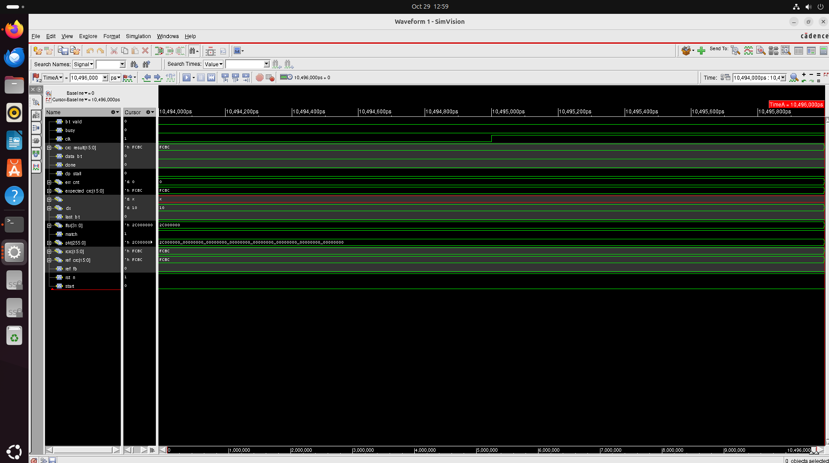

Screenshot from 2026-10-29 13-01-12.png
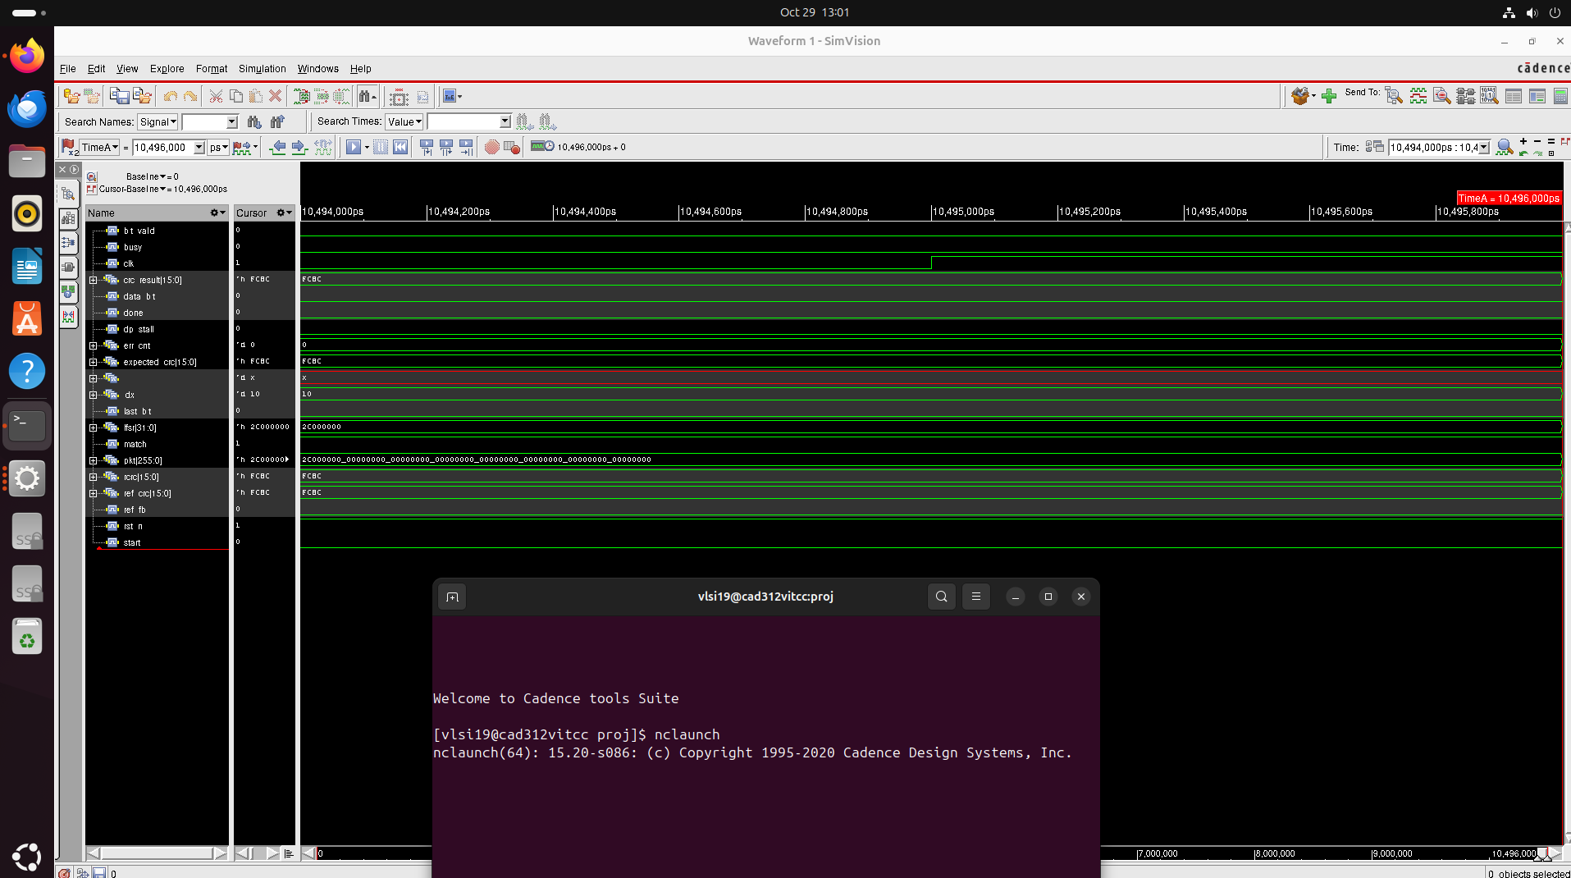

Screenshot from 2026-10-29 13-06-18.png
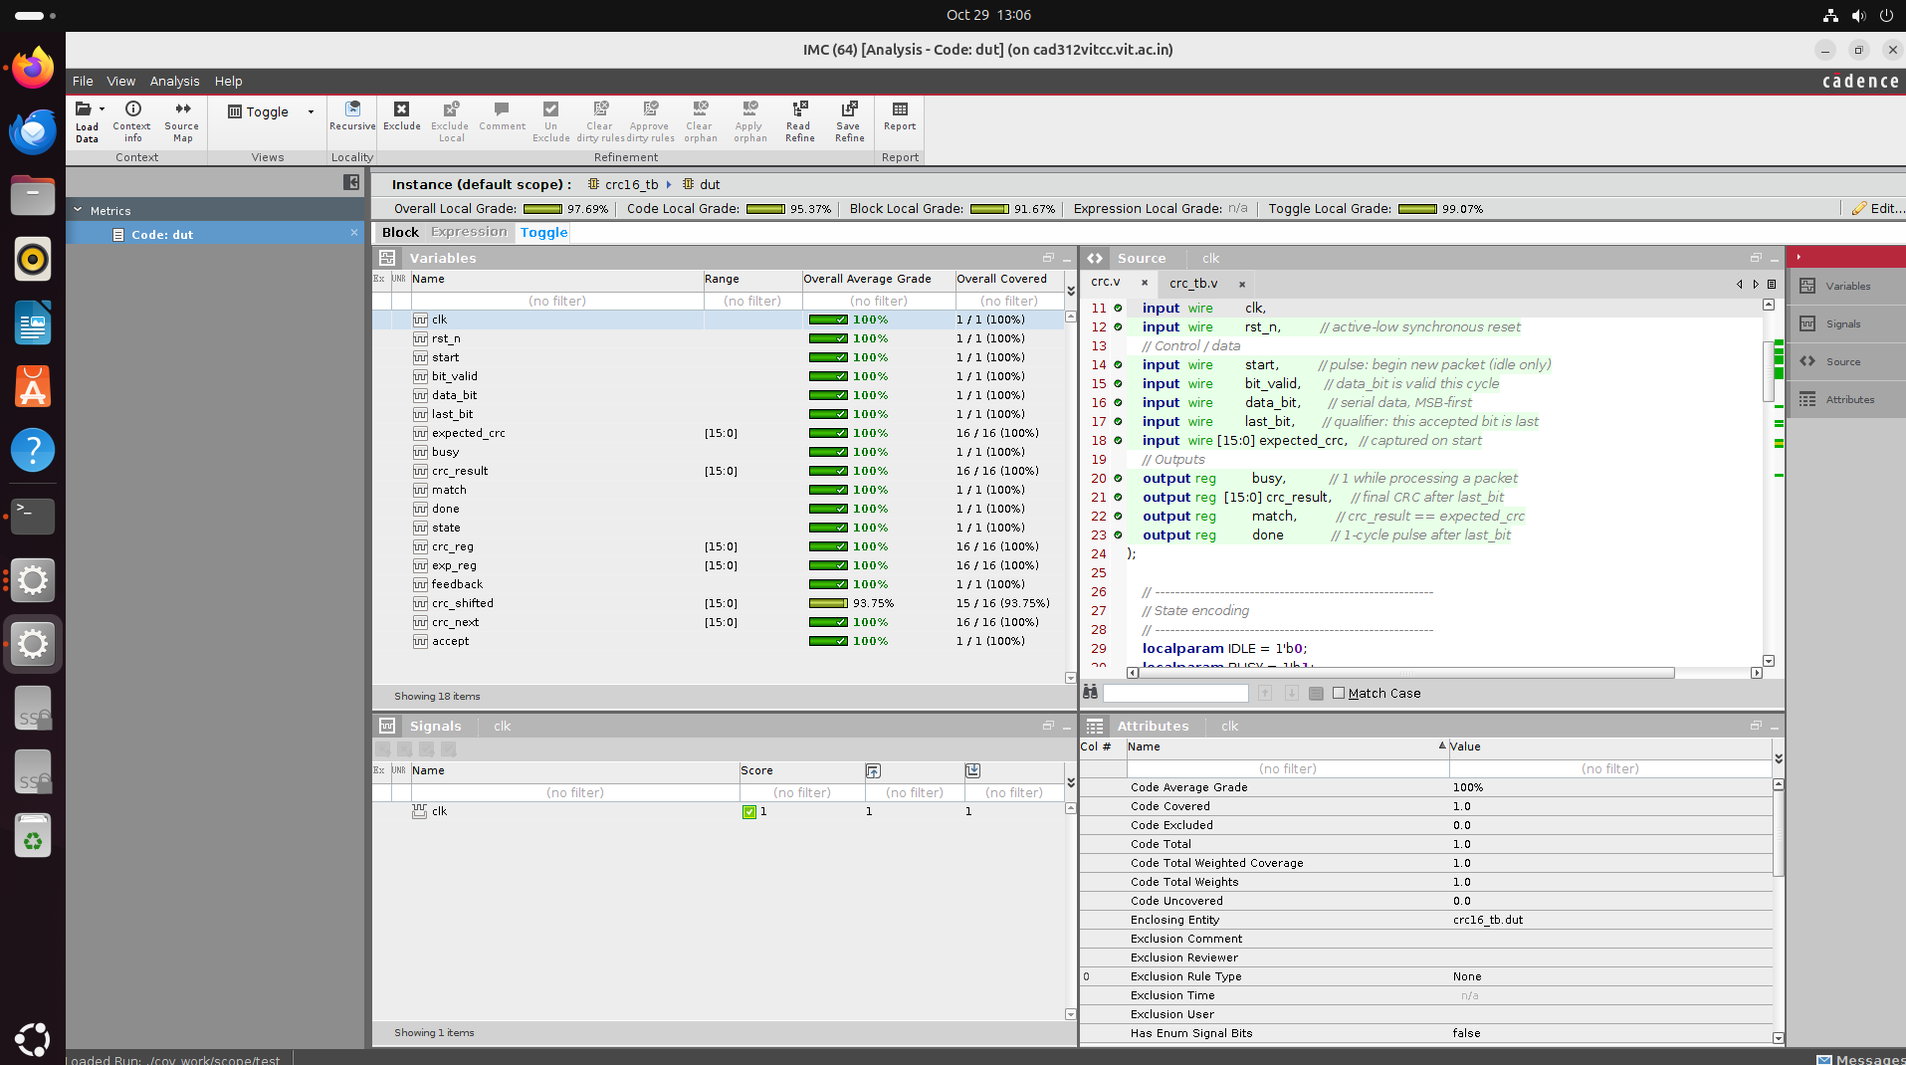

Screenshot from 2026-10-29 13-11-35.png
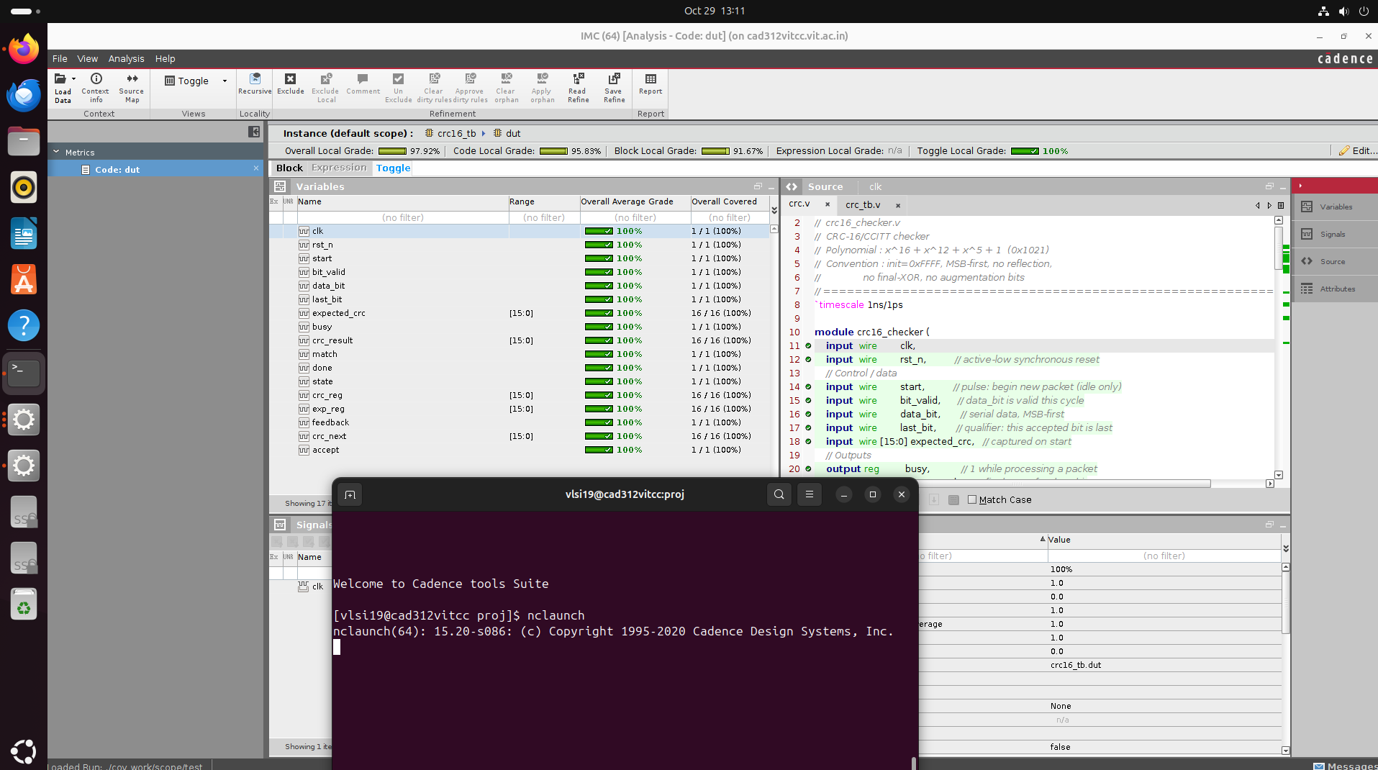

Screenshot from 2026-10-29 13-23-49.png
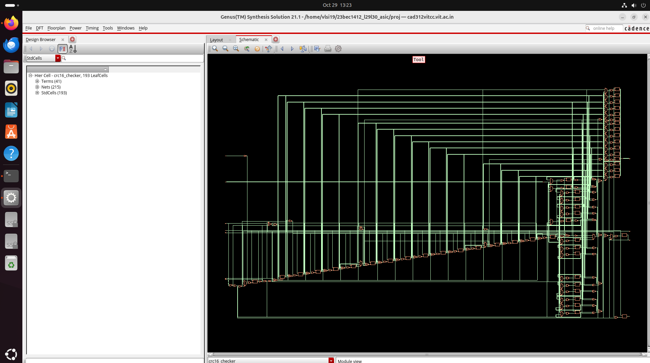

Screenshot from 2026-10-29 13-25-23.png
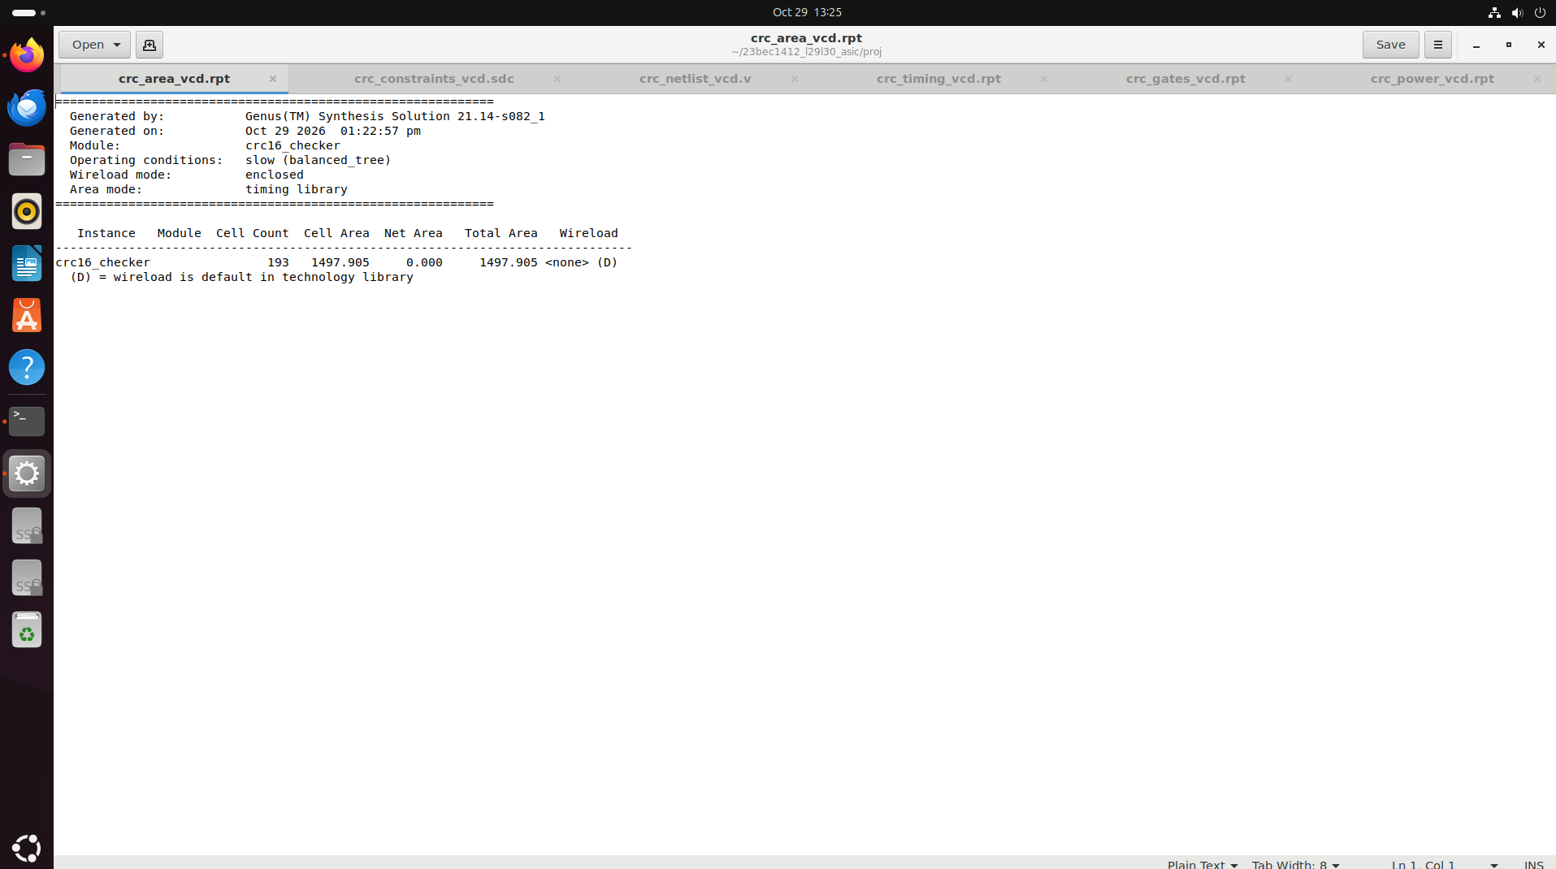

Screenshot from 2026-10-29 13-25-29.png
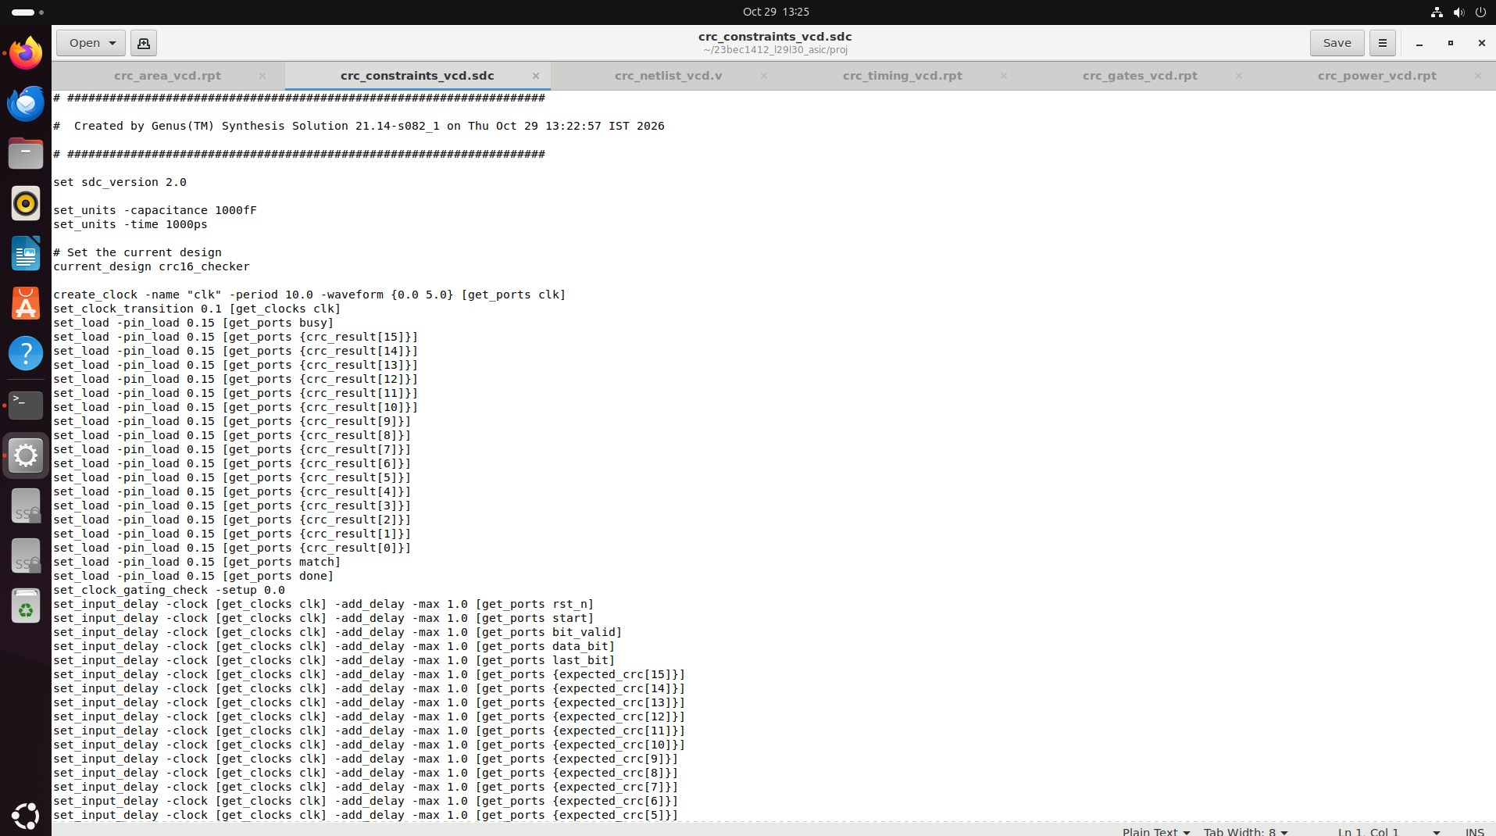

Screenshot from 2026-10-29 13-25-36.png
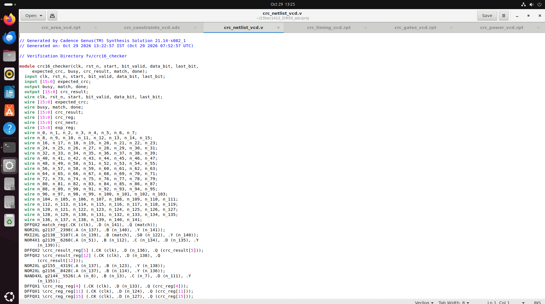

Screenshot from 2026-10-29 13-25-40.png
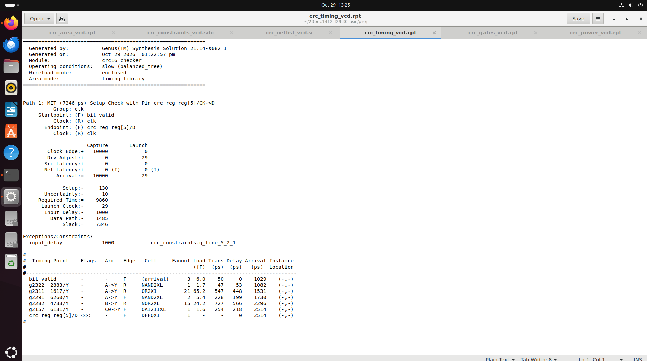

Screenshot from 2026-10-29 13-25-47.png
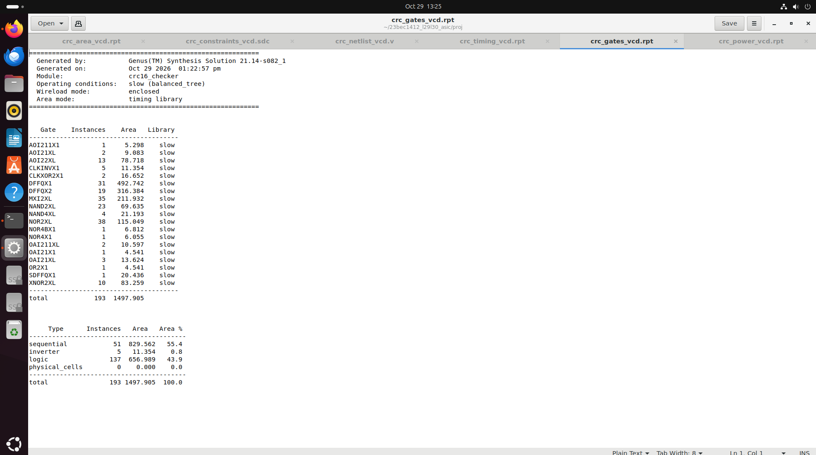

Screenshot from 2026-10-29 13-25-57.png
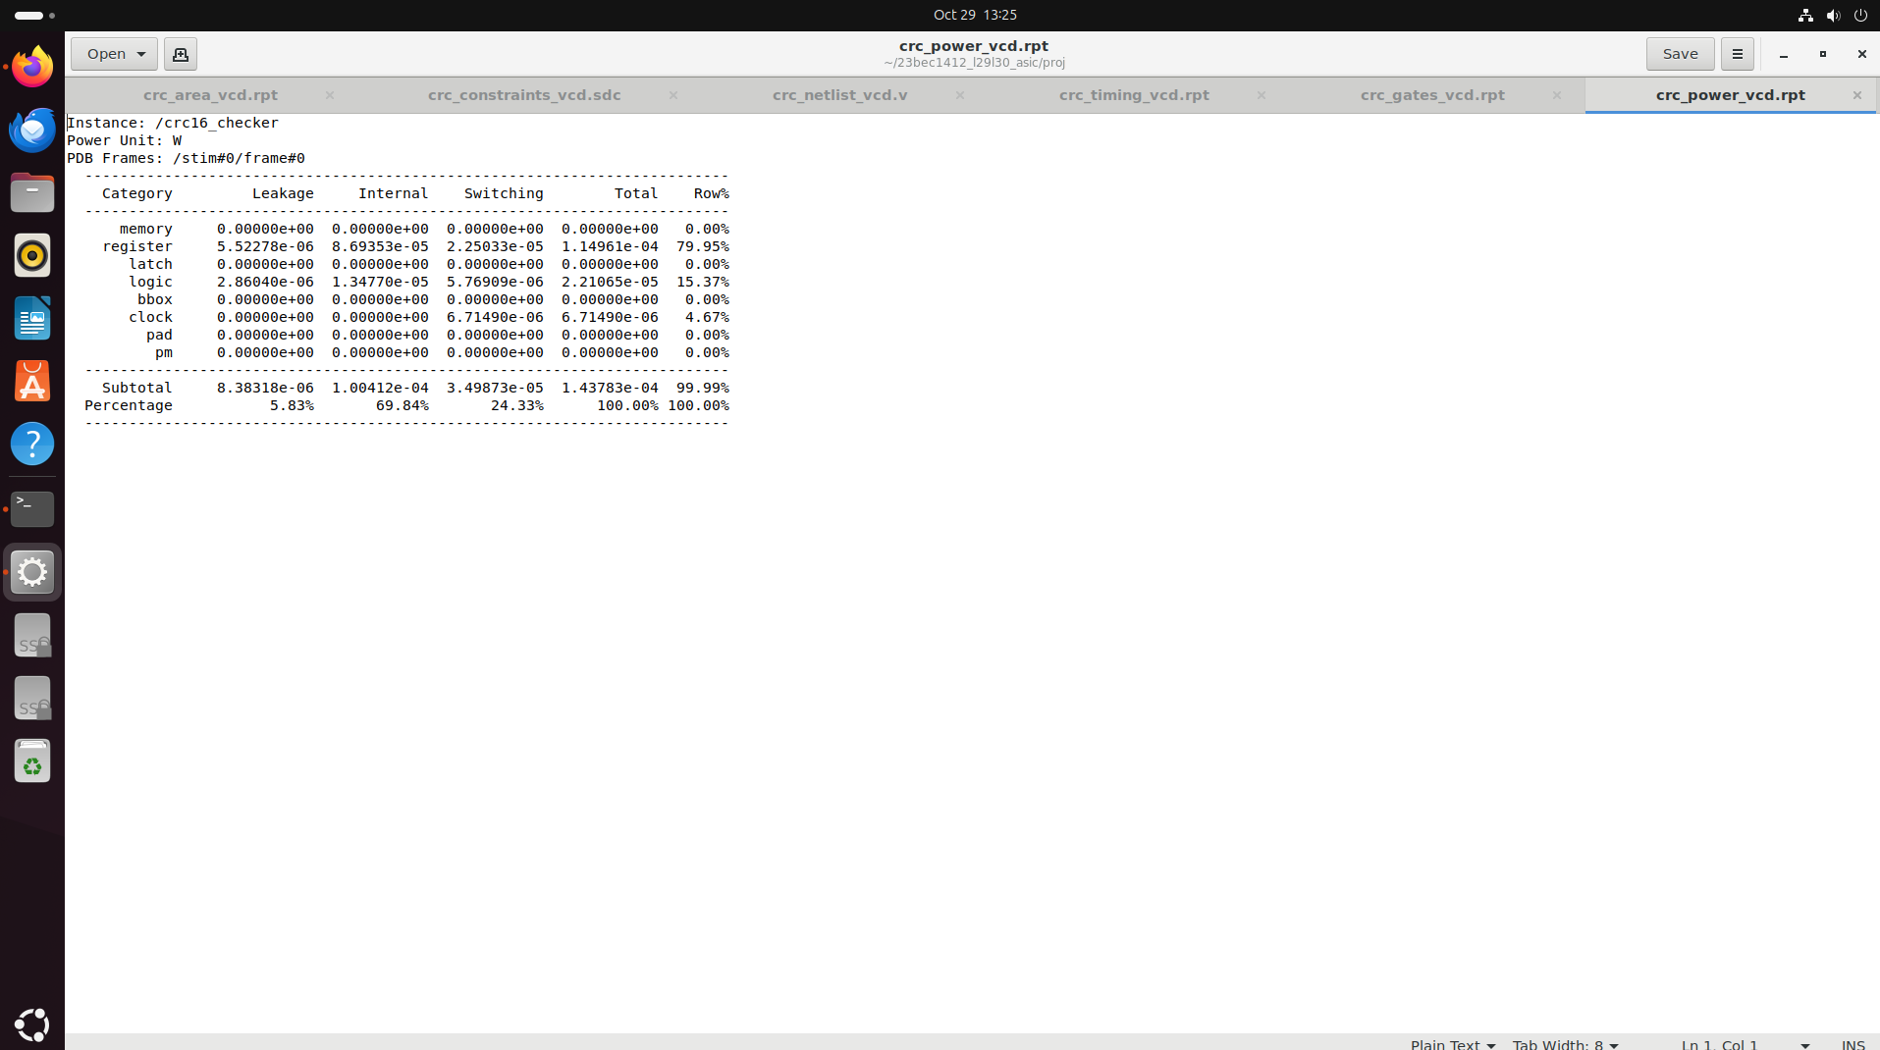

Screenshot from 2026-10-29 13-48-58.png
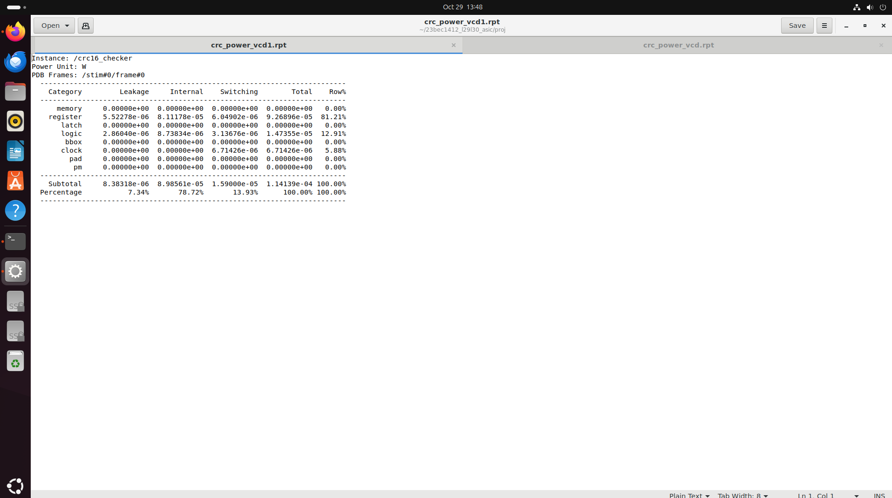

Screenshot from 2026-10-29 13-57-44.png
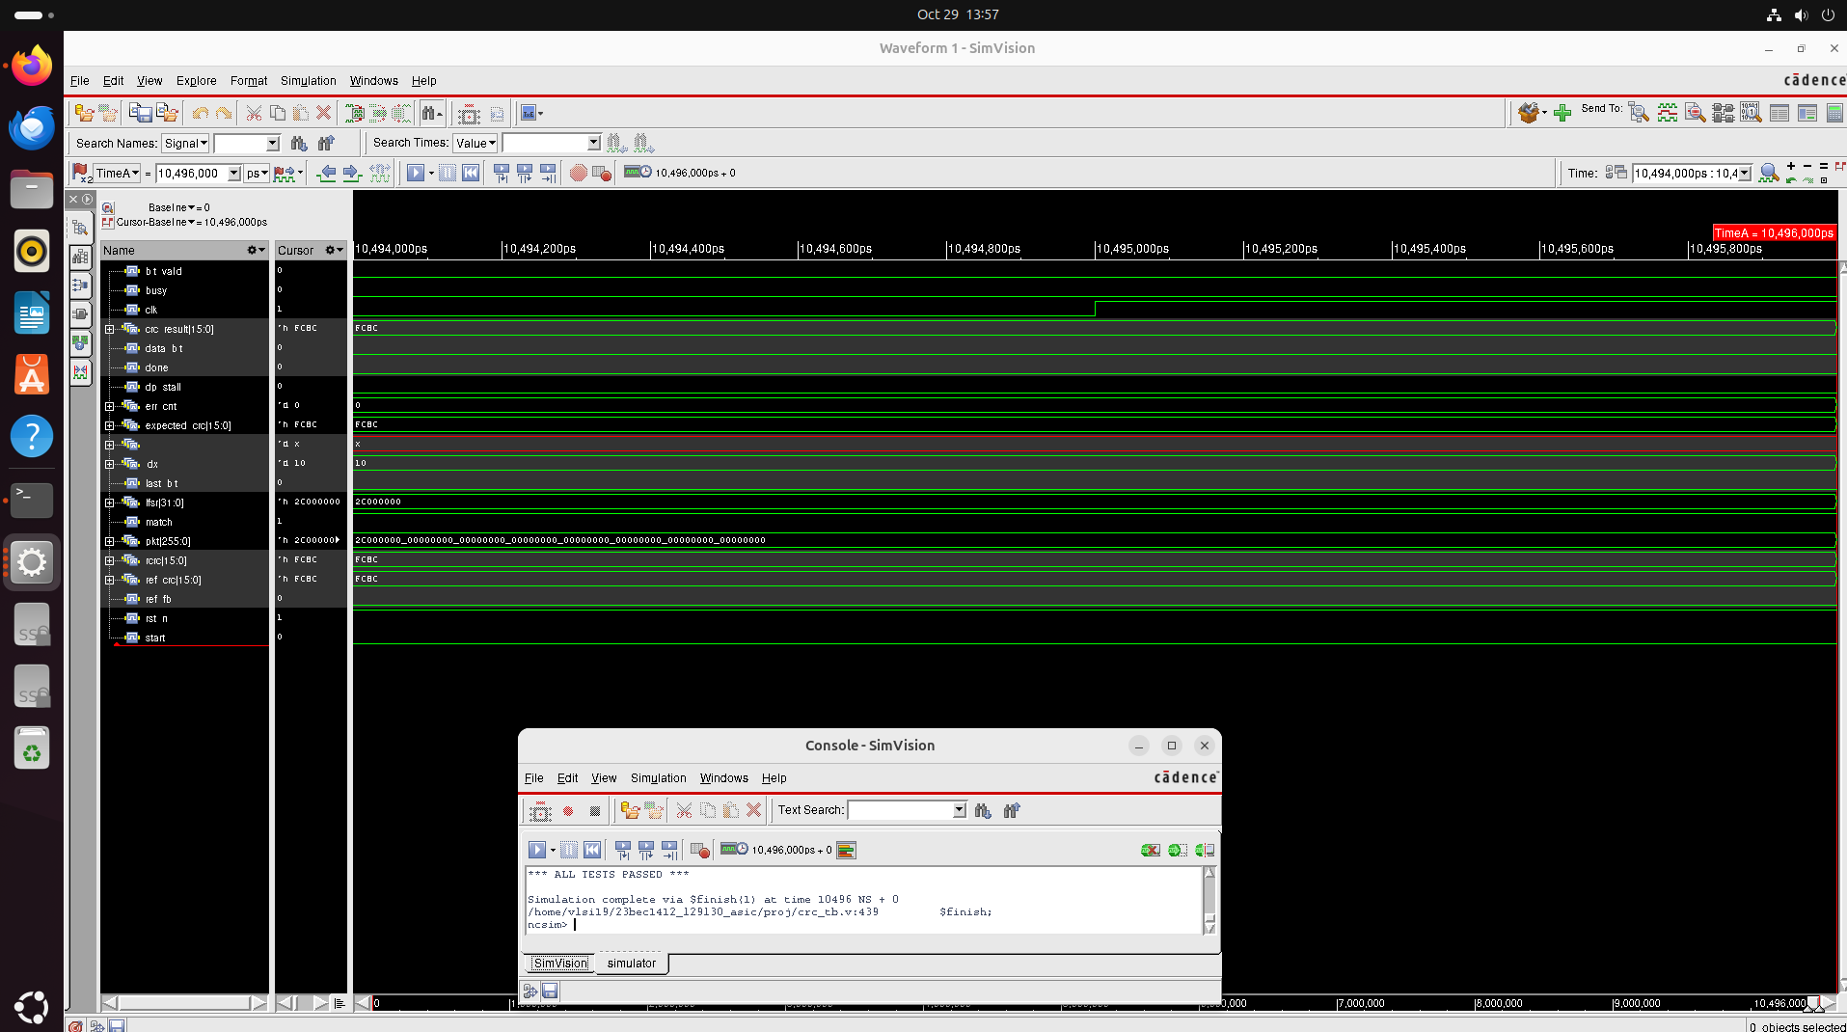

Screenshot from 2026-10-29 14-06-29.png
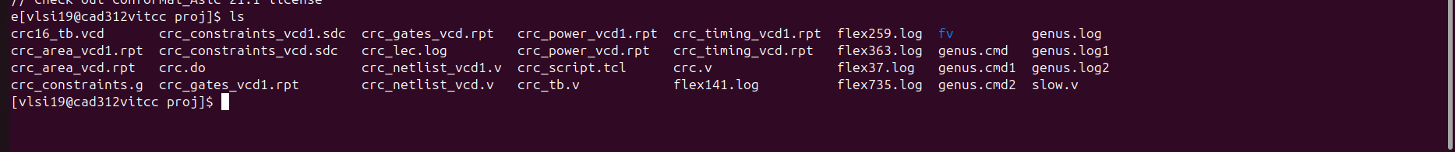

Screenshot from 2026-10-29 14-10-17.png
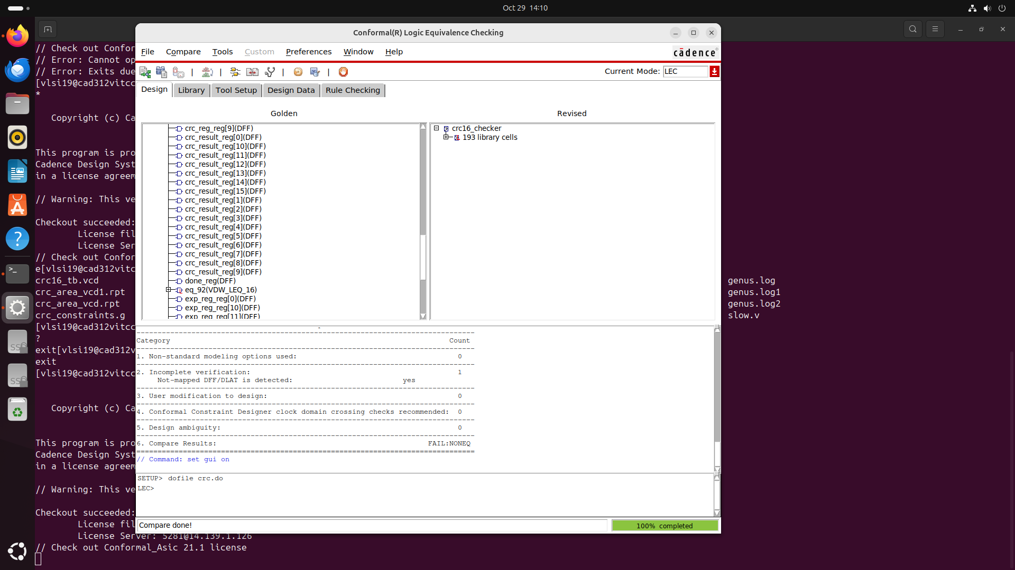

Screenshot from 2026-10-29 14-20-52.png
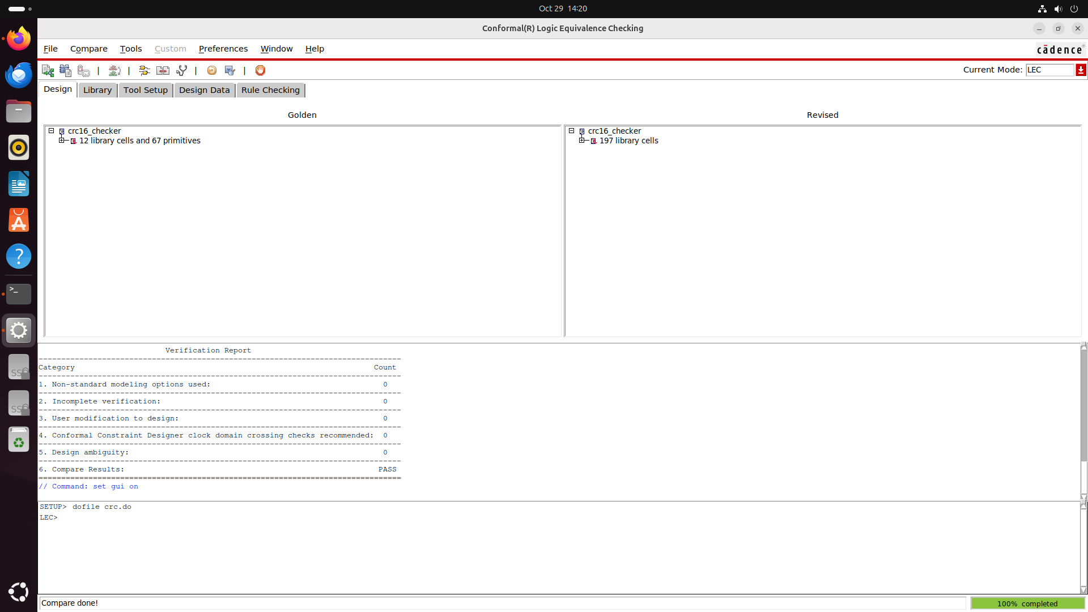

Screenshot from 2026-10-29 14-21-17.png
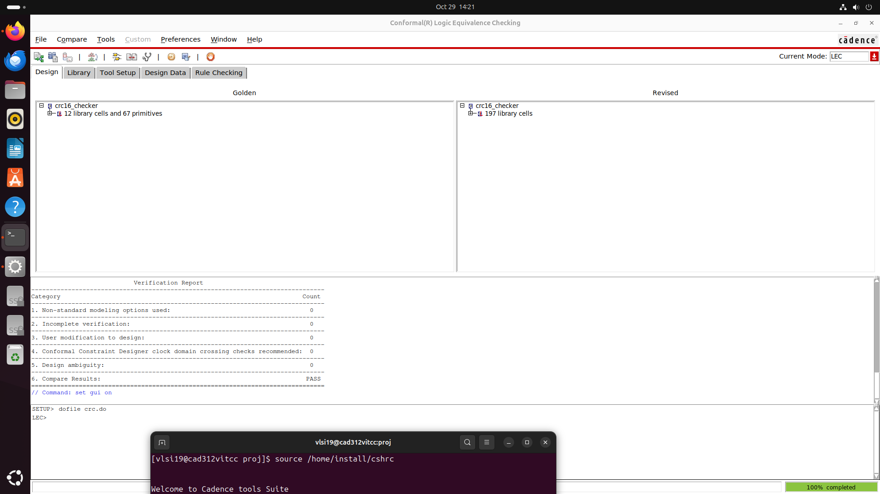

Screenshot from 2026-10-29 14-22-49.png
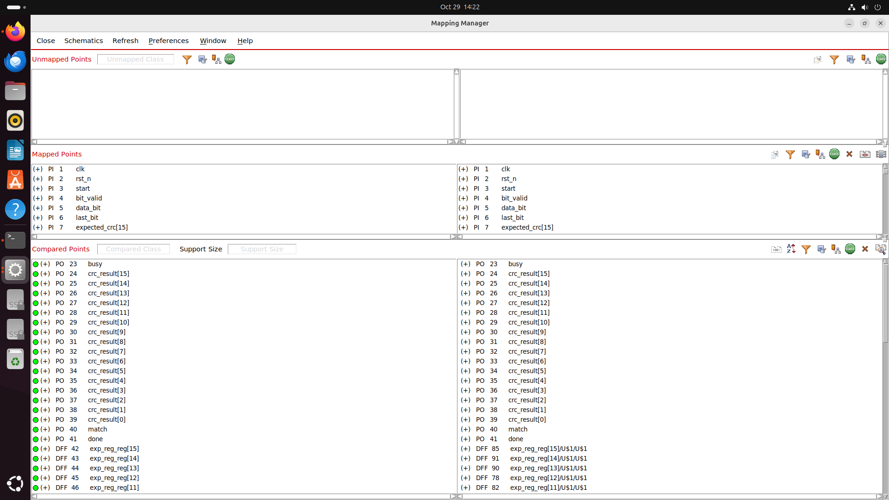

Screenshot from 2026-10-29 14-40-23.png
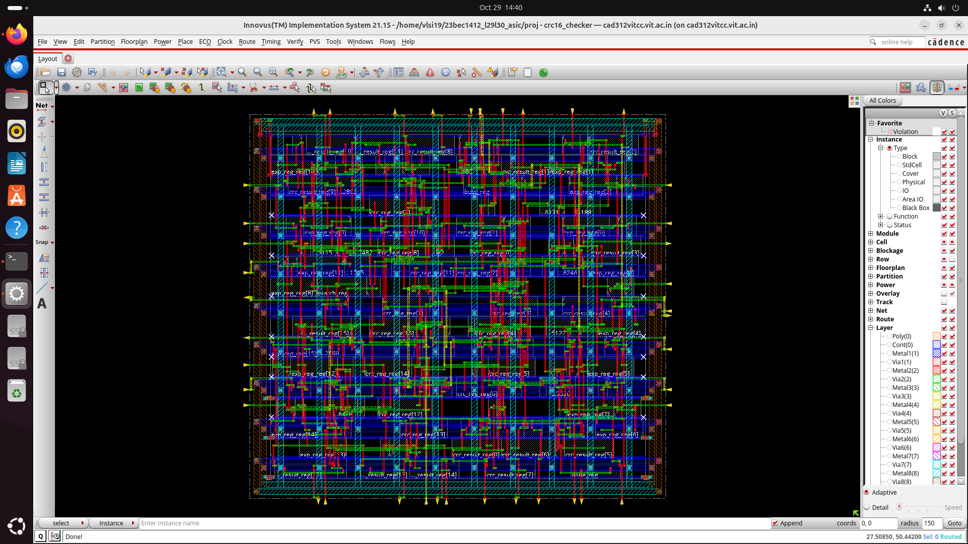

Screenshot from 2026-10-29 14-48-19.png
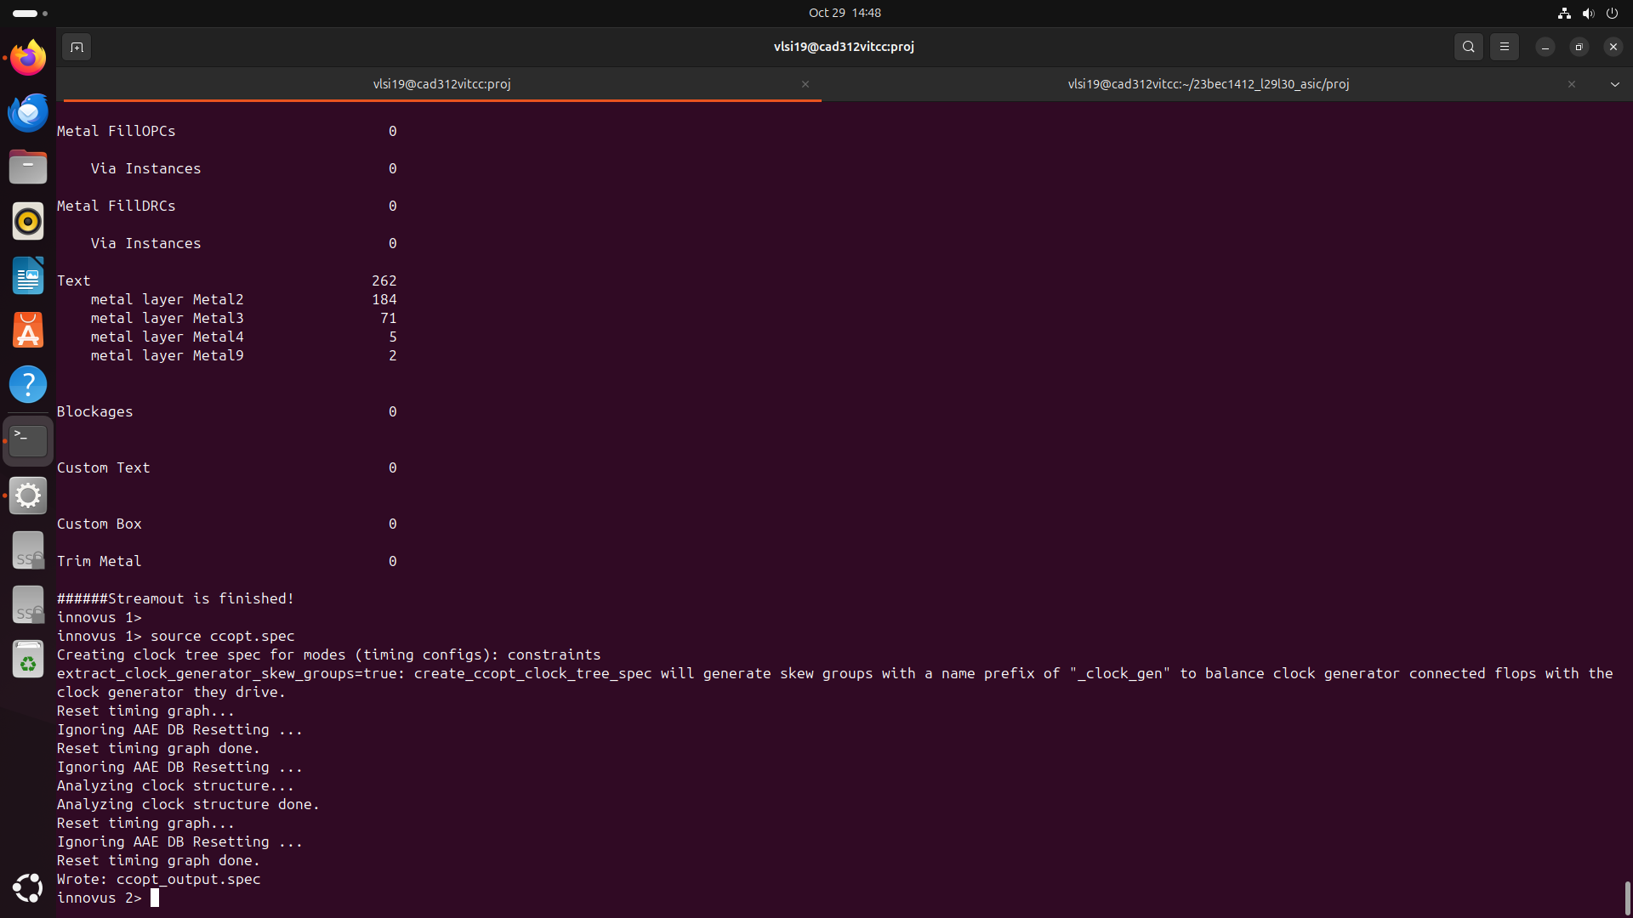

Screenshot from 2026-10-29 14-49-42.png
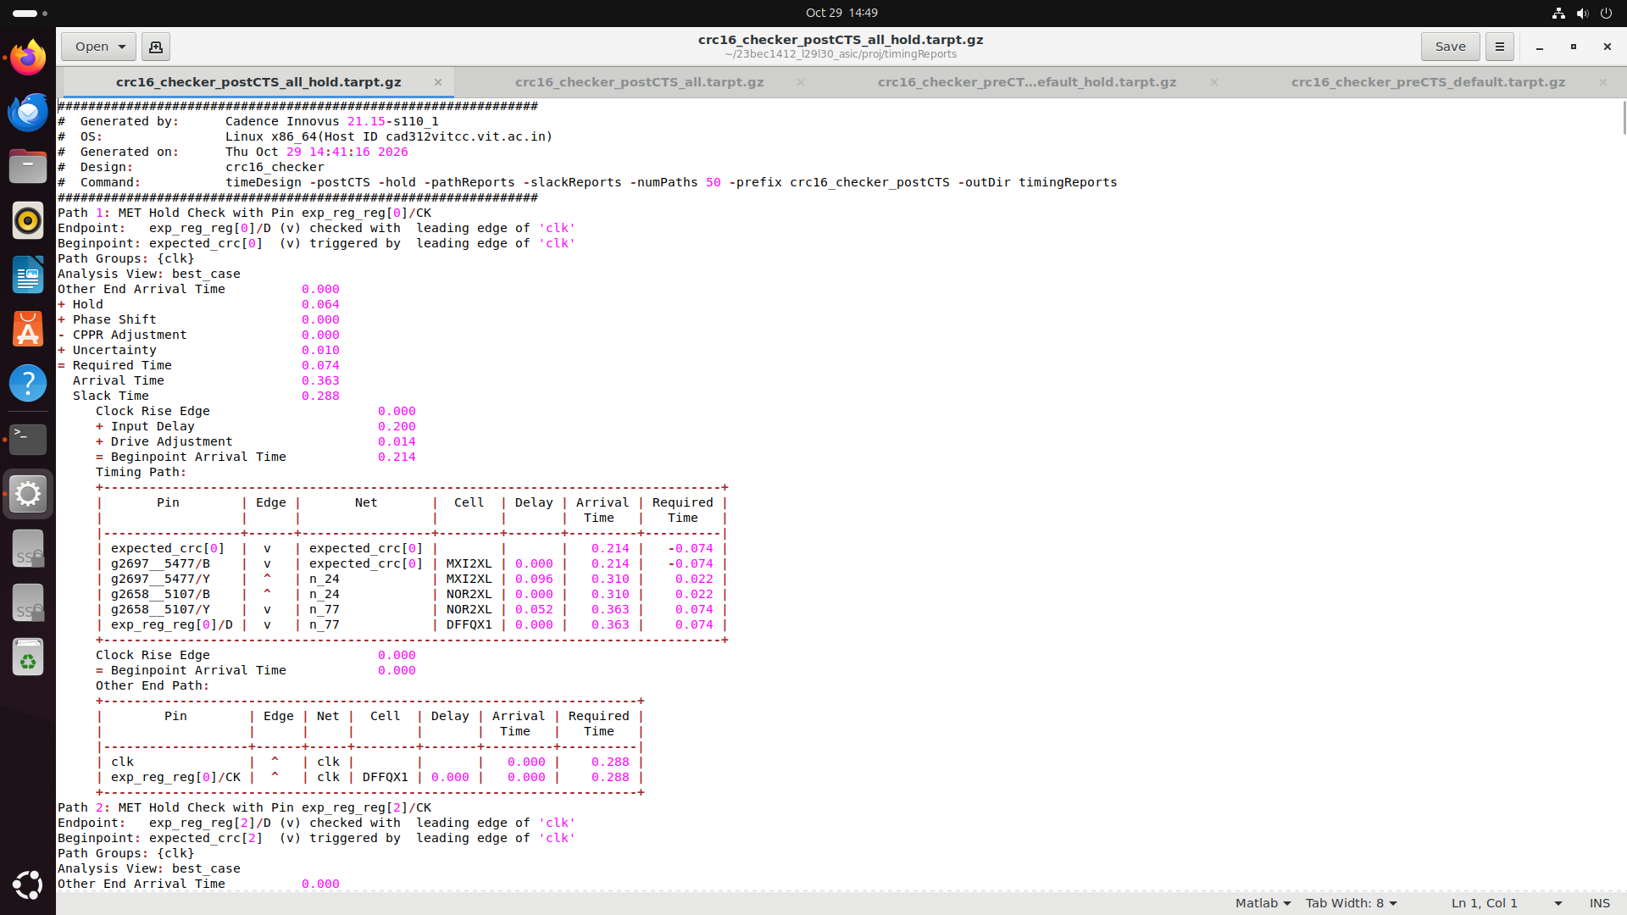

Screenshot from 2026-10-29 14-49-46.png
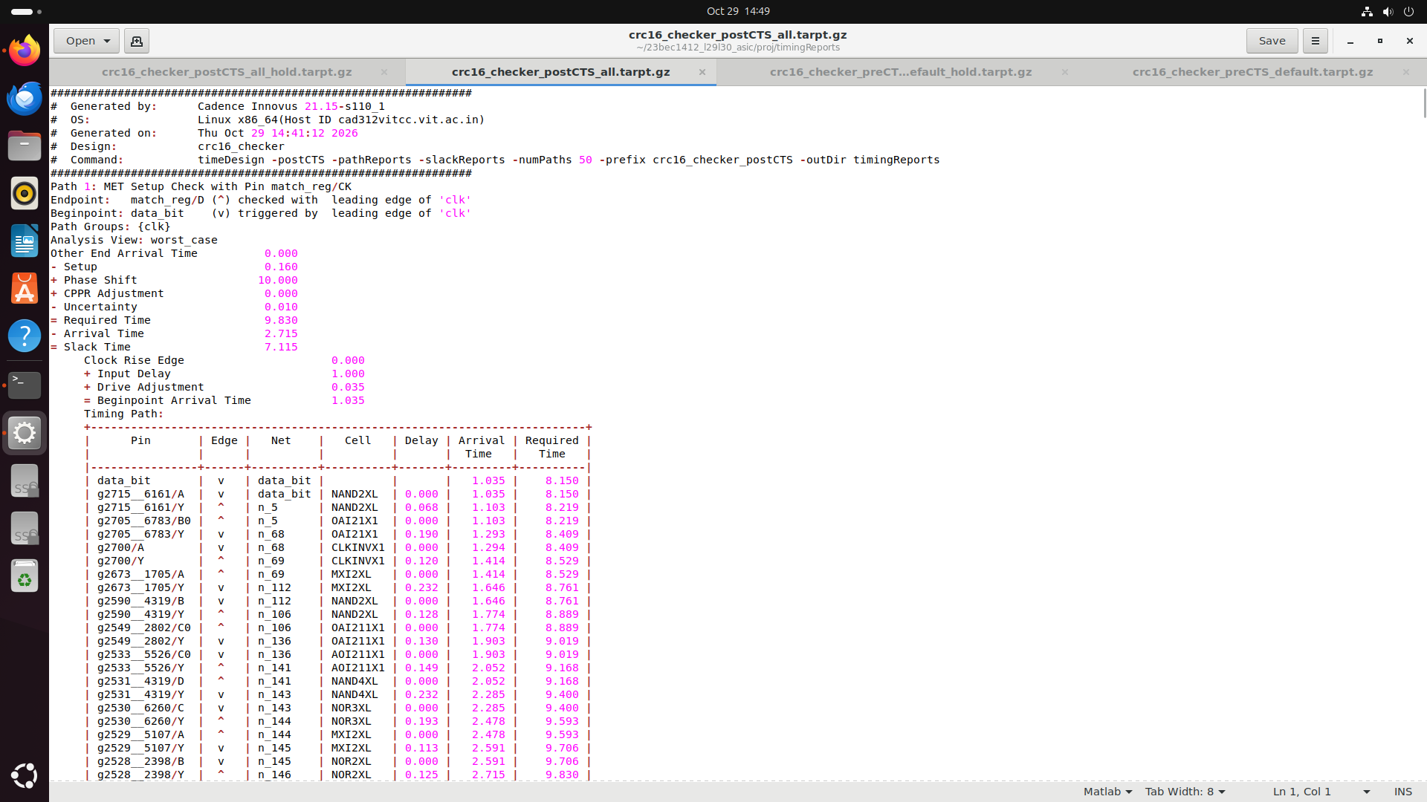

Screenshot from 2026-10-29 14-49-49.png
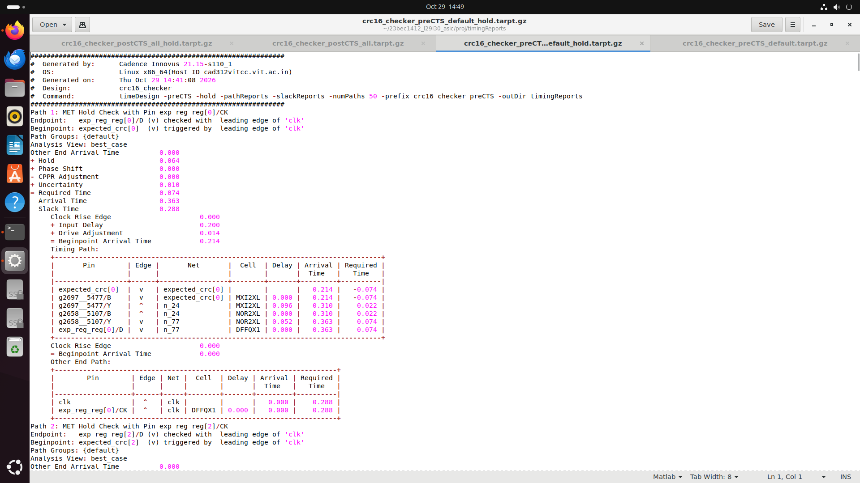

Screenshot from 2026-10-29 14-49-57.png
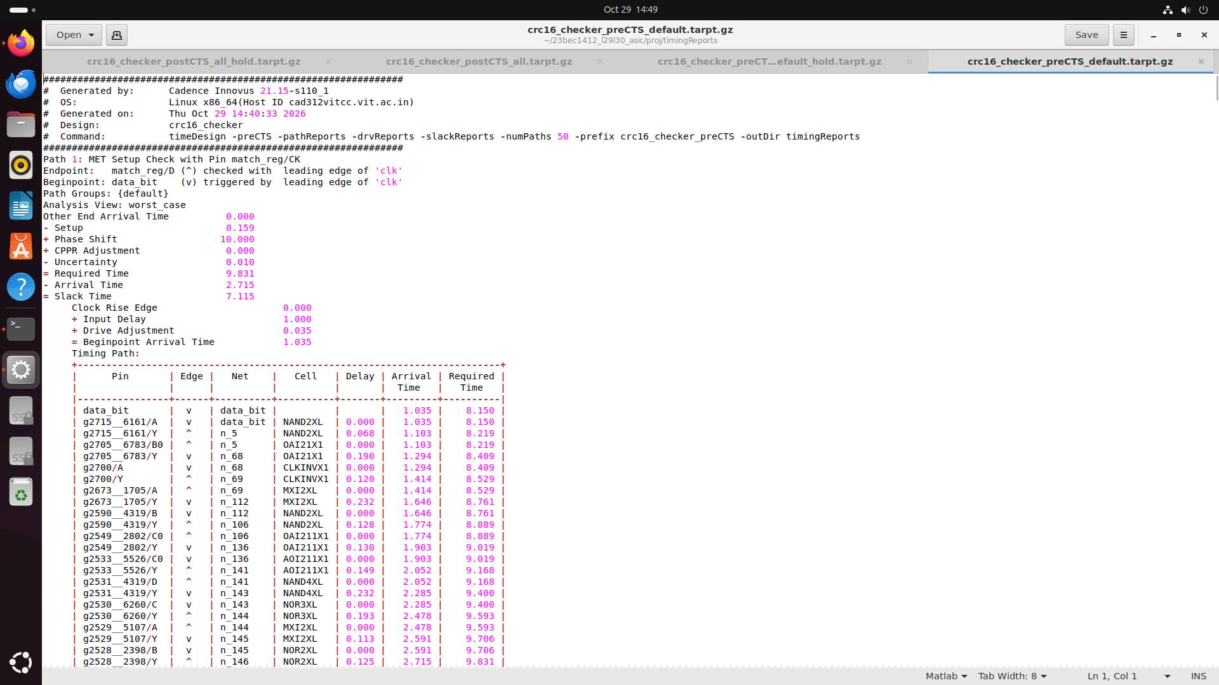

Screenshot from 2026-10-29 14-53-42.png
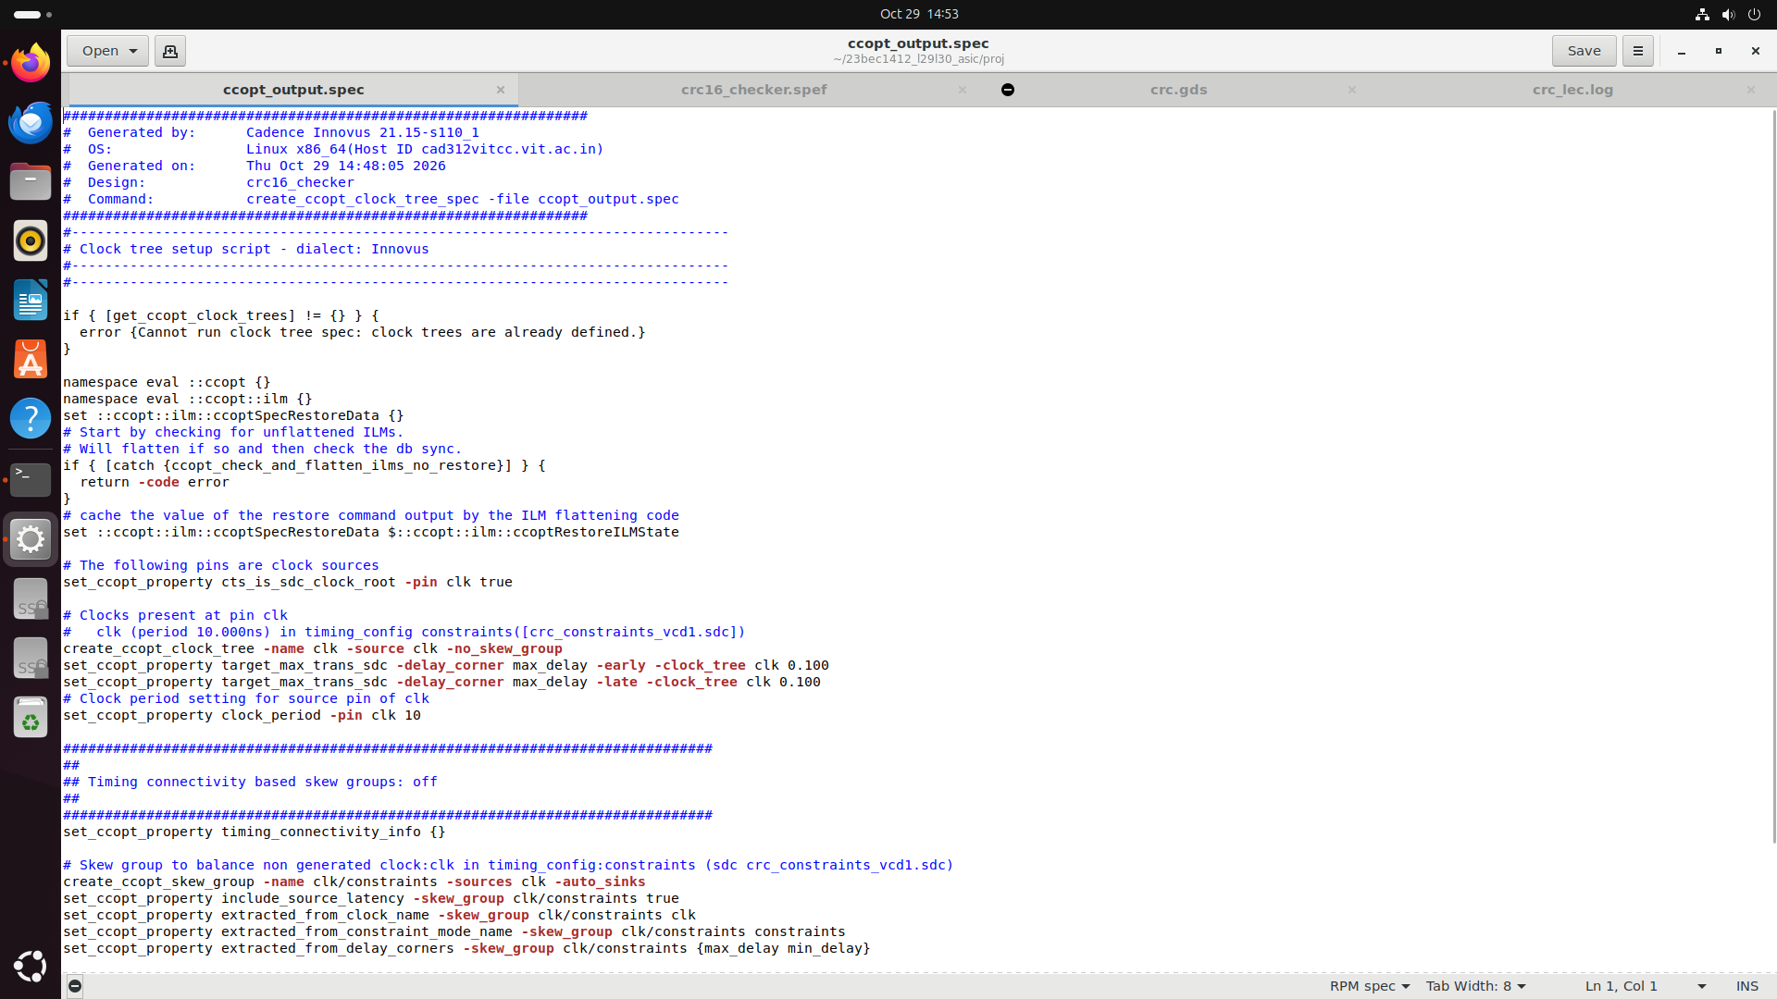

Screenshot from 2026-10-29 14-53-47.png
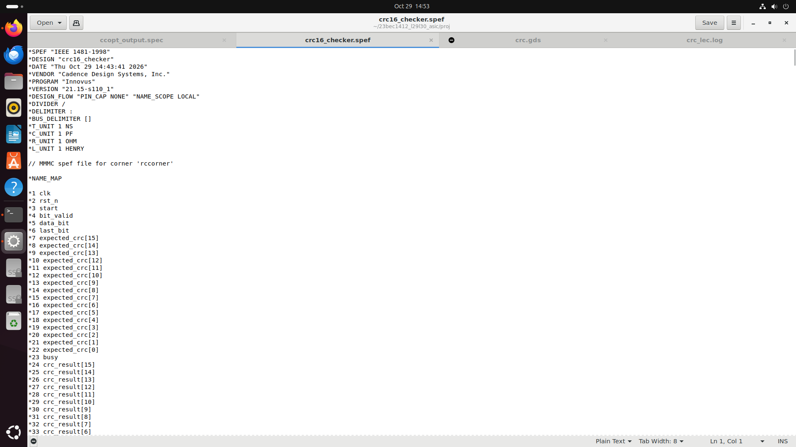

Screenshot from 2026-10-29 14-53-58.png
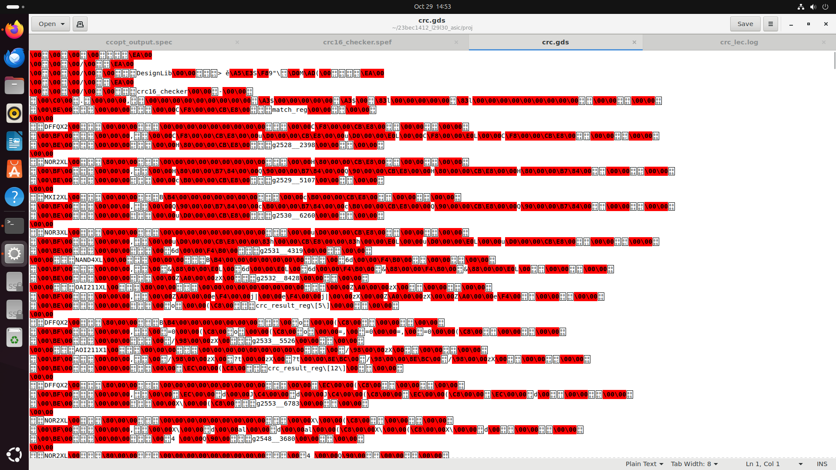

Screenshot from 2026-10-29 14-54-03.png
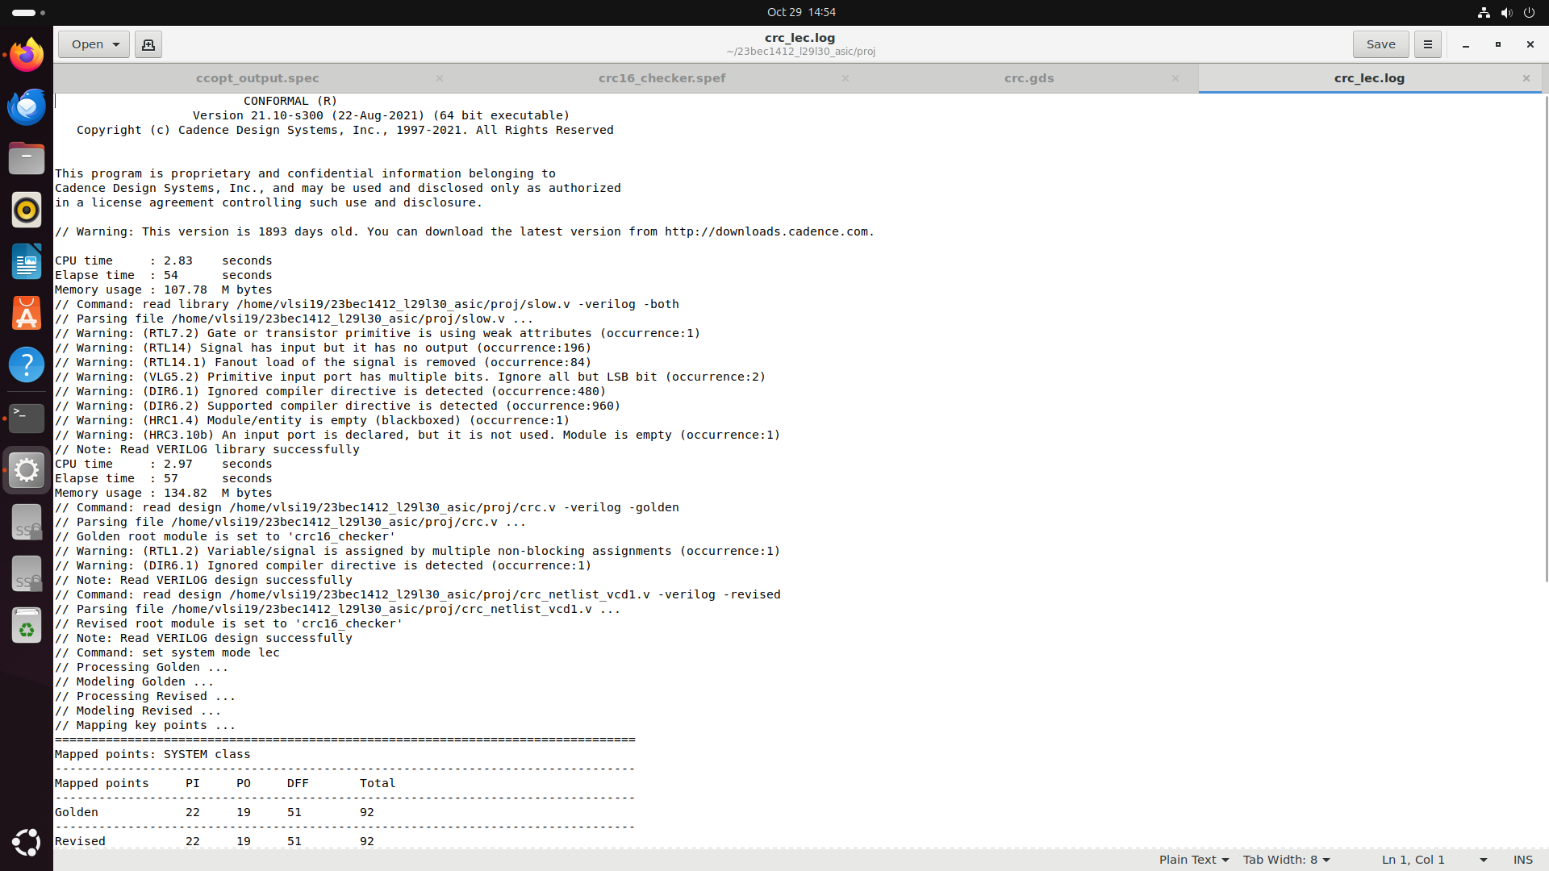

Screenshot from 2026-10-29 14-54-12.png
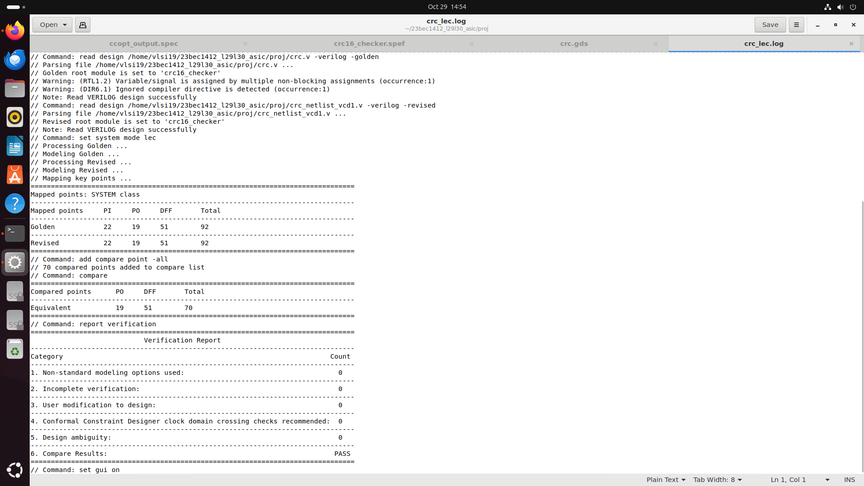

Screenshot from 2026-10-29 14-56-40.png
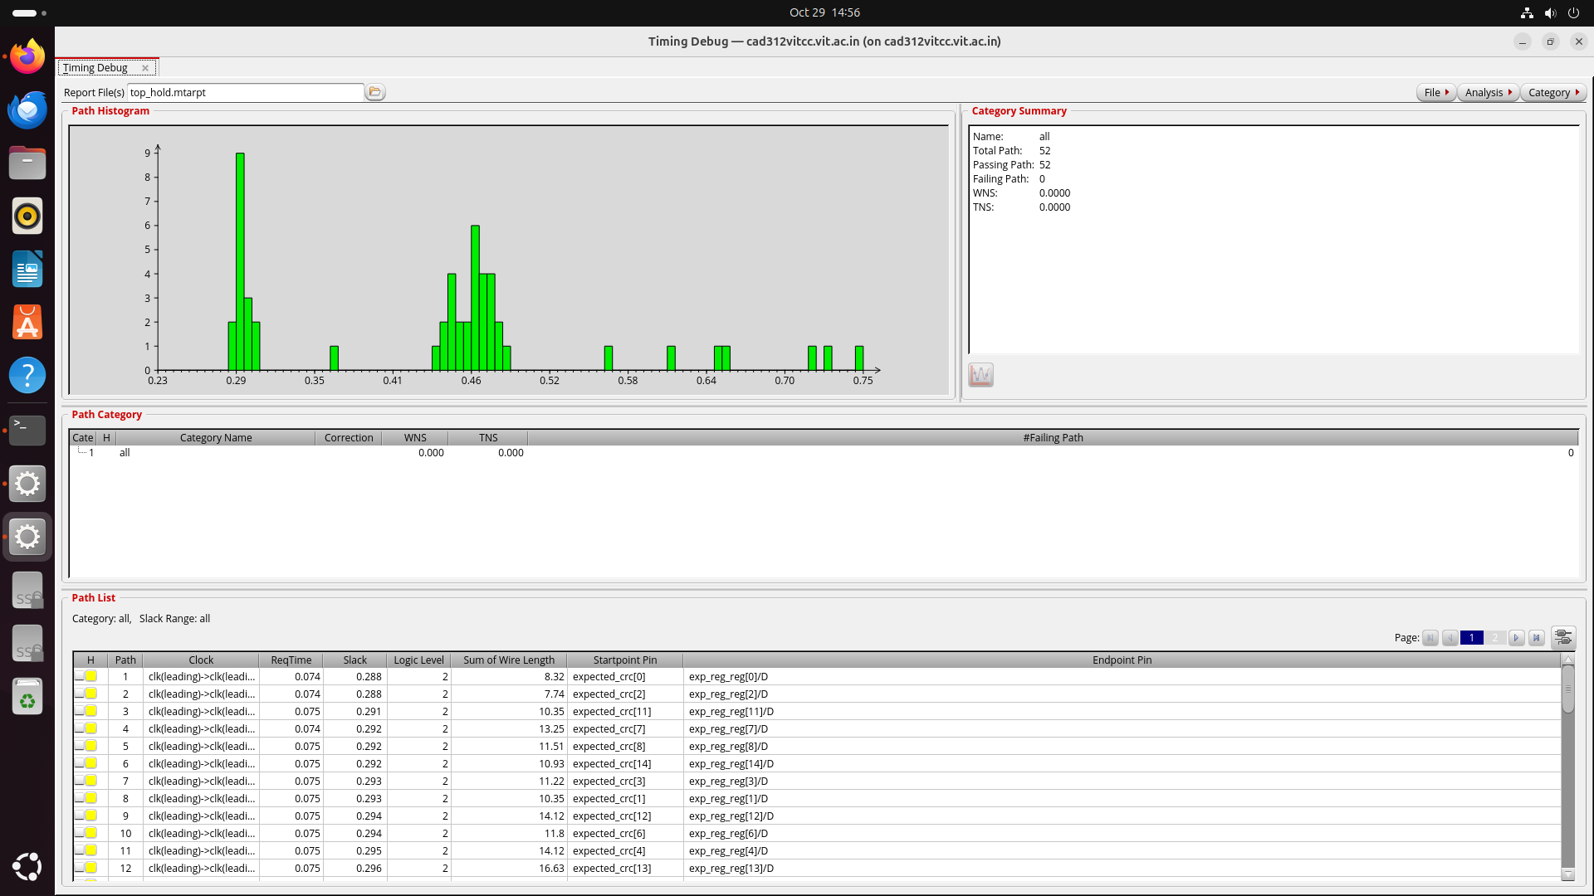

Screenshot from 2026-10-29 14-58-46.png
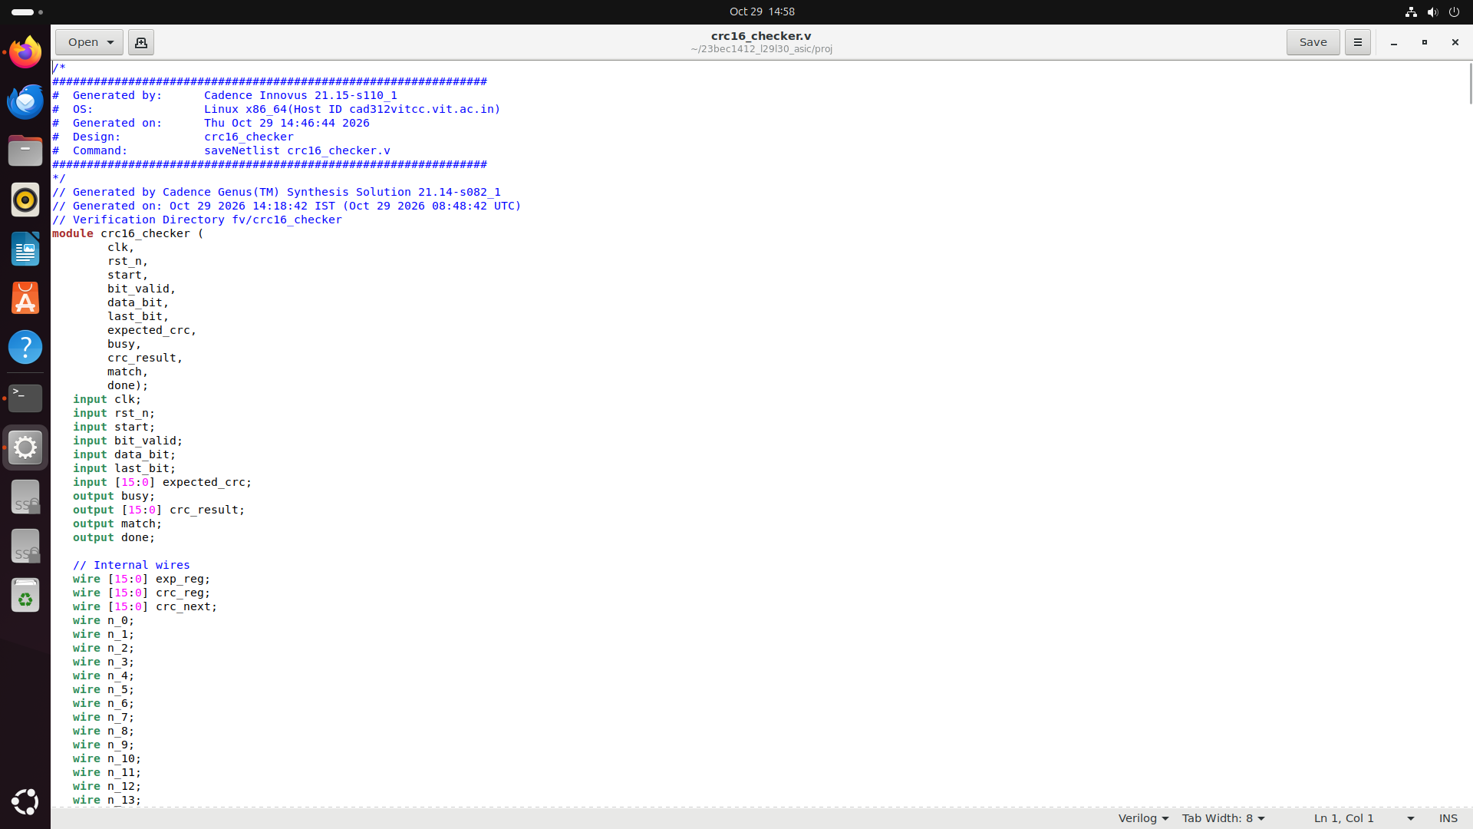

Screenshot from 2026-10-29 15-00-40.png
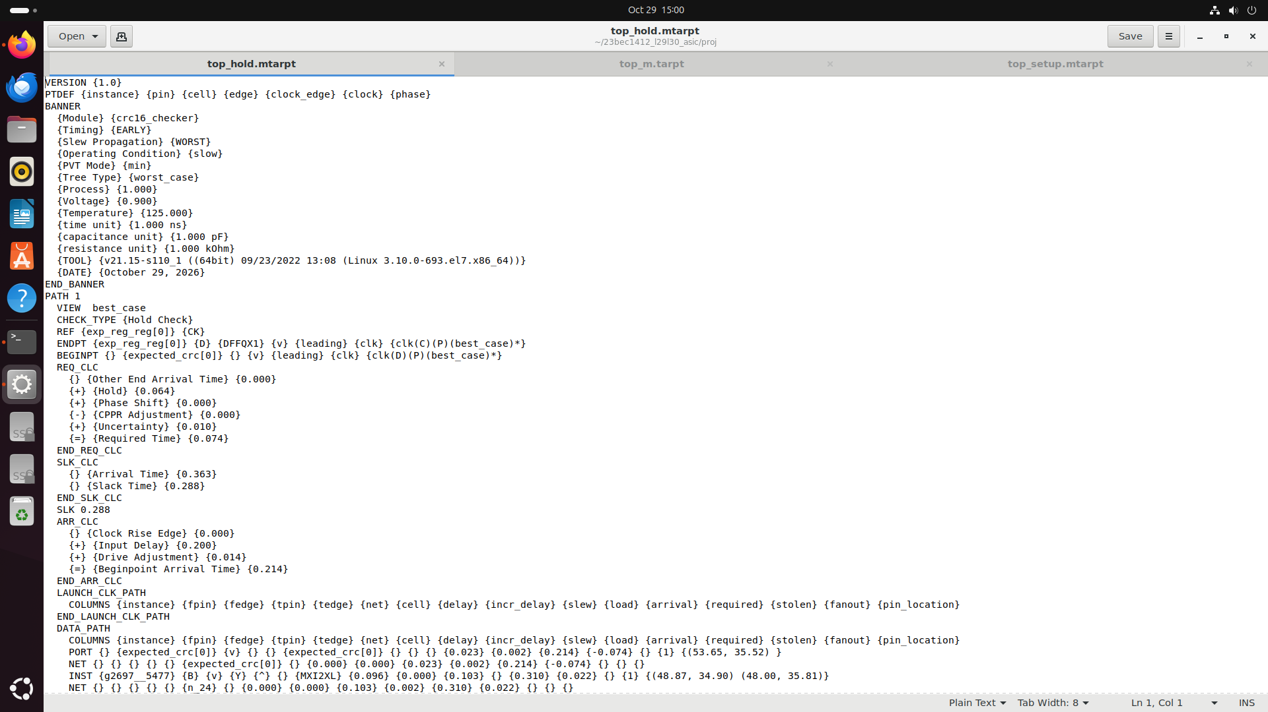

Screenshot from 2026-10-29 15-00-45.png


