**ICT PROJECT**

**Insert Panel and CSS Designer Panel**

**Muhammad Qasim Fuzail 20K-0157**

**Insert panel overview**

The **Insert** panel (Window > Insert) contains buttons for creating and inserting objects such as tables, images, and links. The buttons are organized into several categories, which you can switch by selecting the desired category from the drop-down list at the top.

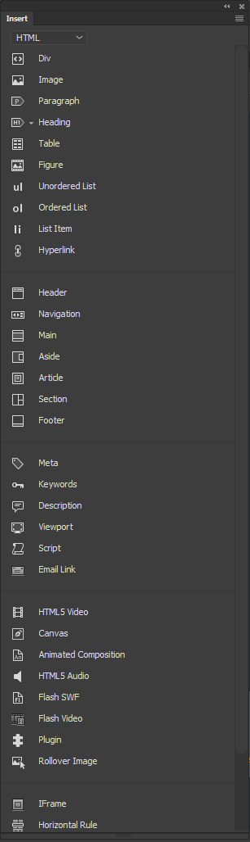

*Insert panel*

Some categories have buttons with pop-up menus. When you select an option from a pop-up menu, it becomes the default action for the button. For example, if you select **Line Break** from the **Character**button’s pop-up menu, the next time you click the **Character** button, Dreamweaver inserts a line break. Anytime you select a new option from the pop-up menu, the default action for the button changes.

The **Insert** panel is organized in the following categories:

**HTML**

Lets you create and insert the most commonly used HTML elements such as **div** tags and objects, such as images, and tables.

**Form**

Contains buttons for creating forms and inserting form elements, such as search, month, and password.

**Templates**

Lets you save the document as a template and mark specific regiions as editable, optional, repeating, or editable optional regions.

**Bootstrap components**

Contains Bootstrap components to provide navigation, containers, dropdowns, and more that you can use in responsive projects.

**jQuery Mobile**

Contains buttons for building sites that use jQuery Mobile.

**jQuery UI**

Lets you insert jQuery UI elements such as accordion, sliders, and buttons.

**Favorites**

Lets you group and organize the **Insert** panel buttons you use the most in one common place.

**Note:**

 If you are working with certain types of files, such as XML, JavaScript, Java, and CSS, the Insert panel and the Design view option are dimmed because you cannot insert items into these code files.

**Insert object**

To insert an object using the Insert panel:

1. Select the appropriate category from the Category pop-up menu of the Insert panel.
2. Do one of the following:
   * Click an object button or drag the button’s icon into the Document window (into Design, Live, or Code View).
   * Click the arrow on a button, then select an option from the menu.

Depending on the object, a corresponding object-insertion dialog box may appear, prompting you to browse to a file or specify parameters for an object. Or, Dreamweaver may insert code into the document, or open a tag editor or a panel for you to specify information before the code is inserted.

For some objects, no dialog box appears if you insert the object in Design view, but a tag editor appears if you insert the object in Code view. For a few objects, inserting the object in Design view causes Dreamweaver to switch to Code view before inserting the object.

**Edit Insert panel preferences**

1. Select Edit > Preferences (Windows) or Dreamweaver > Preferences (Macintosh).
2. In the General category of the Preferences dialog box, deselect Show Dialog When Inserting Objects to suppress dialog boxes when you insert objects such as images, tables, scripts, and head elements or by holding down the Control key (Windows) or the Option key (Macintosh) while creating the object.

**Note:**

When you insert an object with this option off, the object is given default attribute values. Use the Property inspector to change object properties after inserting the object.

**Add, delete, or manage items in the Favorites category of the Insert panel**

1. Select any category in the Insert panel.
2. Right-click (Windows) or Control-click (Macintosh) in the area where the buttons appear, and then select Customize Favorites.
3. In the Cutomize Favorite Objects dialog box, make changes as necessary, and click OK.

To add an object, select an object in the Available Objects pane on the left, and then click the arrow between the two panes or double-click the object in the Available Objects pane.

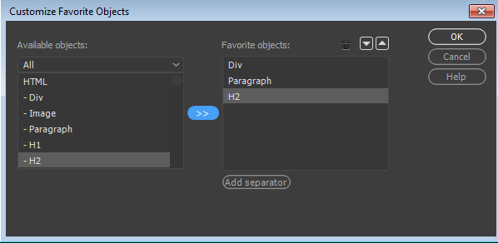

*Customize favorites in the Insert panel*

**Note:**

You can add one object at a time. You cannot select a category name, such as Common, to add an entire category to your favorites list.

* + To delete an object or separator, select an object in the Favorite Objects pane on the right, and then click the Remove Selected Object in Favorite Objects List button above the pane.
  + To move an object, select an object in the Favorite Objects pane on the right, and then click the Up or Down arrow button above the pane.
  + To add a separator below an object, select an object in the Favorite Objects pane on the right, and then click the Add Separator button below the pane.

1. If you’re not in the Favorites category of the Insert panel, select that category to see your changes.

**Files panel overview**

Use the **Files** panel to view and manage the files on your Dreamweaver site.

You can use the Files panel to view files and folders, check whether they are associated with a Dreamweaver site or not, and perform standard file maintenance operations, such as opening and moving files.

The Files panel also helps you manage and transfer files to and from a remote server.

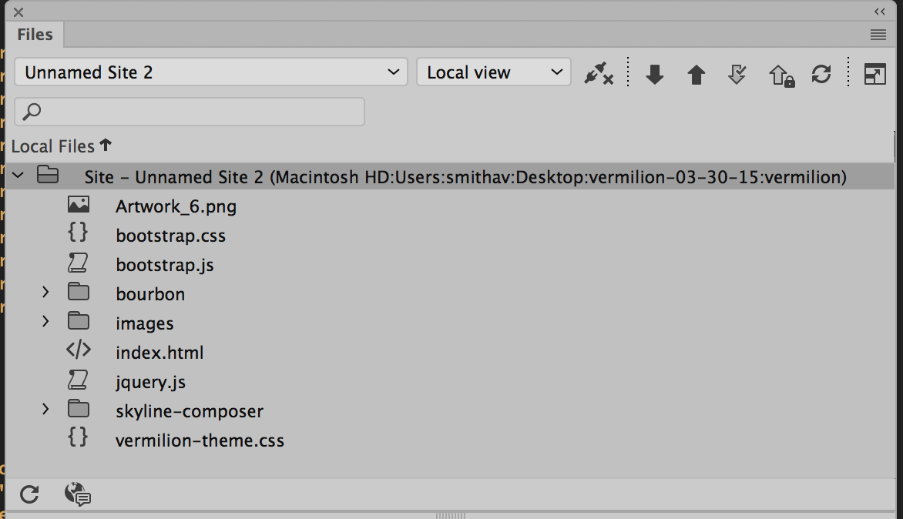

*The Files panel*

For more information on all you can do with the Files panel, see [Manage files and folders](https://helpx.adobe.com/dreamweaver/using/files-folders.html).

**CSS Designer**

CSS Designer panel (**Windows** > **CSS Designer**) is a CSS Property Inspector that lets you 'visually' create CSS styles, files, and set properties, along with media queries.

You can use Ctrl/Cmd+ Z to undo or Ctrl/Cmd + Y to redo all actions you perform in CSS Designer. The changes are automatically reflected in Live View and the relevant CSS file is also refreshed. To let you know that the related file has changed, the affected file’s tab is highlighted for a while (around 8 seconds).

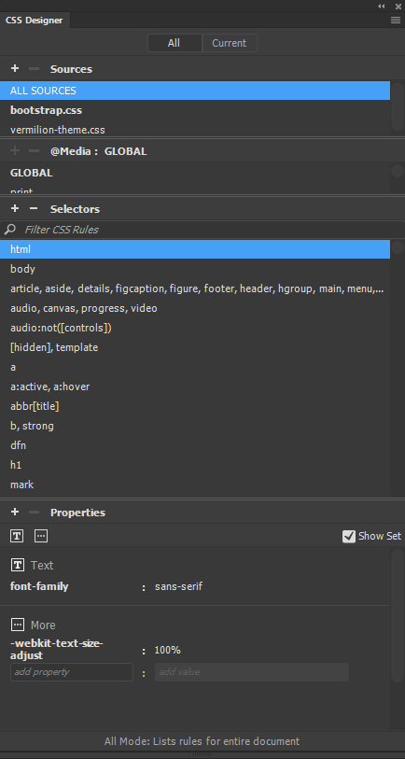

*CSS Designer panel*

The CSS Designer panel consists of the following panes and options:

**All**Lists all the CSS, media queries, and selectors associated with the current document. You can filter for the required CSS rules and modify the properties. You can also use this mode to begin creating selectors or media queries.

This mode is not sensitive to the selection. This means, when you select an element on the page, the associated selector, media query, or CSS are not highlighted in CSS Designer.

**Current**Lists all the computed styles for any selected element in Design or Live view of the current document. When you use this mode for a CSS file in Code view, all the properties for the selector in focus are displayed.

This mode is context-sensitive. Use this option to edit the properties of selectors associated with selected elements in the document.

**Sources**Lists all the CSS style sheets associated with the document. Using this pane, you can create and attach a CSS to the document, or define styles within the document.

**@Media**Lists all the media queries in the source selected in the Sources pane. If you do not select a specific CSS, this pane displays all the media queries associated with the document.

**Selectors**Lists all the selectors in the source selected in the Sources pane. If you also select a media query, this pane narrows down the list of selectors for that media query. If no CSS or media queries are selected, this pane displays all the selectors in the document.

When you select Global in the @Media pane, all the selectors that are not included in a media query of the selected source are displayed.

**Properties**Displays properties that you can set for the specified selector. For more information, see [Set properties](https://helpx.adobe.com/dreamweaver/using/css-designer.html#set-properties).

If you collapse or expand the panes in CSS Designer, the sizes of the panes are remembered within a session. Sources and Media panes stick to the customized sizes until you change their sizes again.

**Note:**When you select a page element, the most specific Selector is selected in the Selectors pane. To view the properties of a specific Selector, click the name of that Selector in the pane.

To view all the selectors, you can choose All Sources in the Sources pane. To view selectors that do not belong to any media query in the selected source, click Global in the @Media pane.