**Lab10**

**20k-0157**

**Section D**

**Task1**

#include <stdio.h>

#include <stdlib.h>

/* run this program using the console pauser or add your own getch, system("pause") or input loop */

int main(int argc, char *argv[]) {

struct movietype

{

char moviename[20];

char prod[20];

char direct[20];

int year;

int copies;

}e;

printf("Enter the following;\nmoviename,producer,director,year of release and no. of copies;\n");

scanf("%s",e.moviename);

scanf("%s",e.prod);

scanf("%s",e.direct);

scanf("%d",&e.year);

scanf("%d",&e.copies);

printf("%s, %s, %s, %d, %d",e.moviename,e.prod,e.direct,e.year,e.copies);

return 0;

}

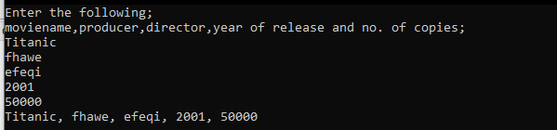

**Task2**

#include <stdio.h>

#include <stdlib.h>

/* run this program using the console pauser or add your own getch, system("pause") or input loop */

int main(int argc, char *argv[]) {

struct menuitemtype

{

char menuitem[20];

double menuprice;

}c;

strcpy(c.menuitem,"pizza");

c.menuprice=20.3;

printf("%s\n%.2lf",c.menuitem,c.menuprice);

return 0;

}



**Task3**

#include <stdio.h>

#include <stdlib.h>

/* run this program using the console pauser or add your own getch, system("pause") or input loop */

int main(int argc, char *argv[]) {

struct checkingaccount

{

char name[20];

int accnum;

double balance;

double rate;

}user;

user.balance=29000;

user.rate=2;

printf("Enter Account Holder's Name;\n");

scanf("%s",user.name);

printf("Enter account number;\n");

scanf("%d",&user.accnum);

printf("%s's account balance is $%.3lf.\n",user.name,user.balance);

printf("He is paying interest on a rate of %.2lf%%\n",user.rate);

printf("He has to pay $%.2lf",user.balance*0.02);

return 0;

}

