Q1.

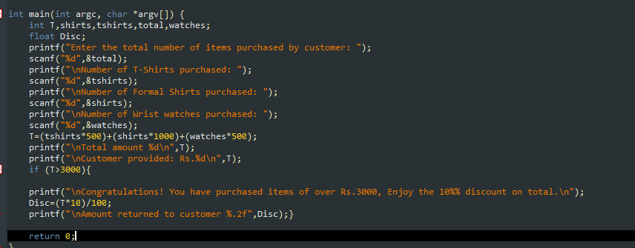

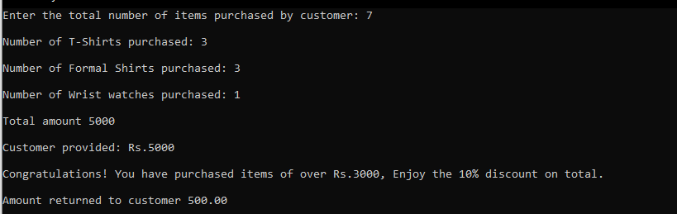

Q2.

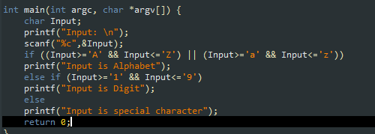 

Q3.

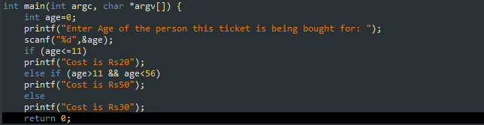



Q4.

a)

void main() {

int x=40,y=30,z=80;

if(x<y && y<z)

{printf("\n Hello world");}

else

{printf("\nGood bye");}

}

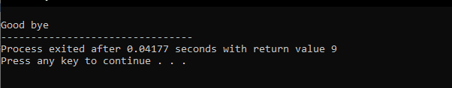

b)

void main ()

{

double a; int x;

if(a>=0 && x==1)

printf("OK all right");

else if(a!=0 || x>=3)

printf("wrong answer");

}

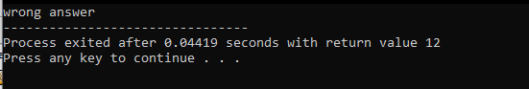

Q5.

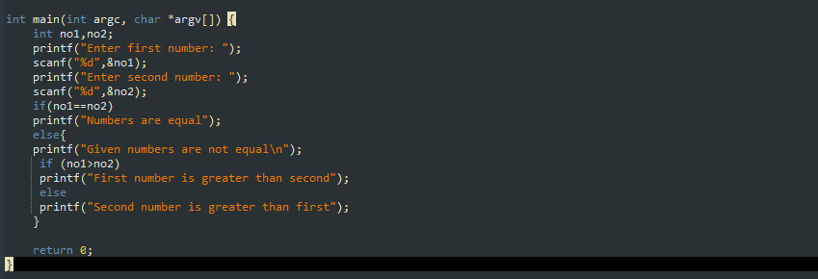

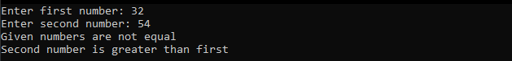

Q6.

**int main(int argc, char *argv[]) {**

**int total_order=0,i,quantity,b=0,s=0,p=0,f=0;**

**float price,b1=0,s1=0,p1=0,f1=0;**

**char Snack1;**

**printf("\t\t ABC Resturant Online Ordering Portal \n");**

**printf("\t\t\t Welcome!\n");**

**printf("Please select from the following menu; \n");**

**printf("B= Burger \nF= French Fries \nP= Pizza\nS= Sandwiches\n");**

**printf("-------------------------------------------\n");**

**printf("How types of snacks you need to order: ");**

**scanf("%d",&total_order);**

**for (i=1;i<=total_order;i++){**

**printf("\nEnter the snack#%d you want to order: ",i);**

**scanf(" %c",&Snack1);**

**printf("\nEnter the quantity: ");**

**scanf(" %d",&quantity);**

**if(Snack1=='B'|| Snack1=='b'){**

**price=price + (quantity*200);**

**b=b+quantity;**

**b1=(quantity*200);**

**}**

**else if (Snack1=='F'|| Snack1=='f'){**

**price=price + (quantity*50);**

**f=f+quantity;**

**f1=(quantity*50);**

**}**

**else if (Snack1=='P'|| Snack1=='p'){**

**price=price + (quantity*500);**

**p=p+quantity;**

**p1=(quantity*500);**

**}**

**else if (Snack1=='S'|| Snack1=='s'){**

**price=price + (quantity*150);**

**s=s+quantity;**

**s1=(quantity*150);**

**}**

**}**

**printf("-------------------------------------------\n");**

**printf("You have ordered!\n");**

**if (b!=0)**

**printf("%d burger (s) of value Rs.%.1f \n",b,b1);**

**if (p!=0)**

**printf("%d pizza (s) of value Rs.%.1f \n",p,p1);**

**if (s!=0)**

**printf("%d sandwiches (s) of value Rs.%.1f \n",s,s1);**

**if (f!=0)**

**printf("%d french fries (s) of value Rs.%.1f \n",f,f1);**

**printf("Total: Rs.%.2f\n",price);**

**printf("Thank you for ordering... Have a Nice Day!");**

**return 0;**

**}**

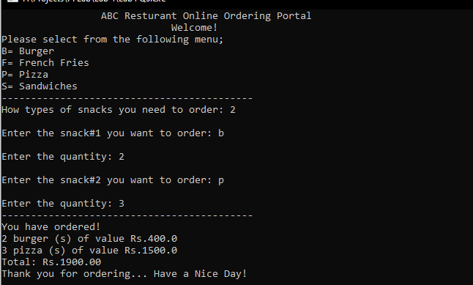

Q7.

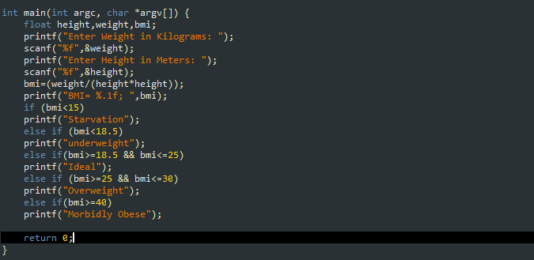

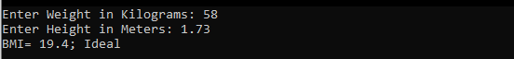

Q8.

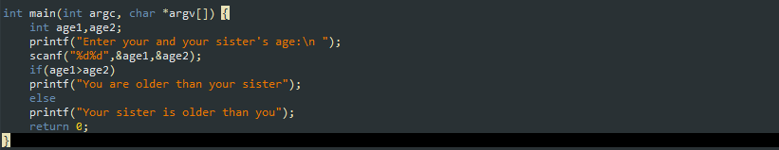

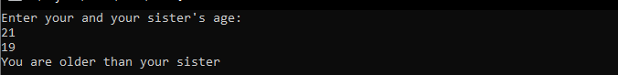

Q9.

**int main(int argc, char *argv[]) {**

**float num1,num2,c;**

**char op;**

**printf("Enter Num1<Space>Operator<Space>Num2: ");**

**scanf("%f%c%f",&num1,&op,&num2);**

**printf("%.1f%c%.1f=",num1,op,num2);**

**switch(op)**

**{**

**case '+':**

**c=num1+num2;**

**printf("%.2f",c);**

**break;**

**case '-':**

**c=num1-num2;**

**printf("%.2f",c);**

**break;**

**case '*':**

**c=num1*num2;**

**printf("%.2f",c);**

**break;**

**case '/':**

**c=num1/num2;**

**printf("%.2f",c);**

**break;**

**default:**

**printf("Error");**

**}**

**return 0;**

**}**

