***20k-0157;***

***Lab 07***

**Task1**

#include <stdio.h>

#include <stdlib.h>

/* run this program using the console pauser or add your own getch, system("pause") or input loop */

void revers_of_string()

{

char string1[100];

int i,a;

printf("Enter a string to be reversed; ");

gets(string1);

a=strlen(string1);

printf("String reversed is;");

for(i=a;i>=0;i--)

{

printf("%c",string1[i]);

}

}

int main(int argc, char *argv[])

{

revers_of_string();

return 0;

}

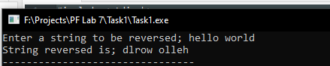

**Task2**

#include <stdio.h>

#include <stdlib.h>

/* run this program using the console pauser or add your own getch, system("pause") or input loop */

void revers_of_string()

{

char string1[100];

int i,a=0,j=0,count=0;

printf("Enter a string to be reversed; ");

gets(string1);

a=strlen(string1);

printf("String reversed is;");

for(i=a;i>=0;i--)

{

printf("%c",string1[i]);

if(string1[i]==string1[j]){

count=count+1;

j++;

}

}

if(count==a){

printf("\nTherefore the string is palindrome");

}

else

printf(“\nNot palindrome”);

}

int main(int argc, char *argv[])

{

revers_of_string();

return 0;

}

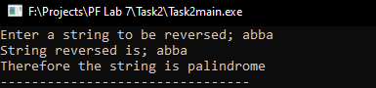

**Task3**

#include <stdio.h>

#include <stdlib.h>

void min_max(int array[])

{

int i=0;

int min=9999,max=0;

for(i=0;i<7;i++)

{

if(array[i]>max)

max=array[i];

if(array[i]<min)

min=array[i];

}

printf("Maximum element in array is; %d\nMinimum element in the array is; %d",max,min);

}

int main(int argc, char *argv[]) {

int e,array[5];

printf("Enter numbers in array:\n");

for(e=0;e<=5;e++)

{

scanf("%d",&array[e]);

}

min_max(array);

return 0;

}

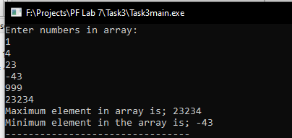

**Task4**

#include <stdio.h>

#include <stdlib.h>

/* run this program using the console pauser or add your own getch, system("pause") or input loop */

void anagram(char string1[])

{

int n,i=0,j=0,count=0;

char string2[10];

printf("\nEnter another word: \n");

scanf("%s",string2);

n=strlen(string1);

for (i=0;i<=n-1;i++)

{

for(j=0;j<=n+1;j++)

{

if(string1[i]==string2[j])

{

count++;

break;

}

}

}

if(n==count)

{

printf("\n%s is an anagaram of %s",string1,string2);

}

}

int main(int argc, char *argv[]) {

char string1[10];

printf("Enter a word;\n");

scanf("%s",string1);

anagram(string1);

return 0;

}

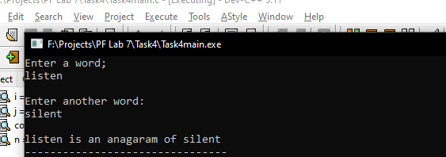

**Task5**

#include <stdio.h>

#include <stdlib.h>

/* run this program using the console pauser or add your own getch, system("pause") or input loop */

int fibonacci(terms)

{

int i,t1=0,t2=1,t3;

for (i = 1; i <= terms; ++i) {

printf("%d, ", t1);

t3 = t1 + t2;

t1 = t2;

t2 = t3;

}

}

int main(int argc, char *argv[]) {

int e;

printf("Enter terms; ");

scanf("%d",&e);

fibonacci(e);

return 0;

}

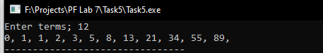

**Task6**

#include <stdio.h>

#include <stdlib.h>

/* run this program using the console pauser or add your own getch, system("pause") or input loop */

int add,i,j;

float sum(float marks)

{

add=add+marks;

return add;

}

float avg(float total)

{

float averg;

averg=total/20;

return averg;

}

int main(int argc, char *argv[]) {

float marks[5][20]={

{8,5,7,6,7,6,8,5,7,4,9,7,10,5,7.6,6,4.7,8.5,7,10},

{8,5,7,6,7,6,8,5,7,8,9.5,10,10,5,7.6,6.2,4.7,8.5,7,9.5},

{8,5,7,6,7,6,8,5,7,4,9,2,10,5,7.6,6,4.7,8.5,7,9},

{8,5,7,6,7,6,8,5,8.3,4,4,7,10,3,7.6,6,4.7,8.5,7,9},

{8,5,7,6,7,6,8,5,7,4,5.10,7,10,8,7.6,6,4.7,8.5,7,9},

},a,total[5]={0,0,0,0,0},average[5];

int e,b;

for(i=0;i<=5;i++)

{

for(j=0;j<=20;j++)

{

a=sum(marks[i][j]);

}

total[i]=(total[i]+a);

add=0;

}

for(b=0;b<=5;b++){

average[b]=avg(total[b]);

}

for(e=0;e<5;e++)

{

printf("Average of Subject %d is: %.2f\n",e+1,average[e]);

}

return 0;

}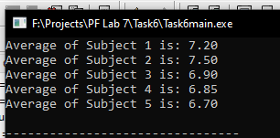

**Task7**

#include <stdio.h>

#include <stdlib.h>

/* run this program using the console pauser or add your own getch, system("pause") or input loop */

int fact3(a,b)

{

int count=0,fact,i;

for(i=a;i<=b;i++)

{

fact=3*i;

if(fact>b){

break;

}

else

printf("%d ",fact);

count=count+1;

}

printf("\nNumber of factors are; %d",count);

}

int main(int argc, char *argv[]) {

int num1,num2;

printf("Enter starting number; ");

scanf("%d",&num1);

printf("Enter ending number; ");

scanf("%d",&num2);

fact3(num1,num2);

return 0;

}

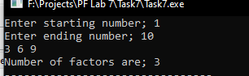

Task8

#include <stdio.h>

#include <stdlib.h>

/* run this program using the console pauser or add your own getch, system("pause") or input loop */

const char* criteria(float math,float phy,float chem)

{

int total=0,total1=0;

total=math+phy+chem;

total1=math+phy;

if((math>=65 && phy>=55 && chem>=50) || (total>180) || (total1>140)){

return "elegible";

}

else

return "not elegible";

}

int main(int argc, char *argv[]) {

float math,phy,chem;

printf("Enter Marks in Maths ");

scanf("%f",&math);

printf("Enter Marks in Physics ");

scanf("%f",&phy);

printf("Enter Marks in Chemistry ");

scanf("%f",&chem);

printf("%s",criteria(math,phy,chem));

return 0;

}

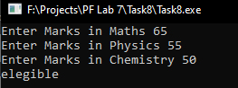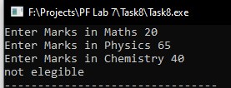

**Task9**

#include <stdio.h>

#include <stdlib.h>

/* run this program using the console pauser or add your own getch, system("pause") or input loop */

const char* quadrant(float x,float y)

{

if(x>0 && y>0)

return "first quadrant";

else if(x<0 && y>0)

return "second quadrant";

else if(x<0 && y<0)

return "third quadrant";

else if(x>0 && y<0)

return "fourth quadrant";

}

int main(int argc, char *argv[]) {

float x,y;

printf("Input x coordinate; ");

scanf("%f",&x);

printf("Input y coordinate; ");

scanf("%f",&y);

printf("(%.1f,%.1f) lies in the %s",x,y,quadrant(x,y));

return 0;

}

