**Lab 9**

**20k-0157**

**Task1**

#include <stdio.h>

#include <stdlib.h>

/* run this program using the console pauser or add your own getch, system("pause") or input loop */

void func(void *ptr,int a){

if(a==1){

printf("integer is %d",*((int*)ptr));

}

else if(a==2){

printf("character is %c",*((char*)ptr));

}

else if(a==3){

printf("float value is %.4f",*((float*)ptr));

}

}

int main(int argc, char *argv[]) {

int a,int1;

float float1;

char char1;

printf("What data type do u want to input?\n1.Int\n2.Char\n3.Float\nEnter the corresponding number\n");

scanf("%d",&a);

if(a==1){

printf("Enter;\n");

scanf("%d",&int1);

func(&int1,a);

}

else if(a==2){

printf("Enter;\n");

scanf(" %c", &char1);

func(&char1,a);

}

else if(a==3){

printf("Enter;\n");

scanf(" %f", &float1);

func(&float1,a);

}

else

printf("Error");

return 0;

}

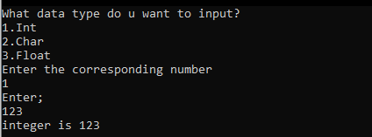

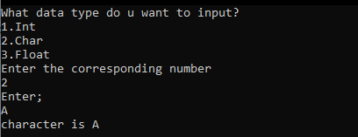

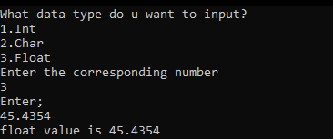

**Task2**

#include <stdio.h>

#include <stdlib.h>

/* run this program using the console pauser or add your own getch, system("pause") or input loop */

int main(int argc, char *argv[]) {

int arr[5],i,j;

printf("Enter values;\n");

for(i=0;i<=4;i++)

{

scanf("%d",&arr[i]);

}

printf("-----------------------\n");

for(j=4;j>=0;j--)

{

printf("%d\n",*(arr+j));

}

return 0;

}

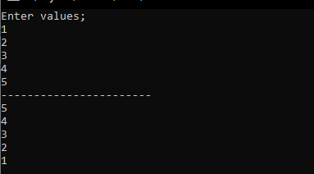

**Task3**

#include<stdio.h>

int sumEvenIndex(int *j)

{

int c[10];

int i,sum = 0;

for(i = 0;i < 10;i++)

{

c[i] = *j;

j++;

}

for(i = 0;i < 10;i += 2)

{

sum=sum + c[i];

}

return sum;

}

int sumOddIndex(int *k)

{

int c[10];

int i,sum = 0;

for(i = 0; i < 10; i++)

{

c[i] = *k;

k++;

}

for(i = 1; i < 10; i += 2)

{

sum = sum + c[i];

}

return sum;

}

void sortArray(int b[])

{

int i,j,temp=0;

for ( i = 0; i < 10; i++)

{

for ( j = 0; j < 10; j++)

{

if (b[j] > b[i])

{

temp = b[i];

b[i] = b[j];

b[j] = temp;

}

}

}

printf("Array sorted:\n");

for(i=0;i<10;i++)

{

printf("%d ",b[i]);

}

}

int main()

{

int a[10], i;

printf("Enter Elements: \n");

for(i = 0;i < 10; i++)

{

scanf("%d", &a[i]);

}

printf("Sum of even index: %d\n", sumEvenIndex(&a[0]) );

printf("Sum of odd index: %d\n", sumOddIndex(&a[0]));

sortArray(a);

}

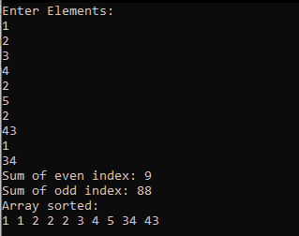

**Task4**

#include <stdio.h>

#include <stdlib.h>

/* run this program using the console pauser or add your own getch, system("pause") or input loop */

void min(int *a,int *b)

{

if(*a<*b)

printf("Min number is %d ",*a);

else

printf("Min number is %d",*b);

}

int main(int argc, char *argv[]) {

int num1,num2;

printf("Enter two numbers\n");

scanf("%d %d",&num1,&num2);

min(&num1,&num2);

return 0;

}

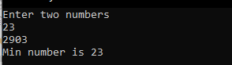

**Task5**

#include <stdio.h>

#include <stdlib.h>

/* run this program using the console pauser or add your own getch, system("pause") or input loop */

void func(int *sum,float *sd,float *avg,int array[])

{

int n=5,i,j;

float submission=0,a=0;

for(i=0;i<=n;i++)

{

*sum=*sum+array[i];

}

*avg=*sum/n;

for(j=0;j<=n-1;j++)

{

a=((array[j]-*avg)*(array[j]-*avg));

submission=submission+a;

}

*sd=sqrt(submission/n);

}

int main(int argc, char *argv[]) {

int sum=0;

float sd=0,avg=0;

int arr[5],k;

printf("Enter values\n");

for(k=0;k<=4;k++)

{

scanf("%d",&arr[k]);

}

func(&sum,&sd,&avg,arr);

printf("SD = %.3f\nSum = %d\navg = %.1f ",sd,sum,avg);

return 0;

}

