**PF LAB 11**

*20K-0157 Section D*

Task1

int main() {

void *ptr;

char choice[10];

int count = 0;

while (count < 3) {

printf("What Datatype do you wish to enter: ");

fflush(stdin);

gets(choice);

if (strcmp(choice, "int") == 0) {

ptr = (int *) malloc(sizeof(int));

printf("Enter int: ");

scanf("%d", &ptr);

printf("Value Entered: %d\n", ptr);

}

else if (strcmp(choice, "char") == 0) {

ptr = (char *) malloc(sizeof(char));

printf("Enter char: ");

scanf("%c", &ptr);

printf("Value Entered: %c\n", ptr);

}

else if (strcmp(choice, "float") == 0) {

float ptr;

printf("Enter float: ");

scanf("%f", &ptr);

printf("Value Entered: %.2f\n", ptr);

}

count += 1;

}

}

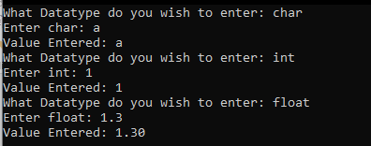

Task2

int main() {

int *int_var;

char *char_var;

float *float_var;

int_var = (int *)malloc(sizeof(int));

char_var = (char *)malloc(sizeof(char));

float_var = (float *)malloc(sizeof(float));

scanf("%d",int_var);

scanf("%c",char_var);

scanf("%f",float_var);

printf("%d %c %f",*int_var,*char_var,*float_var);

}

Task3

int main() {

int *array, n, i, min;

printf("Input a total number of elements (1 to 50): ");

scanf("%d", &n);

if (n > 50 || n < 1) {

printf("Number not valid!");

return;

}

array = (int*)malloc(n * sizeof(int));

for (i = 0; i < n; i++) {

printf("Number %d: ", i+1);

scanf("%d", &array[i]);

if (i == 0) min = array[i];

else if (array[i] < min) {

min = array[i];

}

}

printf("Smallest Number: %d", min);

}

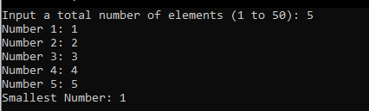

Task4

int main() {

int n, i, j, avg, temp, sum = 0;

int high = 0, low = 9999;

printf("Enter number of student's: ");

scanf("%d", &n);

int *array = (int *)malloc(n * sizeof(int));

for (i = 0; i < n; i++) {

printf("Enter marks for Student %d:", i + 1);

scanf("%d", &array[i]);

}

for (i = 0; i < n; i++) {

for (j = 0; j < n - i - 1; j++) {

if (array[j] > array[j + 1]) {

temp = array[j];

array[j] = array[j + 1];

array[j + 1] = temp;

}

}

}

for (i = 0; i < n; i++) {

sum += array[i];

}

printf("Highest Marks: %d - Second Highest Marks %d\n", array[n - 1], array[n - 2]);

printf("Average %f:", (float) sum / n);

}

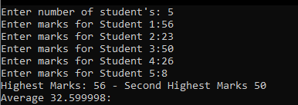

Task5

int main() {

float *array;

array = (float *)malloc(3 * sizeof(float));

printf("Enter approx width of the toy: ");

scanf("%f", &array[0]);

printf("Enter approx height of the toy: ");

scanf("%f", &array[1]);

printf("Enter approx breadth of the toy: ");

scanf("%f", &array[2]);

printf("Volume needed is: %.2f", array[0] * array[1] * array[2]);

}

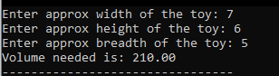

Task6

#include <stdio.h>

#include <stdlib.h>

int main()

{

int n;

char *text;

printf("Enter limit of the text: ");

scanf("%d",&n);

/*allocate memory dynamically*/

text=(char*)malloc(n*sizeof(char));

printf("Enter text: ");

scanf(" "); /*clear input buffer*/

gets(text);

printf("Inputted text is: %s\n",text);

/*Free Memory*/

free(text);

return 0;

}

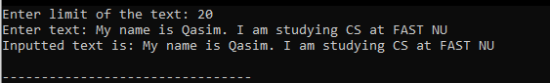

Task7

int main() {

void *ptr;

printf("Enter an int value: ");

scanf("%d", &ptr);

printf("Value: %d\n", ptr);

printf("Address: %d\n", &ptr);

printf("\n");

printf("Enter a char value: ");

scanf(" %c", &ptr);

printf("Value: %c\n", ptr);

printf("Address: %d\n", &ptr);

printf("\n");

printf("Enter a float value: ");

scanf("%lf", &ptr);

printf("Value: %.2lf\n", ptr);

printf("Address: %d\n", &ptr);

}

