**PF LAB ASSIGNMENT**

**13DEC2020**

**20k-0157**

**Task1**

/* C Program to Concatenate two singly linked lists*/

#include<stdio.h>

#include<stdlib.h>

struct node

{

int info;

struct node *link;

};

struct node *create_list(struct node *);

struct node *concat( struct node *start1,struct node *start2);

struct node *addatbeg(struct node *start, int data);

struct node *addatend(struct node *start,int data);

void display(struct node *start);

int main()

{

struct node *start1=NULL,*start2=NULL;

start1=create_list(start1);

start2=create_list(start2);

printf("\nFirst list is : ");

display(start1);

printf("\nSecond list is : ");

display(start2);

start1=concat(start1, start2);

printf("\nConcatenated list is : ");

display(start1);

return 0;

}

struct node *concat( struct node *start1,struct node *start2)

{

struct node *ptr;

if(start1==NULL)

{

start1=start2;

return start1;

}

if(start2==NULL)

return start1;

ptr=start1;

while(ptr->link!=NULL)

ptr=ptr->link;

ptr->link=start2;

return start1;

}

struct node *create_list(struct node *start)

{

int i,n,data;

printf("\nEnter the number of nodes : ");

scanf("%d",&n);

start=NULL;

if(n==0)

return start;

printf("Enter the element to be inserted : ");

scanf("%d",&data);

start=addatbeg(start,data);

for(i=2;i<=n;i++)

{

printf("Enter the element to be inserted : ");

scanf("%d",&data);

start=addatend(start,data);

}

return start;

}

void display(struct node *start)

{

struct node *p;

if(start==NULL)

{

printf("\nList is empty\n");

return;

}

p=start;

while(p!=NULL)

{

printf("%d ", p->info);

p=p->link;

}

printf("\n");

}/*End of display() */

struct node *addatbeg(struct node *start,int data)

{

struct node *tmp;

tmp=(struct node *)malloc(sizeof(struct node));

tmp->info=data;

tmp->link=start;

start=tmp;

return start;

}

struct node *addatend(struct node *start, int data)

{

struct node *p,*tmp;

tmp= (struct node *)malloc(sizeof(struct node));

tmp->info=data;

p=start;

while(p->link!=NULL)

p=p->link;

p->link=tmp;

tmp->link=NULL;

return start;

}

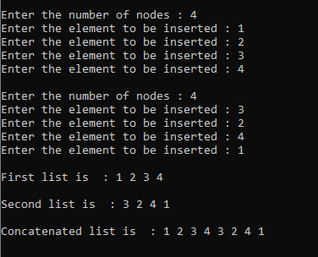

**Task2**

/* Program to insert in a sorted list */

#include <stdio.h>

#include <stdlib.h>

/* Link list node */

struct Node {

int data;

struct Node* next;

};

void sortedInsert(struct Node** head_ref,

struct Node* new_node)

{

struct Node* current;

/* Special case for the head end */

if (*head_ref == NULL

|| (*head_ref)->data

>= new_node->data) {

new_node->next = *head_ref;

*head_ref = new_node;

}

else {

/* Locate the node before

the point of insertion */

current = *head_ref;

while (current->next != NULL

&& current->next->data < new_node->data) {

current = current->next;

}

new_node->next = current->next;

current->next = new_node;

}

}

/* A utility function to create a new node */

struct Node* newNode(int new_data)

{

/* allocate node */

struct Node* new_node

= (struct Node*)malloc(

sizeof(struct Node));

/* put in the data */

new_node->data = new_data;

new_node->next = NULL;

return new_node;

}

/* Function to print linked list */

void printList(struct Node* head)

{

struct Node* temp = head;

while (temp != NULL) {

printf("%d ", temp->data);

temp = temp->next;

}

}

/* Driver program to test count function*/

int main()

{

/* Start with the empty list */

struct Node* head = NULL;

struct Node* new_node = newNode(20);

sortedInsert(&head, new_node);

new_node = newNode(17);

sortedInsert(&head, new_node);

new_node = newNode(3);

sortedInsert(&head, new_node);

new_node = newNode(18);

sortedInsert(&head, new_node);

new_node = newNode(27);

sortedInsert(&head, new_node);

printf("Created Linked List\n ");

printList(head);

return 0;

}



**Task3**

#include<stdio.h>

#include<stdlib.h>

/* Link list node */

struct Node

{

int data;

struct Node* next;

};

/* Function to get the middle of the linked list*/

void printMiddle(struct Node *head)

{

struct Node *slow_ptr = head;

struct Node *fast_ptr = head;

if (head!=NULL)

{

while (fast_ptr != NULL && fast_ptr->next != NULL)

{

fast_ptr = fast_ptr->next->next;

slow_ptr = slow_ptr->next;

}

printf("The middle element is [%d]\n\n", slow_ptr->data);

}

}

void push(struct Node** head_ref, int new_data)

{

/* allocate node */

struct Node* new_node =

(struct Node*) malloc(sizeof(struct Node));

/* put in the data */

new_node->data = new_data;

/* link the old list off the new node */

new_node->next = (*head_ref);

/* move the head to point to the new node */

(*head_ref) = new_node;

}

// A utility function to print a given linked list

void printList(struct Node *ptr)

{

while (ptr != NULL)

{

printf("%d->", ptr->data);

ptr = ptr->next;

}

printf("NULL\n");

}

/* Driver program to test above function*/

int main()

{

/* Start with the empty list */

struct Node* head = NULL;

int i,n,val;

printf("How many elements do u want to enter?");

scanf("%d",&n);

if(n==0)

printf("Median of empty list is [0]");

for (i=n; i>0; i--)

{

printf("Enter value;");

scanf("%d",&val);

push(&head, val);

if(i==1)

{

printList(head);

printMiddle(head);

}

}

return 0;

}

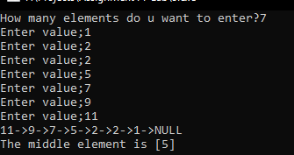

**Task4**

/**

* C program to reverse a Singly Linked List

*/

#include <stdio.h>

#include <stdlib.h>

/* Structure of a node */

struct node {

int data; //Data part

struct node *next; //Address part

}*head;

/* Functions used in the program */

void createList(int n);

void reverseList();

void displayList();

int main()

{

int n, choice;

/*

* Create a singly linked list of n nodes

*/

printf("Enter the total number of nodes: ");

scanf("%d", &n);

createList(n);

printf("\nData in the list \n");

displayList();

/*

* Reverse the list

*/

printf("\nPress 1 to reverse the order of singly linked list\n");

scanf("%d", &choice);

if(choice == 1)

{

reverseList();

}

printf("\nData in the list\n");

displayList();

return 0;

}

/*

* Create a list of n nodes

*/

void createList(int n)

{

struct node *newNode, *temp;

int data, i;

if(n <= 0)

{

printf("List size must be greater than zero.\n");

return;

}

head = (struct node *)malloc(sizeof(struct node));

/*

* If unable to allocate memory for head node

*/

if(head == NULL)

{

printf("Unable to allocate memory.");

}

else

{

/*

* Read data of node from the user

*/

printf("Enter the data of node 1: ");

scanf("%d", &data);

head->data = data; // Link the data field with data

head->next = NULL; // Link the address field to NULL

temp = head;

/*

* Create n nodes and adds to linked list

*/

for(i=2; i<=n; i++)

{

newNode = (struct node *)malloc(sizeof(struct node));

/* If memory is not allocated for newNode */

if(newNode == NULL)

{

printf("Unable to allocate memory.");

break;

}

else

{

printf("Enter the data of node %d: ", i);

scanf("%d", &data);

newNode->data = data; // Link the data field of newNode with data

newNode->next = NULL; // Link the address field of newNode with NULL

temp->next = newNode; // Link previous node i.e. temp to the newNode

temp = temp->next;

}

}

printf("SINGLY LINKED LIST CREATED SUCCESSFULLY\n");

}

}

/*

* Reverse the order of nodes of a singly linked list

*/

void reverseList()

{

struct node *prevNode, *curNode;

if(head != NULL)

{

prevNode = head;

curNode = head->next;

head = head->next;

prevNode->next = NULL; // Make first node as last node

while(head != NULL)

{

head = head->next;

curNode->next = prevNode;

prevNode = curNode;

curNode = head;

}

head = prevNode; // Make last node as head

printf("SUCCESSFULLY REVERSED LIST\n");

}

}

/*

* Display entire list

*/

void displayList()

{

struct node *temp;

/*

* If the list is empty i.e. head = NULL

*/

if(head == NULL)

{

printf("List is empty.");

}

else

{

temp = head;

while(temp != NULL)

{

printf("Data = %d\n", temp->data); // Print the data of current node

temp = temp->next; // Move to next node

}

}

}

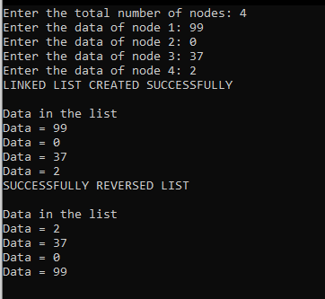

**Task5i**

#include <stdio.h>

#include <stdlib.h>

/*

* Basic structure of Node

*/

struct node {

int data;

struct node * prev;

struct node * next;

}*head, *last;

/*

* Function used in this program

*/

void createList(int n);

void displayListFromFirst();

void displayListFromEnd();

int main()

{

int n, choice;

head = NULL;

last = NULL;

printf("Enter the number of nodes you want to create: ");

scanf("%d", &n);

createList(n); // Create list of n nodes

displayListFromFirst();

return 0;

}

/**

* Create a doubly linked list of n nodes.

* @n Number of nodes to be created

*/

void createList(int n)

{

int i, data;

struct node *newNode;

if(n >= 1)

{

head = (struct node *)malloc(sizeof(struct node));

if(head != NULL)

{

printf("Enter data of 1 node: ");

scanf("%d", &data);

head->data = data;

head->prev = NULL;

head->next = NULL;

last = head;

/*

* Create rest of the n-1 nodes

*/

for(i=2; i<=n; i++)

{

newNode = (struct node *)malloc(sizeof(struct node));

if(newNode != NULL)

{

printf("Enter data of %d node: ", i);

scanf("%d", &data);

newNode->data = data;

newNode->prev = last; // Link new node with the previous node

newNode->next = NULL;

last->next = newNode; // Link previous node with the new node

last = newNode; // Make new node as last/previous node

}

else

{

printf("Unable to allocate memory.");

break;

}

}

printf("\nDOUBLY LINKED LIST CREATED SUCCESSFULLY\n");

}

else

{

printf("Unable to allocate memory");

}

}

}

/**

* Displays the content of the list from beginning to end

*/

void displayListFromFirst()

{

struct node * temp;

int n = 1;

if(head == NULL)

{

printf("List is empty.");

}

else

{

temp = head;

printf("\n\nDATA IN THE LIST:\n");

while(temp != NULL)

{

printf("DATA of %d node = %d\n", n, temp->data);

n++;

/* Move the current pointer to next node */

temp = temp->next;

}

}

}

/**

* Display the content of the list from last to first

*/

void displayListFromEnd()

{

struct node * temp;

int n = 0;

if(last == NULL)

{

printf("List is empty.");

}

else

{

temp = last;

printf("\n\nDATA IN THE LIST:\n");

while(temp != NULL)

{

printf("DATA of last-%d node = %d\n", n, temp->data);

n++;

/* Move the current pointer to previous node */

temp = temp->prev;

}

}

}

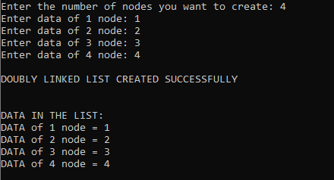

**Task5ii**

#include <stdio.h>

#include <stdlib.h>

#include <limits.h>

struct node {

int num;

struct node * preptr;

struct node * nextptr;

}*stnode, *ennode;

void DlListcreation(int n);

int getMaxNode(struct node *stnode);

void displayDlList();

int main()

{

int n;

stnode = NULL;

ennode = NULL;

printf(" Input the number of nodes : ");

scanf("%d", &n);

DlListcreation(n);

displayDlList();

printf("\n The Minimum Value in the Linked List : %d\n\n", getminNode(stnode));

return 0;

}

void DlListcreation(int n)

{

int i, num;

struct node *fnNode;

if(n >= 1)

{

stnode = (struct node *)malloc(sizeof(struct node));

if(stnode != NULL)

{

printf(" Input data for node 1 : "); // assigning data in the first node

scanf("%d", &num);

stnode->num = num;

stnode->preptr = NULL;

stnode->nextptr = NULL;

ennode = stnode;

// putting data for rest of the nodes

for(i=2; i<=n; i++)

{

fnNode = (struct node *)malloc(sizeof(struct node));

if(fnNode != NULL)

{

printf(" Input data for node %d : ", i);

scanf("%d", &num);

fnNode->num = num;

fnNode->preptr = ennode; // new node is linking with the previous node

fnNode->nextptr = NULL;

ennode->nextptr = fnNode; // previous node is linking with the new node

ennode = fnNode; // assign new node as last node

}

else

{

printf(" Memory can not be allocated.");

break;

}

}

}

else

{

printf(" Memory can not be allocated.");

}

}

}

int getminNode(struct node *stnode)

{

if(stnode == NULL){

printf(" User message : Invalid Input !!!!\n");

return INT_MIN;

}

int min = stnode->num;

while(stnode != NULL){

if(stnode->num < min){

min = stnode->num;

}

stnode = stnode->nextptr;

}

return min;

}

void displayDlList()

{

struct node * tmp;

int n = 1;

if(stnode == NULL)

{

printf(" No data found in the List yet.");

}

else

{

tmp = stnode;

printf("\n\n Data entered in the list are :\n");

while(tmp != NULL)

{

printf(" node %d : %d\n", n, tmp->num);

n++;

tmp = tmp->nextptr; // current pointer moves to the next node

}

}

}

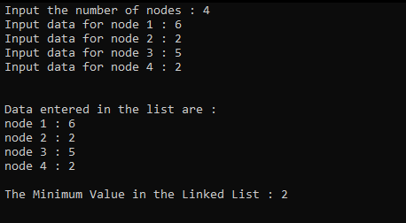

**Task5iii**

#include <stdio.h>

#include <stdlib.h>

#include <limits.h>

struct node {

int num;

struct node * preptr;

struct node * nextptr;

}*stnode, *ennode;

void DlListcreation(int n);

int getMaxNode(struct node *stnode);

void displayDlList();

void displayDlList1(int a);

int main()

{

int n;

stnode = NULL;

ennode = NULL;

printf(" Input the number of nodes : ");

scanf("%d", &n);

DlListcreation(n);

displayDlList();

printf("\n The Minimum Value in the Linked List : %d\n\n", getminNode(stnode));

printf("Min Node deleted successfully ; New LinkedList;\n");

displayDlList1(getminNode(stnode));

return 0;

}

void DlListcreation(int n)

{

int i, num;

struct node *fnNode;

if(n >= 1)

{

stnode = (struct node *)malloc(sizeof(struct node));

if(stnode != NULL)

{

printf(" Input data for node 1 : "); // assigning data in the first node

scanf("%d", &num);

stnode->num = num;

stnode->preptr = NULL;

stnode->nextptr = NULL;

ennode = stnode;

// putting data for rest of the nodes

for(i=2; i<=n; i++)

{

fnNode = (struct node *)malloc(sizeof(struct node));

if(fnNode != NULL)

{

printf(" Input data for node %d : ", i);

scanf("%d", &num);

fnNode->num = num;

fnNode->preptr = ennode; // new node is linking with the previous node

fnNode->nextptr = NULL;

ennode->nextptr = fnNode; // previous node is linking with the new node

ennode = fnNode; // assign new node as last node

}

else

{

printf(" Memory can not be allocated.");

break;

}

}

}

else

{

printf(" Memory can not be allocated.");

}

}

}

int getminNode(struct node *stnode)

{

if(stnode == NULL){

printf(" User message : Invalid Input !!!!\n");

return INT_MIN;

}

int min = stnode->num;

while(stnode != NULL){

if(stnode->num < min){

min = stnode->num;

}

stnode = stnode->nextptr;

}

return min;

}

void displayDlList()

{

struct node * tmp;

int n = 1;

if(stnode == NULL)

{

printf(" No data found in the List yet.");

}

else

{

tmp = stnode;

printf("\n\n Data entered in the list are :\n");

while(tmp != NULL)

{

printf(" node %d : %d\n", n, tmp->num);

n++;

tmp = tmp->nextptr; // current pointer moves to the next node

}

}

}

void displayDlList1(int a)

{

struct node * tmp;

int n = 1;

if(stnode == NULL)

{

printf(" No data found in the List yet.");

}

else

{

tmp = stnode;

printf("\n\n Data entered in the list are :\n");

while(tmp != NULL)

{

if(tmp->num==a)

{

}

else

{

printf(" node %d : %d\n", n, tmp->num);

}

n++;

tmp = tmp->nextptr; // current pointer moves to the next node

}

}

}

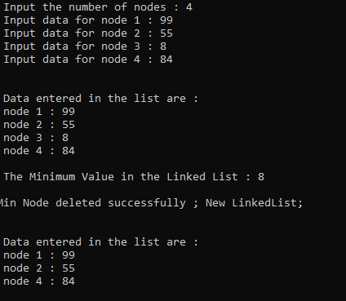

**Task5iv**

/**

* C program to reverse a Doubly linked list

*/

#include <stdio.h>

#include <stdlib.h>

/*

* Basic structure of Node

*/

struct node {

int data;

struct node * prev;

struct node * next;

}*head, *last;

/*

* Functions used in this program

*/

void createList(int n);

void displayList();

void reverseList();

int main()

{

int n, data, choice=1;

head = NULL;

last = NULL;

printf("Enter the total number of nodes in list: ");

scanf("%d", &n);

createList(n);

reverseList();

displayList();

return 0;

}

/**

* Creates a doubly linked list of n nodes.

* @n Number of nodes to be created

*/

void createList(int n)

{

int i, data;

struct node *newNode;

if(n >= 1)

{

/*

* Create and link head node

*/

head = (struct node *)malloc(sizeof(struct node));

printf("Enter data of 1 node: ");

scanf("%d", &data);

head->data = data;

head->prev = NULL;

head->next = NULL;

last = head;

/*

* Create and link rest of the n-1 nodes

*/

for(i=2; i<=n; i++)

{

newNode = (struct node *)malloc(sizeof(struct node));

printf("Enter data of %d node: ", i);

scanf("%d", &data);

newNode->data = data;

newNode->prev = last; // Link new node with the previous node

newNode->next = NULL;

last->next = newNode; // Link previous node with the new node

last = newNode; // Make new node as last/previous node

}

printf("\nDOUBLY LINKED LIST CREATED SUCCESSFULLY\n");

}

}

/**

* Display the content of the list from beginning to end

*/

void displayList()

{

struct node * temp;

int n = 1;

if(head == NULL)

{

printf("List is empty.\n");

}

else

{

temp = head;

printf("DATA IN THE LIST:\n");

while(temp != NULL)

{

printf("DATA of %d node = %d\n", n, temp->data);

n++;

/* Move pointer to next node */

temp = temp->next;

}

}

}

/**

* Reverse order of the doubly linked list

*/

void reverseList()

{

struct node *current, *temp;

current = head;

while(current != NULL)

{

/*

* Swap the previous and next address fields of current node

*/

temp = current->next;

current->next = current->prev;

current->prev = temp;

/* Move the current pointer to next node which is stored in temp */

current = temp;

}

/*

* Swap the head and last pointers

*/

temp = head;

head = last;

last = temp;

printf("LIST REVERSED SUCCESSFULLY.\n");

}

