PF Lab 12 Task

20k-0157

Task1

#include <stdio.h>

#include <stdlib.h>

/\* run this program using the console pauser or add your own getch, system("pause") or input loop \*/

int main(int argc, char \*argv[]) {

FILE \*fp;

struct userdata

{

char name[20];

int marks;

}userx;

int i,n;

printf(" Enter number of students ");

scanf("%d",&n);

for(i=1;i<=n;i++){

fp=fopen("data.txt","a");

printf(" Enter student name: ");

scanf("%s",userx.name);

printf(" Enter marks: ");

scanf("%d",&userx.marks);

fprintf(fp,"\n%s",userx.name);

fprintf(fp," %d",userx.marks);

printf(" --- Entry sucessfull ---\n");

fclose(fp);

}

return 0;

}

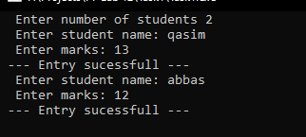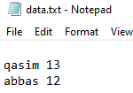

Task2

#include <stdio.h>

#include <stdlib.h>

/\* run this program using the console pauser or add your own getch, system("pause") or input loop \*/

int main(int argc, char \*argv[]) {

FILE \*fp;

char sent[20];

fp=fopen("data.txt","a");

printf(" Enter : ");

gets(sent);

fprintf(fp,"%s",sent);

printf(" --- Entry sucessfull ---\n");

fclose(fp);

return 0;

}

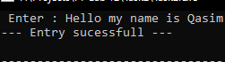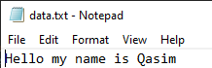

Task3

#include <stdio.h>

#define FILENAME "test.txt"

int main()

{

FILE \*fp;

char ch;

int linesCount=0;

fp=fopen(FILENAME,"r");

if(fp==NULL)

{

printf("File \"%s\" does not exist!!!\n",FILENAME);

return -1;

}

while((ch=fgetc(fp))!=EOF)

{

if(ch=='\n')

linesCount++;

}

fclose(fp);

printf("Total number of lines are: %d\n",linesCount);

return 0;

}

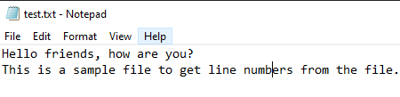

Task4

#include <stdio.h>

struct s

{

char name[50];

int marks;

};

int main(){

struct s a[2],b[2];

FILE \*fptr;

int i;

fptr=fopen("file.txt","wb");

for(i=0;i<2;++i)

{

fflush(stdin);

printf("Enter name: ");

gets(a[i].name);

printf("Enter marks: ");

scanf("%d",&a[i].marks);

}

fwrite(a,sizeof(a),1,fptr);

fclose(fptr);

fptr=fopen("file.txt","rb");

fread(b,sizeof(b),1,fptr);

for(i=0;i<2;++i)

{

printf("Name: %s \ Marks: %d\n",b[i].name,b[i].marks);

}

fclose(fptr);

}

