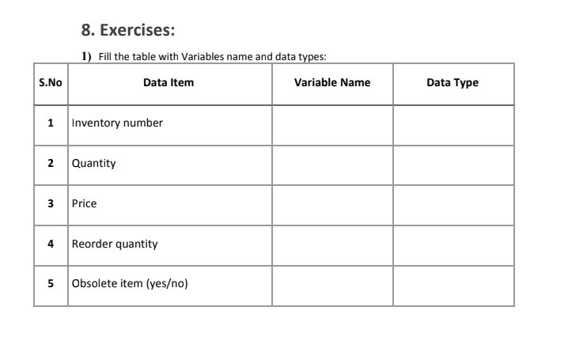 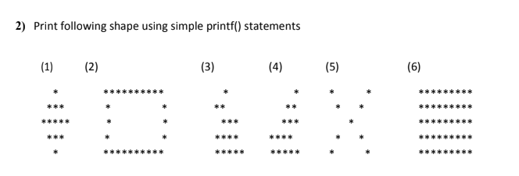

Boolean

Obsolete

Integer

Re_Quantity

float

Price

Integer

Quantity

Integer

Inventory_Num

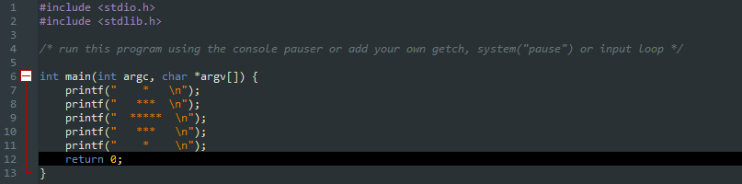**i)**

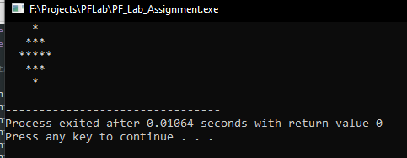

**ii)**

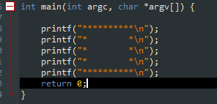

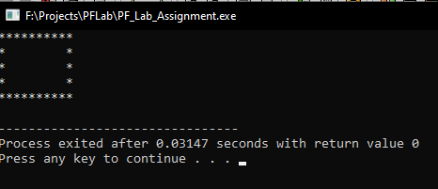

**iii)**

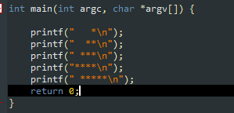

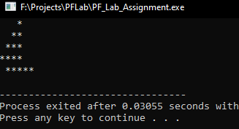

**iv)**

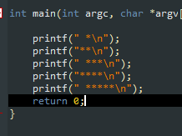

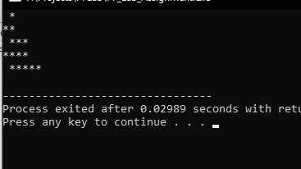

**v)**

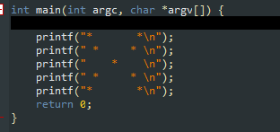

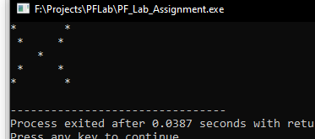

**vi)**

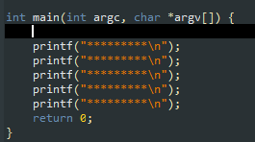

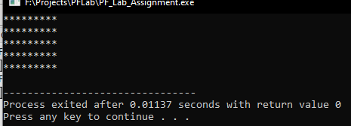

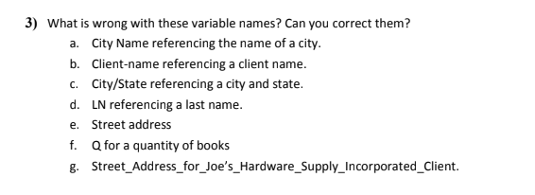

a). There is space between the variable name. Correct: City_Name / CityName

b). Special character “-“ used. Correct: Client_Name / ClientName

c). Special character “/” cannot be used. Correct: City_State / CityORState

d). Should be easily understandable, LN can mean many things. Correct: Last_Name / L_Name

e). There is space between the variable name. Correct: Street_Address / Address

f). Should be easily understandable, Q can mean many things. Correct: BookQuantity / Book_Quantity

g). Too long. Correct: ClientAddress / Client_Address

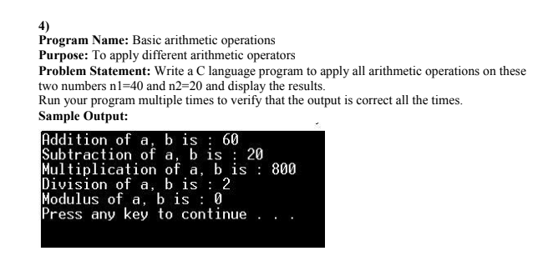

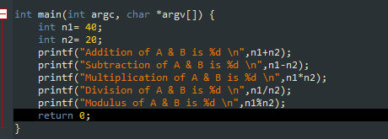

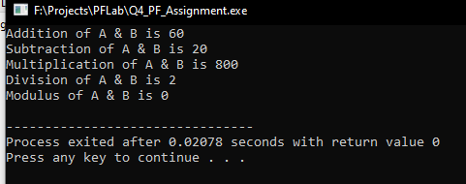

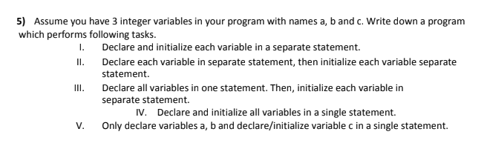

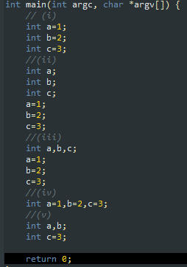

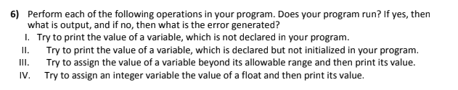

**i)**

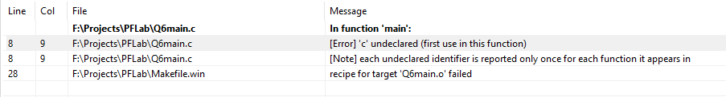

**ii)**

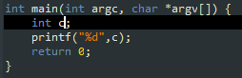

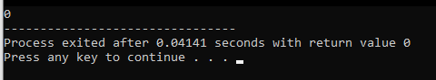

**iii)**

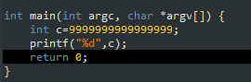

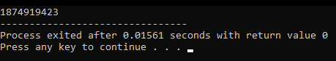

**iv)**

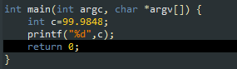

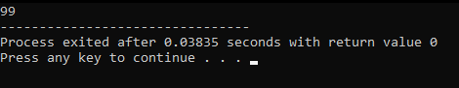

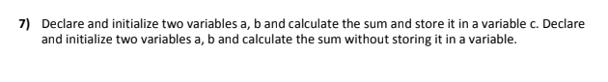

**i)**

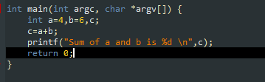

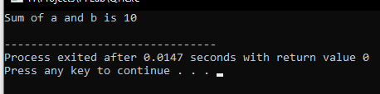

**ii)**

