Q1.

#include <stdio.h>

#include <stdlib.h>

/\* run this program using the console pauser or add your own getch, system("pause") or input loop \*/

int main(int argc, char \*argv[]) {

int i,a,j,num[9];

for (i=0;i<=9;i++){

printf("Enter a random num: ");

scanf("%d",&num[i]);

}

printf("Enter the number you want to search in the array: ");

scanf("%d",&a);

for (j=0;j<=9;j++){

if(num[j]==a){

printf("Number found at position %d",j+1);

break;

}

}

return 0;

}

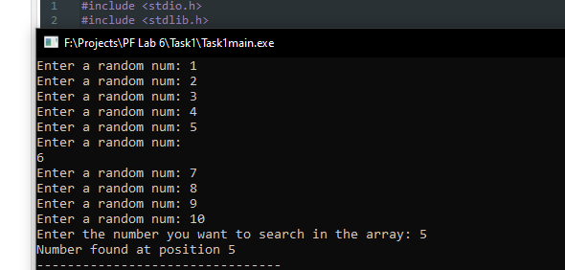

Q2.

#include <stdio.h>

#include <stdlib.h>

/\* run this program using the console pauser or add your own getch, system("pause") or input loop \*/

int main(int argc, char \*argv[]) {

const int a=50;

char str[a],find;

int count=0,i;

printf("Enter a string: ");

gets(str);

printf("Enter a character to find the frequency: ");

scanf("%c",&find);

for (i=0;i<=a;i++){

if (str[i]==find || str[i]==toupper(find) || str[i]==tolower(find))

count=count+1;

}

printf("Frequency of %c: %d",find,count);

return 0;

}

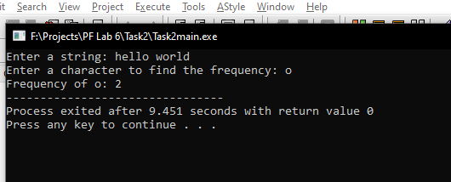

Q3.

#include <stdio.h>

#include <stdlib.h>

/\* run this program using the console pauser or add your own getch, system("pause") or input loop \*/

int main(int argc, char \*argv[]) {

int i,temp[7],maxtemp=0,mintemp=99999;

char day[10],day1[10],day2[10];

for(i=1;i<=7;i++){

printf("Enter Day: ");

scanf("%s",day);

printf("Enter Temperature that day; ");

scanf(" %d",&temp[i]);

if (temp[i]>maxtemp){

maxtemp=temp[i];

strcpy(day1,day);}

else if (temp[i]<mintemp){

mintemp=temp[i];

strcpy(day2,day);

}

}

printf("Max temp was %d at ",maxtemp);

printf("%s\n",day1);

printf("Min temp was %d at ",mintemp);

printf("%s\n",day2);

}

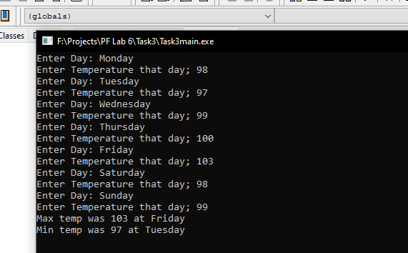

Q4.

#include <stdio.h>

#include <stdlib.h>

/\* run this program using the console pauser or add your own getch, system("pause") or input loop \*/

int main(int argc, char \*argv[]) {

int total=0,pos=0,neg=0,zero=0,num[8],i;

printf("Enter Values\n");

for(i=0;i<=7;i++){

scanf("%d",&num[i]);

if(num[i]>0){

pos=pos+1;

total=total+num[i];

}

else if(num[i]<0)

neg=neg+1;

else if(num[i]==0)

zero=zero+1;

}

printf("Number of zeros, positive and negative values respectively; %d, %d, %d \n", zero,pos,neg);

printf("Sum of positive values is %d",total);

return 0;

}

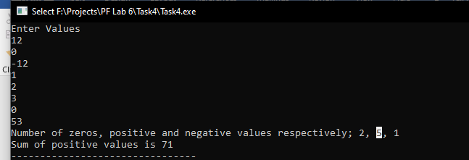

Q5.

#include <stdio.h>

#include <stdlib.h>

int main()

{

int n=6,temp,i,a,j;

int salary[6]={50,70,55,66,67,72};

float sum=0,avg=0;

for(i=0;i<6;i++){

sum=sum+salary[i];

}

for(i=0;i<n-1;i++){

for(j=0;j<n-1-i;j++){

if(salary[j]>salary[j+1]){

temp=salary[j];

salary[j]=salary[j+1];

salary[j+1]=temp;

}

}

}

printf("To find sum of salary, press 1;\nTo list the salary in ascending order, press 2;\nTo print salary of all months; press 3. \n");

scanf("%d",&a);

avg=sum/6;

if(a==1){

printf("Sum of total salary of all months: Rs.%.1fK\n",sum);

printf("\n");}

else if(a==2){

printf("The salaries arranged in ascending order\n");

for(i=0;i<n;i++)

printf("\nRs.%dK ",salary[i]);

printf("\n");

}

else if(a==3){

printf("\nAverage of the salary of 6 months: Rs.%.3fK\n",avg);

}

return 0;

}

