**Lab10 Remaining**

**20k-0157**

**Task1**

#include <stdio.h>

#include <stdlib.h>

/* run this program using the console pauser or add your own getch, system("pause") or input loop */

int main(int argc, char *argv[]) {

struct student

{

char Name[20];

char RollNum[5];

int AttendanceMarks;

int test1;

int test2;

int test3;

}a,b;

strcpy(a.Name,"Ahmed");

strcpy(a.RollNum,"k200154");

a.test1=92;

a.test2=86;

a.test3=74;

a.AttendanceMarks=84;

strcpy(b.Name,"Ikram");

strcpy(b.RollNum,"k200145");

b.test1=92;

b.test2=86;

b.test3=84;

b.AttendanceMarks=90;

float total[2];

total[1]=((a.AttendanceMarks+a.test1+a.test2+a.test3)*100);

total[0]=((b.AttendanceMarks+b.test1+b.test2+b.test3)*100);

printf("StudentName|RollNumber |Marks\n");

printf(" %s | %s | %.0f/100\n",a.Name,a.RollNum,total[1]/400);

printf(" %s | %s | %.0f/100\n",b.Name,b.RollNum,total[0]/400);

return 0;

}

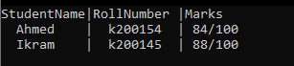

**Task2**

#include <string.h>

#include <stdio.h>

#include <stdlib.h>

#include <conio.h>

struct time

{

int hours;

int minutes;

int seconds;

}time1, time2;

void timecalculator(int initialhours, int initialminutes, int initialseconds, int endinghours, int endingminutes, int endingseconds, time* finaltime) {

if (endingseconds<initialseconds){

finaltime->seconds = ((endingseconds+60) - initialseconds);

endingminutes = endingminutes - 1;

}

else

finaltime->seconds = (endingseconds -initialseconds );

if (endingminutes < initialminutes) {

finaltime->minutes = ((endingminutes+60) - initialminutes);

endinghours = endinghours - 1;

}

else

finaltime->minutes = (endingminutes - initialminutes);

if (initialhours > endinghours) {

finaltime->hours = ((endinghours+24)-initialhours);

}

}

int main() {

printf("NOTE: all calculataions are done according to 24 hour clock\nPress any button to continue");

getch();

system("CLS");

struct time* timeptr, time3;

timeptr = &time3;

printf("Enter the starting time's hour ");

scanf(" %d", &time1.hours);

printf("Enter the starting time's minutes ");

scanf(" %d", &time1.minutes);

printf("Enter the starting time's seconds ");

scanf(" %d", &time1.seconds);

printf("Enter the ending time's hour ");

scanf(" %d", &time2.hours);

printf("Enter the ending time's minutes ");

scanf(" %d", &time2.minutes);

printf("Enter the ending time's seconds ");

scanf(" %d", &time2.seconds);

timecalculator(time1.hours, time1.minutes, time1.seconds, time2.hours, time2.minutes, time2.seconds, timeptr);

//system("CLS");

printf("Elapsed Time is\n%d:%d:%d", time3.hours, time3.minutes, time3.seconds);

}

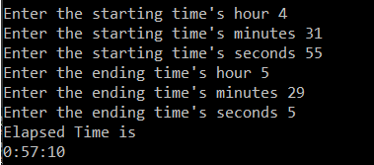

**Task3**

#include <stdio.h>

#include <stdlib.h>

/* run this program using the console pauser or add your own getch, system("pause") or input loop */

int main(int argc, char *argv[]) {

struct address

{

int hno;

int stno;

char area[20];

char city[10];

char country[15];

};

struct employee

{

char name[10];

char id[5];

float salary;

struct address adrs;

int age;

char desig[20];

}a[9];

int i,j;

for(i=0;i<=9;i++)

{

printf("----Employee profile----\n");

printf("Enter Name\n");

scanf("%s",a[i].name);

printf("Enter ID\n");

scanf("%s",a[i].id);

printf("Enter Salary\n");

scanf("%f",&a[i].salary);

printf("Enter Address in this form house number/street number/area/city/country\n");

scanf("%d",&a[i].adrs.hno);

scanf("%d",&a[i].adrs.stno);

scanf("%s",a[i].adrs.area);

scanf("%s",a[i].adrs.city);

scanf("%s",a[i].adrs.country);

printf("Enter Age\n");

scanf("%d",&a[i].age);

printf("Enter Designation\n");

scanf(" %s",a[i].desig);

};

for(j=0;j<=9;j++)

{

printf("%s | %s | $%.2f | HouseNo.%d Street %d %s,%s,%s | %dYearsOld | %s\n",a[j].name,a[j].id,a[j].salary,a[j].adrs.hno,a[j].adrs.stno,a[j].adrs.area,a[j].adrs.city,a[j].adrs.country,a[j].age,a[j].desig);

}

return 0;}

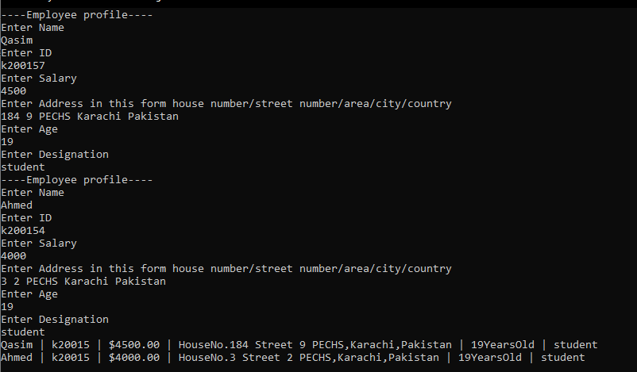

**\*Two Sets of data used for the sake of simplicity\***

**Task4**

#include <stdio.h>

#include <stdlib.h>

/* run this program using the console pauser or add your own getch, system("pause") or input loop */

struct address

{

int hno;

int stno;

char area[20];

char city[10];

char country[15];

};

struct employee

{

char name[10];

char id[5];

float salary;

struct address adrs;

int age;

char desig[20];

}a[9];

float avgsalary(struct employee a[])

{

int k,total=0;

float avg=0;

for(k=0;k<=9;k++)

{

total=total+a[k].salary;

}

avg=total/k;

return avg;

}

int main(int argc, char *argv[]) {

int i,j;

for(i=0;i<=9;i++)

{

printf("----Employee profile----\n");

printf("Enter Name\n");

scanf("%s",a[i].name);

printf("Enter ID\n");

scanf("%s",a[i].id);

printf("Enter Salary\n");

scanf("%f",&a[i].salary);

printf("Enter Address in this form house number/street number/area/city/country\n");

scanf("%d",&a[i].adrs.hno);

scanf("%d",&a[i].adrs.stno);

scanf("%s",a[i].adrs.area);

scanf("%s",a[i].adrs.city);

scanf("%s",a[i].adrs.country);

printf("Enter Age\n");

scanf("%d",&a[i].age);

printf("Enter Designation\n");

scanf(" %s",a[i].desig);

};

for(j=0;j<=9;j++)

{

printf("%s | %s | $%.2f | HouseNo.%d Street %d %s,%s,%s | %dYearsOld | %s\n",a[j].name,a[j].id,a[j].salary,a[j].adrs.hno,a[j].adrs.stno,a[j].adrs.area,a[j].adrs.city,a[j].adrs.country,a[j].age,a[j].desig);

}

float avgsal;

avgsal=avgsalary(a);

printf("\n");

printf("Average Salary of the employees is $%f ",avgsal);

return 0;

}

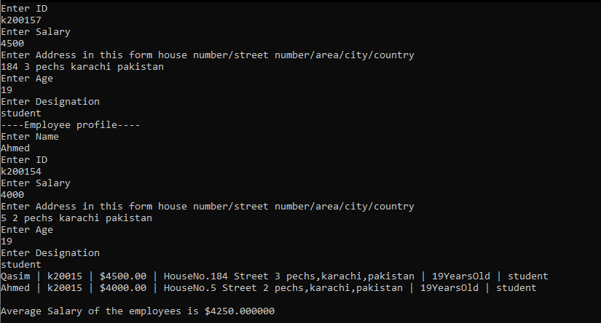

**\*Two Sets of data used for the sake of simplicity\***

**Task5**

#include <string.h>

#include <stdio.h>

#include <stdlib.h>

struct student

{

char name[20];

char rollNumber[20];

int attendance_Marks;

int test1;

int test2;

int test3;

};

int main() {

struct student *ptra,a;

ptra = &a;

struct student *ptrb,b;

ptrb = &b;

gets(a.name);

gets(a.rollNumber);

scanf(" %d", &a.test1);

scanf(" %d", &a.test2);

scanf(" %d", &a.test3);

scanf(" %d", &a.attendance_Marks);

scanf(" %[^\n]", &b.name);

scanf(" %[^\n]", &b.rollNumber);

scanf(" %d", &b.test1);

scanf(" %d", &b.test2);

scanf(" %d", &b.test3);

scanf(" %d", &b.attendance_Marks);

ptra->test1 += 3;

ptra->test2 += 10;

ptra->test3 += +8;

ptrb->test1 += 3;

ptrb->test2 += 10;

ptrb->test3 += 8;

printf("StudentName | RollNumber | Marks\n");

printf(" %s | %s | %d\n", a.name, a.rollNumber, (a.test1 + a.test2 + a.test3 + a.attendance_Marks));

printf(" %s | %s | %d\n", b.name, b.rollNumber, (b.test1 + b.test2 + b.test3 + b.attendance_Marks));

}

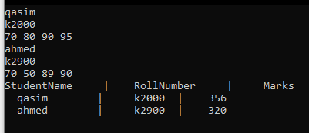

**Task6**

#include <stdio.h>

#include <stdlib.h>

/* run this program using the console pauser or add your own getch, system("pause") or input loop */

int main(int argc, char *argv[]) {

struct address

{

int hno;

int stno;

char area[20];

char city[10];

char country[15];

};

struct employee

{

char name[10];

char id[5];

float salary;

struct address adrs;

int age;

char desig[20];

}a[9];

printf("Size of the structure Employee is %d",sizeof(a));

return 0;

}



**Task 7**

#include <stdio.h>

#include <stdlib.h>

/* run this program using the console pauser or add your own getch, system("pause") or input loop */

int main(int argc, char *argv[]) {

struct Date

{

int day;

int month;

int year;

}a,b;

printf("Enter day / month / year;\n ");

scanf("%d%d%d",&a.day,&a.month,&a.year);

printf("Enter day / month / year;\n ");

scanf("%d%d%d",&b.day,&b.month,&b.year);

if(a.day==b.day && a.month==b.month && a.year==b.year)

printf("Dates are equal");

else printf("Dates are not equal");

return 0;

}

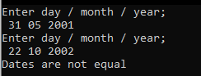 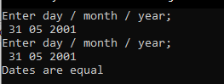

**Task8i**

#include <stdio.h>

#include <stdlib.h>

/* run this program using the console pauser or add your own getch, system("pause") or input loop */

int n=1;

struct bankinfo

{

char name[20];

char accnum[5];

float balance;

}a[1];

void lessbal(struct bankinfo a[])

{

int i;

for(i=0;i<=n;i++){

if((a[i].balance)<2000)

{

printf("\n%s's Balance less than $2000'",a[i].name);

}

}

}

int main(int argc, char *argv[]) {

int k;

for(k=0;k<=n;k++)

{

printf("----BANK INFO----\n\n");

printf("Enter Name;\n");

scanf("%s",a[k].name);

printf("Enter Account Number;\n");

scanf("%s",a[k].accnum);

printf("Enter account balance\n$");

scanf("%f",&a[k].balance);

}

lessbal(a);

return 0;

}

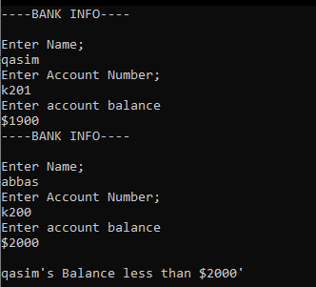

**Task8ii**

#include <string.h>

#include <stdio.h>

#include <stdlib.h>

#include <conio.h>

struct BankDataStruct

{

char name[30];

int accountNo;

int balance;

};

void lessthen20k(struct BankDataStruct *ptrB) {

for (int j = 0; j < 11; j++) {

if (ptrB->balance < 2000) {

printf("\nCustomer %s has balance %d\n", ptrB->name, ptrB->balance);

}

else

ptrB->balance += 1000;

ptrB++;

}

}

int main() {

struct BankDataStruct *ptrB, BankData[11];

ptrB = &BankData[0];

for (int i = 0; i < 11; i++) {

printf("Enter customer %d name ", i + 1);

scanf(" %[^\n]",&BankData[i].name);

printf("Enter customer %d account Number ", i + 1);

scanf(" %d",&BankData[i].accountNo);

printf("Enter customer %d Balance ", i + 1);

scanf(" %d", &BankData[i].balance);

printf("\n");

}

system("CLS");

lessthen20k(ptrB);

for (int i = 0; i < 11; i++) {

printf("customer %s\n", BankData[i].name);

printf("account Number %d\n", BankData[i].accountNo);

printf("Balance %d\n", BankData[i].balance);

printf("\n_____________________\n");

}

}

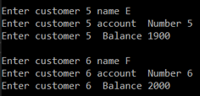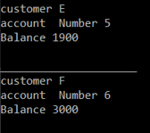

**Task9**

#include <string.h>

#include <stdio.h>

#include <stdlib.h>

#include <math.h>

struct student

{

int rollno;

char name[10];

int age;

char address[30];

};

void evenrollno(struct student *ptr) {

int j;

for (j = 0; j < 12; j++) {

if (ptr->rollno > 0) {

if ((ptr->rollno % 2) == 0) {

puts(ptr->name);

}

ptr++;

}

}

}

void age14(struct student* ptr) {

int j;

for (j = 0; j < 12; j++) {

if (ptr->age ==14)

printf("\n%s is age 14\n", ptr->name);

ptr++;

}

}

void rollnogiven(struct student* ptr) {

int j;

for (j = 0; j < 12; j++) {

if (ptr->rollno > 0)

puts(ptr->name);

ptr++;

}

}

int main() {

struct student *ptrS,studentlist[12];

ptrS = &studentlist[0];

strcpy(studentlist[0].name,"Musab");

studentlist[0].rollno = 2;

studentlist[0].age = 14;

strcpy(studentlist[1].name, "Mahad");

studentlist[1].rollno = 3;

studentlist[1].age = 13;

strcpy(studentlist[2].name, "Abbas");

studentlist[2].rollno = 7;

studentlist[2].age = 15;

strcpy(studentlist[3].name, "Ahmed");

studentlist[3].rollno = 8;

studentlist[3].age = 14;

strcpy(studentlist[4].name, "Danish");

studentlist[4].rollno = 10;

studentlist[4].age = 11;

strcpy(studentlist[5].name, "Qasim");

studentlist[5].rollno = 11;

studentlist[5].age = 14;

evenrollno(ptrS);

printf("\n");

age14(ptrS);

printf("\n");

rollnogiven(ptrS);

}

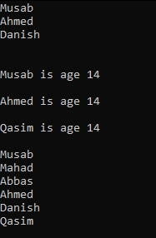

**Task10**

#include <string.h>

#include <stdio.h>

#include <stdlib.h>

#include <math.h>

#define PI 3.14159265358979323846

struct Square

{

float length;

float area;

};

struct Sphere

{

float radius;

float volume;

};

struct Triangle

{

float base;

float perpendicular;

float hypotenus;

};

struct Circle {

float radius;

float circumference;

};

int main() {

struct Square Square1;

struct Sphere Sphere1;

struct Triangle Triangle1;

struct Circle Circle1;

printf("Enter length of one side of square ");

scanf("%f",&Square1.length);

printf("Enter radius of Sphere ");

scanf("%f", &Sphere1.radius);

printf("Enter length of base of triangle ");

scanf("%f",&Triangle1.base);

printf("Enter length of perpendicular of triangle ");

scanf("%f", &Triangle1.perpendicular);

printf("Enter radius of Circle ");

scanf("%f",&Circle1.radius);

printf("\n==============================\n");

Square1.area = Square1.length * Square1.length;

printf("Area of Square is %f\n",Square1.area);

Sphere1.volume = (1.33333 * PI * (Sphere1.radius*Sphere1.radius*Sphere1.radius));

printf("Volume of Sphere is %f\n", Sphere1.volume);

Triangle1.hypotenus = sqrt((Triangle1.base * Triangle1.base) + (Triangle1.perpendicular * Triangle1.perpendicular));

printf("Hypotenus of Triangle is %f\n",Triangle1.hypotenus);

Circle1.circumference = (Circle1.radius * 2 * PI);

printf("Circumference of circle is %f\n",Circle1.circumference);

}

