C05
UNIT V – Suggested Lab Programs (Python)

Lab Program 1: Rule-Based Classification using Sequential Covering Algorithm
PROGRAM CODE:
data = [(1,"Yes"), (0,"No"), (1,"Yes")]
for x,y in data:
if x == 1:
print("Rule: IF x=1 THEN", y)
OUTPUT
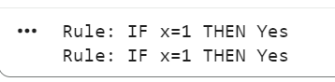

Lab Program 2: Learning Rule Sets using Decision Tree to Rule Conversion
PROGRAM CODE
tree = {1:"Yes", 0:"No"}
for feature in tree:
print("Rule: IF x =", feature, "THEN class =", tree[feature])

OUTPUT
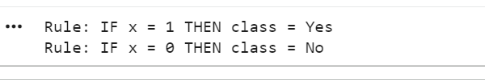

Lab Program 3: Explanation-Based Learning (EBL)
PROGRAM CODE
example = ("Bird", "CanFly")
if example[0] == "Bird":
print("Rule: IF object is Bird THEN it can Fly")

OUTPUT
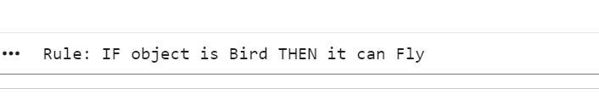

Lab Program 4: Reinforcement Learning – Q-Learning Algorithm
PROGRAM CODE
Q = {}
state, action, reward = 1, "move", 10
Q[(state, action)] = reward
print("Q-value:", Q[(state, action)])
OUTPUT
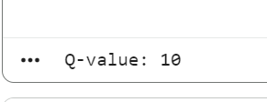
Lab Program 5: Reinforcement Learning – Optimization using Grid World / Business
Simulation

PROGRAM CODE
grid = [[0,0],[0,10]]
pos = (0,0)
pos = (1,1)
print("Reached goal reward:", grid[1][1])
OUTPUT
