20K-1751

OsLab03

1. HOW TO SET STATIC IP IN UBUNTU SERVER

a) Identifying the Network Interface Name

Ip link

Using Netplan to Define a Static IP Address

We can locate the netplan files using

ls /etc/netplan

We can begin editing the Netplan configuration file by utilizing the nano text editor. Make

sure you change the filename in the following command

sudo nano /etc/netplan/ 01-network-manager-all.yaml

Now that you understand the default configuration, we can now modify it to suit our needs.

Please note that indentation is crucial to the Netplan configuration file. Anything inside a

block needs to have an extra two spaces added before it.

At the end of these steps, you should have a configuration file that looks like we have

below. The IP addresses and network interface names will likely differ from what we have

here.

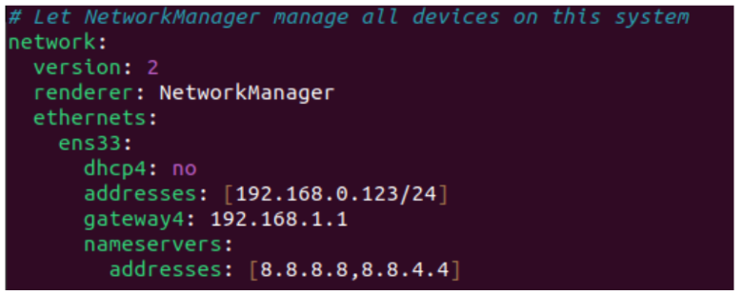

Now to check whether your configuration has been accepted or not, type the below

commands

sudo netplan try

With the configuration file modified, we need to get the Netplan tool to apply the changes.

Applying the changes is as simple as using the following command on your Ubuntu device.

sudo netplan apply

Verifying that the Ubuntu 22.04 operating system is now utilizing a static IP address, we can

use the ip command again.

ip a

Restart your network service manager

sudo systemctl restart NetworkManager.service

DISADVANTAGES OF STATIC IP

Static IP address has a few drawbacks:

• The router will never guarantee that the IP is actually available. As there is no

reservation in place, the IP can be assigned to another device.

• Additionally, suppose the static IP address is not available when your Ubuntu 22.04

device connects. In that case, it will fail to connect to the router.

• As your device asks for a specific IP, the router will not fall back to assigning an IP from

the router’s pool.

Samba

To install SAMAB on your Ubuntu use the following command

sudo apt install samba –y

After installing check SAMBA stsus using the following command

sudo systemctl status smbd

This will show that your SAMBA server is active/running.

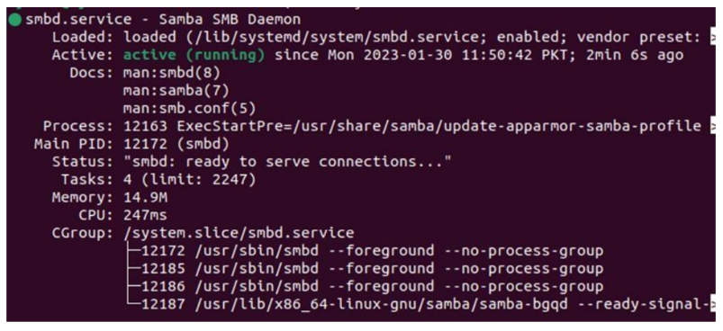

Now create a directory that will be shared across platforms

mkdir /home/username/sharingFolder

Now give permissions to the above directory named sharingFolder

chmod 777 /home/ayesha/sharingFolder

Now create a SAMBA side user to access the directory

sudo useradd user1

Now set SAMBA user password

Sudo ambpasswd –a user

Now go to SAMBA configuration file to enable sharing of the directory sharingFolder

Sudo nano /etc/samba/smb.conf

After opening the file. Go to the bottom of the file using ctrl+V and type the below

commands:

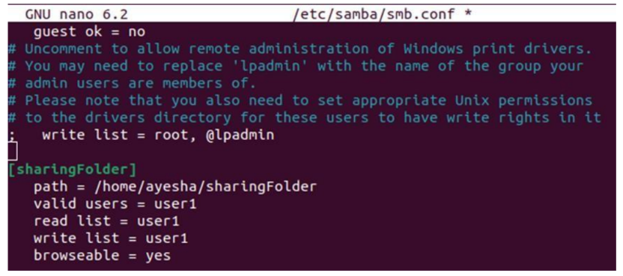

Now to check your changes type

Testparm

Now to check the sharing of your folder between Linux and Windows OS. Press Window + R

to open run terminal and insert the ip address of your linux. To get the ip address use the

following command

ip a

Now you can acces the folder using different system.