**A SURVEY ON ROUTING PROTOCOLS IN**

**WIRELESS SENSOR NETWORKS (WSN)**



INTRUCTOR: SIR KARIZ KAMAL

GROUP MEMBERS:

M. AHSAN RAZA (20K-0137)

SARIM KHAN (20K-0481)

HAMDAN QURESHI (20K-0327)

**INTRODUCTION:**

In recent years, Wireless Sensor Networks (WSNs) have emerged as a powerful and promising technology, attracting significant interest due to their extensive applications across various sectors such as environmental monitoring, healthcare, agriculture, surveillance, smart cities, and industrial automation. WSNs comprise a vast array of small, energy-efficient, and self-sufficient sensor nodes that are dispersed within a specific region to wirelessly gather, process, and transmit data. These nodes come equipped with a range of sensors like temperature, humidity, pressure, light, and motion sensors, allowing them to collect and send data from the physical world to the end-users or central server for subsequent analysis and decision-making.

Several factors contribute to the popularity of WSNs. Primarily, they offer an economical alternative to conventional wired solutions, making them appealing for numerous applications. Moreover, without the need for physical connections between nodes or access points, WSNs provide enhanced flexibility that enables effortless deployment and reconfiguration. Additionally, WSNs demonstrate scalability by allowing seamless expansion or reduction based on application requirements while avoiding the need for replacing existing hardware components or wiring infrastructure. Lastly, WSNs have proven to be dependable in challenging environments where traditional wired solutions may falter due to interference or extreme conditions.

Some of the key characteristics of WSNs are:

* Limited Energy Resources: Sensor nodes in Wireless Sensor Networks (WSNs) rely on batteries or energy-harvesting techniques, thus having restricted energy reserves. The energy consumption of these nodes is crucial to the WSN's lifespan. Effective energy management is vital for extending the network's lifetime and ensuring dependable data delivery.
* Unstable Network Topology: WSNs are frequently deployed in dynamic and unpredictable environments, such as forests, deserts, and battlefields. Factors like node mobility, failures, or environmental conditions can frequently change the network topology. WSN routing protocols must continually adapt to these changes and find efficient pathways for data routing.
* Network Scalability: WSNs may include a vast number of densely distributed sensor nodes in a designated area. As the number of nodes and data generated from them grows, the routing protocols in WSNs must be able to accommodate the increase in scale.
* Restricted Bandwidth: Wireless communication channels in WSNs typically have limited bandwidth, constraining the volume of data that can be transmitted within a specific time limit. Routing protocols in WSNs need to optimize the use of available bandwidth and minimize data transmission overheads.

In wireless sensor networks (WSNs), routing protocols are vital for creating communication pathways among sensor nodes, managing network resources, and ensuring dependable data transfer with minimal energy consumption and optimal network longevity. These protocols define the methods for transmitting data packets from source to sink nodes and address unique WSN challenges such as energy efficiency, scalability, fault tolerance, and adaptability to fluctuating network conditions.

Designing WSN routing protocols is quite challenging due to their distinct characteristics. Several design factors must be considered to guarantee efficient and reliable data transmission. Key aspects of WSN routing protocol design include:

* Energy efficiency: Since sensor nodes in WSNs possess limited energy supplies, routing protocols must optimize routes, minimize unnecessary data transmissions, and incorporate strategies like data aggregation, sleep schedules, and duty cycling to conserve energy and extend network lifespan.
* Scalability: WSNs often comprise numerous sensor nodes, hence routing protocols must be capable of efficiently handling the increasing amounts of data generated by these nodes. Scalable protocols effectively manage network resources, adapt to changing topologies, and offer reliable data delivery in extensive WSNs.
* Adaptability to changing topologies: Given that WSNs are typically deployed in dynamic environments where network topologies frequently vary due to node mobility, failures, or environmental factors, routing protocols must establish new routes and reroute data packets to ensure reliable delivery.
* Fault tolerance: Routing protocols need to detect and recover from node failures while still offering reliable data delivery in the face of hardware/software failures or link breakdowns.
* Data aggregation: Employing data aggregation techniques can decrease transmitted data amounts - thereby conserving energy and bandwidth. Allowing sensor nodes to aggregate and compress redundant or correlated information before sending it to the sink node or base station supports this goal.
* Quality of Service (QoS) requirements: For certain WSN applications that necessitate low latency, reliability, and high throughput, routing protocols should take these factors into account, optimizing routes to meet specific needs while conserving energy and bandwidth.
* Security measures are essential for Wireless Sensor Networks (WSNs) to guarantee safe and dependable data transmission, as the information being transmitted might be sensitive or exposed to various threats. To maintain data confidentiality, integrity, and authenticity, routing protocols in WSNs must include encryption methods. Additionally, authentication and authorization mechanisms should be in place to confirm that only approved nodes are involved in the routing procedure.

**MOTIVATION:**

The performance of routing protocols in WSNs is influenced by network conditions, such as node mobility, energy constraints, and network scalability.

Several routing protocols have been proposed for WSNs to address these challenges. These include EESSTBRP (Energy Efficient Stable Spanning Tree Based Routing Protocol), PEGASUS (Position Enhanced Gateway Selection and Upgrade Strategy) [1], EBR-RL (Energy Balanced Routing with Reinforcement Learning) [2], EER-RL (Energy Efficient Routing with Reinforcement Learning) [3], and Energy Aware Multiuser & Multi-hop Hierarchical (EAMMH) routing protocols [4]. Each of these protocols has its unique features and advantages based on several factors and constraints.

However, there is a need to comprehensively evaluate the performance of these routing protocols in WSNs to understand their strengths and weaknesses and identify the most suitable protocol for specific application scenarios. Furthermore, there is a lack of comparative studies that consider multiple performance metrics, such as energy consumption, network lifetime, packet delivery ratio, and delay, to provide a holistic evaluation of these routing protocols.

Therefore, the motivation of this survey paper is to conduct a systematic evaluation of the performance of five routing protocols in WSNs, namely EESSTBRP, PEGASUS, EBR-RL, EER-RL, and EAMMH. The paper aims to provide an in-depth analysis of the strengths and weaknesses of these protocols and identify their applicability in different WSN scenarios. The findings of this survey will be beneficial for researchers and practitioners in selecting the most appropriate routing protocol for their specific WSN deployment, leading to improved performance and energy efficiency in WSNs.

**Related Work:**

Routing is a core issue for Wireless Sensor Networks, and several routing protocols have been proposed, and implemented, to address it. Routing protocols affect energy consumption, network lifespan, latency, and scalability of the entire network; therefore, selection of the appropriate protocol for the use case is essential. In this paper, we consider a two-dimensional static network with nodes randomly distributed in a one hundred meter by 100 meter field. The base station is situated in the center of this field.

In such a network, the sensor nodes are responsible for collecting information from the environment and relaying it to the base station. This can be achieved through a direct connection to the base station, or through a multi-hop path through the network. Due to the distances and associated energy requirement of direct connections, multi-hop paths are the more desirable option. Hence, the need for efficient routing protocols emerges.

**Routing Protocols:**

A comprehensive survey of routing protocols in WSNs provides valuable insights into the state-of-the-art techniques, challenges, and trends in this field. In recent years, several routing protocols have been proposed to address the challenges of routing in WSNs. In this literature review, we will survey and analyze five such routing protocols: EESSTBRP, PEGASUS, EBR-RL, EER-RL, and EAMMH, which have been proposed as solutions to enhance routing performance in WSNs.

**Hierarchical:**

**Low Energy Adaptive Clustering Hierarchy**

Low-Energy Adaptive Clustering Hierarchy (LEACH) protocol was developed based on energy balancing principles. LEACH is a hierarchical, cluster-based routing protocol for WSNs, where sensor nodes are organized into clusters with one or more cluster heads (CHs) that are responsible for aggregating and transmitting data to a central base station (BS). The protocol uses a randomized rotation of CHs to distribute the energy load among nodes and prolong the network lifetime [12]. Numerous studies have been conducted to evaluate the performance of the LEACH protocol and propose improvements. Although LEACH reduces energy consumption, it suffers from packet loss [13]. An attempt was made to address this issue by using Delay Tolerant Network (DTN) [13] and fuzzy-based clustering [14].

**Energy-Aware Multiuser and Multi-hop Hierarchical**

EAMMH is a multi-objective routing protocol that takes a hierarchical approach to optimize multiple objectives, including energy efficiency, network lifetime, and secure communication. EAMMH divides the network into multiple levels of hierarchy, with each level having a designated cluster head that acts as a gateway for inter-cluster communication [4]. EAMMH employs a multi-objective optimization approach to select the optimal routing paths that balance energy consumption, prolong the network lifetime, and ensure secure communication. It also incorporates load-balancing mechanisms to distribute the traffic evenly across the network and avoid hotspots [4]. EAMMH's multi-objective and hierarchical approach makes it suitable for large-scale WSNs where multiple objectives need to be optimized simultaneously.

**Reinforcement Learning:**

**Energy Balanced Routing – Reinforcement Learning**

EBR-RL is a reinforcement learning-based routing protocol that aims to balance the energy consumption among the sensor nodes in WSNs. EBR-RL employs a Q-learning algorithm to learn the optimal routing decisions based on the energy levels of the nodes and the network conditions [11]. The Q-learning algorithm enables the nodes to adaptively learn and update their routing decisions to minimize energy consumption while maintaining network connectivity. EBR-RL also incorporates energy-aware metrics to evaluate the energy levels of the nodes and make routing decisions accordingly. By dynamically adjusting routing decisions based on the energy levels and network conditions, EBR-RL can achieve energy balance among the sensor nodes, prolonging the network lifetime.

**Energy Efficient Routing – Reinforcement Learning**

EER-RL is another reinforcement learning-based routing protocol that focuses on energy efficiency in WSNs. EER-RL utilizes a Q-learning algorithm to learn the optimal routing decisions based on the energy levels of the nodes, the network conditions, and the traffic load. EER-RL aims to achieve energy-efficient routing by selecting the paths that require the least amount of energy for data forwarding [15]. It also incorporates adaptive transmission power control to further reduce energy consumption by making use of cooperative reinforcement learning approaches such as SSAR [16] and fuzzy logic [17].

**Sleep Scheduling:**

**Power Efficient Gathering in Sensor Information Systems**

PEGASIS utilizes a chain-based approach where sensor nodes form chains to transmit data to a designated node called the base station or the sink node. The chain formation in PEGASIS is based on a greedy algorithm that selects the next hop node in the chain based on the remaining energy and distance to the base station [8]. The selected node becomes the leader of the chain and collects data from neighboring nodes, which are then forwarded to the base station. PEGASIS eliminates the need for global knowledge of network topology, which makes it scalable for large-scale networks. PEGASIS also incorporates techniques such as data aggregation and node sleep schedules to further reduce energy consumption [9]. Data aggregation involves combining similar data from multiple nodes before transmission, reducing the amount of data that needs to be transmitted and saving energy. Node sleep scheduling involves turning off or putting nodes into sleep mode when they are not actively participating in the data transmission process, conserving energy.

PEGASIS has been widely studied and evaluated in various scenarios, and it has been shown to achieve significant energy savings and prolong the network lifetime compared to other traditional routing protocols in WSNs [10]. However, like other routing protocols, PEGASIS also has its limitations and may not be optimal for all WSN applications or network scenarios. Further research and evaluation are needed to determine its performance under different conditions and to address its limitations.

**Energy Efficient Sleep-Scheduled Tree-Based Routing Protocol**

EESSTBRP is a distributed routing protocol that aims to achieve energy efficiency and security in WSNs. It utilizes a spanning tree-based approach to construct a connected network topology with a designated root node as the central hub. EESSTBRP incorporates energy-aware routing decisions to minimize energy consumption by selecting the most energy-efficient paths from the root node to the sensor nodes [5]. It also integrates secure communication mechanisms, such as authentication and encryption, to protect against various security threats, such as node compromise and data tampering. EESSTBRP's energy-aware and secure routing features make it suitable for WSNs where energy conservation and data security are critical requirements. This protocol utilizes systematic sleep-wake combinations to improve the battery’s lifespan [6]. An approach of using a red-black tree alongside a sleep schedule was also sought to determine its feasibility of it in 2019 [7].

**Performance Comparison:**

There are several aspects that can be considered when evaluating the performance of WSN routing algorithms, including: energy efficiency, network lifetime, latency, etc. In this paper, we focus on energy consumption, and the number of dead nodes at the end of 1000 rounds. To ensure as fair a comparison as possible, MATLAB simulations of each of the covered protocols were run with control parameters as described in Table 1. The results of the simulations are summarized in Table 2. In the following subsection, we provide more detailed results for each class of routing protocols.

|  |  |
| --- | --- |
| Parameter | Value |
| Total Rounds | 1000 |
| Number of Nodes | 100 |
| Initial Energy(J) | 0.5 |
| Range(m) | 20 |

Table 1 Control Parameters

|  |  |  |  |  |  |
| --- | --- | --- | --- | --- | --- |
| Classification | Protocol | Year | Ref. | Remaining Energy(J) | Dead Nodes |
| Hierarchical | LEACH |  |  |  |  |
| EAMMH | 2018 | [4] | 0.02 | 81 |
| Reinforcement Learning | EER-RL | 2021 | [3] | 0.2 | 25 |
| EBR-RL | 2021 | [2] | 0.2 | 6 |
| Sleep Scheduling | PEGASIS |  |  | 0.075 | 3 |
| EESSTBRP | 2019 | [1] | 0.49 | 0 |

Table 2 Simulation Results

**Hierarchical:**

Overall, hierarchical based routing protocols perform the worst out of the selected protocols. Simulations consistently produce the lowest remaining energy and significantly more dead nodes at the end of 1000 rounds when these protocols are used.

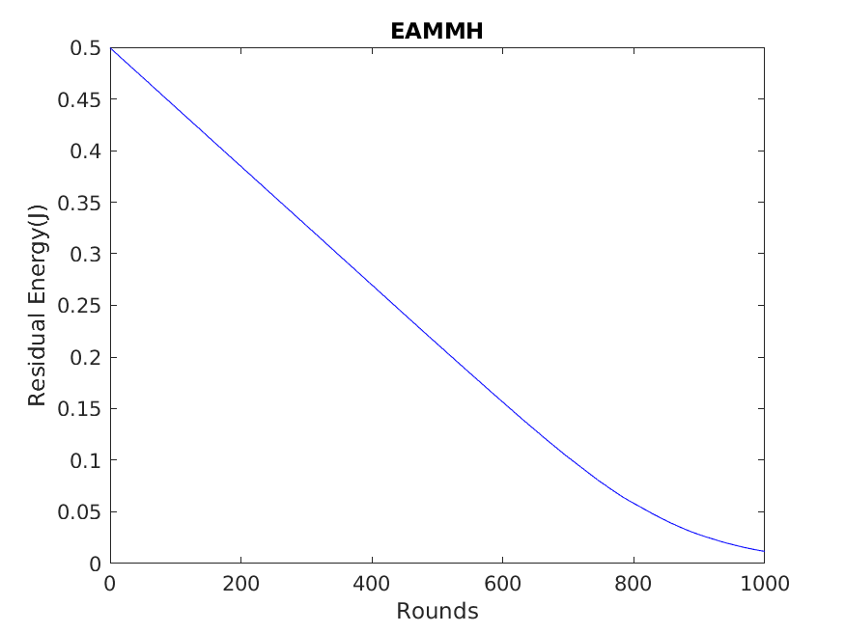

Figure 1 EAMMH Residual Energy

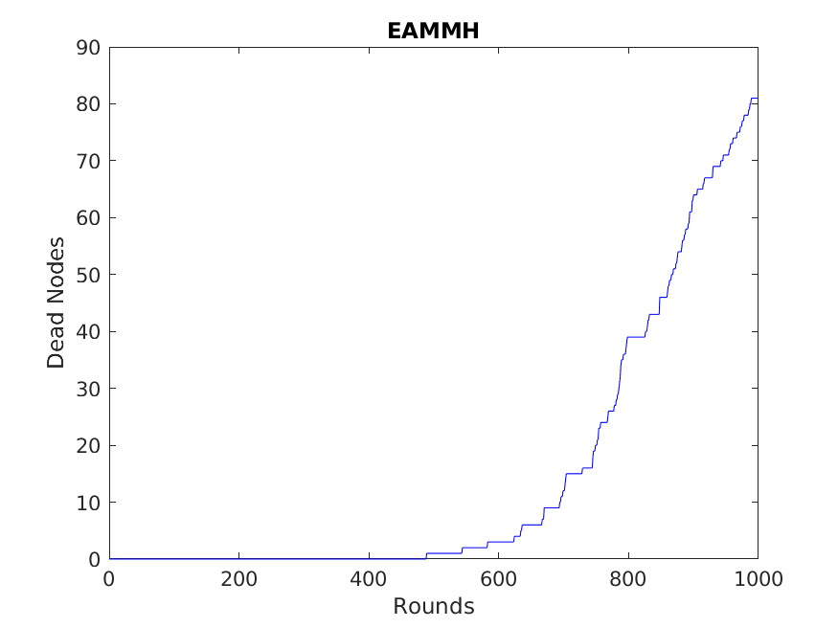

Figure 2 EAMMH Dean Nodes

**Reinforcement Learning:**

Reinforcement Learning based routing protocols offer better energy efficiency, but with inconsistent results. Simulations consistently produce better energy consumption and fewer dead nodes compared to hierarchical based protocols; however, over repeated simulations, these protocols show significant variations in results with the same control parameters.

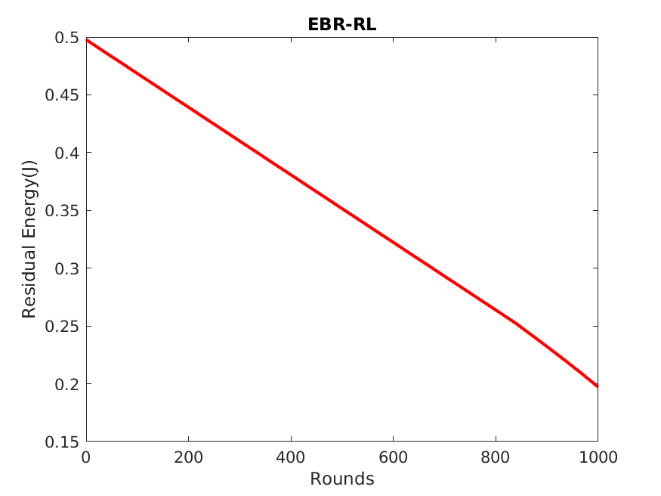

Figure 3 EBR-RL Residual Energy

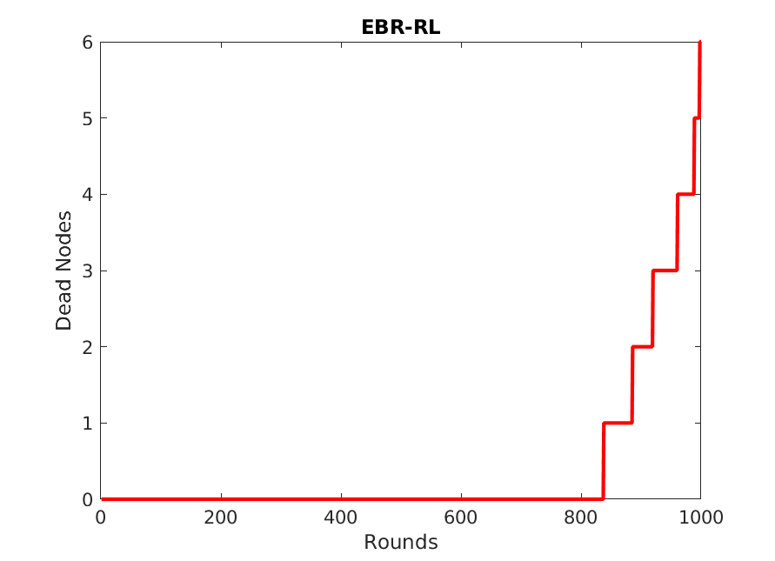

Figure 4 EBR-RL Dead Nodes

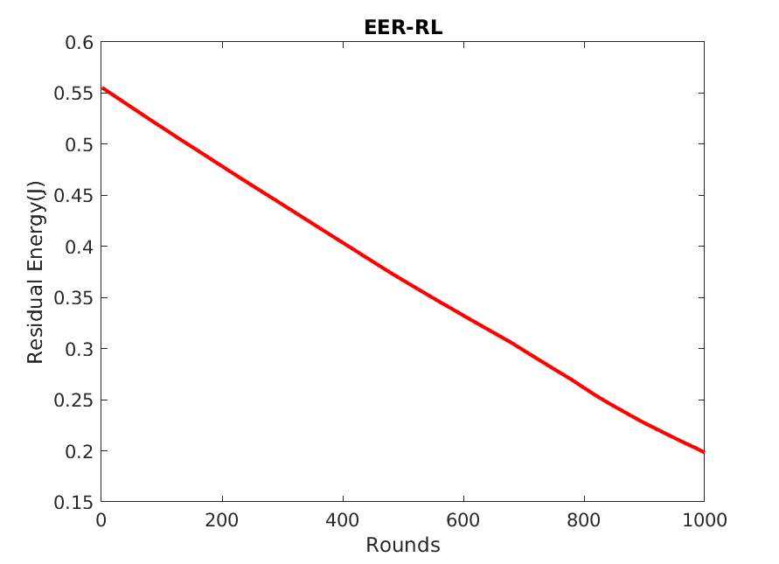

Figure 5 EER-RL Residual Energy

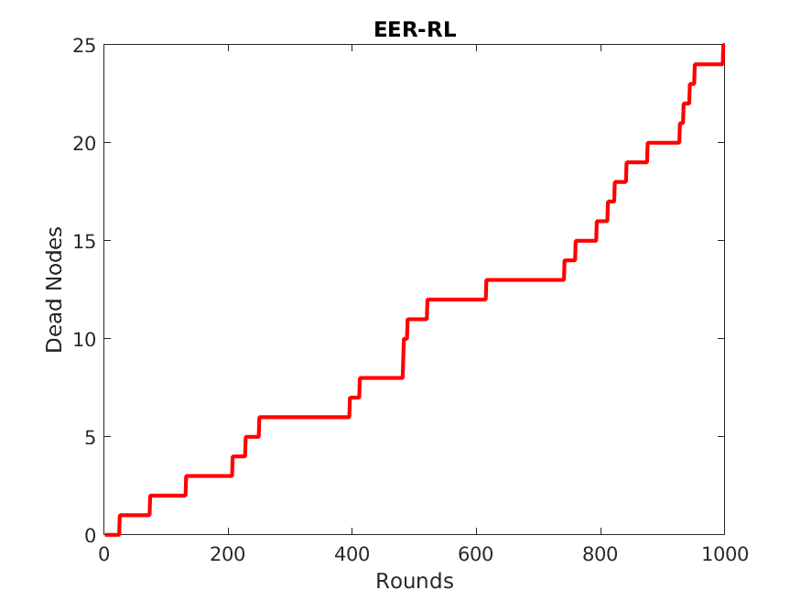

Figure 6 EER-RL Dead Nodes

**Sleep Scheduling:**

Sleep Scheduling based algorithms by far outperform both hierarchical and reinforcement learning based algorithms. The simulations show little energy consumption and no dead nodes after 1000 rounds. These protocols are highly effective at distributing energy consumption fairly. As seen in PEGASIS, dead nodes only begin to appear after the average residual energy per node is incredibly low.

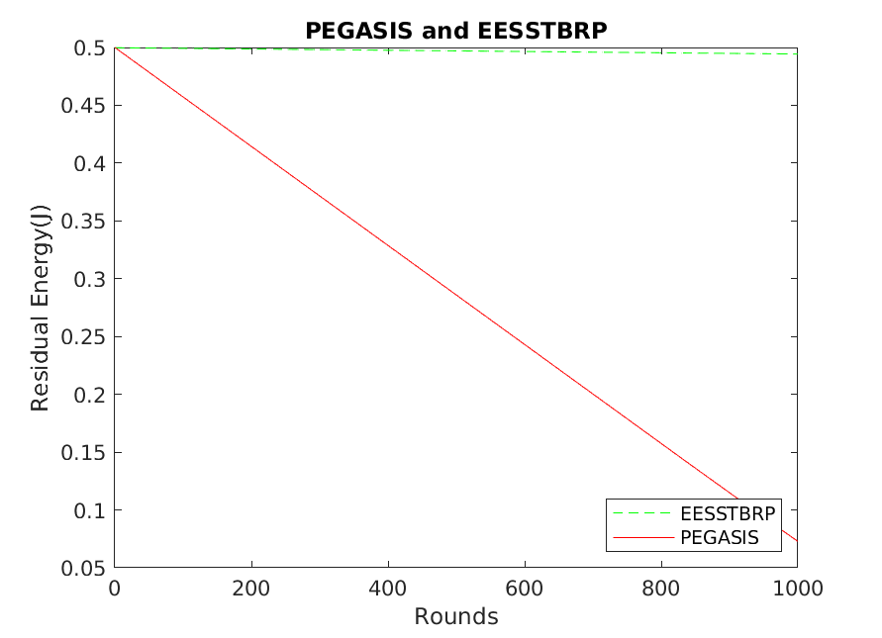

Figure 7 PEGASIS and EESSTBRP Residual Energy

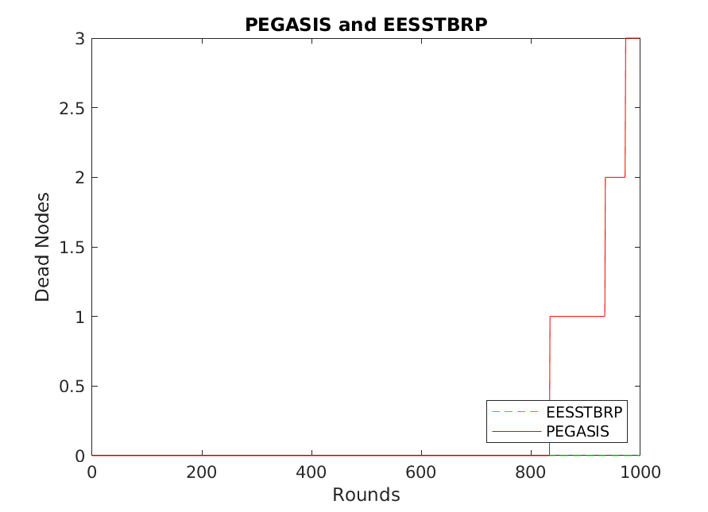

Figure 8 PEGASIS and EESSTBRP Dead Nodes

**Analysis of Results:**

Based on the results of the simulations, certain obesrvations can be made about the advantages and disadvantages of the selected protocols. The hierarchical-based protocols i.e. LEACH and EAMMH offer the worst performance; however, they are also well known and possess several variants. The Reinforcement learning-based protocols offer significantly better performance in average energy consumption, but more dead nodes than sleep scheduled protocols. They also produce inconsistent results across simulations, likely due to the random nature of reinforcement learning, and may require futher testing to determine their effectiveness. Lastly, among the sleep scheduling-based algorithms, EESSTBRP provides the best performance of all selected protocols. And PEGASIS, while offerring lower residual energy than even the reinforcement learning-based alternatives, produces a lower number of dead nodes.

|  |  |  |
| --- | --- | --- |
| Protocol | Advantage | Disadvantage |
| LEACH | Simpler  Well known  Several variants | Worst performance overall |
| EAMMH | More efficient Energy usage than LEACH | High number of dead nodes  Much better alternatives available |
| EER-RL | High residual energy after many rounds | High number of dead nodes  Inconsistent results, need for further testing |
| EBR-RL | High residual energy after many rounds | High number of dead nodes  Inconsistet results, need for further testing |
| PEGASIS | Fairly distributes energy usage resulting in very few dead nodes | Lower residual energy compared to Reinforcement Learning-based alternative |
| EESSTBRP | Most residual energy  Fewest dead nodes | Complex |

Table 3 Comparison of protocols based on simulation results

**Conclusion:**

In conclusion, our survey paper on routing protocols in Wireless Sensor Networks (WSN) highlights that sleep scheduling-based protocols, particularly EESSTBRP, demonstrate superior performance compared to other protocols in terms of surviving nodes and average remaining energy per node. This indicates that sleep scheduling-based protocols are more efficient and effective in prolonging the network lifetime and conserving energy resources in WSNs. On the other hand, hierarchical protocols are found to perform poorly, while reinforcement learning-based protocols fall in between.

These findings suggest that sleep scheduling-based protocols, such as EESSTBRP, can be considered as a promising approach for routing in WSNs, offering better performance in terms of network longevity and energy utilization. Further research in this area can focus on enhancing the scalability, adaptability, and robustness of sleep scheduling-based protocols to different WSN scenarios and applications. Additionally, investigating the potential synergies between sleep scheduling-based protocols and reinforcement learning-based approaches may yield further improvements in the performance of WSN routing protocols. Overall, our findings contribute to the understanding of routing protocols in WSNs and provide valuable insights for researchers and practitioners in selecting appropriate protocols for their specific WSN deployments.

**Future Research:**

Based on the results of our survey paper on routing protocols in wireless sensor networks (WSNs), several potential areas for future work can be identified.

Firstly, our simulations were conducted using a specific set of parameters and network conditions, and it would be interesting to investigate the performance of the evaluated routing protocols under different scenarios, such as varying network topologies, node densities, and traffic patterns. This could help to identify the strengths and weaknesses of each protocol in different environments and provide insights into the most suitable routing protocol for different WSN applications.

Secondly, while our study focused on traditional routing protocols, there is a growing interest in leveraging machine learning and artificial intelligence techniques in WSNs to improve network performance and adaptability. Therefore, future work could explore the potential of integrating machine learning techniques into routing protocols to enable them to optimize their performance in real-time based on changing network conditions.

Thirdly, the security and privacy implications of routing protocols in WSNs are a major area for future research. Specifically, it would be valuable to investigate the effectiveness of different security mechanisms and solutions to enhance the security and privacy of WSNs, as well as the trade-offs between security and network performance.

Fourthly, our survey paper focused on comparing existing routing protocols, but there may be opportunities to develop new protocols that are specifically designed for emerging WSN applications. For example, routing protocols that are optimized for energy efficiency, reliability, or scalability could be developed for specific types of WSNs.

Finally, our simulations were conducted in a virtual environment, and future work could involve testing and validating the findings from our study using real-world WSN deployments. This would enable us to assess the practical feasibility and performance of different routing protocols in real-world scenarios.

**REFERENCES:**

[1] P. Zhuojin, S. D. Semujju, L. Zhen, and Y. Hua, "Extending Lifetime of Sensor Networks Based on Sleep-scheduled Routing Algorithm," Journal of System Simulation, vol. 31, no. 4, Apr 2019.

[2] University, V.K.M.S., et al. (2021) EBR-RL: Proceedings of the 36th annual ACM Symposium on applied computing, ACM Conferences. Available at: <https://dl.acm.org/doi/10.1145/3412841.3442063> (Accessed: April 16, 2023).

[3] Mutombo, V.K. et al. (2021) “EER-RL: Energy-efficient routing based on reinforcement learning,” Mobile Information Systems, 2021, pp. 1–12. Available at: <https://doi.org/10.1155/2021/5589145>.

[4] M. Priyanga, S. Leones Sherwin Vimalraj, and J. Lydia, "Energy-Aware Multiuser & Multi-hop Hierarchical –Based Routing Protocol for Energy Management in WSN-Assisted IoT," 2018 3rd International Conference on Communication and Electronics Systems (ICCES), Coimbatore, India, 2018, pp. 701-705, doi: 10.1109/CESYS.2018.8724073.

[5] S. Sanjana, L. Shavanthi and R. Bhagya, "Analysis of Energy-Aware Sleep Scheduling Routing protocol (EASSR) in wireless sensor networks," 2017 International Conference on Intelligent Computing and Control (I2C2), Coimbatore, India, 2017, pp. 1-6, doi: 10.1109/I2C2.2017.8321920.

[6] S. Thomas, I. K. Gayathri, and A. Raj, "Joint design of Dijkstra's shortest path routing and sleep-wake scheduling in wireless sensor networks," 2017 International Conference on Energy, Communication, Data Analytics and Soft Computing (ICECDS), Chennai, India, 2017, pp. 981-986, doi: 10.1109/ICECDS.2017.8389583.

[7] Pranesh and S. L. Deshpande, "Application of Tree Data Structures for Improving Energy Efficiency & Life Time Of Wireless Sensor Networks (WSN): A Critical Study of the State-of-the-Art and Feasibility For Further Research," 2019 International Conference on Communication and Electronics Systems (ICCES), Coimbatore, India, 2019, pp. 1494-1499, doi: 10.1109/ICCES45898.2019.9002595.

[8] ShivaniRana, S. Jain and R. Kanji, "Design of Multi Chain Power-Efficient Gathering for Sensor Information System Using Sink Mobility," 2021 Sixth International Conference on Image Information Processing (ICIIP), Shimla, India, 2021, pp. 81-86, doi: 10.1109/ICIIP53038.2021.9702634.

[9] Sadhana, S., Sivaraman, E. and Daniel, D. (2021) “Enhanced Energy Efficient Routing for wireless sensor network using extended Power efficient Gathering in Sensor Information Systems (E-PEGASIS) protocol,” Procedia Computer Science, 194, pp. 89–101. Available at: <https://doi.org/10.1016/j.procs.2021.10.062>.

[10] S. Misra and R. Kumar, "An analytical study of LEACH and PEGASIS protocol in wireless sensor network," 2017 International Conference on Innovations in Information, Embedded and Communication Systems (ICIIECS), Coimbatore, India, 2017, pp. 1-5, doi: 10.1109/ICIIECS.2017.8276118.

[11] A. J. Ahmed et al., "Congestion Aware Q-Learning (CAQL) in RPL Protocol – WSN based IoT Networks," 2022 5th International Conference on Engineering Technology and its Applications (IICETA), Al-Najaf, Iraq, 2022, pp. 429-435, doi: 10.1109/IICETA54559.2022.9888322.

[12] L. SU et al., "Routing Protocol Based on LEACH-GAF Algorithm in WSN," 2020 Chinese Automation Congress (CAC), Shanghai, China, 2020, pp. 4119-4124, doi: 10.1109/CAC51589.2020.9326790.

[13] M. A. Rahmadhani, L. V. Yovita, and R. Mayasari, "Energy Consumption and Packet Loss Analysis of LEACH Routing Protocol on WSN Over DTN," 2018 4th International Conference on Wireless and Telematics (ICWT), Nusa Dua, Bali, Indonesia, 2018, pp. 1-5, doi: 10.1109/ICWT.2018.8527827.

[14] M. Gamal, N. E. Mekky, H. H. Soliman and N. A. Hikal, "Enhancing the Lifetime of Wireless Sensor Networks Using Fuzzy Logic LEACH Technique-Based Particle Swarm Optimization," in IEEE Access, vol. 10, pp. 36935-36948, 2022, doi: 10.1109/ACCESS.2022.3163254.

[15] Swati and M. Arora, "Several Categories of Energy-Efficient Routing Protocols, Features, and Security Necessities in WSN: A Review," 2022 3rd International Conference on Issues and Challenges in Intelligent Computing Techniques (ICICT), Ghaziabad, India, 2022, pp. 1-6, doi: 10.1109/ICICT55121.2022.10064506.

[16] S. Hamrioui, C. A. M. Hamrioui, J. Lioret, and P. Lorenz, “Smart and self-organized routing algorithm for efficient IoT communications in smart cities,” IET Wireless Sensor Systems, vol. 8, no. 6, pp. 305–312, 2018.

[17] Y. Akbari and S. Tabatabaei, “A new method to find a high reliable route in IOT by using reinforcement learning and fuzzy logic,” Wireless Personal Communications, vol. 112, no. 2, pp. 967–983, 2020.