# 6CCS3MDE/7CCSMMDD – Model-Driven Development

## Coursework group 7

### Group members:

Jeongho Yoo 1559860

Petko Kazandzhiev 1800767

Name of the project language:

EduLangauage

### Overview:

The language for the project is called EduLangauage. This project aims to help young student education. The name stands for education language for short. The domain of this project is written by Xtext. It is a domain specific language that designed for textual languages description.

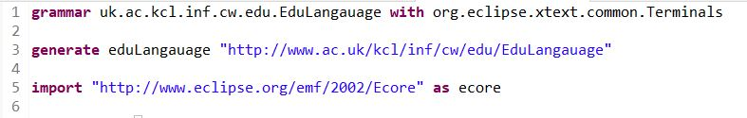

*Figure 1: Language and EPackage Declaration*

The Xtext grammar should start with grammar which defines some properties. The first line declares the language name. The grammar file name must correspond to the language name, EduLangauage.xtext. The rest of the codes in the first line declare another existing grammar to be used so that they have relationship to the language.

The third line means to generate an EPackage, named eduLangauage, and the nsURI is "http://www.ac.uk/kcl/inf/cw/edu/EduLangauage". The line 5 provides all the following rules returns instances of ecore.

### Language domain and MDD approach:

The reason why the EduLangauage is chosen is that domain-specific modelling language (DSML) has strong benefit for specific purpose. Education could be a great purpose for the language and implemented specifically. Trigonometry, based on a right-angled triangle, has three main functions such as Sine, Cosine, and Tangent. The project focuses on the Trigonometry and implements the value of the functions.

The MDD approach would help for the domain. One of the strong approaches would be MDD provides meta-model. The construction generates a complex scenario for controlling the structure of the meta-model generated.

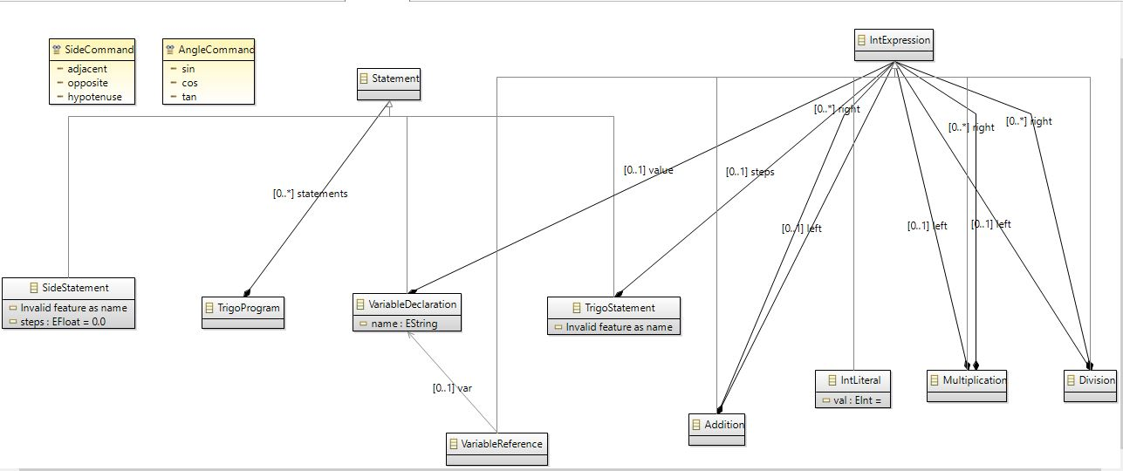

*Figure 2: Meta-model generation*

This meta-model describes the abstract syntax of the modelling language. /IntExpression is a super class that has relationships with sub classes such as Addition, IntLiteral, Multiplication, and Division.

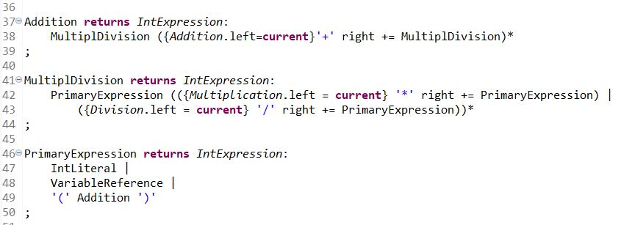

*Figure 3: Expressions grammar with Xtext*

This figure represents the expressions of basic calculation. All the trigonometry should have multiplication and division. The MDD grammar approach helps this calculation with syntax highlighting.

### Syntax of the project language:

This project aims to provide a textual language. Xtext Grammar provides textual languages and the trigonometry shows calculation which means it is a textual language rather than displaying a graphical language.

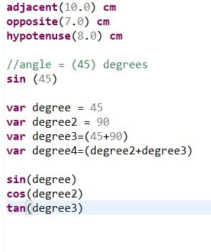

*Figure 4: example of test.edu editor file*

The above figure represents the textual language. They are executed on runtime eclipse based on the grammar from Xtext. A user types length of adjacent, opposite, hypotenuse, and degree

as input. The sin, cos, and tan functions calculate based on what the user provided the values, which stand for the last three codes. This runtime eclipse proves the textual syntax language.

### Conclusion:

This project needs to have a lot of improvement to execute perfect on its purpose. We had tried to implement a graphical language instead of a textual language. This way, we thought, might be providing better understanding in displaying with right-angled triangle. However, as this is first time to use Xtext grammar, the textual language would be more suitable to implement the project’s purpose.