*Executive Summary*

RUSocial was created exclusively for Ryerson students. It is an Android-based social media app that allows users to interact with both their friends on campus and with the Ryerson community as a whole. By integrating the dynamic features of Google maps, users are able to interact with their Ryerson peers like never before. Users are able to pull up the Socialite Map that shows them their current location on campus and indicates other nearby RUSocialites.

A status message feature allows users to update other RUSocialites on their current thoughts and activities that is displayed when you tap on one of the markers, making sure students never miss what's happening on campus. Become friends with other RUSocialites and add them to your Socialite List, view their profiles, send them messages, and always stay alert with the newest happenings. RUSocial aims to bring a whole new level of social media to Ryerson, and with campus Wi-Fi available to the community, no one will ever have to miss a thing.

Users must have a valid Ryerson e-mail in order to sign up for RUSocial.

The RUSocial app utilizes the Model-View-Controller architecture pattern alongside Ruby on Rails to organize the backend programming and database server hosted on rhcloud. The hosted Rails application is located at <http://rusocial-rusocialbackend.rhcloud.com/RUSocial>. RUSocial is supported on both mobile and tablet platforms. It has been optimized for the Google Nexus 4 Android Phone, with future optimizations in the future. The target and minimum API supported is 17.

Our goal is to make a seamless transition between information and technology to ensure each user can have the ultimate experience on campus.

*Installation*   
 To install RUSocial, download/import it to your phone and launch from Eclipse.

You may login with the username "Eggy" and password "Ram" or you may also register yourself as a user. Ensure that your username is more than 3 characters long and your email ends with either the "@ryerson.ca" or "@ scs.ryerson.ca" domains. Everything is fully functional, so please enjoy sampling our app.

*UML Diagrams*

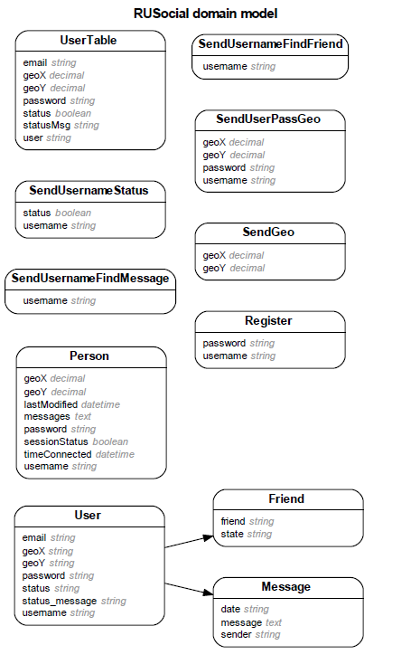

*Features and Functions*

**Look Around: Socialite List —** Thispulls up a list of other RUSocial users that displays their name, display picture, geographical location, and most recent update status.   
**Look Around:** **Socialite Map —** RUSocialutilizes Google maps to display the location of users on Ryerson campus with custom markers. When a user clicks on a marker, it displays the selected RUSocialite's username, display picture, and status.   
**Status Updates** — Users can update their current status, which lets RUSocial users get the most recent news and happenings around campus.  
**Friends —** A user can view a list of their friends that displays the current friend request status, and lets users leap to their friend's profiles or lets them send their friend a new message.  
**Messaging System** — RUSocial has implemented a messaging system, which lets users send messages to both their friends and other RUSocial users.  
**Registration and** **Validation —** RUSocial is exclusively for the Ryerson community. The app has implemented full registration and validation. Username lengths, password matching against the database, and email domains are checked and fully functional.

*Future Functions*

In the future, RUSocial plans to integrate a scheduling system which allows users to manage their schedule and compare it with their friends. We also plan to incorporate detailed maps that indicate when all classes happen and their locations, as well as indicate when Ryerson events occur. We envision RUSocial as the ultimate app that every Ryerson student will use, maximizing their time for a whole new level of campus experience.

*Team Feed Back*

Our team successfully rose to the challenge of creating a fully functional and dynamic app, and we have learned a lot on our journey. Github helped to immensely keep us all updated on everyone's progress and to coordinate version control for our app. We have all improved our Android and Ruby on Rails skills. In the future, we believe that we can improve ourselves by recording all meetings and emails exchanged on Github so that all references are in one area.