Kaltham Alkubaisi
202406330

Class diagram:

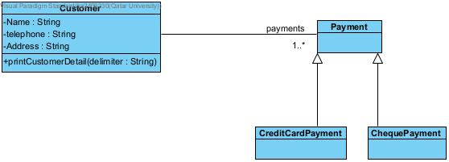

use Case diagram:

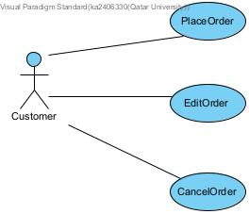

Sequence Diagram:
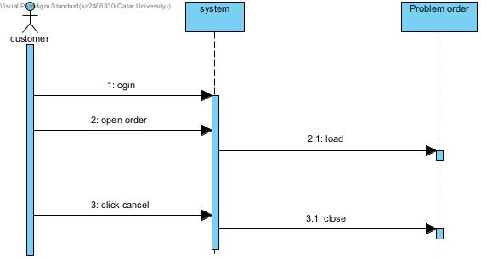

Hotel reservation:
