Qatar university
College of engineering
Department of computer science and engineering

CMPS310- Software Engineering

Milestone 1 Report
PrearlMart inventory Management System

Prepared by:
Laraib khan
Kaltham alkubaisi
Noof alyafei

Instructor:
Eng. Fatima Hamza

Submission date: 18 October 2026

Section: B52

DECLARATION: We hereby certify that no part of this project or product has been copied from any other student’s work or from any other sources except where due acknowledgment is made in the project. No part of this project/product has been written/produced for us by any other persons.
- Scrum responsibilities

Role | Member
Product owner | Eng. Fatma Hamza
Scrum master | Kaltham alkubaisi
Developer | Noof alyafei
Developer | Laraib khan

- Product Goal
to develop an inventory management system for pearlMart that helps authorized employees efficiently manage inventory, supplier order, sales, and related transactions while maintaining accurate records and supporting inventory reporting.

- Definition of Done
a work is considered done when:
- It meets the project requirements.
- It has been reviewed by at least by at least one member
- Any identified errors have been corrected
- The final version has been saved and uploaded to the team’s GitHub repository in the main branch

- Assumptions:

- Assumption1: The inventory manager is the authorized employee responsible for performing inventory management operation including adding, removing, searching, and updating inventory item information
- Justification: to clearly define the responsibilities of the inventory manager and avoid ambiguity regarding which employee is authorized to manage inventory records
- Affected models: Data flow diagram level 0,1,2 and use case diagram

- Assumption2: The authorized managers who can request summary reports are the inventory manager and the store manager
- Justification: Both managers have management responsibilities and need access to summary reports to monitor inventory and store activities
- Affected models: Data flow diagram level 0,1,2 and use case diagram

- Assumption3: Expiration date is an optional attribute of Item ([0..1]). An item with no date doesn’t count as expired
- Justification: The project requirements doc said the date is recorded “when applicable”
- Affected models: Class Diagram

- Assumption4: StockMovement records only manual additions, removals and expired-goods removals. Supplier deleiveries recorded on SupplierOrder, sales on Sale and replacements on Repkacement
- Justification: The project requirements doc said “goods added or removed” as tracked activities
- Affected models: Class Diagram

- Assumption5: Delivery verification is stored on SupplierOrder (as receivedDate) and OrderLine (as receivedQuantity), so there’s no separate Receipt class.
- Justification: The project requirements doc said the store manager verifies the goods and the system “records the received quantities”
- Affected models: Class Diagram

- Assumption6: Discount and tax are calculated per sale line
- Justification: The project requirements doc gave no info on rules and rates, so I treated them as calculation logic
- Affected models: Class Diagram

- Assumption7: Only accepted replacements are stores and the accepted replacements hands out the same item so its quantity is deducted from the stock
- Justification: The project requirements doc said “necessary updates to the inventory” so I feel its necessary
- Affected models: Class Diagram

- Sprints review

- Sprint1

- Sprint retrospective

Duration: September18 – October 2 ,2026

Goal: develop initial system analysis model for the pearl mart
inventory management system

Backlog: create DFD level 0, DFD level 1, DFD leve2

- Sprint review

Completed work: During Sprint 1, the team completed the DFD Level 0, Level 1, and Level 2.

Feedback: Team members reviewed the diagrams and provided feedback regarding spelling mistakes, missing methods, and missing use cases. These comments helped the team identify areas that needed improvement.

- Sprint retrospective

Difficulties: The main difficulty faced during Sprint 1 was limited time, which made it challenging to complete and review all tasks efficiently.

Improvement actions: To address this issue, the team decided to improve time management by organizing tasks more effectively and allocating sufficient time for reviewing and correcting the diagrams in Sprint 2.

- Sprint 2

- Sprint retrospective

Duration: September3 – October 17 ,2026

Goal: to continue developing the pearlMart system models, complete the remaining design tasks, and improve the quality and consistency of the project deliverables.

Backlog: create the use case diagram and the use case specification tables, and the class diagram.

- Sprint review

Completed work: During sprint2 the team worked on the use case diagram and specification tables and the class diagram.

Feedback: t Team members reviewed the diagrams and provided feedback regarding some additional redundant classes and some weak alternatives flows.

- Sprint retrospective

Difficulties: the main difficulty
Improvement actions: the team focused on improving task organization and allocating more time for reviewing and correcting project deliverables, as planned after sprint1. team members agreed the the initial draft must be submitted at least 2 days before the deadline to allocate more time to review.

- DFD level-1
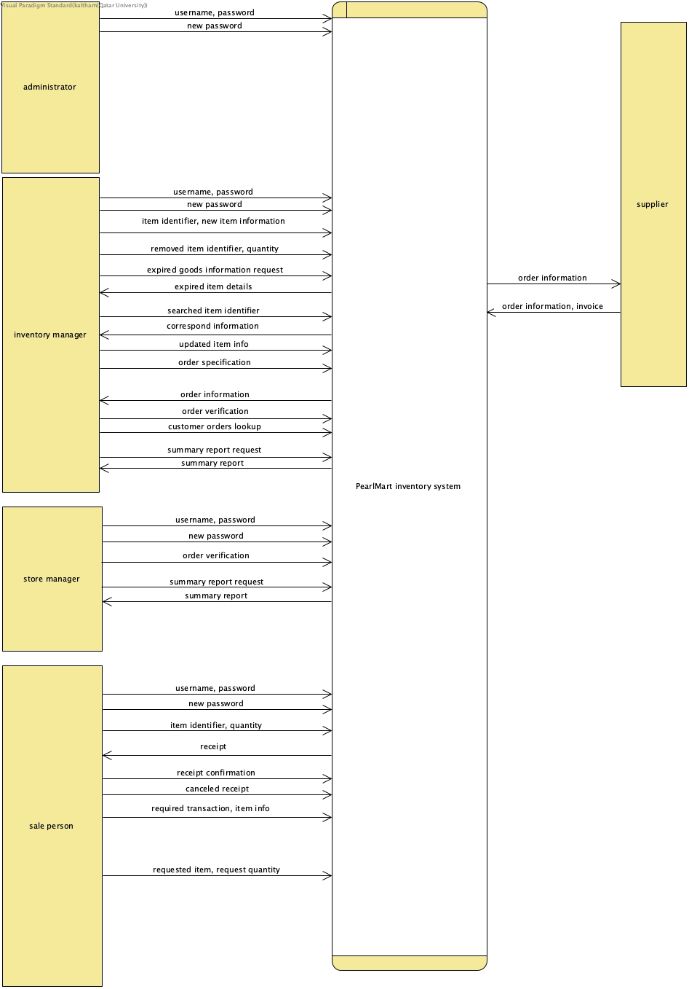

- DFD level 1:

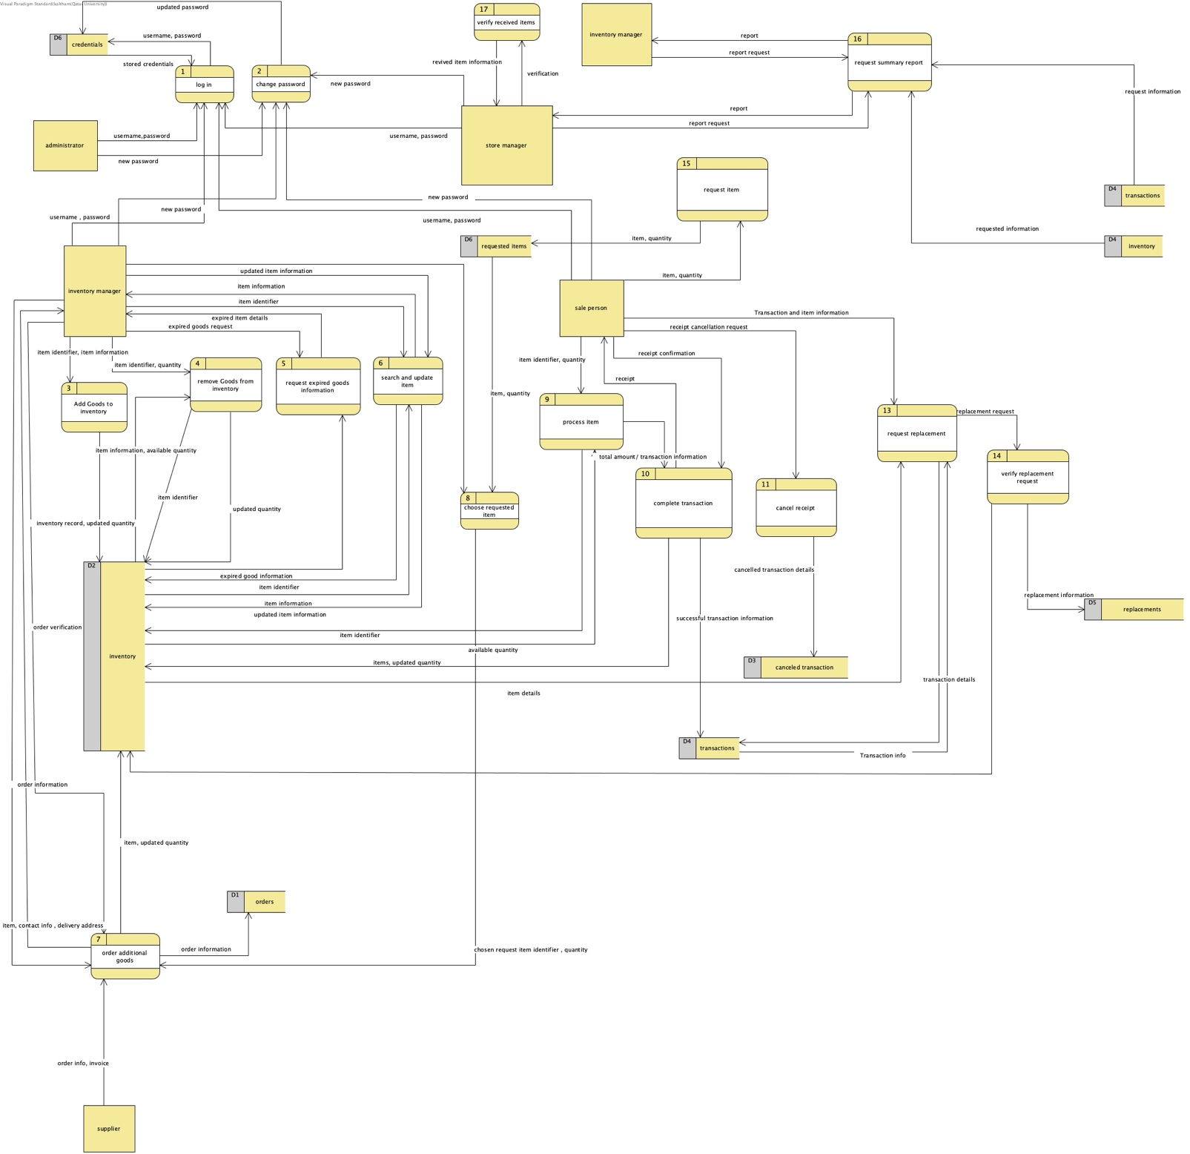

- DFD level 2
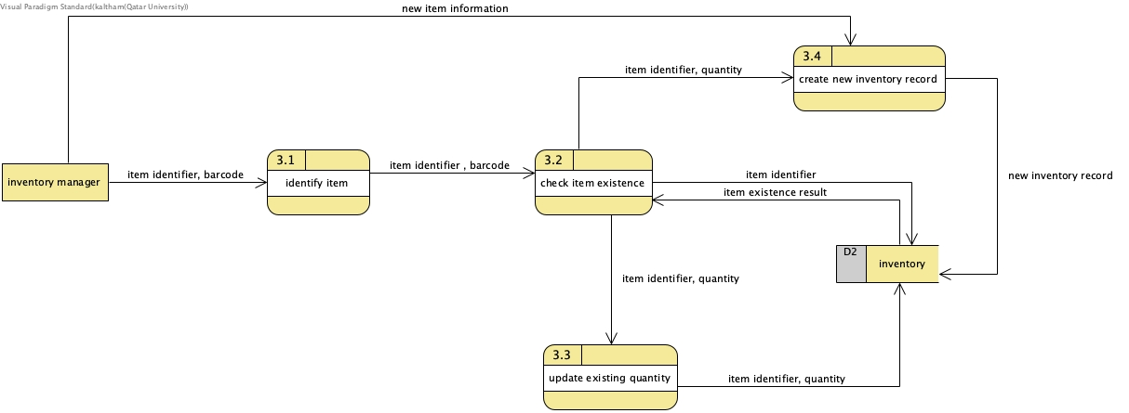

- DFD checklist

DFD comparison | Boundary flow verified | Balanced
Level0⇔ level 1 | external input and output data flows are preserved | Yes
Level1⇔ level 2 | external input and output data flows are preserved | Yes

- Use Case diagram:
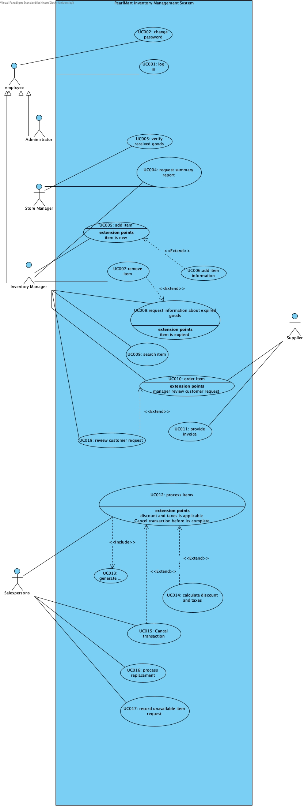

- DFD and UseCase comparison:

The DFD and Use Case Diagram show different parts of the PearlMart Inventory Management System. The DFD shows how data moves through the system, including the processes, external entities, and data stores. For example, it shows how item information is received and used when adding or updating items in the inventory. The main advantage of the DFD is that it helps us understand how data is processed and where it is stored. However, it does not clearly show the functions available to each user. On the other hand, the Use Case Diagram shows how different actors interact with the system and what functions they can perform. For example, it shows that the Inventory Manager can add and remove items. Its main advantage is that it makes the system functions and user roles easier to understand. However, it does not show how data moves inside the system or how it is stored. Both diagrams are useful because they explain the system from different perspectives. The Use Case Diagram shows who can use each function, while the DFD shows how data moves between the different parts of the system. For example, if we want to know how item information moves through the system when adding a new item, the DFD is more useful because it shows the data flows and processes involved. The Use Case Diagram only shows that the actor can perform the Add Item function

- Use Case Specifications:
Task 1: Add Item
Use case ID: UC005 | Add Item
Brief description | An authorized employee adds goods to inventory. If the item is new, the system creates a record; if it already exists, the system increases its available quantity.
Primary actors | Inventory Manager
trigger | New goods arrive and the employee selects Add Item.
Preconditions | The employee is logged in and authorized to manage inventory.
Post condition | A new inventory record is created, or the quantity of an existing item is increased.
Main success scenario
Actor action | System response
1. The employee selects Add Item. | 2. The system asks the employee to scan the barcode or enter the item identifier.
3. The employee enters or scans the identifier. | 4. The system checks whether the item already exists.
 | 5. If it is a new item, the system requests its name, selling price, quantity, manufacturer, place of origin, and expiration date when applicable.
6. The employee enters the required details. | 7. The system creates the new inventory record and record the addition.
 | 8. The system confirms that the inventory has been updated.
Alternatives flow:
4.a. If the item already exists, the system asks for the quantity to add, the employee enters it and the system increases the quantity and records the addition, resumes at step 8.
6.a. If required information is missing, the system asks the employee to complete it before saving.

Task 2 : Remove Item
Use case ID: UC007 | Remove Item
Brief description | An authorized employee removes a specified quantity of an item from the inventory, and the system updates the available quantity and records the change.
Primary actors | Inventory Manager
trigger | Employee selects Remove Item.
Preconditions | Employee is logged in.
Post condition | The available quantity is reduced, and the inventory change is recorded if the removal is successful.
Main success scenario
Actor action | System response
1. The employee selects Remove Item. | 2. The system asks for the item identifier and quantity.
3. The employee enters the item identifier and quantity. | 4. The system retrieves the item information.
 | 5. The system checks whether the requested quantity is available.
 | 6. The system reduces the available quantity and records the change.
 | 7. The system confirms that the item was removed successfully.
Alternatives flow:
5.a. If the requested quantity is unavailable, the system rejects the request and informs the employee.
4.a. If the item does not exist, the system informs the employee that the item was not found.

Task 3 : Order Item
Use case ID: UC010 | Order Item
Brief description | The Inventory Manager prepares an order for required goods from a selected Supplier. The system records the order and forwards the necessary information to the Supplier.
Primary actors | Inventory Manager; Supplier (external actor).
trigger | The Inventory Manager determines that additional goods are required and selects Order Item.
Preconditions | The Inventory Manager is logged in and has identified the required item and quantity.
Post condition | The order is recorded and the necessary order information is forwarded to the selected Supplier.
Main success scenario
Actor action | System response
1. The Inventory Manager selects Order Item. | 2. The system requests the item, quantity, delivery address, contact information, and comments.
3. The manager enters the order details and selects a Supplier. | 4. The system validates the order information.
 | 5. The system records the order.
 | 6. The system forwards the order information to the selected Supplier.
 | 7. The system confirms that the order has been recorded.
Alternatives flow:
4.a. If required order information is missing, the system asks the manager to complete it before recording the order.

Task 4 : Process Items

Use case ID: UC012 | Process Items
Brief description | The Salesperson processes items selected by a customer. The system checks availability, calculates selling amounts and applicable discounts and taxes, generates a receipt, and updates inventory after successful completion.
Primary actors | Salesperson.
trigger | The Salesperson begins processing a customer's purchase at the billing counter.
Preconditions | The Salesperson is logged in and the customer's selected items are identified.
Post condition | If completed, a receipt is generated and quantities are deducted from inventory. If cancelled, the transaction ends without permanently deducting quantities.
Main success scenario
Actor action | System response
1. The Salesperson scans a barcode or enters the item identifier and quantity. | 2. The system retrieves item information and checks availability.
3. The Salesperson enters the remaining selected items. | 4. The system determines the selling amount for each valid item.
 | 5. Where applicable, the system calculates discounts and taxes.
6. The Salesperson completes the transaction. | 7. The system calculates the final amount and generates a receipt with items, quantities, prices, discounts, taxes, and total.
 | 8. The system deducts purchased quantities from inventory and records the transaction.
Alternatives flow:
2.a. If the requested quantity is unavailable, the system informs the Salesperson, and the item cannot be processed as requested.
The Salesperson continues with the next item (resume at step 1)
6.a. Cancel: before completing, the Salesperson cancels the receipt. The system ends the transaction and records the cancelled transaction. Use case ends

- Design Class Diagram:
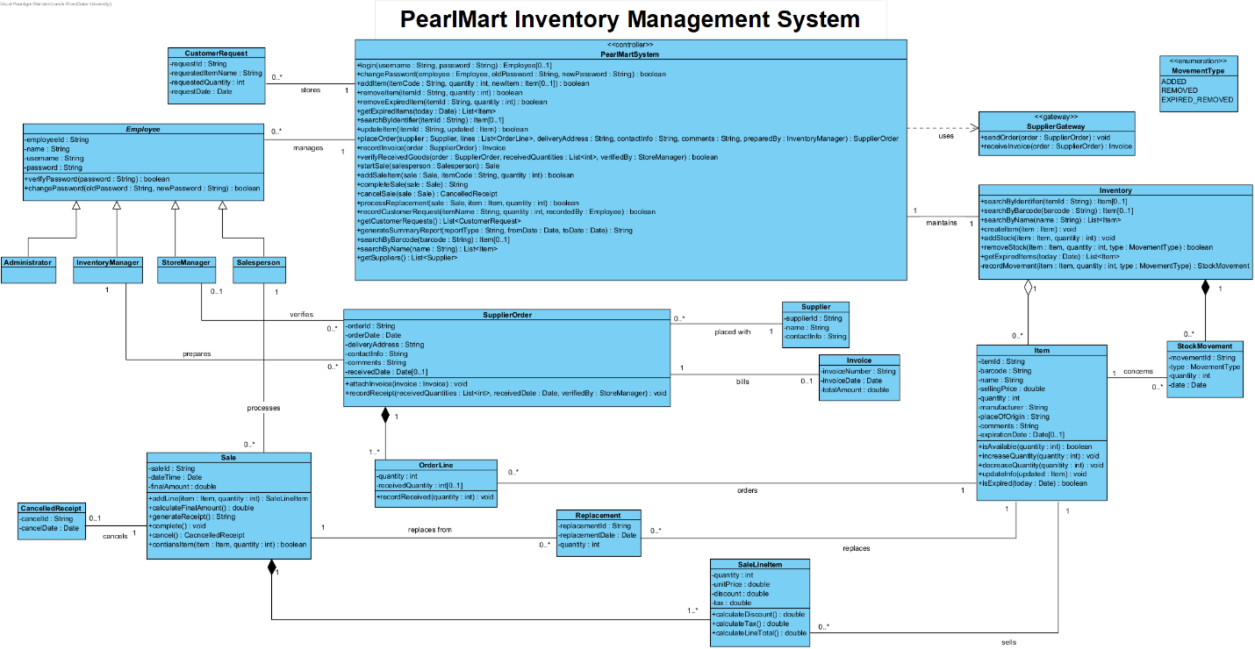

- Design Explanation:

Responsibility Assignment
- We assigned each responsibility to the class that holds the information needed to carry it out. Item owns its quantity so it provides isAvailable, increaseQuantity and decreaseQuantity. Inventory manages the collection of items and provides the search, createItem, addStock and removeStock operations. A SaleLineItem calculates its own discount, tax and line total, and Sale combines its lines to calculate the final amount, generate the receipt and complete the transaction. PearlMartSystem is a controller that receives each use case request, such as completeSale or placeOrder, and delegates the detailed work to these classes instead of doing it itself. SupplierGateway is responsible for all communication with the external Supplier.
Encapsulation
- All attributes are private and can only be changed through operations. Inventory.recordMovement is a private operation called only by addStock, createItem and removeStock. This guarantees that stock cannot change without the change being logged as a StockMovement, which matches the brief’s requirement that the system records every addition and removal.
Abstraction:
- Employee is an abstract class that captures only what all users share: login information and password handling. Other classes work with an Employee without knowing the role. SupplierGateway hides the external Supplier behind two operations, sendOrder and receiveInvoice, so the rest of the system never depends on how the Supplier’s system works. The controller likewise exposes use-case-level operations
Modularity:
- The design is divided into cohesive groups: users, inventory, ordering and sales. Each group changes for its own reason, and they interact through a few operations.
Justified Relationship:
- Generalization is used for Employee, because the Administrator, Inventory Manager, Store Manager and Salesperson are kinds of employees that share login data and differ in the work they do. Composition is used for SupplierOrder-OrderLine, Sale-SaleLineItem and Inventory-StockMovement, because those parts cannot exist without their whole and are removed with it. Aggregation is used for Inventory-Item, because items are also referenced by order lines, sale lines and replacements, so they exist independently of any one of them.

