Final Project Report — Programming Fundamentals
University Name: FAST NUSEC, Karachi Campus
Department: Department of Artificial Intelligence
Course: Programming Fundamentals (LAB)
Project Title: Online Election Management System
Submitted By: Muhammad Mujtaba, Arham Alam
Roll No.: 25K-0157 (BAI-1B), 25k-0162
Submitted To: Miss. Izzah Salam
Semester: Fall 2025
Date: 23 November 2025

Abstract
The Online Election Management System is a console-based program developed in C language. It enables secure and fair voting by validating voter age, preventing duplicate CNIC registrations, automatically tallying votes and instantaneous viewing of registered voters for transparency. This project applies fundamental programming concepts such as decision structures, pointers, loops, 2D arrays, and functions. The system eliminates the weaknesses of Google Forms(online) voting and ensures transparent and accurate election results.

1. Introduction
Free and fair elections are essential, but many small-scale voting systems lack verification and security. Traditional tools like Google Forms allow duplicate votes, provide no age checks, no email authentication and require manual tallying for registered voters. This project provides an efficient, automated election system using C programming fundamentals.

2. Objectives
- To prevent duplicate voting using unique CNIC validation.
- To verify voter age before allowing registration.
- To allow province-based candidate voting.
- To automatically tally results without manual calculation.
- To provide an easy, menu-driven system for users.
- To keep make voting easy.

3. System Design

The election system is structured around several core modules: registration, voting, voter listing, and result calculation. The program uses arrays to store CNIC values, voter names, and votes per candidate per province. It ensures input validation at every step to maintain data integrity

System Overview

Flow of the program:

Start → Display Menu → Select voting and registration →View all the registered voter for authentication → Display province vise winners and overall winner

→ Exit

Algorithm

1. Start the program

2. Prompt user to enter the choice between registration and voting, display result and listing of voters

3. For each voter input CNIC name, age and which province he or she wants to vote

4. Display the suitable candidates for the voter.

5. Display the results province wise

6. End

Input & Output

Input: CNIC, name, age and province,

Output: Display the total voting results province wise.

4. Implementation
Language: C
Compiler/IDE: VS Code
Key Features:
- CNIC-based duplicate voter prevention
- Age validation (must be 18+)
- Province-wise candidate display
- Secure vote confirmation system
- Automatic computation of province and overall winners
- Menu-driven navigation

Code Snippet:
void voting(int votes[PROVINCES][CANDIDATES]){
int province, candidate;
char confirm;

printf("Select your province:\n");
for(int i = 0; i < PROVINCES; i++)
printf("%d: %s\n", i + 1, province_names[i]);

printf("Enter province number: ");
if (scanf("%d", &province) != 1 || province < 1 || province > PROVINCES){
printf("Invalid province.\n");
return;
}

printf("Candidates in %s:\n", province_names[province-1]);
for(int i = 0; i < CANDIDATES; i++)
printf("%d: %s\n", i + 1, candidate_names[province-1][i]);

printf("Enter candidate number: ");
if (scanf("%d", &candidate) != 1 || candidate < 1 || candidate > CANDIDATES){
printf("Invalid candidate.\n");
return;
}
printf("Confirm vote for %s (y/n): ", candidate_names[province-1][candidate-1]);
scanf(" %c", &confirm);
if(confirm != 'y' && confirm != 'Y'){
printf("Vote cancelled.\n");
return;
}
votes[province-1][candidate-1]++;
printf("Vote cast successfully!\n");
}
Sample Output
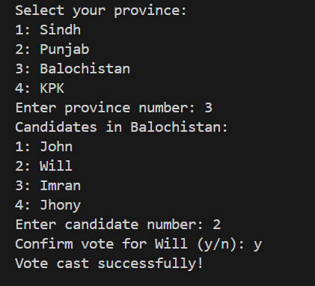

5. Testing & Results
- Test: Duplicate CNIC Check — Expected Output: Second registration rejected
- Test: Underage Voter — Expected Output: Voter denied access to voting
- Test: Invalid Province Input — Expected Output: Error displayed
- Test: Invalid Candidate Input — Expected Output: Error displayed
- Test: Vote Counting — Expected Output: Vote increments correctly
- Test: Results — Expected Output: Correct winners displayed

The program performed successfully for all test cases. It handled all the different cases which could occur at runtime when user input different input which crates different situations. It efficiently, produced accurate totals and voting results when needed, and validated all inputs. Execution speed
was near-instant, and the program required minimal system resources.

6. Conclusion
The Online Election Management System successfully resolves issues present in simple form-based voting systems. It ensures secure, accurate, and fair elections using basic C programming concepts. The system provides reliable age validation, duplicate prevention, and automatic vote counting.

7. Limitations & Future Enhancements
Limitations:

- No permanent vote storage (data resets on program exit).

- No administrator login system.
Future Enhancements:
- Add file handling to store votes permanently.
- Add encryption for CNIC data.
- Add district-level voting if needed.
- Add admin-based system for keeping the voters info secret.

