FAST National University of Computer and Emerging Sciences
Karachi Campus
Department of Computer Science


FINAL PROJECT REPORT
Online Shopping / E-Commerce Simulator
A GUI-Based Object-Oriented C++ Application Implementing Inheritance, Polymorphism, File Handling, Billing System, and Product Management

Course: OOP Lab
Instructor: Sir Muhammad Khalid Khan
Section: BAI-2B
Semester: Spring 2026
Group Members:
Tooba Ilyas 25K-0127
Rameen Jawaid 25K-0027
Deepa Kataria 25K-0131

1. Executive Summary
This report presents the complete design and implementation of the Online Shopping / E-Commerce Simulator, a C++ based desktop application developed as the second semester project for OOP Lab. The system simulates a real-world online shopping platform where customers can browse products, manage a cart, checkout, and generate bills, while administrators can manage inventory and product records. The project demonstrates practical application of major OOP concepts including encapsulation, inheritance, polymorphism, abstraction, file handling, and exception handling.

2. Introduction
The rapid growth of online shopping platforms has transformed consumer purchasing behavior. Manual management of products, customer carts, and billing is inefficient and prone to human error. Therefore, this project was designed to automate shopping workflows in a desktop environment using Object-Oriented Programming concepts. The project also serves as a practical implementation of the theoretical OOP concepts studied during the semester.

3. System Analysis
Functional requirements include product listing, cart management, billing, checkout, admin inventory control, and file-based data persistence. Non-functional requirements include usability, maintainability, code modularity, and robust exception handling.

4. Object-Oriented Design
The system is structured around multiple interacting classes including Product, CartItem, ShoppingCart, User, Customer, Admin, Bill, FileHandler, and MainWindow. Inheritance is used between User, Customer, and Admin. Aggregation exists between ShoppingCart and Product objects. Composition is used in the billing module.

5. Implementation
The application was implemented in C++ using Qt framework for GUI. Separate header and source files were created for each class. Core modules include product management, cart operations, billing calculations, and file persistence. All user actions are handled through menu buttons and forms.

6. Testing and Results
Multiple test cases were executed to verify system functionality including adding products, editing inventory, cart operations, billing generation, invalid quantity handling, and file save/load operations. All critical functions produced expected outputs.

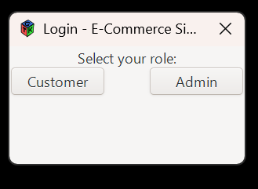
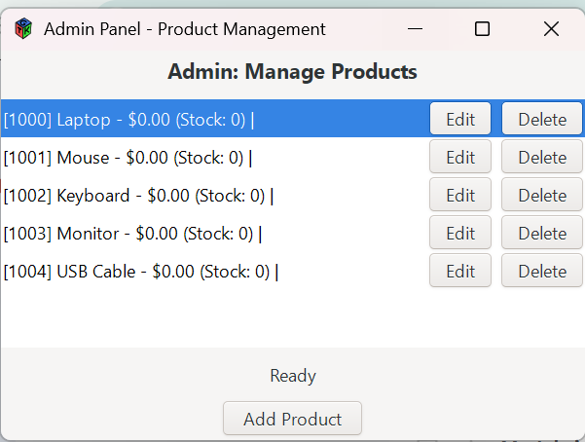
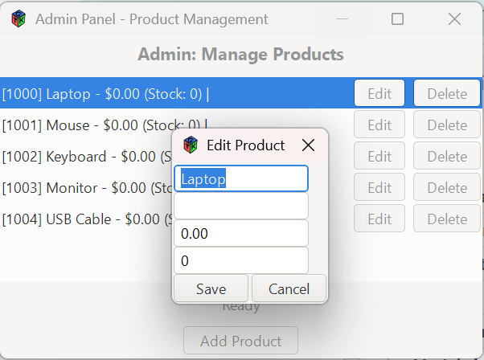
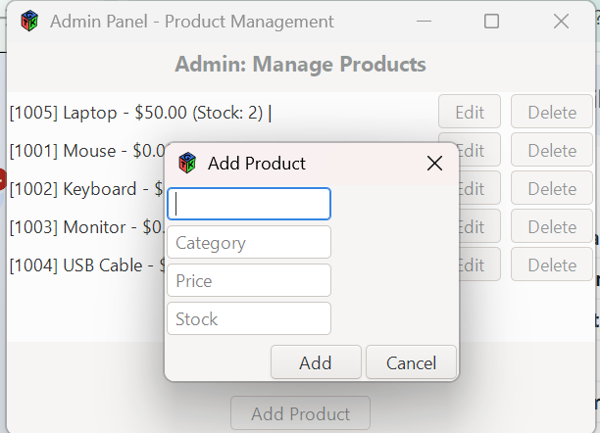
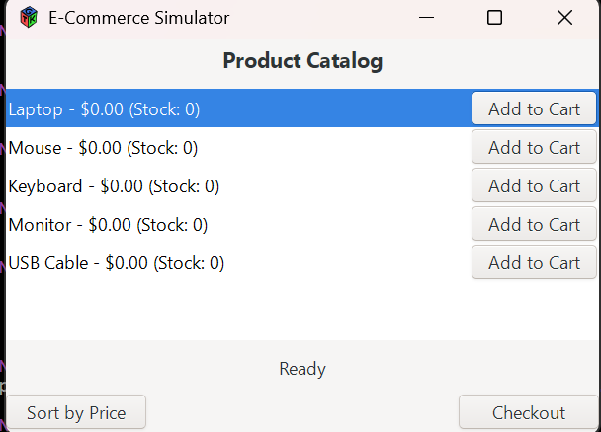

7. Challenges and Solutions
During development, challenges included GUI signal-slot integration, synchronizing cart totals, persistent file parsing, and maintaining object relationships. These issues were solved through modular coding, helper functions, and structured validation.

8. Division of Work
Tooba Ilyas worked on GUI layouts and customer cart workflows. Rameen Jawaid worked on class hierarchy, OOP implementation, and billing logic. Deepa Kataria worked on file handling, admin inventory management, and documentation. All members contributed equally in debugging and testing.

9. Conclusion and Future Work
The Online Shopping / E-Commerce Simulator successfully demonstrates the practical use of Object-Oriented Programming in a real-world application. Future enhancements may include database integration, user authentication, payment gateway simulation, discount coupons, and order history.

10. References
1. Bjarne Stroustrup, The C++ Programming Language.
2. C++ Primer.
3. Qt Documentation.
4. GeeksforGeeks OOP in C++.
5. FAST OOP Lab Course Material.

